PROJECT REPORT
LIBRARY MANAGEMENT SYSTEM
Digitizing the Document Borrowing Process at Phenikaa University Library

Academic year | 2025 – 2026
Submission date | June 2026
Supervisor | TS. Nguyễn Thanh Bình
Team member | Nguyễn Thị Thu Hà  Bùi Thanh Thảo  Phạm Minh Tuyên  Lê Hà Hải Vân
Technology | Java 21 · Spring Boot 3.4.13 · Spring Security · Spring Scheduling · Thymeleaf · H2 / MySQL · Bootstrap 5

Table of Contents
Table of Contents 3
1. Introduction & Project Overview 4
1.1 Background 4
1.2 Project Objectives 4
1.3 Technology Stack 5
1.4 Summary of Changes in This Version 5
2. Requirements Analysis 6
2.1 Stakeholders 6
2.2 Functional Requirements 7
2.3 Non-Functional Requirements 9
3. Business Process Specification 10
3.1 Revised Borrowing Process (Self-Service) 10
3.2 Borrowing Rules by Reader Type 11
3.3 Validation Rules (RuleEngine.validate) 11
4. System Architecture 12
4.1 Architectural Pattern — MVC 12
4.2 Security Architecture (Role Separation) 13
4.3 Session Management 13
4.4 Transaction Management 13
4.5 Scheduling 14
4.6 Request Flow — Self-Service Submit & Pickup 14
5. Database Design 14
5.1 Entity-Relationship Overview 14
5.2 Table Definitions 15
6. Feature Implementation 17
6.1 Feature List 17
6.2 Key Business Logic Components 19
6.3 Changes & Fixes Applied in This Version 20
7. Task Assignment 21
8. Installation & Setup Guide 22
8.1 Prerequisites 22
8.2 Run in Development (H2) 22
8.3 Sample Accounts (password: password123) 23
8.4 How to Test the New Flow 23
9. Testing & Validation 24
9.1 Functional Test Scenarios (verified) 24
9.2 Build & Runtime Verification 25
10. Conclusion & Future Work 25
10.1 Achievements 25
10.2 Limitations 25
10.3 Future Development Roadmap 25

1. Introduction & Project Overview

1.1 Background
Phenikaa University Library manages the borrowing and returning of academic documents for thousands of students, lecturers, and researchers every semester. The traditional paper-based workflow — physical card presentation, handwritten loan slips, and manual ledger entries — is time-consuming and error-prone.
The first version of this project digitised that workflow but still imitated the old counter model: every loan request had to be manually approved by a librarian before the reader could borrow. Following the supervisor's review, the system has been redesigned to be genuinely more convenient than traditional borrowing:
- No librarian/admin approval is required. If the reader satisfies the borrowing rules, the loan is granted immediately.
- Each loan request generates a unique pickup code. Librarians simply prepare the books for that code.
- The reader picks up the books within 24 hours and self-confirms receipt online by re-entering the pickup code; otherwise the request auto-cancels and the held copies are released.
- The roles of Administrator and Librarian are now clearly separated. The administrator manages user accounts and a functional-permission matrix (which actions each role may perform), while the librarian configures the borrowing rules and shows/hides document types per role from a configuration screen — all without editing any code.

1.2 Project Objectives
- Provide a self-service, cart-based borrowing experience with no manual approval step.
- Issue a pickup code per request, hold the copies, and auto-cancel un-collected requests after 24 hours.
- Let readers self-confirm pickup by re-entering their pickup code (ownership + code verified).
- Enforce role-based borrowing rules (quota, duration, renewals, late fines) for Students, Lecturers, and Researchers.
- Separate the Administrator (user accounts + functional-permission matrix) from the Librarian (day-to-day operations + borrowing-rule configuration).
- Offer on-screen configuration with no code change and no redeploy: the librarian edits borrowing rules and document-type visibility per role, and the administrator grants or revokes functional permissions per role.

1.3 Technology Stack
Layer | Technology | Version / Notes
Backend Framework | Spring Boot | 3.4.13 — Java 21, Maven
Web MVC | Spring Web MVC + Thymeleaf | Server-side template rendering
Security | Spring Security | Form login, strict role-based access (no role hierarchy)
Scheduling | Spring Scheduling (@EnableScheduling) | Background job auto-cancels expired pickups
ORM / Persistence | Spring Data JPA / Hibernate | H2 in-memory (dev), MySQL-compatible
Database (Dev) | H2 In-Memory | Auto-seeded via data.sql on startup
Database (Prod) | MySQL | Switch via application.properties
UI Framework | Bootstrap 5.3.2 + Bootstrap Icons 1.11.3 | Responsive layout
Build Tool | Maven 3.8+ | pom.xml dependency management
Language | Java 21 | Records, switch expressions, pattern matching

1.4 Summary of Changes in This Version
This revised edition reflects every change requested in the supervisor's feedback. The table below summarises the difference between the first submission (v2) and the current version (v3).
Aspect | v2 (previous) | v3 (current)
Approval | Librarian must approve each PENDING loan | No approval — granted immediately if eligible
Pickup | Implicit, no code | Pickup code + 24h window; reader self-confirms by code
Un-collected loans | Stay forever / manual cancel | Auto-cancelled after 24h by a scheduled job
Roles | ADMIN + readers only | ADMIN, LIBRARIAN + readers (clearly separated)
Admin scope | Everything (loans, books, users) | Only Users + a functional-permission matrix (no loans/books/rules)
Librarian scope | (did not exist) | Dashboard, pickup orders, returns, book/stock management
Doc-type visibility | Hard-coded | Toggled per role by the librarian on the /librarian/rules page
Loan status | PENDING/APPROVED/RETURNED/CANCELLED | AWAITING_PICKUP / BORROWED / COMPLETED / CANCELLED
Spring Boot | 3.3.5 | 3.4.13
Notifications | (none) | In-app notifications for loan / pickup / return / fine / cancel events (navbar bell)
In-house reading | (none) | Librarian issues read-on-site slips for restricted documents
Fine settlement | (none) | Per-item fine tracked & marked paid; a loan completes only when settled

2. Requirements Analysis

2.1 Stakeholders
Stakeholder | Role in System | Key Needs
Student | Borrower (STUDENT) | Search, request loans, self-confirm pickup, view history, renew
Lecturer / Staff | Borrower (LECTURER) | Unlimited loan duration on textbooks & specialised references
Researcher | Borrower (RESEARCHER) | Extended quotas on specialised references
Librarian | Operations (LIBRARIAN) | Prepare books for pickup orders, process returns & fines, configure borrowing rules & document-type visibility, issue in-house reading slips, manage catalogue & stock
Administrator | System admin (ADMIN) | Manage users & roles; configure the functional-permission matrix per role

2.2 Functional Requirements
FR-1 Authentication & Routing
- Authenticate users by student/staff code and BCrypt password.
- Deny borrowing to accounts whose card status is LOCKED.
- After login, route ADMIN to user management, LIBRARIAN to the operations dashboard, and readers to the client home page.
FR-2 Catalogue & Search
- Display books with title, author, ISBN, document type, classification code, and available copies.
- Search by keyword (title / author / ISBN / classification code) and filter by document type and availability.
- Show a reader only the document types that are visible for their role (configurable by the librarian).
FR-3 Cart & Self-Service Loan Request
- A reader can add up to 5 books to a session cart.
- On submit, the RuleEngine validates the cart; if valid the loan is created immediately (no approval).
- The loan is created with status AWAITING_PICKUP, a unique pickup code, and a 24-hour pickup deadline; held copies are decremented at once.
FR-4 Self-Confirm Pickup (replaces approval)
- The reader collects the books and re-enters the pickup code on the 'My Loans' page to confirm receipt.
- The system verifies ownership, the AWAITING_PICKUP status, and an exact (case-insensitive) code match.
- On success the loan becomes BORROWED and each item's due date is set per the reader's role and document type.
FR-5 Auto-Cancellation of Expired Pickups
- A scheduled job runs periodically and cancels every AWAITING_PICKUP loan whose 24-hour deadline has passed.
- Cancellation restores the held copies back to the catalogue.
FR-6 Book Return & Fine Calculation
- A librarian processes the return of each loan item.
- The overdue fine is computed at 2,000 VND per overdue day (full day count).
- The returned condition (GOOD / DAMAGED) is recorded; the parent loan auto-closes (status COMPLETED) once all items are returned and all fines are settled.
FR-7 Renewal
- A reader can renew an active item within the permitted number of renewals.
- A renewal extends the due date by the configured renewal_days.
- Renewal is denied for items not owned by the reader, not in BORROWING status, or beyond the renewal limit.
FR-8 Administrator — Users & Permissions
- Create, update, search and delete user accounts (including LIBRARIAN) and assign roles from the UI; lock/unlock reader cards and reset passwords.
- Grant or revoke functional permissions per role on the /admin/permissions page (book CRUD, return, pay-fine, cancel, in-house lending, rule management, borrow / renew / self-cancel).
- The administrator's own management permissions (users + permission matrix) are fixed and cannot be revoked; the admin does not touch books, loans or borrowing rules.
FR-9 Librarian — Operations
- View pickup orders (codes & deadlines) to prepare books.
- Process returns, record condition and collect overdue fines; manage the book catalogue and copy counts (CRUD).
- View the operations dashboard (awaiting pickup, active borrowings, overdue items).
- Edit the borrowing-rule matrix and toggle document-type visibility per role on the /librarian/rules page — without modifying code.
- Issue in-house reading slips for restricted (internal) documents on the /librarian/inhouse page.
- Cancel a pickup order with a mandatory reason that is sent to the reader; the held copies are released back to stock.
FR-10 Account Self-Service (seeded accounts & password change)
- The database is pre-seeded with 82 accounts (2 administrators and 20 each of student, lecturer, researcher and librarian), all using the default password password123.
- After signing in, any user can change their own password at /account/password; the current password is verified and the new one (>= 6 characters) is stored as a BCrypt hash.
FR-11 In-App Notifications
- Business events — loan created, pickup confirmed, return, fine collected, cancellation and completion — raise in-app notifications shown through a navbar bell.
- A reader is notified about their own orders; every librarian is notified about new orders, self-confirmations and auto-cancellations (NotificationService.notify / notifyRole).
- Users open /notifications to read the full list and mark items read individually or all at once.

2.3 Non-Functional Requirements
Category | Requirement
Security | Strict RBAC. /admin/** requires ADMIN; /librarian/** requires LIBRARIAN; /client/** requires a reader role; /notifications/** requires any authenticated user. No role inheritance between ADMIN and LIBRARIAN.
Data Integrity | All mutating service methods are @Transactional; copies are validated for all cart items before any decrement.
Reliability | A scheduled job guarantees that held copies are released if a reader never collects the books.
Usability | Bootstrap 5 responsive UI; inline validation messages; pickup code shown prominently to the reader.
Portability | H2 in-memory for zero-config development; MySQL-compatible schema for production.
Maintainability | Clean MVC layering; all borrowing calculations encapsulated in RuleEngine; rule administration in RuleService.

3. Business Process Specification

3.1 Revised Borrowing Process (Self-Service)
The counter-approval step of the original 8-step process has been removed. The digital flow is now:
Step | Activity | Actor | Digital Implementation
1 | Sign in | Reader | Login + card_status == ACTIVE check
2 | Search documents | Reader | GET /client/home — keyword + type filter, role-based visibility
3 | Build cart & submit | Reader | POST /client/loans/submit — RuleEngine validates
4 | Loan granted instantly | System | Create loan AWAITING_PICKUP + pickup code + 24h deadline; hold copies
5 | Prepare books | Librarian | View pickup orders (GET /librarian/loans?status=AWAITING_PICKUP) and gather books
6 | Collect & self-confirm | Reader | Re-enter pickup code → POST /client/loans/{id}/pickup → BORROWED + due dates
7 | Auto-cancel if not collected | System | Scheduled job cancels expired AWAITING_PICKUP loans, releases copies
8 | Return / renew / fine | Reader + Librarian | Return via /librarian/loans/details/{id}/return; renew via /client/loans/renew/{detailId}

3.2 Borrowing Rules by Reader Type
These 12 rows seed the borrowing_rules table and are enforced by the RuleEngine. They match the QT.03.TV.DV regulation and are now editable by the librarian on the /librarian/rules page (including a per-row visibility switch).
Reader | Document Type | Max Qty | Loan Duration | Max Renewals | Days / Renewal
Student | Textbook | 10 | 150 days | 0 | —
Student | Specialised Ref. | 5 | 90 days | 2 | 3 days
Student | General Ref. | 3 | 15 days | 0 | —
Student | Restricted | 0 | — | 0 | Not allowed
Lecturer | Textbook | 10 | Unlimited | 0 | —
Lecturer | Specialised Ref. | 5 | Unlimited | 0 | —
Lecturer | General Ref. | 5 | 15 days | 2 | 3 days
Lecturer | Restricted | 0 | — | 0 | Not allowed
Researcher | Textbook | 5 | 150 days | 0 | —
Researcher | Specialised Ref. | 10 | 30 days | 2 | 3 days
Researcher | General Ref. | 10 | 15 days | 0 | —
Researcher | Restricted | 0 | — | 0 | Not allowed

3.3 Validation Rules (RuleEngine.validate)
Before a loan is created, the cart is checked in layers. Actual user-facing messages are in Vietnamese.
Layer | Rule | Message (shown in Vietnamese in-app)
Account | Card status must be ACTIVE | Your account is locked. Please contact the librarian.
Account | No outstanding overdue items | You have N overdue documents. Please return them before borrowing more.
Cart | Cart not empty | Your cart is empty. Please add books before submitting.
Cart | At most 5 items per loan | A single loan may not exceed 5 documents in total...
Type | Restricted documents not borrowable | Internal documents (red sticker) are read-on-site only and cannot be taken away.
Type | Type must be visible & permitted (max_quantity>0) | You are not allowed to borrow documents of type: [type name].
Quota | Per-type count ≤ max_quantity | Over the limit for type '[type]': max N, you selected M.

4. System Architecture

4.1 Architectural Pattern — MVC
Layer | Package | Key Classes
Presentation | controller/ | ClientController, LibrarianController, AdminController, AuthController, AccountController, NotificationController
Business Logic | service/ | LoanService, BookService, UserService, RuleService, NotificationService, PermissionService, CustomUserDetailsService
Rule Engine | util/ | RuleEngine
Scheduling | config/ | PickupExpiryScheduler
Data Access | repository/ | LoanRepository, LoanDetailRepository, BookRepository, BorrowingRuleRepository, UserRepository, NotificationRepository, RolePermissionRepository
Domain Model | entity/ | Loan, LoanDetail, Book, User, BorrowingRule, RolePermission, Permission, Notification (+ enums)
DTOs | dto/ | CartItem, BookForm, ValidationResult, RuleConfigForm, ReturnBookForm
View | templates/ | client/, librarian/, admin/, auth/, account/, fragments/, error/, notifications.html

4.2 Security Architecture (Role Separation)
Spring Security uses form login backed by CustomUserDetailsService (lookup by student_code, BCrypt passwords). Authorisation is strict — there is no role hierarchy, so ADMIN and LIBRARIAN are disjoint:
.requestMatchers("/login", "/css/**", "/images/**", "/error").permitAll()
.requestMatchers("/h2-console/**").permitAll()
.requestMatchers("/admin/**").hasRole("ADMIN")
.requestMatchers("/librarian/**").hasRole("LIBRARIAN")
.requestMatchers("/client/**").hasAnyRole("STUDENT","LECTURER","RESEARCHER")
.requestMatchers("/notifications/**").authenticated()
.anyRequest().authenticated()
Post-login routing: ADMIN → /admin/users, LIBRARIAN → /librarian/dashboard, readers → /client/home.
The /notifications/** path needs only an authenticated user, and /account/password falls through to .anyRequest().authenticated(), so every role can read its notifications and change its own password.

4.3 Session Management
The cart is stored in the HTTP session as a List<CartItem> (60-minute timeout) and cleared on a successful submit.

4.4 Transaction Management
All mutating service methods are @Transactional. submitLoan first verifies availability for every cart item, then atomically creates the Loan and its LoanDetails and decrements available copies, so a single out-of-stock item never leaves partially-held copies behind.

4.5 Scheduling
PickupExpiryScheduler is a @Component whose @Scheduled(fixedRate = 600000) method (every 10 minutes) calls LoanService.cancelExpiredPickups(), which cancels AWAITING_PICKUP loans past their deadline and restores the held copies. @EnableScheduling is declared on the application class.

4.6 Request Flow — Self-Service Submit & Pickup
Browser → POST /client/loans/submit
→ ClientController.submitLoan()
→ LoanService.submitLoan(user, cart)
├─ RuleEngine.validate(user, cart) [account/cart/type/quota]
├─ verify all books available
├─ save Loan [AWAITING_PICKUP] + pickupCode + deadline(now+24h)
└─ for each book: save LoanDetail [RESERVED], available_copies -= 1
→ flash 'Pickup code: XXXXXX' → redirect /client/my-loans
Browser → POST /client/loans/{id}/pickup (code re-entered by reader)
→ LoanService.confirmPickup(id, user, code)
├─ check owner + AWAITING_PICKUP + code matches
└─ Loan → BORROWED; each detail → BORROWING + due_date set

5. Database Design

5.1 Entity-Relationship Overview
users ──< loans ──< loan_details >── books
borrowing_rules (user_role + doc_type + visible)
role_permissions (user_role + permission) notifications (user_id, type, is_read)
- One User has many Loans (1–N).
- One Loan has many LoanDetails (1–N, cascade ALL).
- One LoanDetail references exactly one Book.
- BorrowingRule is keyed on (user_role, doc_type) and drives quota, due-date and visibility logic.
- RolePermission is keyed on (user_role, permission); Notification belongs to one User and backs the in-app alert feed.

5.2 Table Definitions
Table: users
Column | Type | Notes
id | BIGINT | PK, auto-increment
student_code | VARCHAR | UNIQUE, NOT NULL — login id
full_name | VARCHAR | NOT NULL
password_hash | VARCHAR | NOT NULL — BCrypt
role | VARCHAR(20) | STUDENT | LECTURER | RESEARCHER | LIBRARIAN | ADMIN
card_status | VARCHAR(10) | ACTIVE | LOCKED
created_at | DATETIME | Account creation timestamp

Table: books
Column | Type | Notes
id | BIGINT | PK
title / author | VARCHAR | NOT NULL
isbn | VARCHAR | ISBN / ISSN
category | VARCHAR | Subject category
doc_type | VARCHAR(20) | TEXTBOOK | SPECIALIZED_REF | GENERAL_REF | RESTRICTED
total_copies / available_copies | INT | Stock counters
classification_code, publisher, publish_year, description, image_url | — | Catalogue metadata

Table: loans
Column | Type | Notes
id | BIGINT | PK
user_id | BIGINT | FK → users.id
created_at | DATETIME | When the request was submitted
pickup_code | VARCHAR(10) | 6-char code the reader uses to collect & confirm
pickup_deadline | DATETIME | created_at + 24h; after this the loan auto-cancels
picked_up_at | DATETIME | When the reader confirmed receipt
status | VARCHAR(20) | AWAITING_PICKUP | BORROWED | COMPLETED | CANCELLED
in_house | BOOLEAN | TRUE for in-house (read-on-site) slips of restricted documents
cancel_reason | VARCHAR(255) | Reason shown to the reader when an order is cancelled
cancelled_by_role | VARCHAR(20) | Role that cancelled (LIBRARIAN / reader); NULL if auto-cancelled

Table: loan_details
Column | Type | Notes
id | BIGINT | PK
loan_id | BIGINT | FK → loans.id
book_id | BIGINT | FK → books.id
due_date | DATE | Set on pickup (NULL before pickup, or unlimited for lecturers)
return_date | DATETIME | Actual return timestamp
renewal_count | INT | DEFAULT 0
condition_status | VARCHAR(10) | GOOD | DAMAGED (set on return)
fine_amount | DECIMAL | Overdue fine in VND
fine_paid | BOOLEAN | Whether the overdue fine has been collected (auto-true when fine = 0)
status | VARCHAR(20) | RESERVED | BORROWING | RETURNED | OVERDUE

Table: borrowing_rules
Column | Type | Notes
id | BIGINT | PK
user_role | VARCHAR | part of UNIQUE(user_role, doc_type)
doc_type | VARCHAR | part of UNIQUE(user_role, doc_type)
max_quantity | INT | Max copies per loan (0 = not permitted)
borrow_days | INT (nullable) | Loan duration; NULL = unlimited
max_renewals | INT | 0 = no renewal
renewal_days | INT (nullable) | Days added per renewal
visible | BOOLEAN | NEW — whether this role sees/borrows this doc type (admin-toggled)

6. Feature Implementation

6.1 Feature List
Reader (client) features
# | Feature | Route | Description
1 | Browse & Search | GET /client/home | Keyword/type/availability filters; only role-visible document types
2 | Book Detail | GET /client/books/{id} | Full metadata, availability, in-cart indicator
3 | Add to Cart | POST /client/cart/add (+ /client/cart/add-ajax) | Duplicate & 5-item limit, availability and visibility checks
4 | View / Remove / Clear Cart | GET /client/cart, POST .../remove, .../clear | Manage session cart
5 | Submit Loan (self-service) | POST /client/loans/submit | Validate → create AWAITING_PICKUP + pickup code; show code
6 | My Loans | GET /client/my-loans | Awaiting-pickup orders (with code & countdown), active loans, history
7 | Self-Confirm Pickup | POST /client/loans/{id}/pickup | Re-enter code → BORROWED + due dates
8 | Renew | POST /client/loans/renew/{detailId} | Ownership + BORROWING + renewal-limit checks
9 | Change Password (all roles) | GET/POST /account/password | Verify current password, set a new one (>= 6 chars), saved as BCrypt hash
10 | Cancel Pickup Order | POST /client/loans/{id}/cancel | Reader cancels an own AWAITING_PICKUP order; held copies released
11 | Notifications | GET /notifications, POST /notifications/{id}/read, /notifications/read-all | Read in-app notifications; mark one or all as read

Librarian features (operations)
# | Feature | Route | Description
12 | Operations Dashboard | GET /librarian/dashboard | Awaiting-pickup count, active borrowings, overdue list
13 | Pickup Orders | GET /librarian/loans?status=AWAITING_PICKUP | AWAITING_PICKUP list with codes & deadlines (prepare books)
14 | Cancel Order | POST /librarian/loans/{id}/cancel | Cancel with a mandatory reason; held copies restored and the reader notified
15 | Active Borrowings | GET /librarian/loans?status=BORROWED | BORROWING items with due dates / overdue markers
16 | Process Return | POST /librarian/loans/details/{id}/return | Record condition, compute fine, restore copy; loan completes when all items returned & fines settled
17 | Book / Stock Management | GET/POST /librarian/books/** | Full CRUD incl. copy counts
18 | Collect Fine | POST /librarian/loans/details/{id}/pay-fine | Mark an overdue fine collected; completes the loan when fully settled
19 | Borrowing-Rule & Visibility Config | GET/POST /librarian/rules | Edit quotas/durations/renewals and toggle document-type visibility per role
20 | In-House Reading Slip | GET/POST /librarian/inhouse | Issue a read-on-site slip for a RESTRICTED document by reader code

Administrator features (users & system)
# | Feature | Route | Description
21 | User Management | GET /admin/users | List/search users; lock/unlock cards; reset password; delete
22 | Create User | POST /admin/users | Create accounts (incl. LIBRARIAN) and assign role
23 | Permission Matrix | GET & POST /admin/permissions | Grant/revoke functional permissions per role (book CRUD, return, pay-fine, cancel, in-house, rule-manage, borrow/renew/self-cancel)
24 | Login & Routing | GET/POST /login (+ GET /) | Form login; role-based redirect

6.2 Key Business Logic Components
RuleEngine.java (util/)
Method | Description
validate(User, List<CartItem>) | Account/cart/type/quota checks incl. visibility; returns ValidationResult.
calculateDueDate(role, docType, start) | Adds borrow_days; returns null for unlimited.
canRenew(detail, rule) | renewal_count < max_renewals and max_renewals > 0.
calculateFine(detail) | ChronoUnit.DAYS between due date and return date × 2,000 VND.

LoanService.java (service/)
Method | Description
submitLoan(user, cart) | Validate, verify stock, create AWAITING_PICKUP loan + pickup code + 24h deadline, hold copies.
confirmPickup(loanId, user, code) | Reader self-confirm: owner + status + code check → BORROWED + due dates.
cancelLoan(loanId, reason, byRole) | Librarian cancels with a mandatory reason; restores copies, records who cancelled, notifies the reader.
cancelExpiredPickups() | Cancel all AWAITING_PICKUP loans past their deadline (called by scheduler).
returnBook(detailId, condition) | Record return & condition, compute the fine, restore the copy; the loan reaches COMPLETED once all items are returned and all fines are settled.
renewBook(detailId, user) | Ownership + BORROWING + renewal-limit checks, then extend due date.
cancelByReader(loanId, user) | Reader cancels an own AWAITING_PICKUP order; restores the held copies.
payFine(loanDetailId) | Mark an item's overdue fine as collected; completes the loan when every item is settled.
lendInHouse(reader, bookId) | Create an in-house (read-on-site) BORROWED loan for a RESTRICTED document, due same day.
sendDueReminders() | Push due-soon / overdue notifications to readers (implemented; not yet scheduled).

RuleService.java (service/)
Method | Description
findAllOrdered() | All rules ordered by role & type for the config page.
visibleDocTypes(role) | Set of doc types where visible = true for that role.
updateRules(edits) | Persist max_quantity / borrow_days / renewals / visibility edits.

UserService also provides create(...) for admin-created accounts and changePassword(...) for self-service password changes (both using BCrypt).
NotificationService.java (service/) creates in-app notifications for business events via notify(user, …) and notifyRole(role, …), and exposes unreadCount / recent / findAll / markRead / markAllRead consumed by the navbar bell and the /notifications page.
PermissionService.java (service/) reads and writes the role × permission matrix (has, grantedFor, updateGrantsForRole); LibrarianController calls has(…) to gate each operation and the templates use it to show or hide action buttons.

6.3 Changes & Fixes Applied in This Version
Item | Type | Description
Self-service borrowing | Feature | Removed approval; loans are granted immediately with a pickup code and a 24h window.
Reader self-confirm by code | Feature | Reader re-enters the pickup code to move the loan to BORROWED (no librarian accept).
Auto-cancel job | Feature | Scheduled task releases held copies if a reader does not collect within 24h.
Admin/Librarian separation | Security | Disjoint roles: the admin handles user accounts + the functional-permission matrix, the librarian handles operations + borrowing-rule configuration.
On-screen configuration | Feature | borrowing_rules gains a 'visible' flag; the librarian edits rules & visibility on /librarian/rules, while the admin grants functional permissions on /admin/permissions.
Overdue fine bug | Bug fix | calculateFine used Period.getDays() (day-of-month only). Now uses ChronoUnit.DAYS.between for the true day count.
Stock-hold bug | Bug fix | submitLoan now verifies availability for all items before any decrement, preventing leaked held copies.
Carried-over v2 fixes | Bug fix | Transactional cancelLoan, renewal ownership check, and BORROWING-status guard remain in place.
Default-password account seed | Feature | data.sql seeds 82 accounts (2 admins + 20 per role) with default password password123; no manual ids so auto-increment stays correct for admin-created users.
Self-service password change | Feature | Any authenticated user changes their password at /account/password (UserService.changePassword + AccountController + change-password.html).
In-app notifications | Feature | NotificationService raises in-app alerts for loan / pickup / return / fine / cancel / completion events; navbar bell + /notifications page.
In-house reading | Feature | Librarian issues read-on-site slips for RESTRICTED (internal) documents via /librarian/inhouse.
Fine settlement & COMPLETED | Feature | Per-item fine_paid flag; a loan reaches COMPLETED only after all items are returned and all fines settled.
Functional-permission matrix | Security | Permission enum + role_permissions table + PermissionService gate every librarian action and toggle UI buttons.
Reader self-cancel | Feature | A reader can cancel an own AWAITING_PICKUP order, releasing the held copies.

7. Task Assignment
The work is split into four vertical slices (entity → repository → service → controller → view), updated to cover the new self-service and configuration features.
Member | Module | Key Files
Phạm Minh Tuyên | Auth, Users & Permissions (+ account seeding & password change) | SecurityConfig, AuthController, UserService, AdminController (users/permissions), PermissionService, RolePermission/Permission, users.html, permissions.html, AccountController, change-password.html, data.sql (account & permission seed)
Lê Hà Hải vân | Catalogue & Book Search | BookService, BookRepository, Book.java, home.html, book-detail.html, books.html, book-form.html
Bùi Thanh Thảo | Borrowing Rules, Visibility & Cart | RuleEngine, RuleService, BorrowingRule.java (+visible), CartItem, RuleConfigForm, cart.html, rules.html, data.sql (rules seed)
Nguyễn Thị Thu Hà | Loan Lifecycle, Pickup & Scheduling | LoanService, NotificationService, Loan.java (pickup/in-house/cancel fields), LoanDetail.java (fine_paid), PickupExpiryScheduler, LibrarianController (loans/returns/inhouse), Notification.java, loans.html, my-loans.html, inhouse.html, notifications.html

8. Installation & Setup Guide

8.1 Prerequisites
Tool | Version | Purpose
JDK | 21+ | Compile & run
Apache Maven | 3.8+ | Build & dependencies
Web browser | Any modern | Access the app
MySQL | 8.0+ (optional) | Production only

8.2 Run in Development (H2)
Step 1: Clone the repository
git clone https://github.com/tuyenpham2409/library-management.git
cd library-management
Step 2: Verify JDK installation
java -version
mvn -version
Step 3: Build & run the application
mvn spring-boot:run
Step 4: Access the application
- Main app: http://localhost:8080
+ User and password have been set up in the interface
- H2 console: http://localhost:8080/h2-console
+ JDBC URL: jdbc:h2:mem:librarydb
+ User: sa
+ Password: (blank)

8.3 Sample Accounts (password: password123)
On startup the system seeds 82 accounts: 2 administrators (admin, admin02) and 20 each of student (student01-20), lecturer (lecturer01-20), researcher (researcher01-20) and librarian (librarian01-20). All share the default password password123 and should change it after first login at /account/password. Representative accounts:
Login Code | Role | Card Status | Notes
admin | ADMIN | ACTIVE | Users + functional-permission matrix only
librarian01 | LIBRARIAN | ACTIVE | Operations: pickup orders, returns & fines, book/stock, borrowing rules, in-house slips
student01 | STUDENT | ACTIVE | Normal student
student02 | STUDENT | ACTIVE | Lock it from the admin page to test locked-account validation
lecturer01 | LECTURER | ACTIVE | Unlimited duration on textbooks
researcher01 | RESEARCHER | ACTIVE | Extended specialised-reference quotas

8.4 How to Test the New Flow
- Sign in as student01, add a textbook, submit — note the pickup code shown.
- On 'My Loans', re-enter the pickup code and click the 'I have received the books' button → the loan becomes Borrowed.
- Sign in as librarian01 to see pickup orders and process returns; admin pages are blocked (403).
- Sign in as librarian01 → /librarian/rules → toggle a document type's visibility off for STUDENT → that type disappears for students. Then sign in as admin → /admin/permissions → revoke a permission for LIBRARIAN and confirm the matching action is blocked.
- To test auto-cancel quickly, lower the scheduler fixedRate or set pickup_deadline to the past in the H2 console.

9. Testing & Validation

9.1 Functional Test Scenarios (verified)
ID | Scenario | Expected Result | Result
T-01 | Self-service borrow | Loan created AWAITING_PICKUP with a pickup code; copy held; no approval | Pass
T-02 | Self-confirm with WRONG code | Rejected; loan stays AWAITING_PICKUP | Pass
T-03 | Self-confirm with CORRECT code | Loan → BORROWED; due dates set; leaves awaiting list | Pass
T-04 | No staff pickup endpoint | POST /librarian/loans/{id}/pickup → 404 (pickup is reader self-service) | Pass
T-05 | Role separation — Admin | /admin/users & /admin/permissions = 200; /librarian/** = 403 | Pass
T-06 | Role separation — Librarian | /librarian/dashboard, /loans, /books, /rules = 200; /admin/** = 403 | Pass
T-07 | Login routing | admin → /admin/users; librarian → /librarian/dashboard | Pass
T-08 | Hide doc type for STUDENT | Type disappears from catalogue & add-to-cart blocked | Pass
T-09 | Re-show doc type | Type reappears for the role | Pass
T-10 | Edit quota on UI | New max quantity enforced at submit | Pass
T-11 | Return & overdue fine | Fine = overdue days × 2,000 VND (full day count) | Pass
T-12 | Cancel restores stock | Copies returned to catalogue | Pass
T-13 | In-house reading slip | Librarian issues an in-house slip for a RESTRICTED document; copy held, due same day | Pass
T-14 | Fine collection & completion | After a return with an overdue fine the loan stays BORROWED until pay-fine, then becomes COMPLETED | Pass
T-15 | Reader self-cancel | Reader cancels an own AWAITING_PICKUP order; held copies restored | Pass
T-16 | In-app notification | Creating / confirming / cancelling a loan produces the matching navbar notification | Pass
T-17 | Permission gate | Revoking BOOK_DELETE for LIBRARIAN blocks the delete action (flash error) | Pass

9.2 Build & Runtime Verification
- mvn clean package — BUILD SUCCESS on Spring Boot 3.4.13 / Java 21.
- Application starts on port 8080; data.sql seeds 82 users, 24 books, 12 borrowing rules, the default role-permission matrix and demo loans/notifications without error.
- Scheduled auto-cancel job is registered via @EnableScheduling.

10. Business Process: Flowchart & Walkthrough
This section documents the document-borrowing workflow twice: first the original counter-based process of the Phenikaa University Library (regulation QT.03.TV.DV), then the digital self-service process implemented by our system, followed by a concise side-by-side comparison.

10.1 Original Process — Phenikaa University Library (QT.03.TV.DV)
Service hours: Monday–Friday, 08:00–11:30 and 13:30–16:30. The counter-based borrowing procedure has eight steps. The flowchart below reproduces the official regulation; the responsible party and the associated forms are listed per step.
No. | Flowchart (step) | Performed by | Coordinates with | Form
1 | Present card | Reader | Library staff | HD.01.TV.DV.02
2 | Search the catalogue | Reader | Library staff | HD.01.TV.DV.01; BM.03.QT.03.TV.DV
3 | Fill in the request slip | Reader | Library staff | BM.01.QT.03.TV.DV (or record the loan directly in Koha)
4 | Retrieve from the stacks | Library staff | — | HD.01.TV.DV.01
5 | Complete the loan | Library staff | — | BM.01.QT.03.TV.DV; Koha software
6 | Return at the staff desk | Reader | Library staff | BM.02.QT.03.TV.DV; Koha software
7 | Process return / renewal / handle violations (if any) | Library staff | — | BM.02.QT.03.TV.DV; HD.01.TV.DV.02
8 | Reshelve / handle documents per violation status | Library staff | — | HD.01.TV.DV.04; QT.01.TV.DV.04; QT.01.TV.DV.05
Walkthrough:
- Step 1 — Present card: The reader comes to the borrowing room and presents their card; library staff check that the card is valid before lending any document.
- Step 2 — Search the catalogue: The reader searches on a library lookup terminal or at elib.phenikaa-uni.edu.vn / library.phenikaa-uni.edu.vn (by title, author, keyword, ISBN, classification code or course code; advanced search and Z39.50/SRU lookup are available), then views the catalogue record in detail (accession number, classification, publication data, etc.).
- Step 3 — Fill in the request slip: Complete the document request slip BM.01.QT.03.TV.DV and bring it to the librarian's desk (Room P104 – Building A4), or record the loan directly in the Koha software.
- Step 4 — Retrieve from the stacks: Library staff go into the stacks and pick the documents listed on the reader's request slip (the stacks are arranged per HD.01.TV.NV.04).
- Step 5 — Complete the loan: Library staff enter the data into the software's lending module / the borrow–return ledger (BM.02.QT.03.TV.DV); the reader checks the documents, takes the card back and signs. Quotas and loan durations apply per reader type (student / lecturer / researcher) as specified in §3.2.
- Step 6 — Return documents: The reader returns documents at Room P104, Building A4. Renewal: bring the document and card to the counter; renewal is only allowed if the document is still 'available' and has no pending reservation. Overdue: library staff compile an overdue list and send a notice to the reader's unit (BM.04 & BM.05.QT.03.TV.DV).
- Step 7 — Process the return: Library staff inspect the document on return, record the return in the software / have the reader sign the ledger; if it is damaged, handle it under QT.05.TV.DV.
- Step 8 — Reshelve documents: The librarian returns the document to its correct place on the shelf per HD.01.TV.DV.04.

10.2 Our System — Digital Self-Service Process
Our web system keeps the same business intent but removes the counter-approval bottleneck. The reader self-serves the whole borrowing request; trust is enforced by a one-time pickup code instead of staff approval. The flowchart below maps each step to its actor, the system logic involved, and the concrete route / artifact produced.
No. | Step (flowchart) | Performed by | System / Coordination | Route / Artifact
1 | Log in | Reader | Spring Security (BCrypt); role-based routing | GET /login → /client/home
2 | Search & view details | Reader | Shows only visible document types (visibleDocTypes) | GET /client/home, /client/books/{id}
3 | Add to cart | Reader | 6 checks: permission · duplicate · ≤5 · not restricted · visible · in stock | POST /client/cart/add(-ajax)
4 | Submit loan request (self-service) | Reader | RuleEngine 3-tier validate → create AWAITING_PICKUP loan + 6-char code + hold copies (copies−1) | POST /client/loans/submit
5 | Prepare books by code | Librarian | View the awaiting-pickup list by code & 24h deadline | GET /librarian/loans?status=AWAITING_PICKUP
6 | Self-confirm pickup | Reader | confirmPickup: correct owner + correct code → BORROWED, due date set by role × doc type | POST /client/loans/{id}/pickup
7 | Renew (if allowed) | Reader | canRenew: renewalCount < maxRenewals; +renewalDays | POST /client/loans/renew/{detailId}
8 | Return & collect fines | Librarian | returnBook: fine = overdue days × 2,000 VND, restore copies; pay-fine; loan → COMPLETED when all returned & all fines paid | POST /librarian/loans/details/{id}/return, …/pay-fine
9 | Background jobs (automatic) | System | Every 10 min cancels orders not collected within 24h (restores copies); reminds of due-soon/overdue items | PickupExpiryScheduler; LoanService.sendDueReminders()
10 | Order branches | Reader / Librarian / System | Self-cancel (before pickup) · librarian cancel with reason · scheduler auto-cancel — all restore copies. Internal documents: issue an in-house reading slip | /client/loans/{id}/cancel; /librarian/loans/{id}/cancel; /librarian/inhouse
Walkthrough:
- Step 1 — Log in: Authentication uses the student/staff code + a BCrypt password (Spring Security). At “/”, the system routes: Admin → account/permission management; Librarian → the operations dashboard; Reader (student/lecturer/researcher) → the catalogue page. Every URL is guarded by two layers: the role gate (SecurityConfig) and granular permissions (PermissionService).
- Step 2 — Search & view details: The reader searches by keyword / document type / availability; the catalogue shows only the document types the role is allowed to see (configured on the librarian's rules page).
- Step 3 — Add to cart: The cart lives in the HTTP session and passes six checks before an item is added — the BORROW permission, no duplicate in the cart, a total of ≤ 5 items, not an internal (RESTRICTED) document, the document type is visible to the role, and the book still has available copies.
- Step 4 — Submit the loan request: The RuleEngine validates in three tiers (card not locked · no outstanding overdue document · within the per-type quota). If valid, an AWAITING_PICKUP loan is created immediately, a 6-character pickup code is generated, a 24-hour pickup deadline is set and the copies are held (availableCopies decremented) — with no librarian approval.
- Step 5 — Prepare the books: The librarian views the list of awaiting-pickup orders (with codes and 24-hour deadlines) to gather the books; they may cancel an order with a reason (which is sent to the reader and restores the held copies).
- Step 6 — Self-confirm pickup: On 'My Loans', the reader re-enters the pickup code. The system checks the correct owner, the AWAITING_PICKUP status and a matching code (case-insensitive) → the loan becomes BORROWED and the due date is computed at pickup time per role × document type.
- Step 7 — Renew: If renewals remain (renewalCount < maxRenewals and maxRenewals > 0), the due date is extended by renewalDays.
- Step 8 — Return & collect fines: The librarian processes each item's return, records its condition (GOOD/DAMAGED), computes the late fine = overdue days × 2,000 VND (ChronoUnit.DAYS) and restores the copy. Once every item is returned and every fine is paid (finePaid), the loan becomes COMPLETED.
- Step 9 — Background jobs: PickupExpiryScheduler runs every 10 minutes to cancel orders not collected within 24 hours and restore the copies; sendDueReminders() reminds readers of due-soon / overdue documents (implemented, not yet scheduled).
- Branches & supporting flows — A reader self-cancels (only before pickup), the librarian cancels (with a reason), or the scheduler auto-cancels; all restore the copies to stock. Internal (RESTRICTED) documents cannot be taken away — the librarian issues an in-house reading slip (due the same day). All roles: change their own password and view/mark in-app notifications.

10.3 Comparison — Manual Process vs. Our System
The table summarises how each system handles the same business concerns.
Criterion | Phenikaa process (manual / Koha) | Our system (self-service web)
Loan initiation | Reader fills a slip / staff record the loan; requires librarian action | Self-service: the reader creates the order, no approval needed
Order identity | Paper slip / borrow–return ledger | Auto-generated 6-character pickup code
Hand-over confirmation | Librarian hands over at the counter | Reader self-confirms by entering the code (confirmPickup)
Stock holding | Manual when recording the loan | availableCopies decremented automatically when the order is created
Quota & due date | Written regulation; staff apply manually | RuleEngine applies them automatically by role × doc type (configured in the UI)
Pickup expiry | No such concept | Scheduler auto-cancels after 24h and restores the books
Late fine | Calculated manually | Automatic: overdue days × 2,000 VND; payment tracked (finePaid)
Renewal | At the counter; checks 'available' / reservations | Online if renewals remain (canRenew)
Overdue reminders | Staff compile a list and send an official notice (BM.04/05) | Event-driven in-app notifications; sendDueReminders (not yet scheduled)
Internal documents (red mark) | Cannot be taken away | RESTRICTED: borrowing blocked; librarian issues an in-house reading slip
Authorisation | By staff role | Two-layer RBAC: role gate + granular permission matrix
Trace & status | Ledgers / unit emails | A clear loan lifecycle with explicit statuses + in-app notifications

11. System Design Models (UML)
To present the design from complementary viewpoints, four UML models were selected as the most representative for this system: a Use Case diagram (who does what), a Class diagram (the static domain model behind the database), an Activity diagram (the self-service borrowing flow with its decision points), and a State Machine diagram (the rich lifecycle of a loan). Sequence and deployment diagrams were considered but omitted because the activity and class models already convey the behaviour and structure clearly at this scope.

11.1 Use Case Diagram
Actors are grouped exactly as the RBAC design dictates — Reader (Student/Lecturer/Researcher), Librarian, Administrator — plus a non-human Scheduler actor for the background jobs. There is no role inheritance: each actor sees only its own use cases. Log in and Change password apply to every authenticated role.
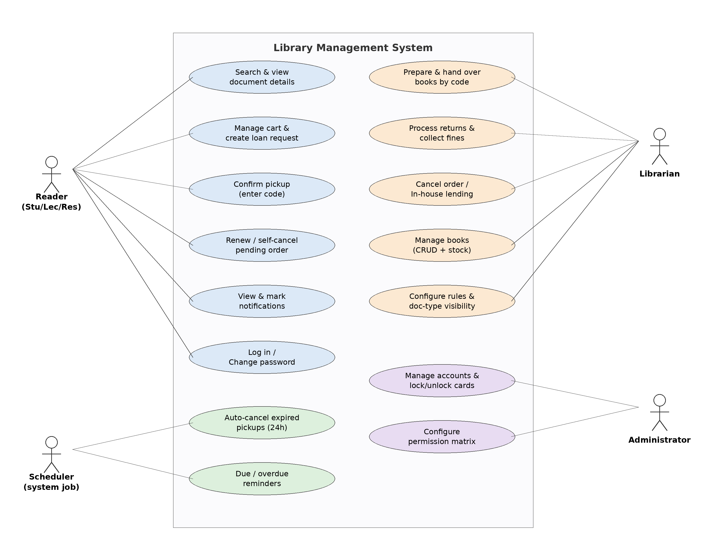
Figure 11.1 — Use Case diagram of the system.

11.2 Class Diagram — Domain Model
The static model mirrors the JPA entities and their relationships: one User has many Loans; a Loan is composed of one-or-more LoanDetails (cascade ALL); each LoanDetail references one Book; a User receives many Notifications. BorrowingRule and RolePermission are enum-keyed configuration tables that drive the rules and the permission matrix.
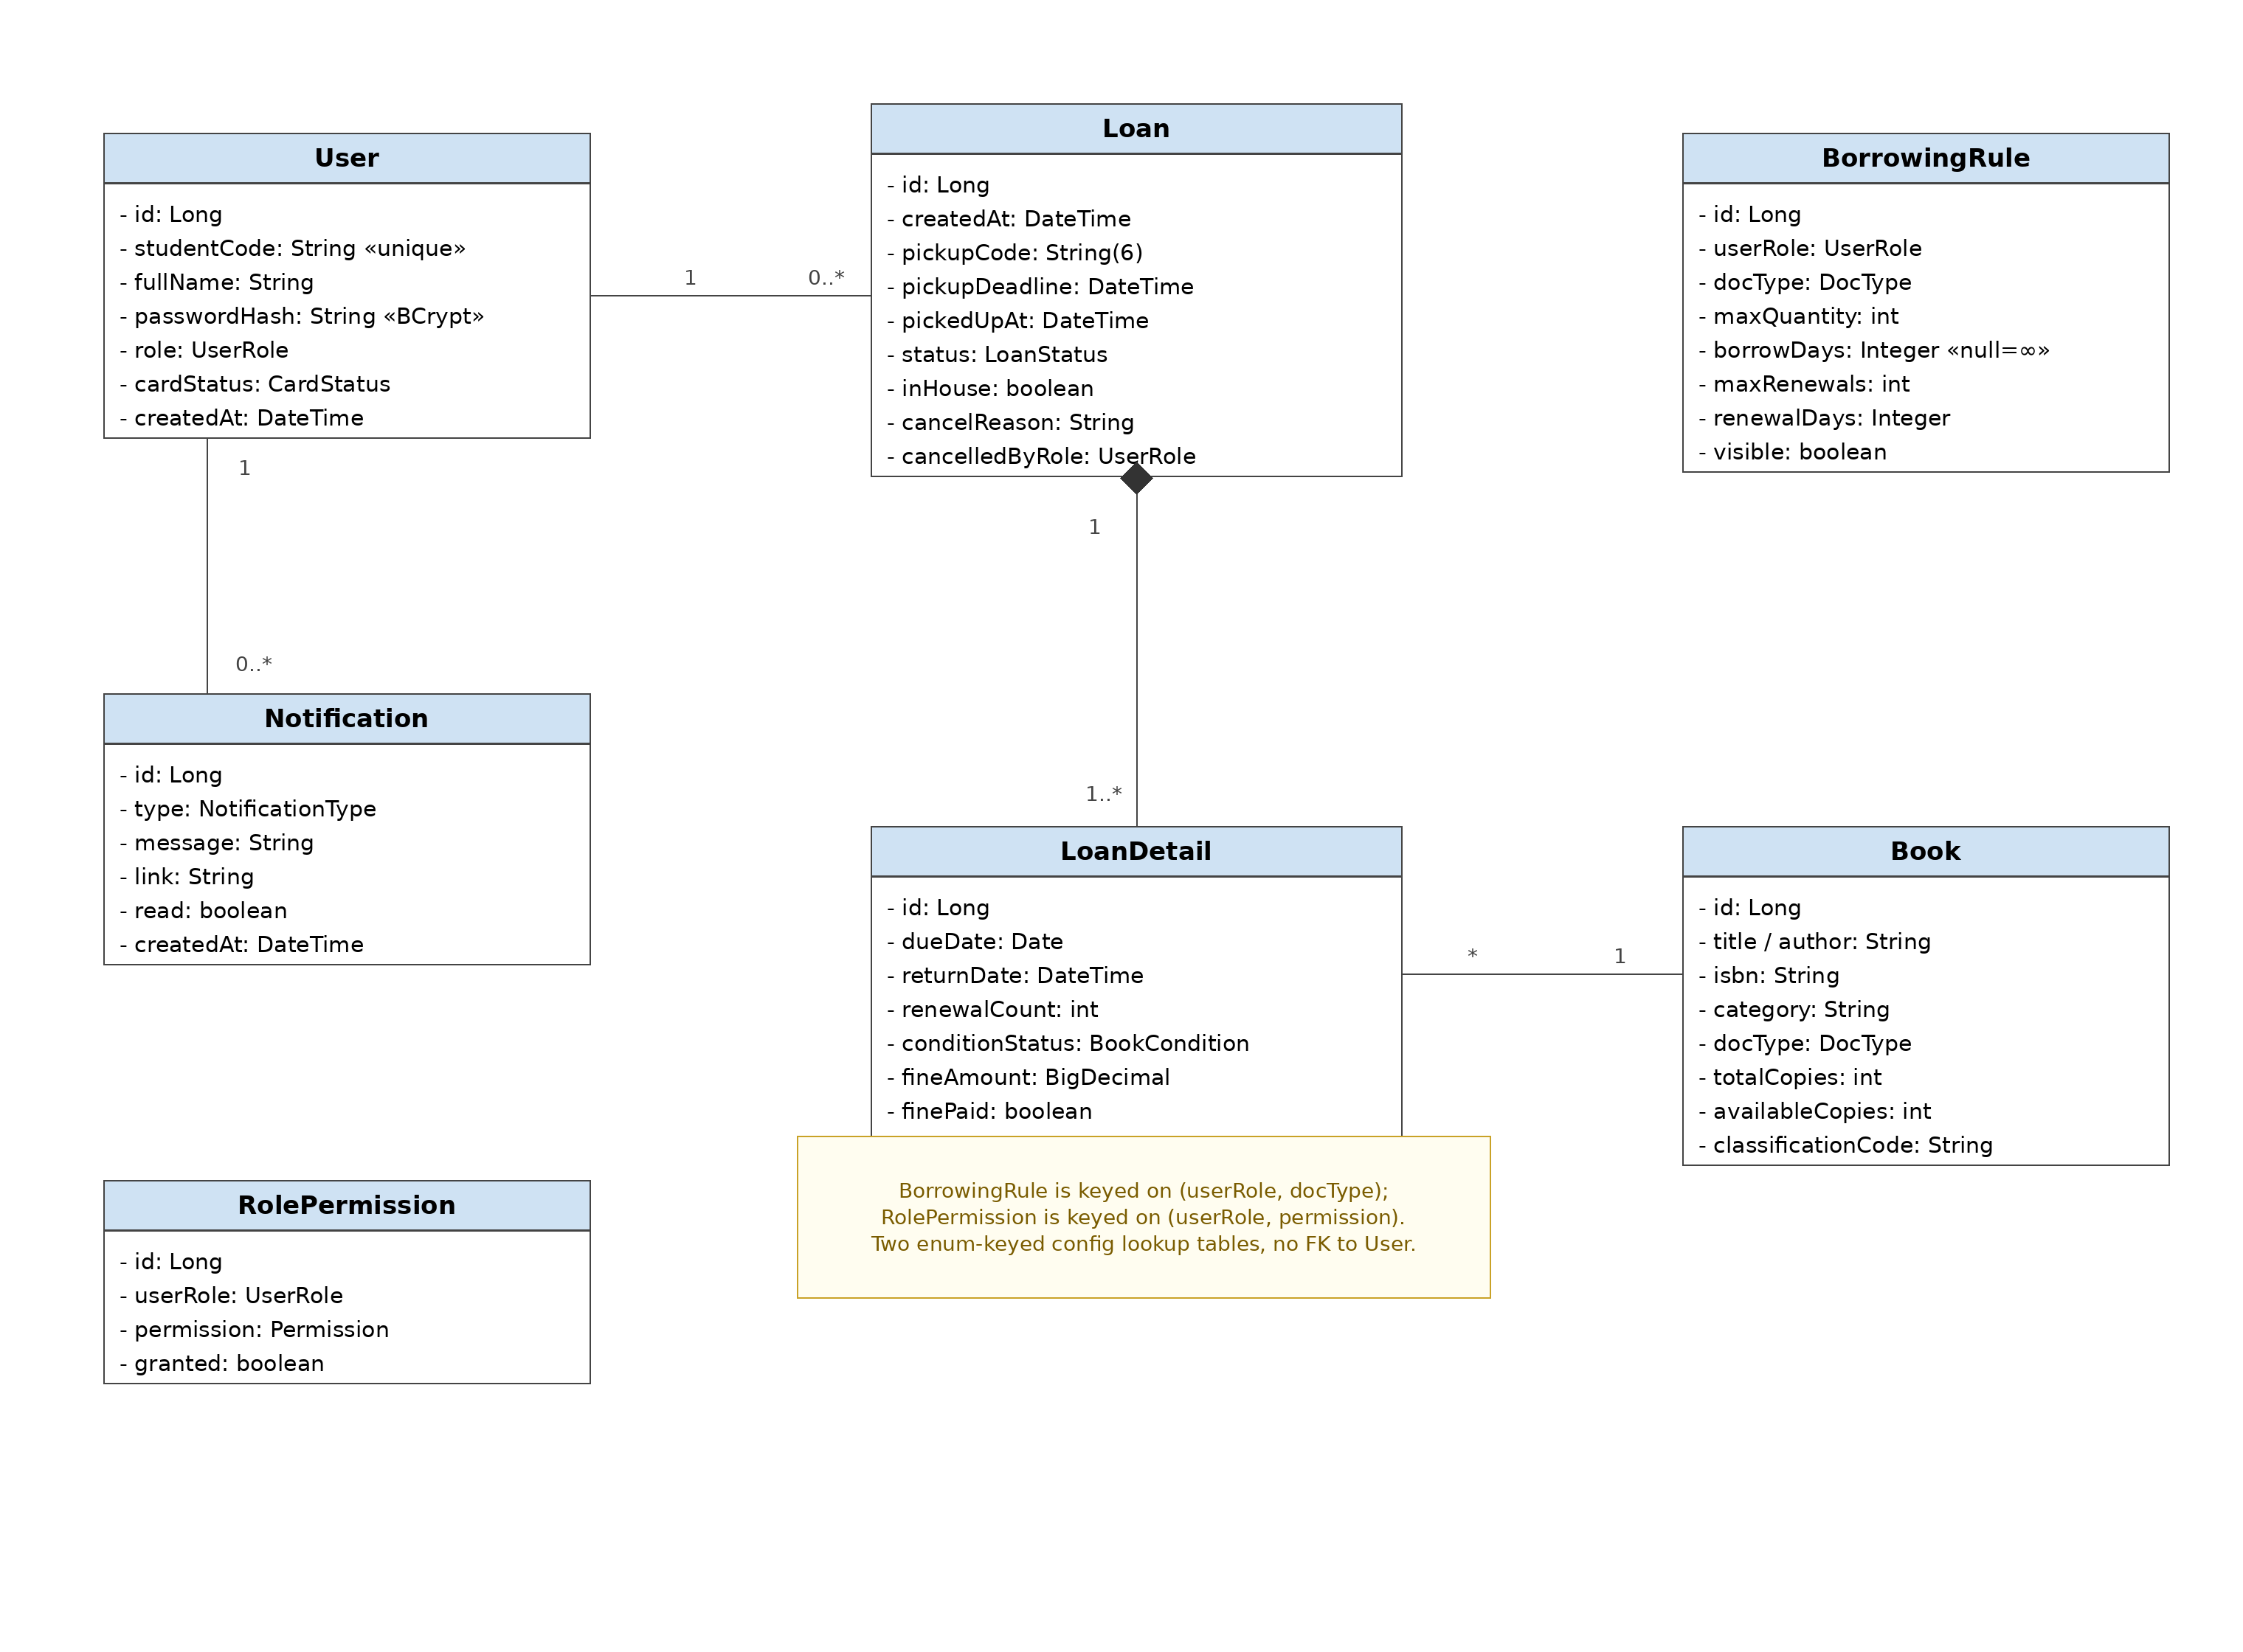
Figure 11.2 — Class diagram (domain model).

11.3 Activity Diagram — Self-Service Borrowing
The main flow runs from login through cart checks, three-tier validation, code-based pickup, renewal, return and fine settlement, to COMPLETED. Failure branches loop back to the cart or stay in the awaiting state, and the 24-hour timeout branch shows the scheduler auto-cancelling an un-collected order.
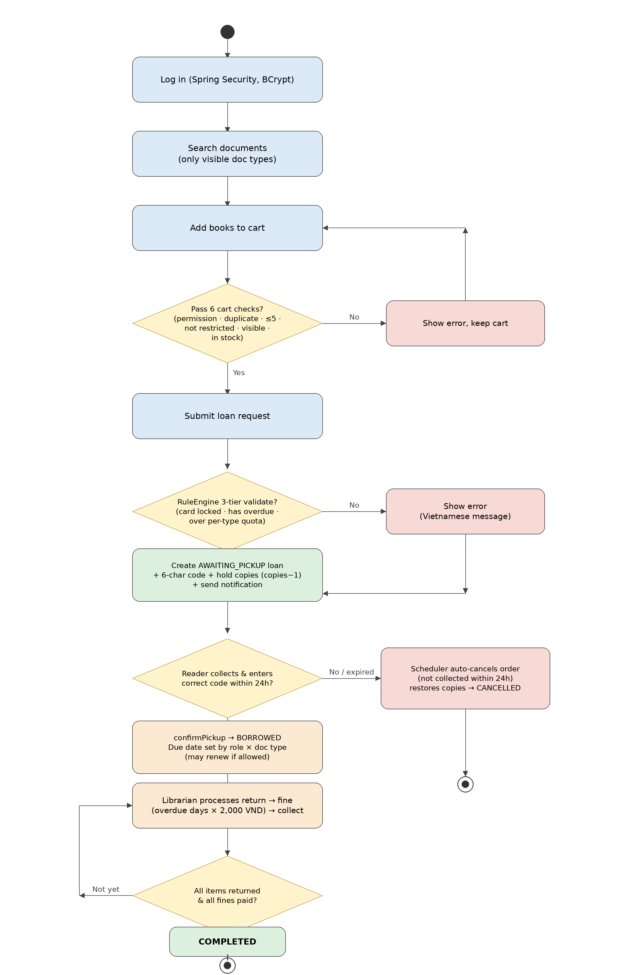
Figure 11.3 — Activity diagram: the self-service borrowing flow.

11.4 State Machine Diagram — Loan Lifecycle
A Loan starts at AWAITING_PICKUP, becomes BORROWED on a valid pickup, and reaches COMPLETED only after every item is returned and every fine is settled; it goes to CANCELLED on reader/staff cancellation or the 24-hour timeout. The lower strip shows the LoanDetail lifecycle (RESERVED → BORROWING → RETURNED); OVERDUE is computed dynamically and is not stored as a separate state.
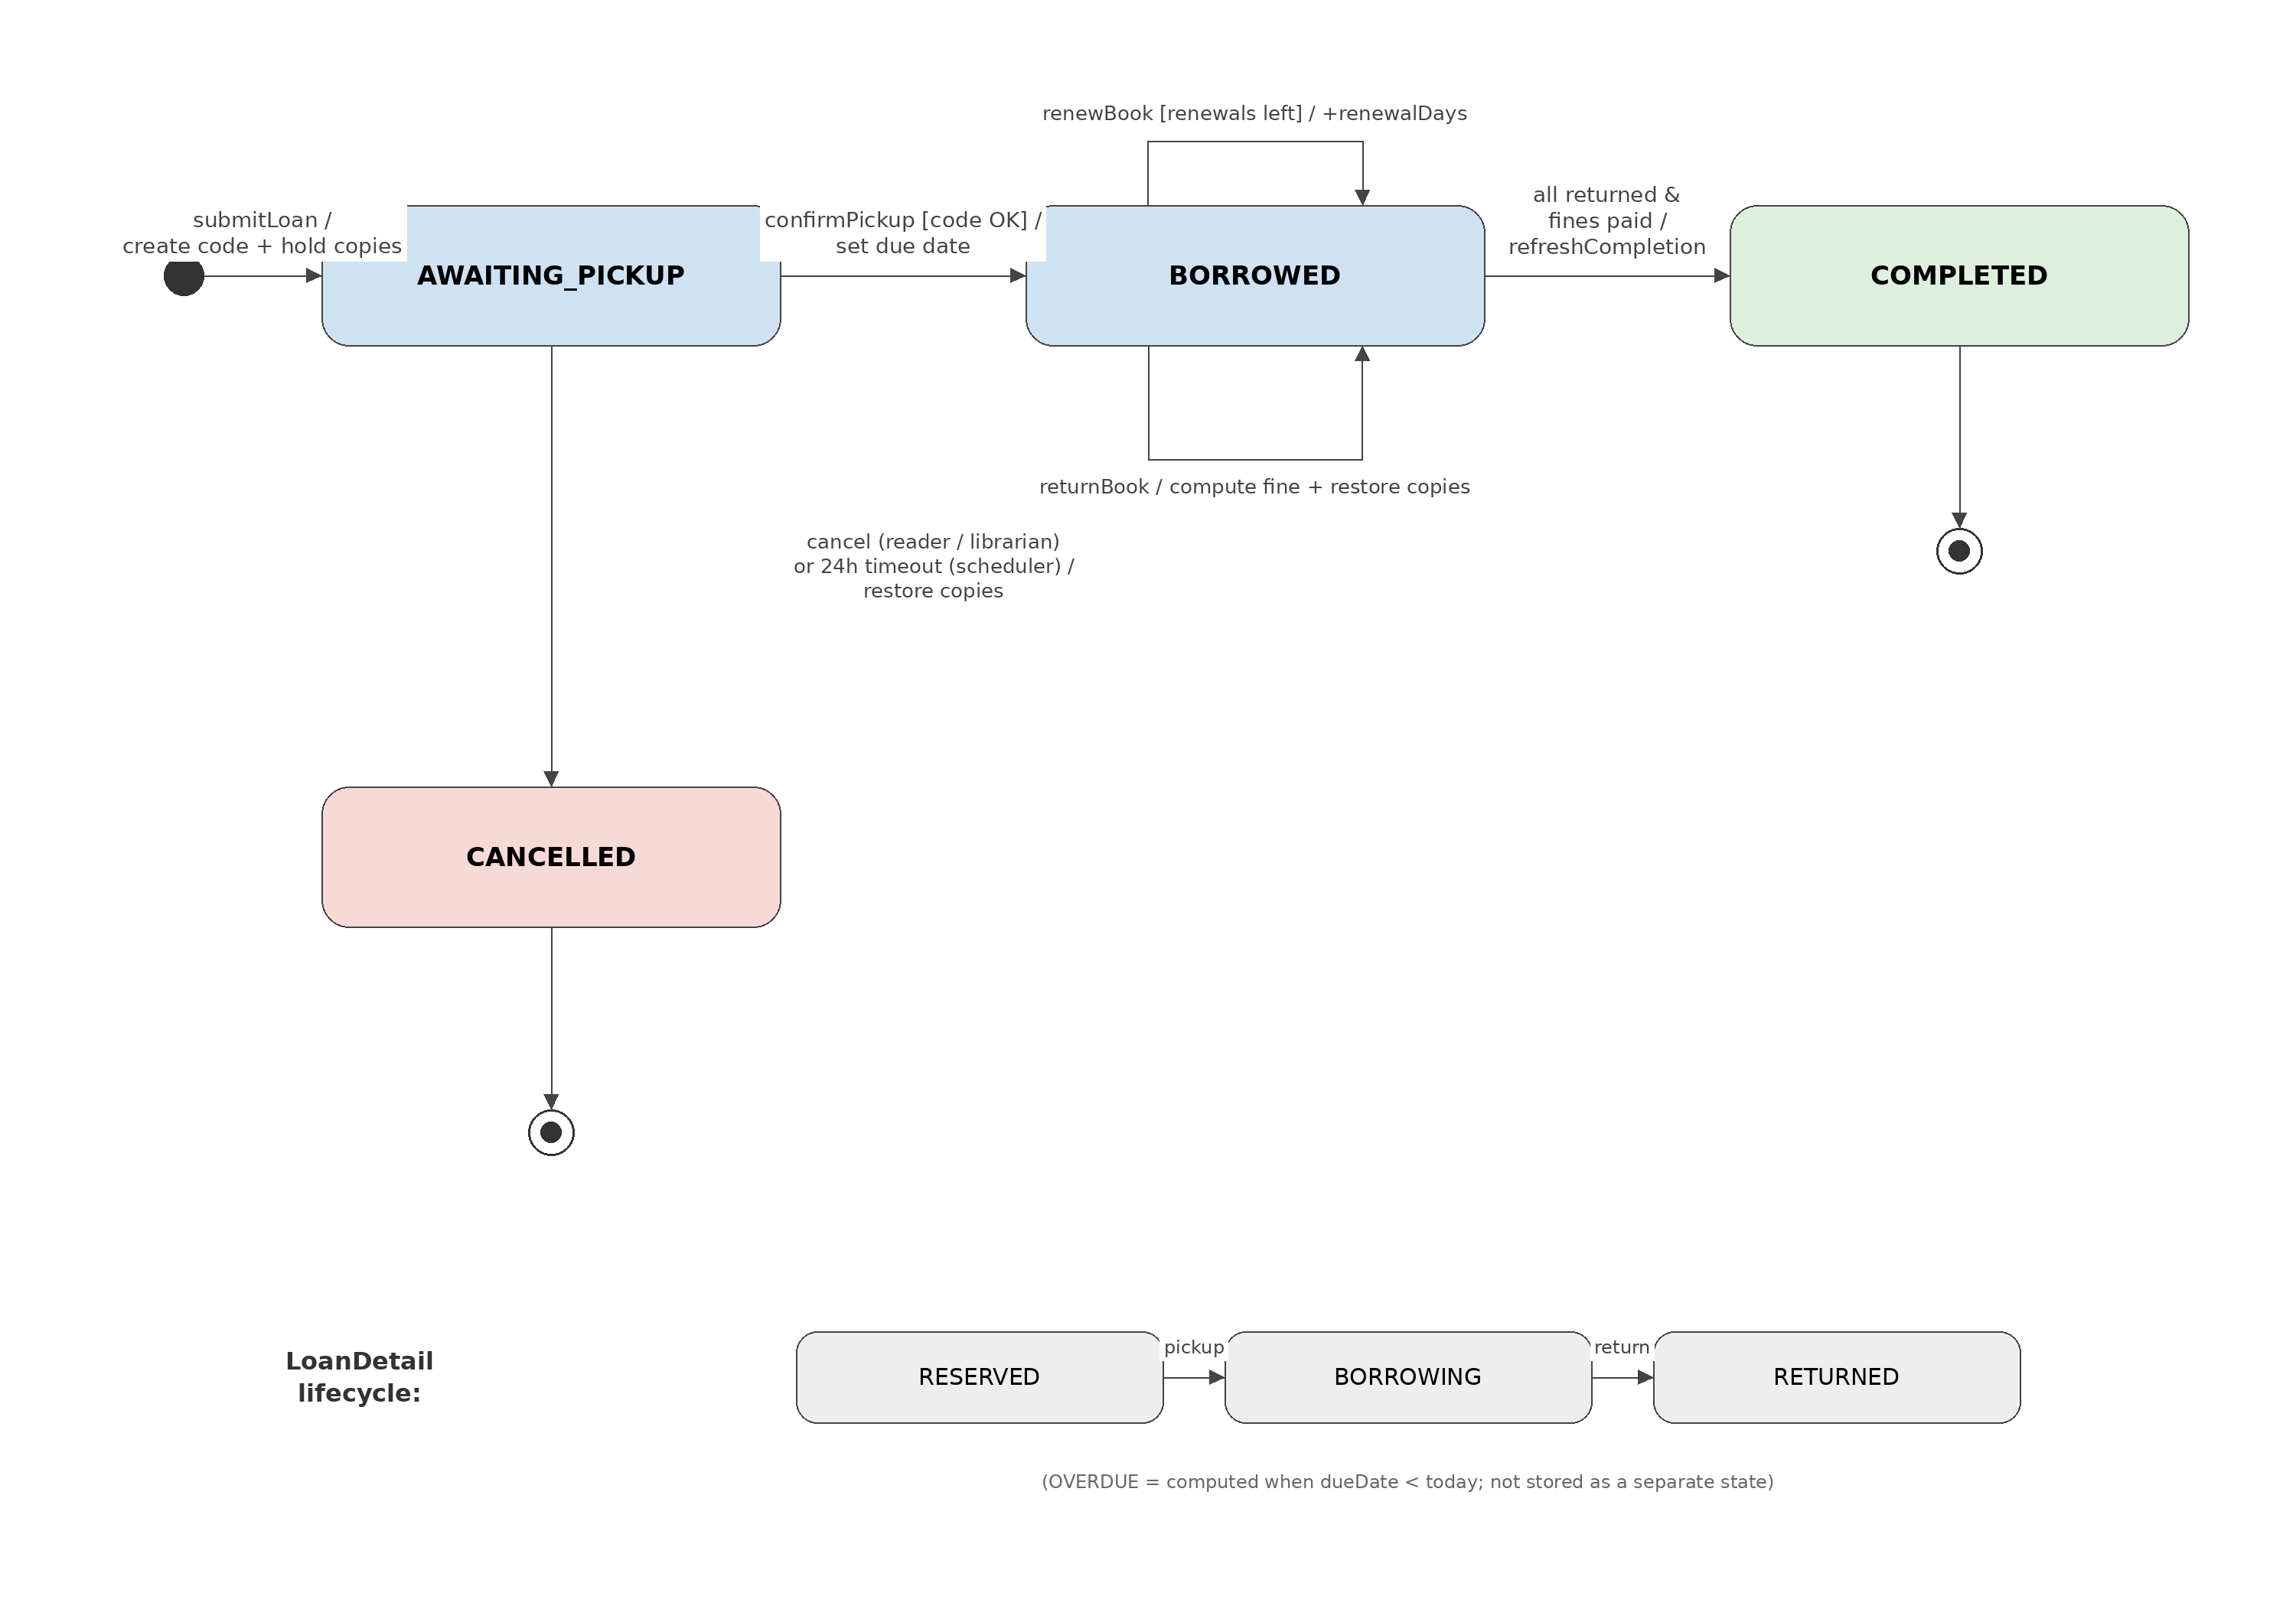
Figure 11.4 — State machine diagram: the loan lifecycle.

12. Conclusion & Future Work

12.1 Achievements
- Delivered a genuinely self-service borrowing model: no approval, pickup code, 24h window, and reader self-confirmation by code.
- Implemented automatic release of un-collected holds through a scheduled background job.
- Cleanly separated Administrator (user accounts + functional-permission matrix) and Librarian (operations + borrowing-rule configuration) with strict, non-inheriting RBAC.
- Added on-screen configuration — a librarian page for borrowing rules and document-type visibility, and an admin functional-permission matrix per role — requiring no code change.
- Fixed two real logic bugs (overdue-fine day count and a stock-hold leak) and upgraded to Spring Boot 3.4.13.
- Pre-seeded a default-password account base (82 accounts) and added self-service password change for every role.
- Added an in-app notification system (navbar bell + /notifications) and a librarian in-house reading workflow for restricted documents.

12.2 Limitations
- Self-confirmation trusts that the reader has physically received the books (mitigated by requiring the pickup code).
- H2 in-memory storage loses data on restart; production needs MySQL.
- No reservation queue for currently-unavailable titles. In-app notifications are implemented, but email delivery is not; the due-soon / overdue reminder method (LoanService.sendDueReminders) exists but is not yet scheduled.

12.3 Future Development Roadmap
Priority | Feature | Description
High | MySQL / production deployment | Persistent storage with Flyway migrations.
Medium | Schedule & email the overdue reminders | Wire LoanService.sendDueReminders() to a scheduler and add email delivery (BM.04/BM.05 of QT.03.TV.DV).
Medium | Reservation queue | Reserve unavailable titles; block renewal when reserved.
Low | QR pickup code | Render the pickup code as a QR for faster counter handover.
Low | Excel / PDF reports | Export borrowing statistics and overdue lists.

