**Packet Tracer - Navigate the IOS**

**Part 1: Establish Basic Connections, Access the CLI, andExploreHelp**

The screen that appears may have several messages displayed. Somewhere on the screen there

should be a Press RETURN to get started! message. Press ENTER.

What is the prompt displayed on the screen?

PressEnter==>Switch>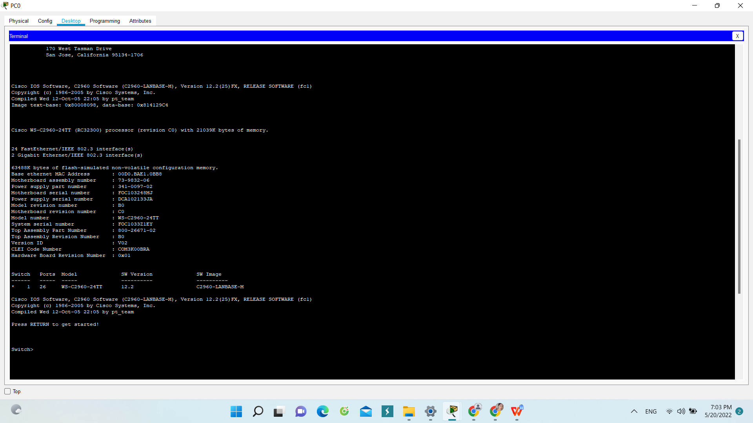

Which command begins with the letter ‘C’?

Answer : Connect

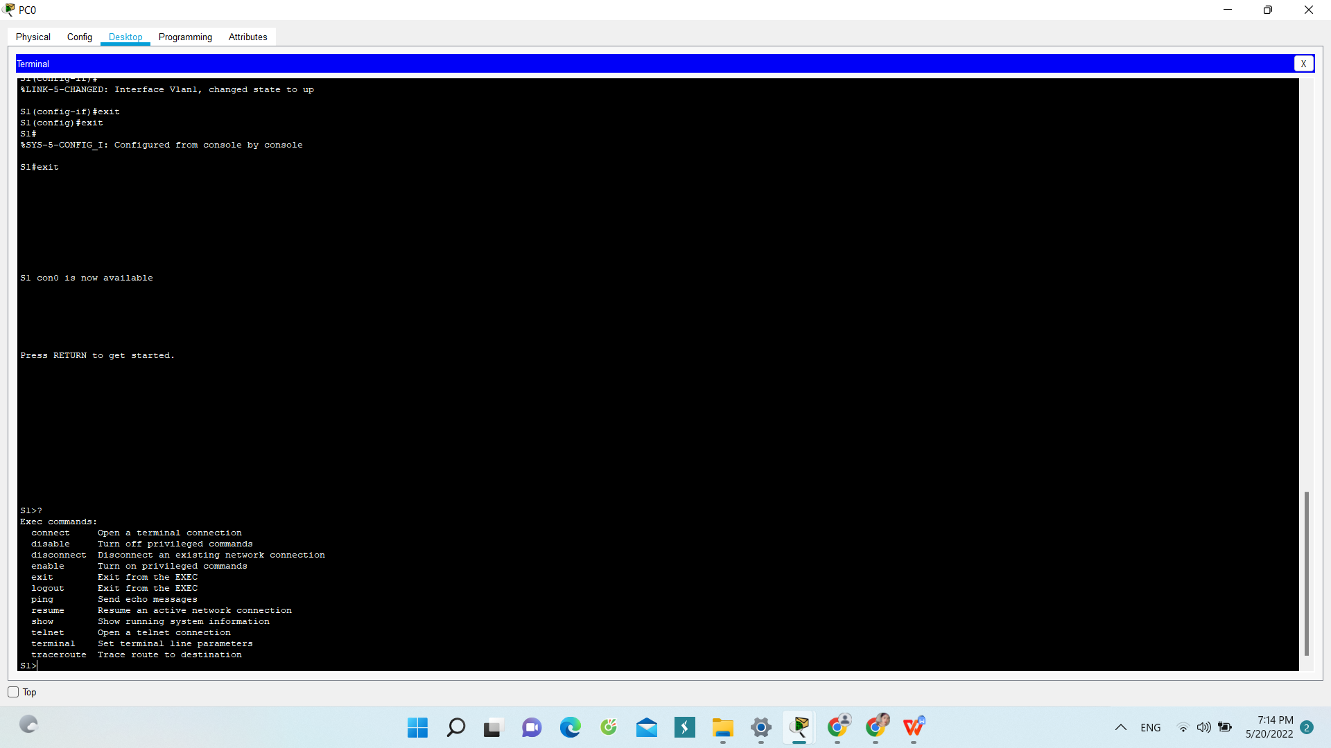

b. At the prompt, type t and then a question mark (?).

S1> t?

Which commands are displayed?



At the prompt, type te and then a question mark (?). S1> te?

Question: Which commands are displayed? This type of help is known as context-sensitive help. It provides more information as the commands are expanded.



**Part 2: Explore EXEC Modes**

1. At the prompt, type the question mark (?). S1> ?

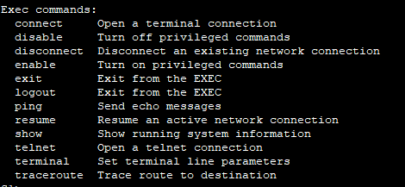

Question: What information is displayed for the enable command?



1. Type en and press the Tab key. S1> en<Tab>

Question: What displays after pressing the Tab key?



What would happen if you typed te<Tab> at the prompt?



1. Enter the enable command and press ENTER. Question: How does the prompt change?



When prompted, type the question mark (?). S1# ?

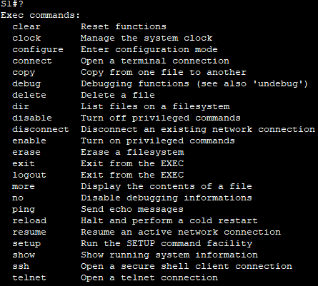

One command starts with the letter ‘C’ in user EXEC mode.

\

How many commands are displayed now that privileged EXEC mode is active? (Hint: you could type c? to list just the commands beginning with ‘C’.)



1. When in privileged EXEC mode, one of the commands starting with the letter ‘C’ is configure. Type either the full command or enough of the command to make it unique. Press the <Tab> key to issue the command and press ENTER. S1# configure Question: What is the message that is displayed?

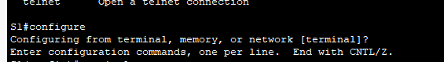

1. Press Enter to accept the default parameter that is enclosed in brackets [terminal]. Question: How does the prompt change?

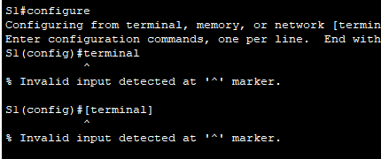\

1. This is called global configuration mode. This mode will be explored further in upcoming activities and labs. For now, return to privileged EXEC mode by typing end, exit, or Ctrl-Z. S1(config)# exit S1#



**Part 3: Set the Clock**

1. Use the clock command to further explore Help and command syntax. Type show clock at the privileged EXEC prompt. S1# show clock Question: What information is displayed?

 What is the year that is displayed? Type your answers here.

1. Use the context-sensitive help and the clock command to set the time on the switch to the current time. Enter the command clock and press ENTER. S1# clock<ENTER> Question What information is displayed?

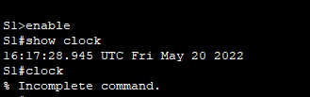

1. The “% Incomplete command” message is returned by the IOS. This indicates that the clock command needs more parameters. Any time more information is needed, help can be provided by typing a space after the command and the question mark (?). S1# clock ? Question: What information is displayed? .



1. Set the clock using the clock set command. Proceed through the command one step at a time. S1# clock set ? Questions: What information is being requested?



1. What would have been displayed if only the clock set command had been entered, and no request for help was made by using the question mark? .



1. . Based on the information requested by issuing the clock set ? command, enter a time of 3:00 p.m. by using the 24-hour format of 15:00:00. Check to see if more parameters are needed. S1# clock set 15:00:00 ? The output returns a request for more information: <1-31> Day of the month MONTH Month of the year

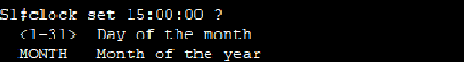

1. Attempt to set the date to 01/31/2035 using the format requested. It may be necessary to request additional help using context-sensitive help to complete the process. When finished, issue the show clock command to display the clock setting. The resulting command output should display as: S1# show clock *15:0:4.869 UTC Tue Jan 31 2035 g. If you were not successful, try the following command to obtain the output above: S1# clock set 15:00:00 31 Jan 2035 Step 2: Explore additional command messages.



1. . The IOS provides various outputs for incorrect or incomplete commands. Continue to use the clock command to explore additional messages that may be encountered as you learn to use the IOS.
2. . Issue the following commands and record the messages: S1# cl<tab> Questions: What information was returned?

. S1# clock

1. Question: What information was returned?

S1# clock set 25:00:00

1. Question: What information was returned?

S1# clock set 15:00:00 32

l.Question: What information was returned?

