**Packet Tracer - Configure Initial Switch Settings**

**Part 1: Verify the Default Switch Configuration**

1/ How many Fast Ethernet interfaces does the switch have?

Answer :24

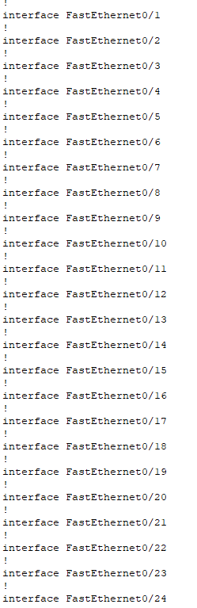

* **How many Gigabit Ethernet interfaces does the switch have?**

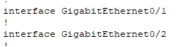

Answer : 2

\***What is the range of values shown for the vty lines?**



**\*Which command will display the current contents of non-volatile random-access memory (NVRAM)?**



**\*Why does the switch respond with “startup-config is not present?”**

The switch responds with “startup-config is not present” because the start up configuration hasn’t been saved yet. Why is the login command required? The login command is required because it makes it so the user will be prompted with a login request. without it, the user won’t be able to access the router.

**Part 2: Create a Basic Switch Configuration**

**Why is the login command required?**

In order for the password checking process to work, it requires both the login and password commands.

**What is displayed for the enable secret password?**

$1$mERr$ILwq/b7kc.7X/ejA4Aosn0

**Why is the enable secret password displayed differently from what we configured?**

The enable secret is shown in encrypted form, whereas the enable password is in plain text.

**If you configure any more passwords on the switch, will they be**

**displayed in the configuration file as plain text or in encrypted form?**

Explain. The service password-encryption command encrypts all current and future passwords.

**Part 3: Configure a MOTD Banner**

**When will this banner be displayed?**

When someone accesses the switch through the console port.

**Why should every switch have a MOTD banner?**

Every switch should have a banner to warn unauthorized users that access is prohibited. Banners can also be used for sending messages to network personnel/technicians (such as impending system shutdowns or who to contact for access).

**Part 4: Save and Verify Configuration Files to NVRAM**

**What is the shortest, abbreviated version of the copy running-config startup-config command?**

cop r s

**Examine the startup configuration file. Which command will display the contents of NVRAM?**

show startup-config

**Are all the changes that were entered recorded in the file?**

Yes, it is the same as the running configuration.

**Part 5: Configure S2**