**VIETNAM NATIONAL UNIVERSITY HO CHI MINH CITY**

**UNIVERSITY OF INFORMATION TECHNOLOGY**

**INFORMATION SYSTEM FACULTY**



Using Statistical Model and Machine Learning Algorithms to Predict Stock Prices of Some Corporations in Vietnam

**Instructor:**

Assoc. Prof. Nguyen Dinh Thuan

Nguyen Minh Nhut

Nguyen Thi Viet Huong

**Group 4:**

Tran Thi Tuyet Linh – 20521540

Nguyen Viet Hoang – 20521348

To Thai Duy – 20521247

**Ho Chi Minh City, April 2023**

# WORK DISTRIBUTION

|  |  |  |  |
| --- | --- | --- | --- |
| **Member**    **Work** | Tran Thi Tuyet Linh  20521540 (Leader) | Nguyen Viet Hoang 20521348 | To Thai Duy 20521247 |
| Problem statement, report template | x | x | x |
| Data part | x | x |  |
| Write abstract | x |  |  |
| Write introduction |  | x |  |
| Do task related to ARIMA, SARIMAX, RNN | x |  |  |
| Do task related to RF, GRU, XGBoost |  |  | x |
| Do task related to DLM, LSTM, LR |  | x |  |
| Write conclusion |  |  | x |
| Total work on the task (%) | 33% | 34% | 33% |
| Completion (%) | 100% | 100% | 100% |

**Contents**

I. Introduction 5

II. Related work 6

III. Data 7

A. Data sources 7

1. GAS 7

2. HPG 8

3. VPB 9

B. Descriptive Statistics 9

1. GAS 9

2. HPG 10

3. VPB 10

C. Visualization 11

1. GAS 11

2. HPG 12

3. VPB 12

IV. Methodology 13

A. Linear Regression 13

B. ARIMA 14

C. SARIMAX 15

D. RF (Random Forest) 16

E. DLM (Dynamic Linear Model) 19

F. XGBoost 20

G. RNN 21

H. LSTM 22

I. GRU (Gated Recurrent Units) 24

V. Result 26

VI. Conclusion 36

Abstract

Stock trading has always been a significant part of the financial world. With the potential of the stock market and the rapid development of machine learning, stock prices prediction has been a hot issue in recent years. Various methods have been proposed to predict stock prices. However, each has unique characteristics that cause differences in performance. In this study, we use Statistical Model and Machine Learning Algorithms such as Linear Regression, ARIMA, SARIMAX, Random Forest, DLM, RNN, LSTM, GRU and XGBoost to predict the stock prices of some corporations in Vietnam based on past prices. The comparison results will be based on three evaluation parameters: RMSE, MAE, and MAPE

**Keywords** — Stock prices, Linear Regression, ARIMA, SARIMAX, Random Forest, DLM, RNN, LSTM, GRU, XGBOOST

# I. Introduction

The prediction of stock prices has always been a challenging task in the financial market. Accurate forecasting of stock prices is important for investors seeking to make decisions. In recent years, the utilization of machine learning algorithms in stock price prediction has garnered significant attention. Machine learning algorithms possess the ability to automatically learn from historical data and identify the best predictive models based on their variations. This enables the generation of potential forecasts for stock prices based on current and past information.

Based on this premise, this research aims to construct a stock price prediction model using various machine learning algorithms. Historical data of stock prices, financial indicators, and market factors will be employed to train the models. Subsequently, the models will be evaluated and tested on new data to determine their accuracy and performance.

The machine learning algorithms considered in this study include Linear Regression, ARIMA, SARIMAX, Random Forest, DLM, RNN, LSTM, GRU and XGBOOST. Each algorithm offers unique capabilities and approaches to capture the underlying patterns and dynamics in stock price movements.

The study aims to explore the effectiveness of these algorithms in forecasting stock market trends and provide valuable insights for investors and financial analysts. By using historical data and advanced machine learning techniques, the research aims to enhance the accuracy and reliability of stock price predictions, facilitating informed decision-making in the dynamic world of financial markets.

# II. Related work

A stock market is where companies issue their shares to expand their business, and investors can buy or sell each other's shares at certain prices. Investors around the world can buy and sell stocks, thus making a profit by selling at a higher price than they bought. The challenge is fluctuating stock price movements can change within minutes or seconds. Therefore, the theory of predicting stock prices emerges.

In Dias Satria’s research he concludes that the ARIMA Box-Jenkins modeling is unsuitable for predicting stock prices. This is due to the data’s nonlinear characteristics, which causes the assumption of white noise in the estimation of the ARIMA Box-Jenkins parameter to be violated. Also, he compared three models: RNN, LSTM, GRU, within GRU presented the best performance in the case of predicting the stock prices based on RMSE value [1].

In another article, Xiwen Jin and Chaoran Yi have concluded that the LSTM and the GRU perform relatively better results and the Random Forest is the worst. The R2 score for different models they have analyzed: LSTM 0.84, GRU 0.86, Random Forest Regressor 0.51, XGBoost Regressor 0.69, Linear Regression 0.73 and LGBM Regressor 0.72. We can see that XGBoost, and Random Forest didn’t have good performance compared to LSTM and GRU models [2].

In another article, Jinlong Ruan, Wei Wu and Jiebo Luo compared LSTM with SARIMAX model. The difference between average accuracies of LSTM and SARIMAX models is minor from either a holistic or a regional perspective. Nevertheless, as the amount of training data increases the class of SARIMAX models falls into a competitive disadvantage: its running time grows at a geometric rate. In comparison, the running time of LSTM models is relatively constant, which reinforces the argument that LSTM outperforms SARIMAX in handling enormous data [3].

# III. Data

## Data sources

### GAS

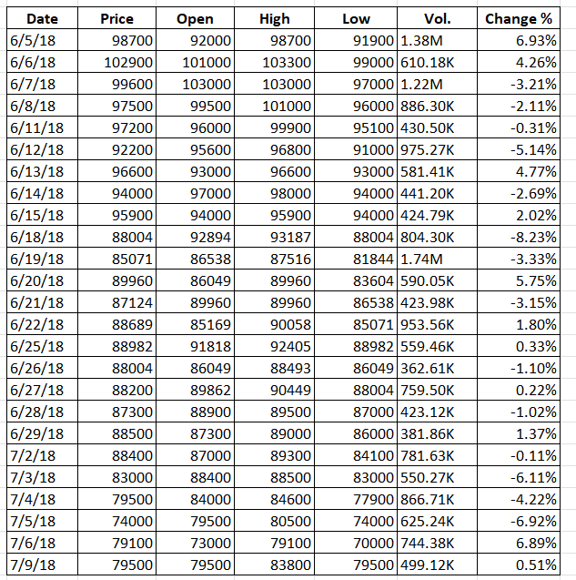

Figure . GAS stock price dataset

The data is about the stock price of Petrovietnam Gas JSC (GAS) from 5/6/2018 to 5/6/2023.

Source data: <https://www.investing.com/equities/petrovietnam-gas-jscrp>

### HPG

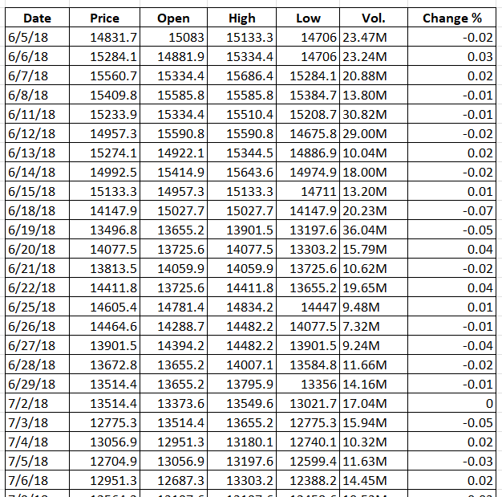

Figure . HPG stock price dataset

The data is about the stock price of Hoa Phat Group JSC (HPG) from 5/6/2018 to 5/6/2023.

Source data: <https://www.investing.com/equities/hoa-phat-group-jsc>

### VPB

Figure . VPB stock price dataset

The data is about the stock price of Vietnam Prosperity Joint Stock Commercial Bank (VPB) from 5/6/2018 to 5/6/2023

Source data: <https://www.investing.com/equities/vietnam-prosperity>

In this research, we will predict the close price for the next 30 days (6/6/2023 – 6/7/2023).

## Descriptive Statistics

### GAS

|  |  |
| --- | --- |
| Value | Result |
| Mean | 94291.68825 |
| Standard Error | 432.7113026 |
| Median | 97200 |
| Mode | 105000 |
| Standard Deviation | 15304.77306 |
| Sample Variance | 234236078.4 |
| Kurtosis | -0.573062611 |
| Skewness | -0.48998054 |
| Range | 76542 |
| Minimum | 53900 |
| Maximum | 130442 |
| Sum | 117958902 |
| Count | 1251 |

Table . Descriptive of GAS

### HPG

|  |  |
| --- | --- |
| Value | Result |
| Mean | 20058.99241 |
| Standard Error | 281.2951062 |
| Median | 16900 |
| Mode | 20800 |
| Standard Deviation | 9949.261174 |
| Sample Variance | 98987797.91 |
| Kurtosis | -0.671410924 |
| Skewness | 0.788744918 |
| Range | 36484 |
| Minimum | 7411.8 |
| Maximum | 43895.8 |
| Sum | 25093799.5 |
| Count | 1251 |

Table . Descriptive of HPG

### VPB

|  |  |
| --- | --- |
| Value | Result |
| Mean | 14247.12126 |
| Standard Error | 188.6386895 |
| Median | 10926.1 |
| Mode | 7926 |
| Standard Deviation | 6672.052049 |
| Sample Variance | 44516278.55 |
| Kurtosis | -1.450534918 |
| Skewness | 0.392879807 |
| Range | 20648.4 |
| Minimum | 6277.8 |
| Maximum | 26926.2 |
| Sum | 17823148.7 |
| Count | 1251 |

Table . Descriptive of VPB

## Visualization

### GAS

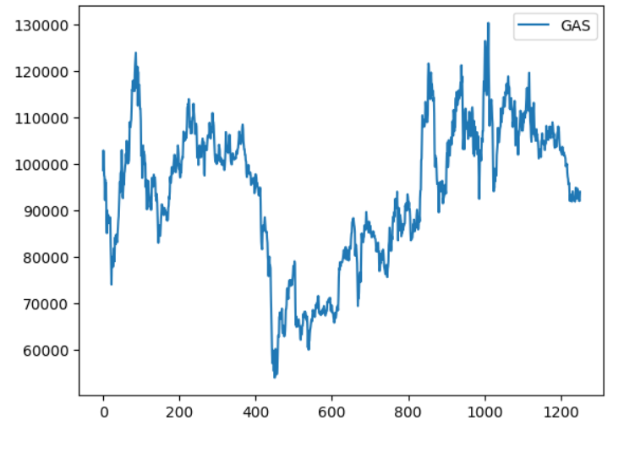

Figure . Visualization of GAS close price

### HPG

Figure . Visualization of HPG close price

### VPB

Figure . Visualization of VPB close price

# IV. Methodology

## Linear Regression

Firstly, *Regression Analysis* is a tool for building statistical models that characterize relationships among a dependent variable and one or more independent variables, all of which are numerical. [4]

Then, *Simple Linear Regression* estimates the relationship between a scalar response *y* and a single explanatory variable *x* (also called dependent variable *y* and independent variable 𝑥), given a set of data that includes observations for both of these variables for a particular sample. [5]

Therefore, ***Multiple Linear Regression*** is a generalization of simple linear regression in which there is more than one predictor variable. If the investigator suspects that the outcome of interest may be associated with or depend on more than one predictor variable, then the approach using simple linear regression may be inappropriate. A multiple regression model that accounts for multiple predictor variables simultaneously may be used. [6]

The basic model for multiple linear regression is [7]:

(1)

Where:

* Y: dependent variable.
* X1, … Xm: the distinct independent or predictor variables
* β0: the y-intercept (value of y when all other parameters are set to 0)
* β1, . . . βm: the regression coefficient of the independent variable
* ε: model error

The multiple linear regression equation is as follows [4]:

(2)

Where:

* : the predicted or expected value of the dependent variable.
* X1, … Xm: the distinct independent or predictor variables
* b1, … bm: the estimates of β1, . . . βm

The formula to determine the formula matrix is :

(3)

Where:



The ANOVA test for significance of the entire model is:

* H0:
* H1:

=> Reject H0 if p-value < 0.05.

## ARIMA

ARIMA is the abbreviation for “Autoregressive integrated moving average”. The ARIMA model is popularly used to forecast univariate time series data. ARIMA model can handle a time series if it is stationary and has no data missing [9]. This method is used in multiple studies for forecasting.

ARIMA models are expressed in the form of ARIMA (p,d,q) [10]. All p, d, and q are non-negative numbers.

* AR is Auto Regression, and p is the number of autoregressive terms [10]. The equation for AR model is:

(4)

in which:

is the current value; is the constant term; p is the number of orders; is the auto-regression coefficient and is the error.

* MA is the Moving Average, and q is the number of terms in the moving average [10]. The equation for MA model is:

(5)

Where: is the current value; is the constant term; p is the number of orders; is the moving average coefficient and is the error

* Last, the I part is Integrated, and d is the number of differences (order) required to make it a stationary sequence. For example:

If d = 0:

If d = 1:

If d = 2: =

After combining them, we will have the ARIMA (p, d, q) express as follow:

(6)

So, we can know that the ARIMA (p, 0, q) model is also ARMA (p, q) model (with d = 0).

The first step to apply ARIMA model is identification of the time series. An Augmented Dicky–Fuller (adf) unit-root test shows if the dataset is stationary or not. If unit root exists then the time series is considered to be non-stationary [10]. If the time series is found to be stationary, then we can use the ARMA model to estimate and forecast. But if it is not stationary, then in order to apply ARIMA it has to be converted into stationary by differencing. The correlogram, autocorrelation function (ACF) and partial autocorrelation function (PACF) of the time series provide information about lags. After identification, ARIMA models are estimated for the specific stationary time series. [12]

## SARIMAX

SARIMAX stands for Seasonal Autoregressive Integrated Moving Average with Exogenous Variables. The SARIMAX model is an advancement of the seasonal ARIMA model with external variables and to handle seasonal aspects of data, called SARIMAX (p, d, q) (P,D,Q)S (X), where X is the vector of external variables; p, d and q are the order of AR autocorrelation, the degree of difference, and the order of the moving average part, respectively, extended by P, D and Q to handle seasonality, which is referred to as the seasonal part of the model, and s is the number of periods per season [13].

The external variables can be modeled by multi linear regression equation is expressed as Equation. 1

So, when we combine the exogenous variables, the basic ARIMA model and seasonal aspect, we will have the SARIMAX models represented by the following equations [14]:



(7)

Where:

* is the t-th observation of the dependent variable,
* X: the corresponding observations of the explanatory variables
* β: the parameters of the regression part
* φ, Φ, θ, Θ are the weights for the non-seasonal and seasonal autoregressive terms and moving average terms.
* The remaining error terms ε are assumed to be white noise.

## RF (Random Forest)

To understand Random Forest, it is essential to understand what they are made from. Decision trees are the foundational building blocks of all tree-based algorithms. Every other tree-based algorithm is a sophisticated ensemble of decision trees. Thus understanding the aspects of decision trees would be a good place to start [15].

Figure . Random Forest structure

Random forest is built on many models Decision Tree, but each Decision Tree model will have random features and data rows

Figure . Random Forest Algorithm

The following steps explain the working Random Forest Algorithm [15]:

Step 1: Select random samples from a given data or training set.

Step 2: This algorithm will construct a decision tree for every training data.

Step 3: Voting will take place by averaging the decision tree.

Step 4: Finally, select the most voted prediction result as the final prediction result.

Random Forest algorithm:

1*. For b = 1 to B*:

(a) Draw a bootstrap sample of size N from the training data.

(b) Grow a random-forest tree to the bootstrapped data, by recursively repeating the following steps for each terminal node of the tree, until the minimum node size is reached.

* 1. Select m variables at random from the *p* variables.
  2. Pick the best variable/split-point among the *m*.
  3. Split the node into two daughter nodes.

2. Output the ensemble of trees.

To make a prediction at a new point x:

*(8)*

## DLM (Dynamic Linear Model)

Dynamic linear models (DLM) offer a very generic framework to analyze time series data. The models can be seen as general regression models where the coefficients can vary in time. In addition, they allow for a state space representation and a formulation as hierarchical statistical models, which in turn is the key for efficient estimation by Kalman formulas and by Markov chain Monte Carlo (MCMC) methods. A dynamic linear model can handle non-stationary processes, missing values and non-uniform sampling as well as observations with varying accuracies [9].

Dynamic Linear Models are a special case of general state-space models where the state and the observation equations are linear, and the distributions follow a normal law. Generalized DLMs relax the assumption of normality by allowing the distribution to be any of the exponential family of functions (which includes the Bernoulli, binomial and Poisson distributions, useful for count data).

There are two constitutive operations for dynamic linear models: filtering and smoothing. In a few words, filtering is the operation consisting in estimating the state values at time t, using only observations up to (and including) t-1. On the contrary, smoothing is the operation which aims at estimating the state values using the whole set of observations [10].

A general dynamic linear model with an observation equation and a model equation is

– *Yt* is the observation at time *t*. We assume this is to be a scalar but could also be a vector.

– *θt = (θt,1, . . ., θp,1)’* is the vector of parameters at time *t* and of dimension *p × 1*.

– *F0t* is the row vector (dimension 1 × *p*) of covariates at time *t*

– *Gt* is a matrix of dimension *p × p* known as *evolution* or *transition matrix*.

– Usually, *Ft* and *Gt* are completely specified and *Ft = F, Gt = G.*

– *t* is the observation error at time *t* and *ωt* is the evolution error (*p* × 1 vector).

– For a Normal DLM, *t* ∼ *N(0, Vt)* and ωt ∼ *N(0, Wt)*.

– *t* is independent of *s*, *ωt* is independent of *ωs* for *t s*. ’*s* independent of *ω’s*.

## XGBoost

XGBoost, which stands for Extreme Gradient Boosting, is a scalable, distributed gradient-boosted decision tree (GBDT) machine learning library. It provides parallel tree boosting and is the leading machine learning library for regression, classification, and ranking problems [16].

It’s vital to an understanding of XGBoost to first grasp the machine learning concepts and algorithms that XGBoost builds upon supervised machine learning, decision trees, ensemble learning, and gradient boosting.

Supervised machine learning uses algorithms to train a model to find patterns in a dataset with labels and features and then uses the trained model to predict the labels on a new dataset’s features [16].

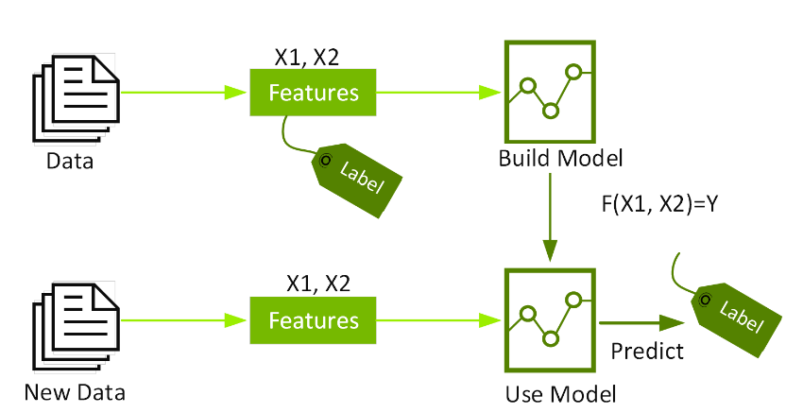

Figure . XGBoost structure

Objective: (9)

: training loss measures well model fit on training data.

: Regularization, measures complexity of trees.

To learn tree ensembles, we need additional training (boosting), start from constant prediction, add a new function each time at a result we will have:

(10)

: model at training round t

: new function at round t

The prediction at round t will be:

(11)

## RNN

RNN is one of the components of an artificial neural network with feedback connections closed by loop. RNNs are called “repetitive” because they perform the same task for each sequence element by leveraging previously captured information sequentially to predict future unknown sequential data [1].

RNN can provide considerably good prediction for the temporal stock data. The hidden states of RNN are given by Equations (12) and (13). [17]

(12)

(13)

Where:

* is the input vector at time t
* b and c are bias values
* W, U, and V denote input-to-hidden, hidden-to-hidden, and hidden-to-output weight matrices, respectively.

While working with time-series data (like the stock market), an attention mechanism can be utilized that can divide the given data into parts so that decoder can utilize specific parts while generating new values [17]. The general structure of RNN loops and the looping modules are shown in Figure 1

Figure . RNN Architecture

Weight correction is carried out until the residual reaches the set value or the number of iterations has reached the specified maximum limit. One of the drawbacks is that the RNN network only store some of the data steps in the previous sequence. Thus, RNNs are not suitable for storing longer sequences. Another type of recurrent network, LSTM, was introduced to overcome this shortcoming. [18]

## LSTM

LSTM uses one of the most common forms of RNN. This time recurrent neural network is meant to avoid long-term dependence problems and is suitable for processing and predicting time series. Proposed by Sepp Hochreiter and Jurgen Schmidhuber in 1997, the LSTM model consists of a unique set of memory cells that replace the hidden layer neurons of the RNN, and its key is the state of the memory cells. The LSTM model filters information through the gate structure to maintain and update the state of memory cells. Its door structure includes input, forgotten, and output gates. Each memory cell has three sigmoid layers and one tanh layer. [19]

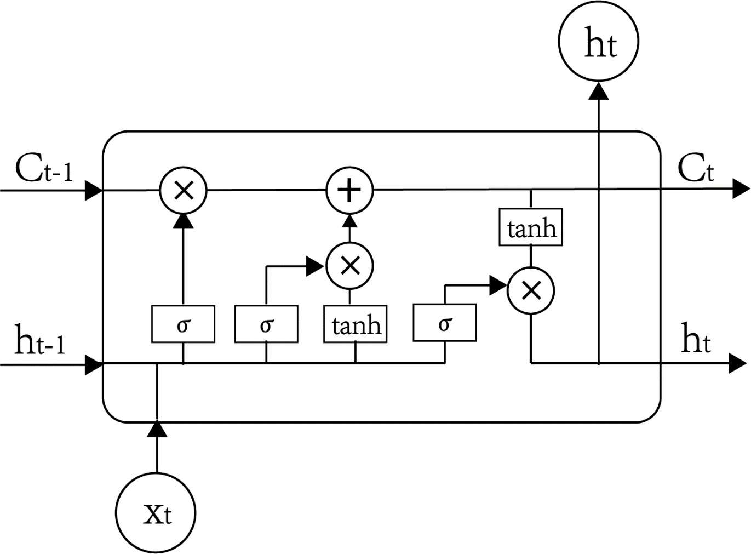

Figure . Structure of LSTM memory cells.

The gate allows information to be passed selectively and Eq. 14 shows the default activation function of the LSTM network, the sigmoid function. The LSTM can add and delete information for neurons through the gating unit. To determine selectively whether information passes or not, it consists of a Sigmoid neural network layer and a pair multiplication operation. Each element output by the Sigmoid layer is a real number between [0, 1], representing the weight through which the corresponding information passes. In the LSTM neural network, there is also a layer containing tanh activation function which shown in Eq. 15. It is used for updating the state of neurons [20].

*(14)*

*(15)*

The forgetting gate of the LSTM neural network determines what information needs to be discarded, which reads *ht−1* and *xt*, gives the neuron state *Ct−1*a value of 0–1. Equation 16 shows the calculation method of forgetting probability [20].

*(16)*

Where:

*ht−1*represents the output of the previous neuron.

*xt*is the input of the current neuron.

is the sigmoid function.

The input gate determines how much new information is added to the neuron state. First, the input layer containing the sigmoid activation function determines which information needs to be updated, and then a tanh layer generates candidate vectors *Ĉt*, an update is made to the state of the neuron, as shown in Eq. 17

*(17)*

where the calculation methods of *it* and *Ĉt* are shown in Eqs. 18 and 6=19

*(18)*

*(19)*

The output gate is used to control how many current neural unites state are fltered and how many controlling units state are fltered which are shown in Eqs. 20 and 21

*(20)*

*(21)*

## GRU (Gated Recurrent Units)

The GRU model is a modified version of the LSTM model, it not only merges the forget gate and the input gate into an update gate but also drops the cell state, achieving reduction of number of parameters. GRU aims to solve the **vanishing gradient problem**. A GRU unit is composed of reset gate and update gate, due to the simpler architecture, it is contributing to train faster and search optimal solution easily [21]. The structure of a GRU unit is shown in one cell in Fig. 3.

The reset gate in a GRU allows us to control how much of the previous state we want to remember. It decides which information from the previous state is still relevant and should be used to predict the future, and which information can be forgotten [1].

The update gate in a GRU determines how much of the information from the previous state and the current input should be used to update the current state. It allows us to selectively update the current state based on the relevant information and determine how much of the new state is influenced by the old state.

Figure . GRU model

In the first step, reset gate is calculated using both the hidden state from the previous time step and the input data at the current time step, it be reserved by applying a sigmoid function σ, as expressed in the equation:

(22)

Where: is input data at the current time step.

is the hidden state from the previous time step.

and are the weighting vectors respectively.

The result values will be transformed to fall between 0 and 1 after using the sigmoid function σ. Therefore, the gate could filter between the less important and more-important information in the subsequent steps. Next, decided the information which will be kept from the previous time steps together with the new inputs. 1) The previous hidden state is multiplied by the reset gate and then multiplied by a trainable weight. 2) The input data at the current time step is multiplied by a trainable weight. 3) Obtained result after summed value from 1) and 2), and that information will be passed to the tanh function. This equation expressed in equation [21]:

(23)

The resultant value is obtained from tanh function that means the candidate hidden state. If the value of rt is equal to 1 then it means the whole information from the previous hidden state ht−1 is being considered. Likewise, if the value of rt is 0 then that means the information from the previous hidden state is completely neglected.

Second, the update gate is computed using the previous hidden state and current input data using the same formula, like the reset gate. But each weight multiplied with the input and hidden state is independent and unique to each gate, which means the final vectors for the update gate are different from the reset gate, as expressed in equation:

(24)

The purpose of the update gate is to help the model determine how much of the past information stored in the previous hidden state needs to be retained for the future. In the last step, obtaining the updated hidden state from the update gate and hidden state. Apply element-wise multiplication to (1-update gate) and hidden state from the previous time step [21]. Next, summed with the output, which is from the update gate multiplied by the candidate hidden state, as expressed in equation:

(25)

The new and updated hidden state will be obtained from the above operations.

# V. Result

Evaluation forecasting model:

**Mean Absolute Error (MAE)**

Average of the absolute error between the actual value and the predicted value

(26)

**Root Mean Squared Error (RMSE)**

The square root of the mean square error is calculated using the following formula:

(27)

**Mean Absolute Percentage Error (MAPE)**

The measure of prediction accuracy of a forecasting method, defined by the formula:

(28)

**

In this evaluation, nine distinct models were assessed for the time series examination on 7:2:1, 6:3:1, 8:1:1 training, validating, and testing. RMSE, MAPE and MAE scores were used to assess model execution.

|  |  |  |  |  |
| --- | --- | --- | --- | --- |
| **GAS dataset** | | | | |
| **Model** | **Proportion** | **MAPE** | **RMSE** | **MAE** |
| **LINEAR** | *7:2:1* | *27.85%* | *31587.77* | *30502.06* |
| *6:3:1* | *37.77%* | *42824.24* | *40311.92* |
| *8:1:1* | *19.16%* | *22535.56* | *21559.57* |
| **ARIMA** | *7:2:1* | *8.96%* | *11507.11* | *9982.91* |
| *6:3:1* | *19.47%* | *23765.07* | *21166.91* |
| *8:1:1* | *6.31%* | *8384.78* | *6750.34* |
| **RNN** | *7:2:1* | *7.47%* | *10057.47* | *7914.38* |
| *6:3:1* | *11.14%* | *13714.76* | *10849.46* |
| *8:1:1* | *5.05%* | *7276.63* | *5546.81* |
| **LSTM** | *7:2:1* | *7.39%* | *9942.21* | *7818.73* |
| *6:3:1* | *11.81%* | *14520.65* | *11486.71* |
| *8:1:1* | *5.05%* | *7292.85* | *5576.32* |
| **GRU** | *7:2:1* | *7.52%* | *10179.54* | *8008.34* |
| *6:3:1* | *10.96%* | *13542.26* | *10809.97* |
| *8:1:1* | *5.04%* | *7258.21* | *5538.75* |
| **SARIMAX** | *7:2:1* | *1.71%* | *2805.41* | *1872.42* |
| *6:3:1* | *1.63%* | *2614.13* | *1734.98* |
| *8:1:1* | *1.62%* | *2754.71* | *1839.19* |
| **RF** | *7:2:1* | *6.31%* | *8577.42* | *6789.20* |
| *6:3:1* | *9.82%* | *12086.52* | *9695.78* |
| *8:1:1* | *5.32%* | *7564.55* | *5888.84* |
| **DLM** | *7:2:1* | *2.39%* | *3362.73* | *2605.39* |
| *6:3:1* | *7.19%* | *9051.91* | *7849.78* |
| *8:1:1* | *5.61%* | *6720.05* | *6080.53* |
| **XGBOOST** | *7:2:1* | *6.30%* | *8572.36* | *6774.99* |
| *6:3:1* | *9.16%* | *11877.31* | *9575.56* |
| *8:1:1* | *8.84%* | *7348.30* | *5657.84* |

Table . Evaluation of GAS

|  |  |  |  |  |
| --- | --- | --- | --- | --- |
| **HPG dataset** | | | | |
| **Model** | **Proportion** | **MAPE** | **RMSE** | **MAE** |
| **LINEAR** | *7:2:1* | *49.72%* | *12762.53* | *9970.27* |
| *6:3:1* | *32.69%* | *8485.49* | *7626.16* |
| *8:1:1* | *89.31%* | *17465.75* | *16864.04* |
| **ARIMA** | *7:2:1* | *46.92%* | *11854.09* | *9581.04* |
| *6:3:1* | *248.69%* | *69419.31* | *59232.21* |
| *8:1:1* | *25.97%* | *5683.12* | *4418.22* |
| **RNN** | *7:2:1* | *29.23%* | *9769.91* | *7952.87* |
| *6:3:1* | *34.99%* | *11878.86* | *9521.47* |
| *8:1:1* | *31.35%* | *7696.02* | *6878.81* |
| **LSTM** | *7:2:1* | *29.05%* | *9582.45* | *7803.23* |
| *6:3:1* | *34.84%* | *11900.47* | *9535.61* |
| *8:1:1* | *27.84%* | *6858.74* | *6066.57* |
| **GRU** | *7:2:1* | *29.17%* | *9749.41* | *7937.89* |
| *6:3:1* | *34.51%* | *11828.86* | *9484.67* |
| *8:1:1* | *29.10%* | *7167.21* | *6378.28* |
| **SARIMAX** | *7:2:1* | *1.36%* | *536.43* | *344.81* |
| *6:3:1* | *1.29%* | *564.15* | *376.69* |
| *8:1:1* | *1.63%* | *474.39* | *321.51* |
| **RF** | *7:2:1* | *30.15%* | *9148.60* | *7449.74* |
| *6:3:1* | *34.90%* | *10753.57* | *8661.18* |
| *8:1:1* | *22.78%* | *5595.20* | *4710.56* |
| **DLM** | *7:2:1* | *29.17%* | *7337.69* | *6003.24* |
| *6:3:1* | *34.98%* | *9759.23* | *8151.12* |
| *8:1:1* | *15.84%* | *3398.39* | *2741.53* |
| **XGBOOST** | *7:2:1* | *29.53%* | *8817.70* | *7180.44* |
| *6:3:1* | *28.15%* | *100024.99* | *7532.29* |
| *8:1:1* | *19.48%* | *4538.69* | *3865.27* |

Table . Evaluation of HPG

|  |  |  |  |  |
| --- | --- | --- | --- | --- |
| **VPB dataset** | | | | |
| **Model** | **Proportion** | **MAPE** | **RMSE** | **MAE** |
| **LINEAR** | *7:2:1* | *19.41%* | *4287.41* | *3812.87* |
| *6:3:1* | *32.69%* | *8485.49* | *7626.16* |
| *8:1:1* | *33.06%* | *6264.67* | *5786.23* |
| **ARIMA** | *7:2:1* | *358.77%* | *78651.86* | *68277.79* |
| *6:3:1* | *141.47%* | *32841.37* | *28355.88* |
| *8:1:1* | *11.79%* | *2591.41* | *1978.59* |
| **RNN** | *7:2:1* | *15.71%* | *4076.06* | *3336.71* |
| *6:3:1* | *17.96%* | *4400.72* | *3556.53* |
| *8:1:1* | *13.49%* | *3051.32* | *2600.78* |
| **LSTM** | *7:2:1* | *15.05%* | *3869.98* | *3182.67* |
| *6:3:1* | *18.49%* | *4632.42* | *3762.75* |
| *8:1:1* | *11.69%* | *2610.57* | *2236.11* |
| **GRU** | *7:2:1* | *15.93%* | *4182.56* | *3418.89* |
| *6:3:1* | *16.61%* | *4384.66* | *3511.98* |
| *8:1:1* | *13.75%* | *3111.87* | *2655.57* |
| **SARIMAX** | *7:2:1* | *1.57%* | *470.94* | *319.06* |
| *6:3:1* | *1.49%* | *459.64* | *321.82* |
| *8:1:1* | *1.82%* | *452.42* | *322.93* |
| **RF** | *7:2:1* | *14.30%* | *3276.38* | *2769.42* |
| *6:3:1* | *15.63%* | *3997.27* | *2998.68* |
| *8:1:1* | *9.27%* | *2036.61* | *1581.02* |
| **DLM** | *7:2:1* | *18.05%* | *3898.94* | *3420.63* |
| *6:3:1* | *20.41%* | *4686.82* | *4071.94* |
| *8:1:1* | *7.81%* | *1705.85* | *1314.61* |
| **XGBOOST** | *7:2:1* | *13.61%* | *3160.35* | *2693.37* |
| *6:3:1* | *14.86%* | *3864.79* | *2808.90* |
| *8:1:1* | *9.86%* | *2183.07* | *1671.03* |

Table . Evaluation of VPB

***Predicting Visualization:***

***For GAS dataset:***

Figure . Predictive results of the Random Forest model with rate of 8-1-1

Figure . Predictive results of the XGBoost model with rate of 7-2-1

Figure . Predictive results of the RNN model with rate of 8-1-1

Figure . Predictive results of the GRU model with rate of 8-1-1

Figure . Predictive results of the LSTM model with rate of 8-1-1

***For HPG dataset:***

Figure . Predictive results of the Random Forest model with rate of 8-1-1

Figure . Predictive results of the XGBoost model with rate of 8-1-1

Figure . Predictive results of the RNN model with rate of 7-2-1

Figure . Predictive results of the GRU model with rate of 8-1-1

Figure . Predictive results of the LSTM model with rate of 7-2-1

***For VPB dataset:***

Figure . Predictive results of the Random Forest model with rate of 8-1-1

Figure . Predictive results of the XGBoost model with rate of 8-1-1

Figure . Predictive results of the RNN model with rate of 8-1-1

Figure . Predictive results of the GRU model with rate of 8-1-1

Figure . Predictive results of the LSTM model with rate of 8-1-1

# VI. Conclusion

In this study, we have employed various learning algorithms and machine learning techniques, accompanied by three different types of train-test splits, to train our models and assess their accuracy. The results reveal that ARIMA, Linear Regression models exhibit relatively high errors because the dataset is not suitable for these models. On the other hand, GRU, SARIMAX and Random Forest outperforms other models in terms of MAPE and RSME measures. However, the result of SARIMAX model is excellent because of the exogenous. Finally, the XGBoost model emerges as the most effective among the mentioned models, displaying the lowest MAPE and RSME values in predictive performance.

Moving forward, our future research endeavors will be dedicated to the development of increasingly refined models, with the overarching objective of attaining heightened precision and accuracy in the prediction of stock prices.

Acknowledgements

Our team want to express our deepest gratitude to ***Assoc. Prof. Dr. Nguyen Dinh Thuan, Mr. Nguyen Minh Nhut, Ms. Nguyen Thi Viet Huong*** for their unwavering care and support throughout this course. Your presence has meant the world to our team, and we are truly grateful for your assistance and the sharing of your valuable experience. Your guidance will undoubtedly help us achieve great things with our project.

REFERENCES

[1] D. Satria, “PREDICTING BANKING STOCK PRICES USING RNN, LSTM, AND GRU APPROACH,” *Appl. Comput. Sci.*, vol. 19, pp. 82–94, Mar. 2023, doi: 10.35784/acs-2023-06.

[2] X. Jin and C. Yi, “The Comparison of Stock Price Prediction Based on Linear Regression Model and Machine Learning Scenarios,” presented at the 2022 International Conference on Bigdata Blockchain and Economy Management (ICBBEM 2022), Atlantis Press, Dec. 2022, pp. 837–842. doi: 10.2991/978-94-6463-030-5_82.

[3] J. Ruan, W. Wu, and J. Luo, “Stock Price Prediction Under Anomalous Circumstances,” in *2020 IEEE International Conference on Big Data (Big Data)*, Atlanta, GA, USA: IEEE, Dec. 2020, pp. 4787–4794. doi: 10.1109/BigData50022.2020.9378030.

[4] “Ch9-Regression Analysis-T.pptx.”

[5] M. Tranmer, J. Murphy, M. Elliot, and M. Pampaka, “Multiple Linear Regression (2nd Edition)”.

[6] K. A. Marill, “Advanced Statistics: Linear Regression, Part II: Multiple Linear Regression,” *Acad. Emerg. Med.*, vol. 11, no. 1, pp. 94–102, 2004, doi: 10.1197/j.aem.2003.09.006.

[7] R. Bevans, “Multiple Linear Regression | A Quick Guide (Examples),” *Scribbr*, Feb. 20, 2020. https://www.scribbr.com/statistics/multiple-linear-regression/ (accessed Apr. 15, 2023).

[8] “Regression.pdf.” Accessed: Apr. 15, 2023. [Online]. Available: https://www.ma.imperial.ac.uk/~das01/GSACourse/Regression.pdf

[9] V. Ş. Ediger and S. Akar, “ARIMA forecasting of primary energy demand by fuel in Turkey,” *Energy Policy*, vol. 35, no. 3, pp. 1701–1708, Mar. 2007, doi: 10.1016/j.enpol.2006.05.009.

[10] “Forecasting ethanol demand in India to meet future blending targets: A comparison of ARIMA and various regression models,” *Energy Rep.*, vol. 9, pp. 411–418, Mar. 2023, doi: 10.1016/j.egyr.2022.11.038.

[11] Y. Zhao, “Comparison of Stock Price Prediction in Context of ARIMA and Random Forest Models,” *BCP Bus. Manag.*, vol. 38, pp. 1880–1885, Mar. 2023, doi: 10.54691/bcpbm.v38i.3996.

[12] B. Dey, B. Roy, S. Datta, and T. S. Ustun, “Forecasting ethanol demand in India to meet future blending targets: A comparison of ARIMA and various regression models,” *Energy Rep.*, vol. 9, pp. 411–418, Mar. 2023, doi: 10.1016/j.egyr.2022.11.038.

[13] N. Arunraj, D. Ahrens, and M. Fernandes, “Application of SARIMAX Model to Forecast Daily Sales in Food Retail Industry,” *Int. J. Oper. Res. Inf. Syst.*, vol. 7, pp. 1–21, Apr. 2016, doi: 10.4018/IJORIS.2016040101.

[14] M. Cools, E. Moons, and G. Wets, “INVESTIGATING THE VARIABILITY IN DAILY TRAFFIC COUNTS USING ARIMAX AND SARIMA(X) MODELS: ASSESSING THE IMPACT OF HOLIDAYS ON TWO DIVERGENT SITE LOCATIONS”.

[15] “randomforest.pdf.” Accessed: Jun. 17, 2023. [Online]. Available: https://www.math.mcgill.ca/yyang/resources/doc/randomforest.pdf?fbclid=IwAR1hi5MSrcuWRBq2zcpM79yZzyWgPZKmgoA5U7RVhQ9_dnre3p6BHlZa1WQ

[16] T. Chen and C. Guestrin, “XGBoost: A Scalable Tree Boosting System,” in *Proceedings of the 22nd ACM SIGKDD International Conference on Knowledge Discovery and Data Mining*, Aug. 2016, pp. 785–794. doi: 10.1145/2939672.2939785.

[17] P. Dey *et al.*, “Comparative Analysis of Recurrent Neural Networks in Stock Price Prediction for Different Frequency Domains,” *Algorithms*, vol. 14, p. 251, Aug. 2021, doi: 10.3390/a14080251.

[18] L. Lin, “Stock Prediction and Analysis based on RNN Neural Network,” *SHS Web Conf.*, vol. 151, p. 01002, Dec. 2022, doi: 10.1051/shsconf/202215101002.

[19] J. Qiu, B. Wang, and C. Zhou, “Forecasting stock prices with long-short term memory neural network based on attention mechanism,” *PLOS ONE*, vol. 15, p. e0227222, Jan. 2020, doi: 10.1371/journal.pone.0227222.

[20] G. Ding and L. Qin, “Study on the prediction of stock price based on the associated network model of LSTM,” *Int. J. Mach. Learn. Cybern.*, vol. 11, Jun. 2020, doi: 10.1007/s13042-019-01041-1.

[21] C.-J. Chen, F.-I. Chou, and J.-H. Chou, “Temperature Prediction for Reheating Furnace by Gated Recurrent Unit Approach,” *IEEE Access*, vol. 10, pp. 33362–33369, 2022, doi: 10.1109/ACCESS.2022.3162424.