**ELECTRICAL ENGINEERING**

**YEAR**

**IRAKOZE Ange 19RP04890**

**TUYISHIME Venant 19RP04619**

**TOPIC: USING BLUETOOTH MODULE TO TURN ON A MOTOR**

**1. ABSTRACT**

The world is moving fast towards automation. People have less time to handle any work, so automation is simple way to handle any device or machine which will work to our desire. This study aims to develop and design a turning on DC motor by using Bluetooth module. a turning on DC motor by using Bluetooth module system gives a simple and reliable technology with Android application industrial appearance like DC motor etc. are controlled by a turning on DC motor by using Bluetooth module system using Arduino Uno with Bluetooth module. The study mainly focuses on the monitoring and control of smart industrial by Android phone and provides a security based smart industries, when the people are not present at the near workplace. This study’s motive is to control a turning on DC motor by using Bluetooth module in a smart industry with user friendly design at low cost and simple installation.

The Key elements used: Adriano uno, smart phone, DC motor, relay, Bluetooth module

**2. PROBLEM STATEMENT**

This project turning on and off DC motor by using Bluetooth module designed to improve working efficiency and decrease quantity of wire that used in motor installation because Bluetooth module communicate with wireless technology. When we are implementing that project Adriano, Bluetooth, DC motor, relay will be connected together and we use smartphone to turn ON and OFF that motor wirelessly So that this system will help us to reduce power required it turning ON DC motor, also this system is working snappily so that it is good for time management. Turning ON and OFF dc motor by using Bluetooth module it can work in range of distance that means that we need no many operators at the field, that why we say that turning ON and OFF DC motor by using Bluetooth module economical.

CIRCUIT DIAGRAM OF USING BLUETOOTH MODULE TO TURN ON MOTOR IN FRITZING

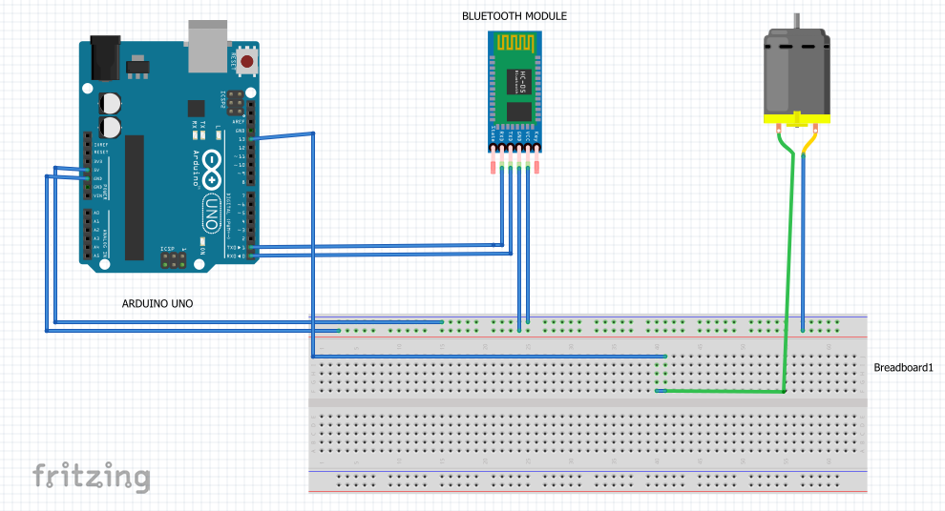

**BLOCK DIAGRAM**

Bluetooth

module HC-05

Arduino microcontroller

DC Motor

**POWER SUPPLY**

The purpose of power supply is to convert the power delivered to its input by the sinusoidally alternating mains electricity supply into power available at its output in the form of a smooth and constant direct voltage to Arduino uno board

**Smartphone**

Telephone communicates between Bluetooth module and Arduino uno by transmitting and receiving data to tun on/off dc motor

**Bluetooth** **module HC-05**

It manages the communication channel of the wireless part. The Bluetooth modules can transmit and receives the data wirelessly by using two devices. The Bluetooth module can receive and transmits the data from a host system with the help of the host controller interface

**Arduino microcontroller**

It is programmable open-source microcontroller which able to read inputs with their onboard microcontroller and helps to control relay for turning dc motor

**DC motor**

DC motor is a type of electric machine that converts electrical energy into mechanical energy. DC motors take electrical power through direct current, and convert this energy into mechanical rotation

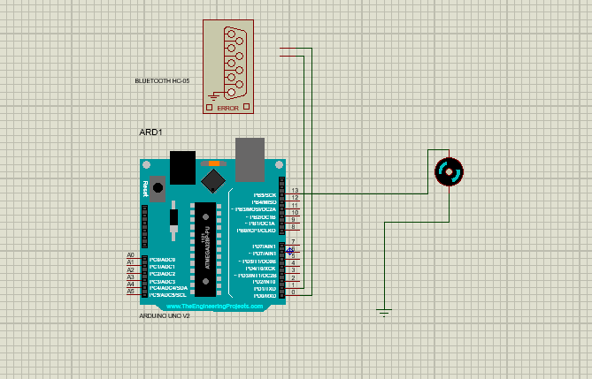**SIMULATION IN PROTEUS**