**Collaboration**

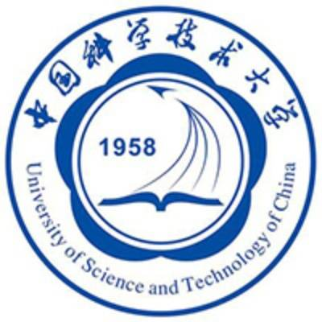

&

Science and technology can not develop without human practice. And the cooperation and communication between teams can not only promote the development of the two sides, but also build an essential bridge for the progress of Science and technology. In this year’s iGEM contest, we have established a relationship of deep communication can collaboration with the team of University of Science and Technology of China (USTC)

The First Online Meeting

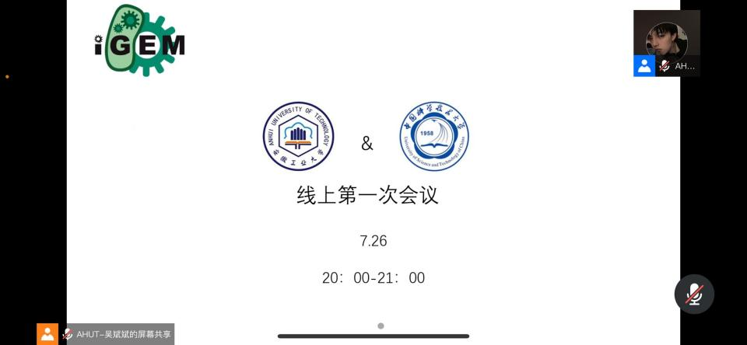

On July 26, the two teams contacted each other to have friendly greetings and communications. Then, from 20:00 to 21:00, we held the first online meeting to share our project background, inspiration and other information. In the process, we got a lot of information about their project:

Alzheimer’s disease is a brain disease with which the patients’ physiological changes occur in the early stages. The USTC team’s project focuses on finding a simple way to diagnose Alzheimer’s disease (AD) in early stages.

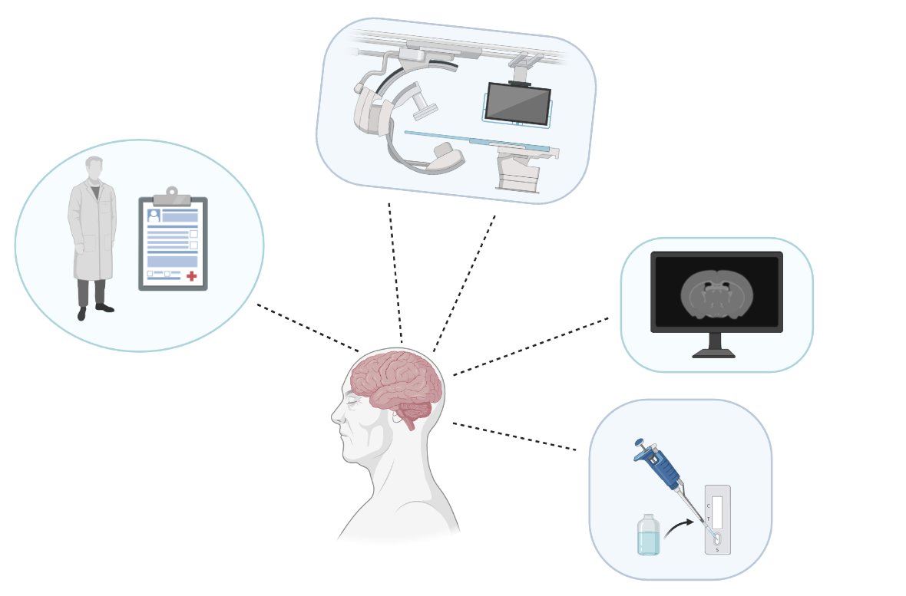

While looking through the data, our team found that the incidence of breast cancer in women is increasing and also tends to be younger, so our team’s project focuses on finding a new and more effective treatment for breast cancer.

USTC team’s project has some overlaps with our team’s project as we all have used the synthetic biology research method. After this meeting we initially established the plan of the cooperative experiment.

The Second Online Meeting

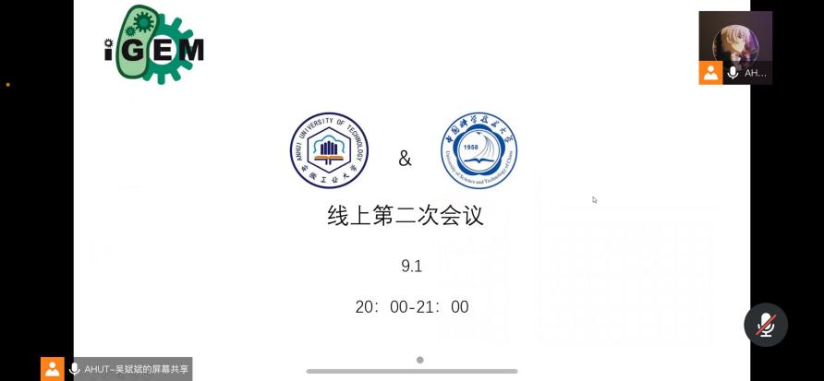

On the basis of the previous meeting, the two teams held a second online meeting from 20:00 to 21:00 on September 1. This time, we communicated on the basis of our ongoing projects and had a better understanding of the two projects:

The USTC team tries to detect and amplify Tau and aptamer messages by in vitro Tau detection. Finally, the detection function was realized. We considered the feasibility and generalizability of this method, and we looked through the papers and asked the teacher for some additional ideas.

Our project ,which is based on the tumor microenvironment, tries to target the release of fusion protein to kill breast cancer through the identification of hypoxia-inducible promoters, thus to achieve the therapeutic effect.

USTC team had given us some advice and help in terms of experimental conditions, ease of process, expectations, etc. .

At the same time, we reported on the progress of the cooperative experiment, pointed out the problems that we were encountering in the experiment, and discussed the possible mistakes in the experiment.

In this meeting, we were very satisfied with the process of cooperation between the two teams. The meeting also strengthened the communication between the two teams. Although there were different views in the process, in the end, both the two teams communicated successfully and affirmed the process of cooperation experiment.

The Third Online Meeting

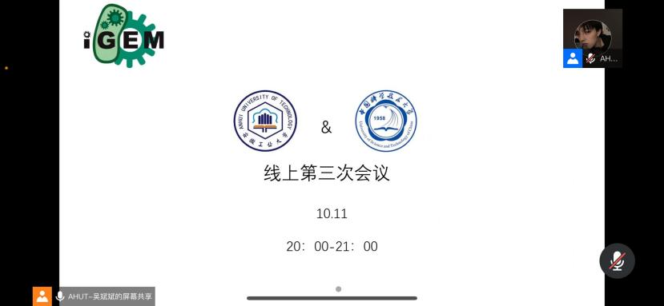

After our last in-depth communication, we scheduled our third online meeting on Octobor 11, according to our respective experimental schedules and the time to complete the results of our collaborative experiments.

In the meeting, we exchanged the results of the cooperative experiment and summarized the results of our experiments. Both teams were very satisfied with the results of the cooperative experiment. The two teams also summarized the cooperation process and agreed that we obtained a lot of different knowledge and related experimental technology from the other team. At the end of the meeting, our host Yi He carried out the closing, and the two sides of the experimental content and results were roughly described.