## Education：

We have organized a number of activities, from children to university students, to promote knowledge of synthetic biology.

## 1.Project publicity in kindergarten

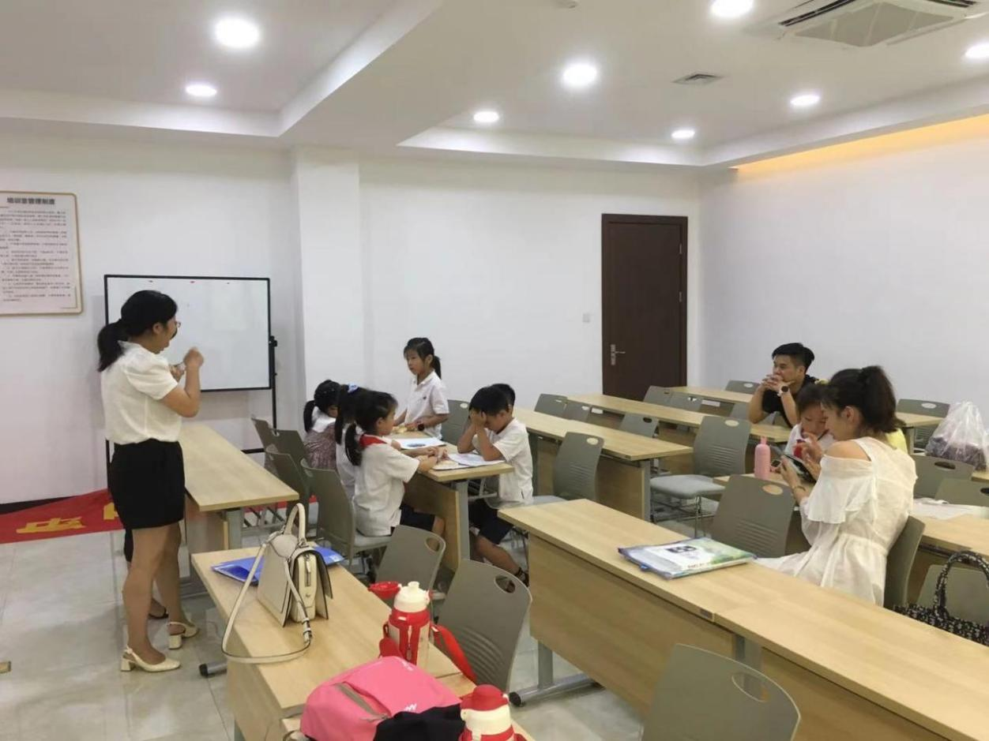

After taking protective measures, the AHUT-China team came to Hu Dong Road Primary School, aiming to introduce the prevention and characteristics of the malignancy to the children and teachers, and introduced to them that malignant tumor can occur at any age, but the incidence rate increased with age. In childhood, the most common are leukemia, brain tumor, and malignant lymphatic cancer; Liver cancer and leukemia are common in young adults; Middle age and old age are mainly stomach, esophagus, cervix, lung, and lung cancer. Then we told the children about our team's project used probiotic secreted proteins to target breast cancer in the iGEM competition this year. Malignant tumor diseases will develop significantly in the future. Therefore, malignant tumor diseases can not be ignored. We should encourage children to establish a correct attitude towards tumors from an early age.

## 2. Project publicity in Universitiy.

## In recent years, the number of people suffering from malignant tumor diseases has been increasing. Therefore, to make everyone treat malignant tumors correctly, find tumor diseases in advance, and actively cooperate with hospital treatment to achieve the effect of cure, iGEM team members carried out relevant knowledge publicity at Anhui University of technology.

The publicity activities were carried out through offline meetings and seminars in the teaching building of AHUT, aiming to popularize the knowledge of synthetic biology among college students and awaken people's understanding of the importance of malignant tumors. The following is the specific content and process of one of the activities:

In September 2021, our team carried out a publicity activity with the theme of "characteristics, preventive measures, and therapeutic drugs of malignant tumors" at Anhui University of technology. Same day， Our team members arrived at the venue in advance for venue arrangement and publicity rehearsal. At the meeting, the team leader of iGEM spent one hour popularizing the basic knowledge of malignant tumors for the audience: normal human cells form new cells through growth and division. The cells will die after aging or damage to maintain the dynamic balance of the body. When the body cells divide and spread unrestricted to form new organisms, which are called tumors. The preventive measures for college students' malignant tumors mainly include strengthening cancer prevention health education, improving cognition and self-protection ability, paying attention to hygiene and changing lousy lifestyle, avoiding high-fat, low vitamin and low cellulose diet, etc. Taking this opportunity, we also publicized the project carried out by our team in the iGEM competition to target probiotic secreted proteins to treat breast cancer as an alternative to expensive targeted drugs. After the meeting, the audience all representatives expressed their heartfelt feelings, indicating that the content of the speech aroused the health awareness of the audience. Thus, the publicity activity has achieved great success, and the publicity scope covers the whole university campus and even off-campus.