**在另一个与合成生物学相关的领域的出色表现**

在这次项目中，我们使用益生菌ECN利用肿瘤微环境、人工Her2抗体的靶向性及sTRAIL的杀伤性来完成了我们的项目目的，在这过程中我们也了解到我们项目并不是只存在于单一的领域而是和多种领域都有交叉关联。如：

**1. 科学教育领域**

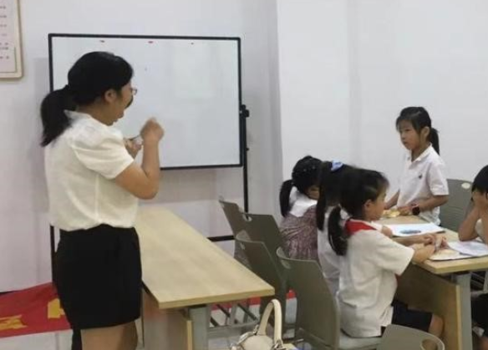合成生物学具有改变人类世界的潜质，只不过目前只在发展阶段，很多人群并不是很了解这一学科。我们在实施这个项目期间去人群中访问，并到幼儿园和一些社区街道进行宣讲，让更多的人了解IGEM这个项目及合成生物。通过我们的宣传，可以让其他人对于科学研究的内容会有更好的理解，引起他们对科学研究的兴趣，埋下一颗对科学研究感兴趣的种子，在不久的将来。科学研究领域一定会出现更多科研人士，前仆后继的对全世界发展做出贡献。

1. **药物领域**

经了解，Ecoli-Nissle 1917已广泛用于治疗婴幼儿急性腹泻和某些肠道疾病，以及日常保健产品，在近几年报道的文献中发现Ecoli-Nissle 1917是一种无毒无害的菌，对肿瘤微环境低氧条件敏感，从而显示出靶向癌细胞的特性。因此我们的项目在合成生物学的基础上使用了这种益生菌，经过我们实验结果的确定，进行普适性改造，医药研发者可以在癌症过程中使用我们工程改造过的益生菌，为乳腺癌及其他癌症患者的治疗提供了一种副作用小，痛苦少的治疗方式。同时，我们改造益生菌分泌毒蛋白的思路拓展了癌症治疗药物的研发思路，是生物制剂的新兴尝试，为其他药物研发提供了参考。

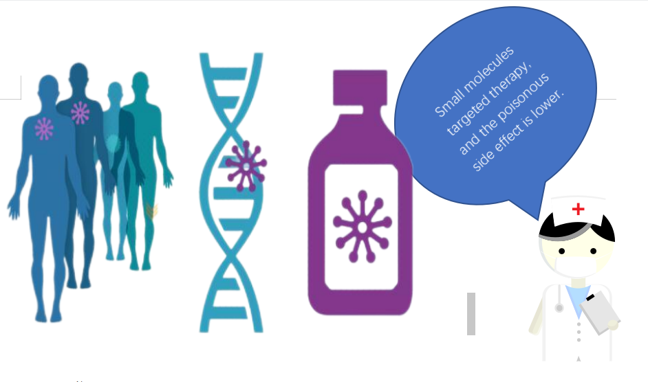

1. **医学领域**

毫无疑问的是，我们使用合成生物学方法改造EcN，为目前肿瘤治疗提供新的思路。不仅对肿瘤的检测、肿瘤临床治疗提供了一种新的思路，还能够在一定程度上缓解肿瘤治疗带来的人体器官组织损伤、机能下降等问题，可以让医疗人员更安全方便的治愈患者。我们相信随着合成生物学的发展及益生菌靶向肿瘤治疗研究的逐步深入，医学领域的发展将突飞猛进，实现各种疾病治疗的方便性和安全性，为更多的患病群体带来福音。

翻译：

**Outstanding performance in another field related to synthetic biology**

1. Education field

Synthetic biology has the potential to change the human world, but it is only in the development stage, and many people do not know this subject very well. During the implementation of this project, we visited the crowds and gave lectures in kindergartens and some community streets to let more people know about the IGEM project and synthetic biology. Through our propaganda, other people can have a better understanding of the content of scientific research, arouse their interest in scientific research, and plant a seed of interest in scientific research in the near future. There will surely be more researchers in the field of scientific research, who will continue to contribute to the development of the world.



2. Pharmaceutical field

It is understood that Ecoli-Nissle 1917 has been widely used in the treatment of acute diarrhea and certain intestinal diseases in infants and young children, as well as daily health products. In the literature reported in recent years, it has been found that Ecoli-Nissle 1917 is a non-toxic and harmless bacteria. , It is sensitive to the low oxygen conditions of the tumor microenvironment, thus showing the characteristics of targeting cancer cells. Therefore, our project uses this probiotic on the basis of synthetic biology. After our experimental results have been determined, and universal transformation has been carried out, medical developers can use our engineered probiotics in the cancer process to provide mammary glands. The treatment of cancer and other cancer patients provides a treatment with less side effects and less pain. At the same time, our idea of transforming probiotics to secrete toxic proteins expands the idea of developing cancer treatment drugs, is an emerging attempt in biological preparations, and provides a reference for the development of other drugs.



3. Medical science

There is no doubt that we use synthetic biology methods to transform EcN to provide new ideas for current tumor treatment. It not only provides a new idea for tumor detection and clinical treatment of tumors, but can also alleviate the problems of human organ tissue damage and function decline caused by tumor treatment to a certain extent, allowing medical staff to cure patients more safely and conveniently. We believe that with the development of synthetic biology and the gradual deepening of research on targeted tumor therapy with probiotics, the development of the medical field will advance by leaps and bounds to realize the convenience and safety of the treatment of various diseases, and bring the gospel to more diseased groups. .