**概念证明**

据报道，女性乳腺癌已超过肺癌成为最常见的癌症，且在人群中的发病，越来越趋向于青年化。而乳腺癌更容易发生在相对年轻的妇女中，乳腺癌是乳腺上皮细胞在多种致癌因子的作用下，发生增殖失控的现象，疾病早期常表现为乳房肿块、腋窝淋巴结肿大等症状，晚期可因癌细胞发生远处转移，出现多器官病变，直接威胁生命。

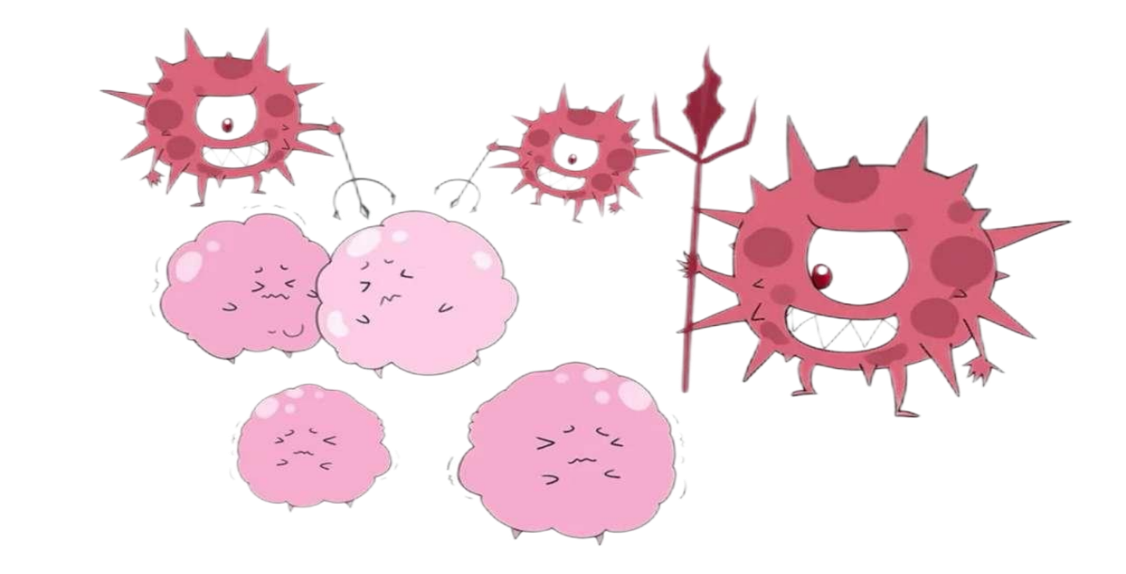

多个报道证明利用合成生物学的手段治疗疾病可以减少传统治疗方法的毒副作用。因此，我们团队提出了益生菌ECN可以利用肿瘤微环境及癌细胞上的Her2受体的双靶向体系识别癌细胞后释放ISZ-sTRAIL融合蛋白，触发细胞的凋亡机制杀死癌细胞的项目实践。

为了实现这一项目我们团队先后多次查阅资料证明：1）Her2人工抗体能够识别乳腺癌细胞表面的Her2受体，进一步增强治疗的靶向作用；2）可溶性sTRAIL融合蛋白可以与癌细胞表面的死亡受体DR4、DR5的胞质死亡结构域结合，转导凋亡信号，从而使癌细胞凋亡。基于这些我们团队构建了含有低氧诱导启动子的益生菌ECN，通过实验验证，考察它对癌细胞的敏感性和杀伤性。

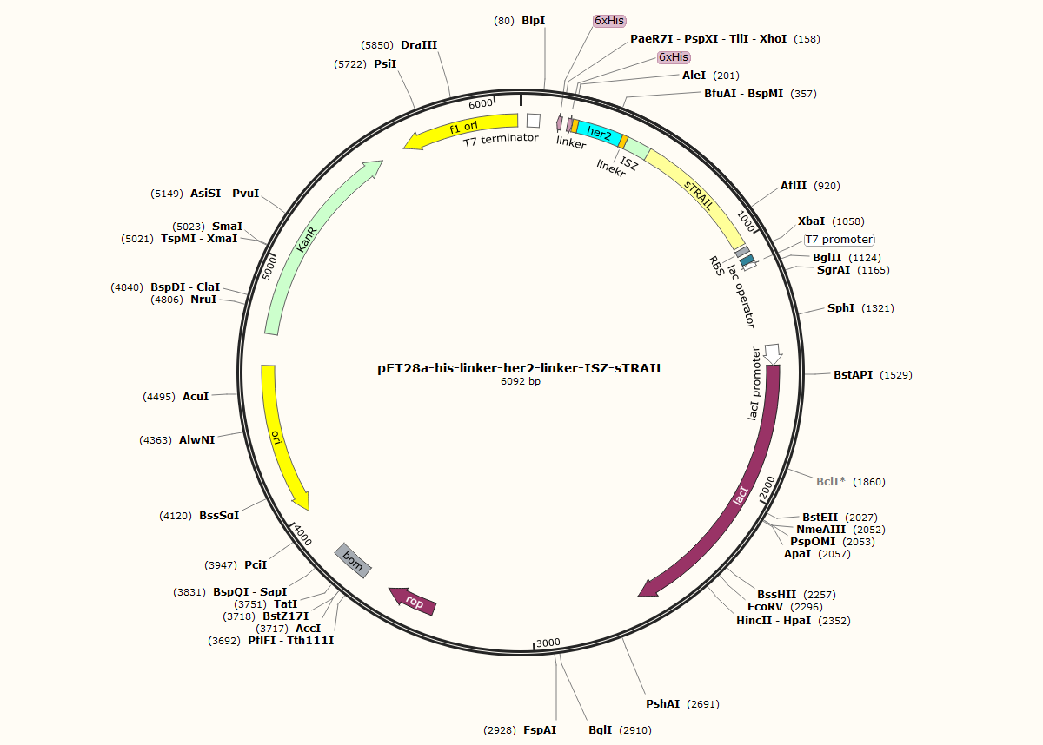我们利用NCBI网站查找相关基因序列，然后构建pET28a-his-linker-her2-linker-ISZ-sTRAIL质粒和pET28a-vgb-pelb-linker-his-linker-her2-linker-ISZ-sTRAIL质粒（交给公司构建），构建结果如图1,图2。

图1.pET28a-his-linker-her2-linker-ISZ-sTRAIL质粒

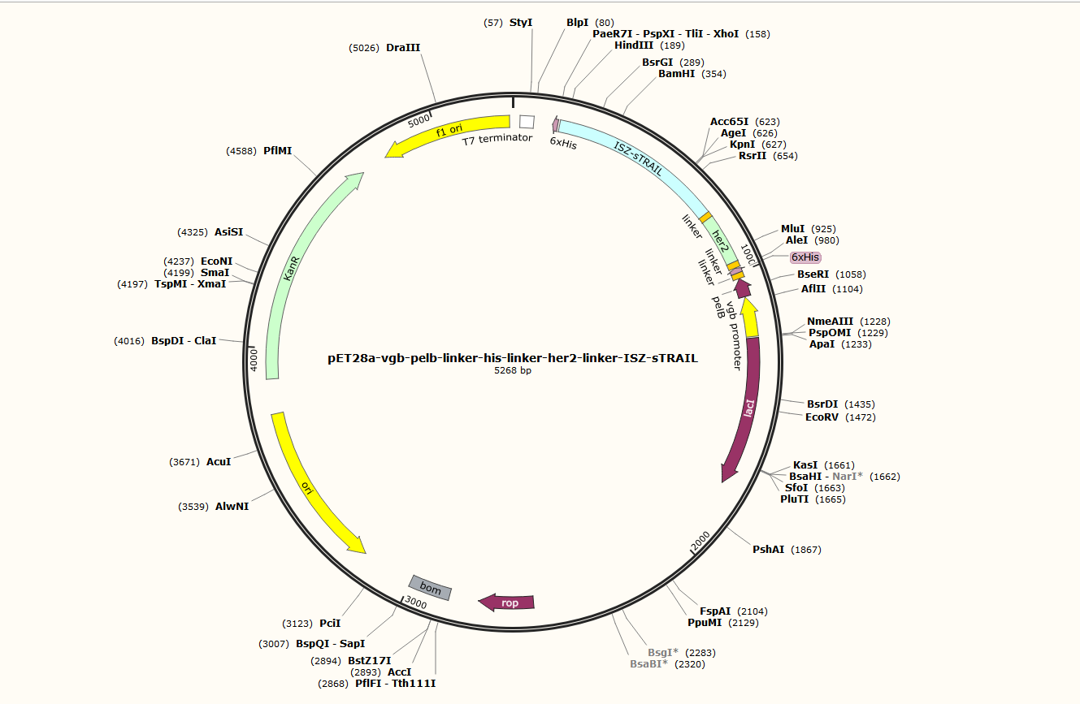

图2.pET28a-vgb-pelb-linker-his-linker-her2-linker-ISZ-sTRAIL质粒

我们将得到的质粒载体pET28a-his-linker-her2-linker-ISZ-sTRAIL转入大肠杆菌BL21（DE3）中使用IPTG诱导表达，提取并纯化了his-Her2-ISZ-sTRAIL。之后利用Western bolt技术和SDS-PAGE对可溶性融合蛋白的活性进行了检测和鉴定，并与未加入IPTG组数据进行比较。同时也检测了沉淀和上清中的蛋白含量，对比并得出数据。发现加入IPTG组的上清中含有的蛋白较沉淀中更高，结果如图3。

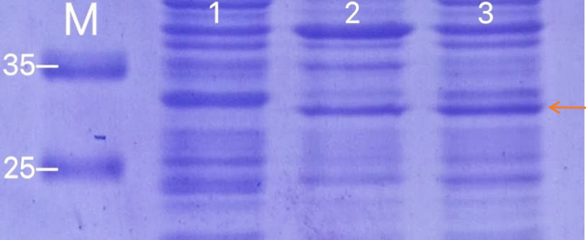图3.her2—ISZ—sTRAIL蛋白检测

注：1.Control；2.沉淀 3.上清

将纯化后获得的融合蛋白和癌细胞（MCF7乳腺癌细胞）共同培养，根据设计的蛋白浓度梯度处理癌细胞，同时设置ISZ-sTRAIL和sTRAIL组别实验分别测试her2—ISZ—sTRAIL融合蛋白、ISZ-sTRAIL蛋白和sTRAIL蛋白对MCF7 乳腺癌细胞的抗肿瘤活性，获得结果如图4(a);发现我们构建质粒表达his-Her2-ISZ-sTRAIL融合蛋白对癌细胞mcf7有明显的毒性作用，细胞形态图如图4（b)，它在较低的浓度范围下就具有高效的癌细胞杀伤性。

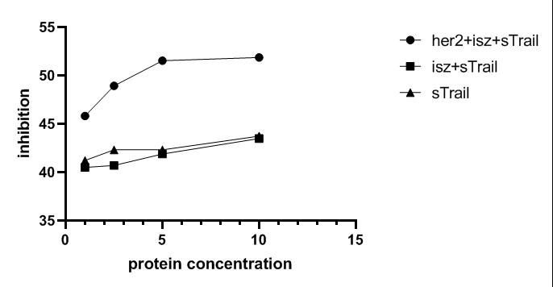图4（a).蛋白处理细胞结果图

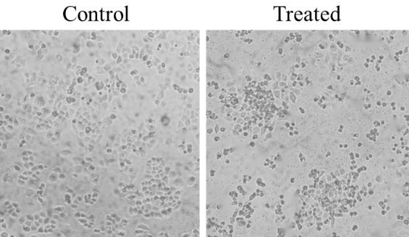

图4（b).经融合蛋白处理后的细胞形态图

在上述基础上，我们团队将获得的pET28a-vgb-pelb-linker-his-linker-her2-linker-ISZ-sTRAIL质粒导入到E.coli Nissle 1917 (EcN）中，在低氧环境中培养表达，利用Western bolt技术来验证低氧启动子可以诱导融合蛋白his-Her2-ISZ-sTRAIL的表达。在这过程中同时设置了有氧组的对照试验，结果如图5。实验结果表明在模拟的肿瘤微环境中pET28a-vgb-pelb-linker-his-linker-her2-linker-ISZ-sTRAIL质粒可以在ECN中表达出具有活性的his-Her2-ISZ-sTRAIL融合蛋白。

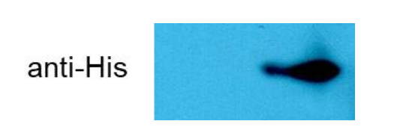

图5. 低氧诱导启动子vgb在大肠杆菌中诱导表达的蛋白质印迹分析

我们通过对实验结果的数据分析和鉴定，发现经改造后的ECN可以在肿瘤微环境中表达出具有高靶向性、高活性的his-Her2-ISZ-sTRAIL融合蛋白且这个融合蛋白对癌细胞有明显的杀伤作用。对于改造益生菌使其双靶向识别癌细胞释放融合蛋白杀死癌细胞的项目，我们已经有了比较完整的实验方法和设计流程。我们将在未来继续研究双靶向系统和his-Her2-ISZ-sTRAIL融合蛋白，并尝试将我们的研究成果与实际应用结合，包括实验结果药物化、生产化。我们会联系更多的医疗、科研者和赞助商，帮助我们项目的实际实施和发展。

**Proof of Concept**

According to reports, female breast cancer has surpassed lung cancer as the most common cancer, and its incidence in the population is becoming more and more youthful. Breast cancer is more likely to occur in relatively young women. Breast cancer is a phenomenon in which breast epithelial cells proliferate out of control under the action of a variety of carcinogens. The early stage of the disease often manifests as breast lumps and axillary lymph node enlargement. The cancer cells may metastasize far away, causing multiple organ disease, which is a direct threat to life.

Multiple reports have proved that the use of synthetic biology to treat diseases can reduce the side effects of traditional treatment methods. Therefore, our team proposed a project that probiotic ECN can use the dual-targeting system of tumor microenvironment and Her2 receptor on cancer cells to identify cancer cells and then release ISZ-sTRAIL fusion protein to trigger the apoptosis mechanism of cells to kill cancer cells. practice.

In order to realize this project, our team has repeatedly checked the data to prove: 1) Her2 artificial antibody can recognize the Her2 receptor on the surface of breast cancer cells, and further enhance the targeting effect of the treatment; 2) The soluble sTRAIL fusion protein can interact with the surface of cancer cells. The cytoplasmic death domains of death receptors DR4 and DR5 combine to transduce apoptosis signals, thereby causing cancer cells to undergo apoptosis. Based on these, our team constructed a probiotic ECN containing a hypoxia-inducible promoter, and verified its sensitivity and lethality to cancer cells through experimental verification.

We use the NCBI website to find the relevant gene sequence, and then construct the pET28a-his-linker-her2-linker-ISZ-sTRAIL plasmid and pET28a-vgb-pelb-linker-his-linker-her2-linker-ISZ-sTRAIL plasmid (to the company Construction), the results of the construction are shown in Figure 1 and Figure 2.



Fig 1.pET28a-his-linker-her2-linker-ISZ-sTRAIL plasmid



Fig 2.pET28a-vgb-pelb-linker-his-linker-her2-linker-ISZ-sTRAIL plasmid

We transferred the obtained plasmid vector pET28a-his-linker-her2-linker-ISZ-sTRAIL into E. coli BL21 (DE3) and induced expression with IPTG, extracted and purified his-Her2-ISZ-sTRAIL. Afterwards, the activity of the soluble fusion protein was detected and identified by Western bolt technology and SDS-PAGE, and compared with the data of the group without IPTG. At the same time, the protein content in the precipitate and supernatant was also tested, compared and data were obtained. It was found that the protein in the supernatant added to the IPTG group was higher than that in the precipitate. The result is shown in Figure 3.



Fig 3. Her2-isz-trail protein detection

Note：1.Control；2. sediment 3.supernatant

The purified fusion protein is co-cultured with cancer cells (MCF7 breast cancer cells), the cancer cells are processed according to the designed protein concentration gradient, and ISZ-sTRAIL and sTRAIL group experiments are set to test her2—ISZ—sTRAIL fusion protein and ISZ respectively. -sTRAIL protein and sTRAIL protein have anti-tumor activity on MCF7 breast cancer cells. The results obtained are shown in Figure 4(a); it is found that our construction of plasmids expressing his-Her2-ISZ-sTRAIL fusion protein has a significant toxic effect on cancer cells mcf7. The morphology is shown in Figure 4(b), which has high efficiency in killing cancer cells in a lower concentration range.

Figure 4 (a).The result of protein treatment of cells



Figure 4 (b).Cell morphology diagram after being treated with the fusion protein

On the basis of the above, our team introduced the obtained pET28a-vgb-pelb-linker-his-linker-her2-linker-ISZ-sTRAIL plasmid into E.coli Nissle 1917 (EcN), cultured and expressed in a hypoxic environment, Using Western bolt technology to verify that hypoxia promoter can induce the expression of the fusion protein his-Her2-ISZ-sTRAIL. In this process, a control experiment of the aerobic group was set up at the same time, and the results are shown in Figure 5. The experimental results show that the pET28a-vgb-pelb-linker-his-linker-her2-linker-ISZ-sTRAIL plasmid can express the active his-Her2-ISZ-sTRAIL fusion protein in the ECN in the simulated tumor microenvironment.



Figure 5. Protein blot analysis of the expression of the inducible hypoxia-inducible promoter vgb in E. coli

Through data analysis and identification of the experimental results, we found that the modified ECN can express a highly targeted and highly active his-Her2-ISZ-sTRAIL fusion protein in the tumor microenvironment, and this fusion protein is effective for cancer cells. It has obvious killing effect. For the project of transforming probiotics to double-target recognition of cancer cells and release fusion proteins to kill cancer cells, we already have a relatively complete experimental method and design process. In the future, we will continue to study the dual-targeting system and his-Her2-ISZ-sTRAIL fusion protein, and try to combine our research results with practical applications, including experimental results for pharmaceuticals and production. We will contact more medical, scientific researchers and sponsors to help the actual implementation and development of our project.