Sample: CHIPS-6-02-25-02-full

Optical Model
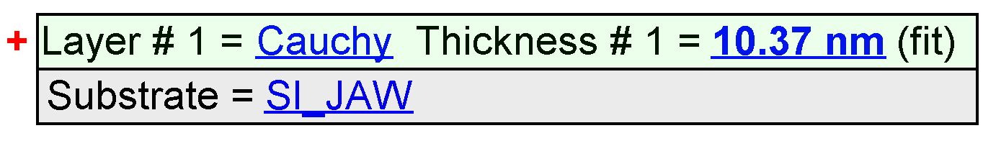
Fit Results
Parameter | Average | Min. | Max. | Std. Dev. | % Range
MSE | 5.980 | 5.389 | 14.498 | 0.840 | 152.324
Thickness # 1 (nm) | 9.64 | 8.86 | 10.37 | 0.37 | 15.6497
A | 2.2444 | 2.2217 | 2.2657 | 0.0052 | 1.9586
B | -0.0236 | -0.0291 | -0.0138 | 0.0029 | -64.8502
C | 0.0011 | 0.0004 | 0.0016 | 0.0003 | 116.5103
n of Cauchy @ 632.8 nm | 2.1920 | 2.1706 | 2.2064 | 0.0074 | 1.6327

Model Parameters vs. Position
