Multimedia Systems –
C-WG3-#1
Design Specification

File: 3_wg1_Implementation.doc Last Modified: 19.1.2003 Approval Date:
Created: 17 syyskuu, 2007 Number of Pages: 9 Approved By:

PURPOSE OF THIS DOCUMENT
This document contains everything concerning design and implementation of the course work.

REVISION HISTORY

Revision # | Date | Author(s) | Comments
0.1 | 09/11/09 | Pasi Keski-Korsu | Template created
0.2 | 09/11/09 | Pasi Keski-Korsu | Notes added
0.3 | 30/11/09 | Pasi Keski-Korsu | Text and pictures added to chapter 5
0.4 | 30/11/09 | Pasi Keski-Korsu | Chapter 4 written

TABLE OF CONTENTS

Introduction

This chapter presents an overview of course work’s design.

Yleiskuvaus koko hommelista

Definitions and acronyms

List of definitions and acronyms used in this design document.

OpenGL | Open Graphics Library
GLC | ALSA and OpenGL capture tool for Linux
RTP | Real-time Transport Protocol
UDP | User Datagram Protocol
UML | Unified Modeling Language
ACK | Acknowledgment
Qt | Application development framework
LibVLC | Library for VLC media player

Framework and protocols

Present some essential tools and framework (IDEs, SDKs, etc.) if any, that the topic will be developed and operate on, e.g. Symbian Series 60, http, ftp, linux, …

Frameworkit ja protokollat:
- Qt (controls)
- Yukon+Seom (OpenGL, capture) (huom. vaihtunu)
- Yunikorn (.mjpg stream) (ei vissiin tätäkään käytetä enää)
- Libvlc (play video stream)
- Xtest (remote controls to X)

Design Limitations

Our program runs on two different computers. Client computer does not have huge limitations on hardware or software. Well, that's the idea of cloud gaming! Nevertheless, server computer needs quite a lot processor capacity. Running the game it self needs a lot resources and added to that server must, among other things, compress the video. One particular task is not heavy to process but when there are lot of small tasks total need of resources is quite high.

Second main limitation in our project is network delay. Any kind of network is usable to our program but on testing we use Ethernet cable. Ethernet cable is the most efficient way to connection between server and client. WLAN or Internet may cause network delay which is not depended on our system.

Project Design

General

In this section, project design is presented with a help of UML graphs. Sequence diagram presents the data packages which are send over the network. Component diagram shows the third party and other software components in this project. Lastly, we introduce you the main algorithms and user interface in our program.

Sequence Diagram

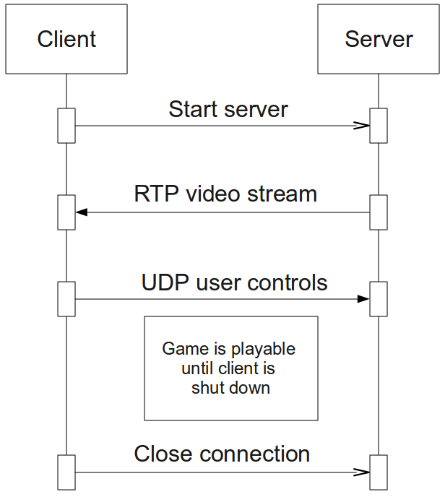
In our sequence diagram, we have client computer on the left and server computer on the right. First, client sends a message to server to start the game. When server has received the message it starts to send video stream and is ready to receive user controls. User plays the game by getting video stream on his/her screen and sending controls over the network. When user wants to close the program client sends a message to server to close the connection. We use UDP packages to communication so client and server do not send ACK messages to each other.

Component Diagram

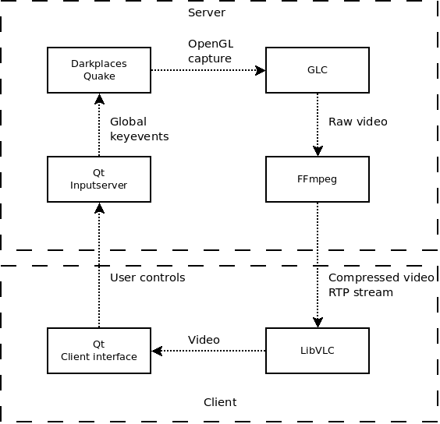
In our project we use third party software components quite a lot. We use FFmpeg, GLC, Qt and Darkplaces in our server computer. Darkplaces is the game which is played by the user from the client computer. GLC captures the video stream and FFmpeg packs the raw video and sends it to client. Client receives compressed video with LibVLC. Client interface and inputserver is developed by using Qt framework.

Main Algorithms

Our main algorithms are mostly third party software components. We use open source program FFmpeg and h263+ video codec to capture, pack and stream the video. With FFmpeg video is captured and streamed. Video codec h263+ packs the video so we can use our network bandwidth more efficiently. RTP is standardized protocol for sending audio and video packages over the Internet.

User Interface

User starts to use the program by executing the file Client.exe. First, program opens the menu screen (Picture 1) where user can press “Connect” to start playing the game or “Exit” to exit the program. After pressing the button “Connect” program connects to the server computer and starts playing the with it's own user interface (Picture 2).
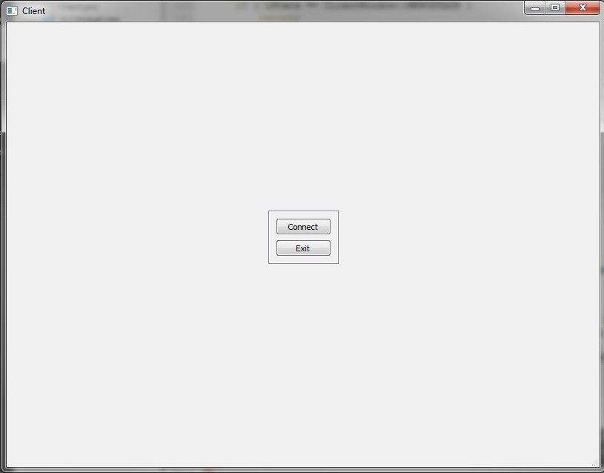
Picture 1. The program menu

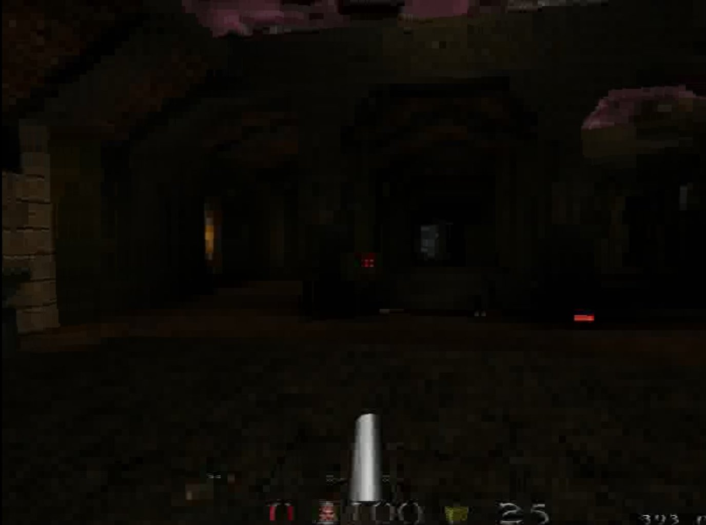
Picture 2. The game

Compiling & Executing instructions

Compiling Instructions

This part of document explains specific compiling instructions (if any).

- Laitetaan copy-pastella ku on jotain laitettavaa (Tuomas)

Executing Instructions

This part of document explains specific running instructions (if any).

References

- Jaaksi A. & Aalto J-M. & Aalto A. & Vättö K. (1999) Tried & True Object Development, Industry-Proven Approaches with UML. Cambridge University Press, SIGS Books.

