1. Cloning the git repository  
   - to make things easier  
   
2. Making own repository



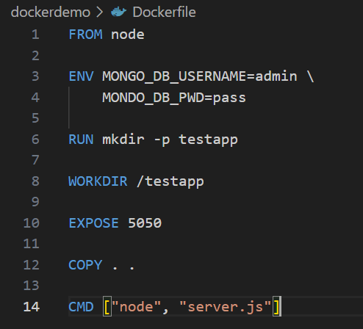

1. A screenshot of a computer program

   AI-generated content may be incorrect.