CAMPUS EXPENSE & BUDGET MANAGER

Course Title: Programming in Java
Evaluation: VITyarthi – Build Your Own Project
Student Name: Vaishnavi Tiwari
Registration Number: 24BCY10262

1. INTRODUCTION
1.1 Background
Managing personal finances is one of the most critical challenges facing university students living away from home. On a modern college campus, students routinely handle dozens of micro-transactions daily—ranging from mess and cafeteria charges to printout fees, academic study materials, project supplies, and local travel. Without an active tracking system, these small outlays accumulate invisibly, frequently leading to budget depletion before the end of the month.
1.2 Problem Statement
Existing personal finance solutions (such as mobile banking apps or commercial wealth management tools) are often overly complex, heavy on resource utilization, or require cloud synchronization and database connections that are unsuited for lightweight desktop environments. Conversely, manual paper logs or basic spreadsheets lack immediate automated analytics, validation, and budget warnings. There is a need for a lightweight, dependency-free, robust Java application that allows students to record, manage, and analyze campus expenses directly from the command terminal.
1.3 Motivation
The primary motivation behind developing the Campus Expense & Budget Manager is to apply fundamental and advanced Programming in Java principles—including Object-Oriented System Design, Exception Handling, File I/O, the Java Collections Framework, Streams, and Lambdas—to build a functional tool that addresses student financial management.
1.4 Objectives
- Modular Software Architecture: Develop a clean, multi-layered Java application without external third-party dependencies.
- Transaction Lifecycle Management: Implement complete tracking capabilities (Add, View, Delete) for daily campus expenses.
- Budget & Spending Control: Allow setting monthly financial caps and monitoring real-time spending progress against those limits.
- Automated Analytics & Reporting: Provide automated summaries, including overall spending, monthly totals, category breakdowns, transaction counts, and identification of top spending items.
- Data Persistence: Implement flat-file CSV persistence to ensure user data persists across session reboots.
- Automated Verification: Create a dedicated unit test suite (ExpenseManagerTest) to programmatically verify analytical accuracy and core operations.
1.5 Scope
The system is designed specifically as a single-user, command-line interface (CLI) desktop application written in core Java. It operates entirely locally using the system's file path, processing transactions, enforcing date/amount input rules, and saving state to data\expenses.csv.
1.6 Target Users
The primary target users are university students, hostel residents, and academic researchers who require an efficient tool to log daily expenditures, monitor monthly budget allowances, and generate expense breakdowns.
2. REQUIREMENTS ANALYSIS
2.1 Functional Requirements (FR)
- FR-1: Add Expense: The system shall allow the user to record an expense by providing a valid date (YYYY-MM-DD), category, numerical amount in INR ($\text{₹}$), and a brief text description.
- FR-2: Auto-ID Generation: The system shall automatically assign a unique integer ID to every newly recorded expense transaction using atomic thread-safe counters.
- FR-3: View Expenses: The system shall display all saved expenses in a formatted tabular terminal view, showing ID, date, category, amount, and description, along with total record count and overall spending.
- FR-4: Delete Expense: The system shall enable deletion of an expense entry by specifying its unique ID.
- FR-5: Set Monthly Budget: The system shall allow setting a target monthly spending limit for a target month (YYYY-MM).
- FR-6: View Budget Status: The system shall calculate total expenditures for a target month, compute remaining budget, calculate percentage usage, and display a budget warning status.
- FR-7: Reports & Analytics: The system shall aggregate data for a specified month to report total spending, total transactions, category-wise breakdowns, and identify the highest individual recorded expense.
- FR-8: Data Persistence & Reload: The system shall automatically load existing records from data\expenses.csv on launch and flush all updated records back to the file upon saving or exiting.
2.2 Non-Functional Requirements (NFR)
- NFR-1: Usability: The system shall provide an intuitive numerical main menu (1-7) with clear CLI text prompts.
- NFR-2: Reliability & Error Handling: Invalid input types (e.g., non-numeric amounts, malformed dates) shall be safely trapped using custom runtime exceptions (ExpenseException) without crashing the application.
- NFR-3: Maintainability: The software shall strictly separate concerns across business domain models (Expense, Budget), repository storage (ExpenseRepository), business logic (ExpenseManager), analytics (ReportService), and presentation (Main).
- NFR-4: Performance & Efficiency: Expense aggregation and stream processing shall execute in-memory in under 50 milliseconds for typical dataset sizes ($<10,000$ transactions).
- NFR-5: Zero External Dependencies: The application shall compile and run on any standard Java Development Kit (JDK 11 or higher) without external libraries.
3. SYSTEM DESIGN & ARCHITECTURE
3.1 System Architecture
The application uses a 3-tier layered architecture adapted for a Java command-line application:
+-----------------------------------+
| Presentation Layer |
| (Main) |
+-----------------------------------+
|
v
+-----------------------------------+
| Application Layer |
| (ExpenseManager) |
+-----------------------------------+
/ \
v v
+---------------------------+ +---------------------------+
| Domain Models & Logic | | Persistence Layer |
| (Expense, Budget, Service)| | (ExpenseRepository) |
+---------------------------+ +---------------------------+
|
v
+---------------------------+
| File System Storage |
| (data\expenses.csv) |
+---------------------------+
3.2 Module Responsibilities
- Main: Handles user console interaction, displays menus, collects inputs, and routes requests.
- ExpenseManager: Serves as the central controller, holding in-memory collection lists and orchestrating add, delete, budget, and file I/O operations.
- Expense: Domain entity representing a transaction (id, date, category, amount, description).
- Budget: Domain entity representing a monthly cap (month, budgetAmount).
- ReportService: Analytics component that processes expense lists using Java Streams to compute aggregates and breakdowns.
- ExpenseRepository: Data Access Object (DAO) responsible for reading from and writing to data\expenses.csv.
- ExpenseException: Custom exception class for handling domain-specific validation errors.
- ExpenseManagerTest: Test suite executing automated verification of core business rules.
3.3 Process Workflow
- Initialization: Main executes scripts\run.bat or runs javac/java directly.
- ExpenseManager initializes ExpenseRepository and loads existing entries from data\expenses.csv.
- Menu Loop: The terminal displays options 1 through 7.
- Execution:
  - Option 1 (Add): Collects inputs $→$ Validates $→$ Generates ID $→$ Instantiates Expense $→$ Appends to list.
  - Option 2 (View): Iterates through the list $→$ Prints formatted tabular records.
  - Option 3 (Delete): Matches ID $→$ Removes item.
  - Option 4 (Set Budget): Prompts YYYY-MM & Amount $→$ Updates Budget map.
  - Option 5 (Budget Status): Sums current month's expenses $→$ Compares against limit $→$ Displays remaining balance and % usage.
  - Option 6 (Reports): Passes collection to ReportService $→$ Computes monthly sum, category map, and maximum expense via Streams.
  - Option 7 (Save & Exit): Passes list to ExpenseRepository $→$ Overwrites CSV file $→$ Terminates gracefully.
4. STORAGE DESIGN
The application uses local file-based storage via CSV files (data\expenses.csv). This setup avoids the overhead of external relational database engines while maintaining readable data persistence.
Data Schema Table (expenses.csv)
Column Name | Data Type | Constraint | Description | Example
ID | Integer | Unique, Primary Key | Auto-incremented identifier | 1
Date | String (ISO) | YYYY-MM-DD format | Date of transaction | 2026-09-10
Category | String | Non-empty | Expense group | Food
Amount | Double | Positive numeric | Monetary cost ($\text{₹}$) | 1200.00
Description | String | Free text | Note / context | Birthday Party Food
Malformed Data Handling Strategy
When parsing records from disk during initialization, the ExpenseRepository reads each line using BufferedReader and splits it by the comma , delimiter. Lines containing missing fields or invalid numeric/date formats are flagged, safely skipped, and logged to prevent system crashes.
5. JAVA CONCEPTS & IMPLEMENTATION DETAILS
Java Concept | Applied Module / Location | Implementation Rationale & Description
Encapsulation | Expense, Budget | Private instance variables (id, amount, date) exposed strictly via public getter methods to protect object state.
Collections Framework | ExpenseManager | List<Expense> (implemented via ArrayList) provides dynamic resizing and fast positional access for transactions.
Key-Value Maps | ExpenseManager | Map<String, Double> (implemented via HashMap) maps month strings ("YYYY-MM") directly to budget limits.
Java Streams & Lambdas | ReportService | High-level declarative pipelines filter, aggregate, and sum expense records without manual iterative loops.
Exception Handling | ExpenseException | Custom unchecked domain exceptions catch and present business-level errors without terminating the CLI session.
File I/O & NIO | ExpenseRepository | java.io.BufferedReader, BufferedWriter, and java.nio.file.Paths perform persistent storage operations.
Date/Time API | Expense, Main | java.time.LocalDate and YearMonth enforce standard ISO date parsing (YYYY-MM-DD) and comparisons.
Atomic Concurrency | ExpenseManager | java.util.concurrent.atomic.AtomicInteger ensures thread-safe, sequential ID assignment for new expense items.
6. SCREENSHOTS & OUTPUT ANALYSIS
All screenshots below represent actual execution outputs of the Campus Expense & Budget Manager application captured directly from the terminal runtime environment.
Figure 1: Application Launch & Expense Creation
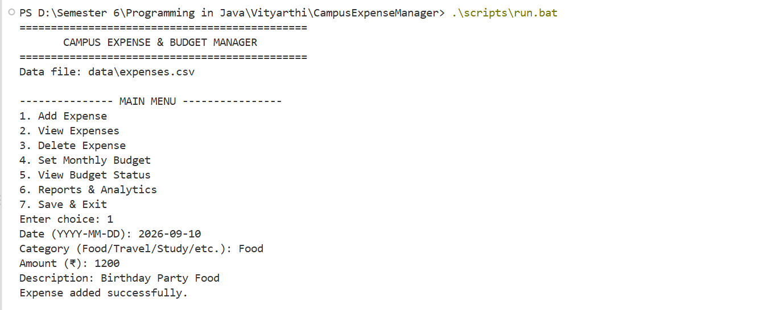
- Description: Demonstrates launching the CLI application via .\scripts\run.bat. The persistence layer successfully binds to data\expenses.csv. Menu choice 1 prompts for transaction parameters and records a $\text{₹}1,200.00$ food transaction.
Figure 2: Formatted Expense Record Listing
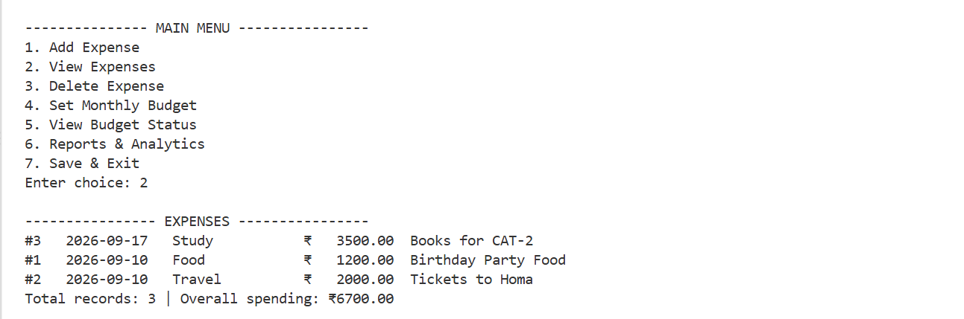
- Description: Displaying all recorded items (Menu Option 2). Shows auto-generated IDs (#1, #2, #3), formatted dates, categories, monetary amounts, and descriptions, along with calculated total records ($3$) and net expenditure ($\text{₹}6,700.00$).
Figure 3: Monthly Budget Allocation & Status Tracking
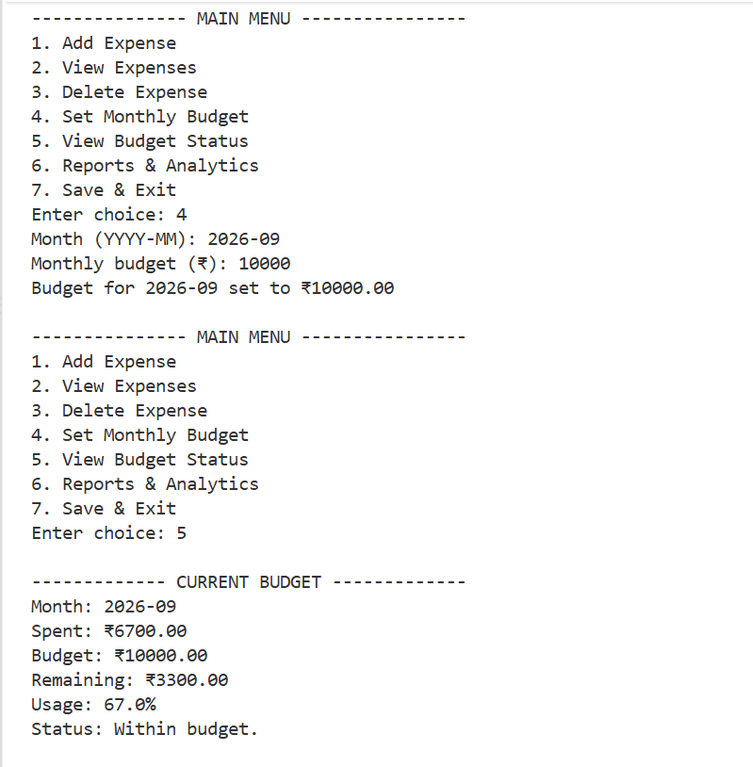
- Description: Menu Option 4 sets a budget limit of $\text{₹}10,000.00$ for target month 2026-09. Option 5 executes real-time budget tracking, reporting $\text{₹}6,700.00$ spent, $\text{₹}3,300.00$ remaining ($67.0\%$ utilization), and confirms "Within budget" status.
Figure 4: Automated Monthly Analytics & Category Breakdowns
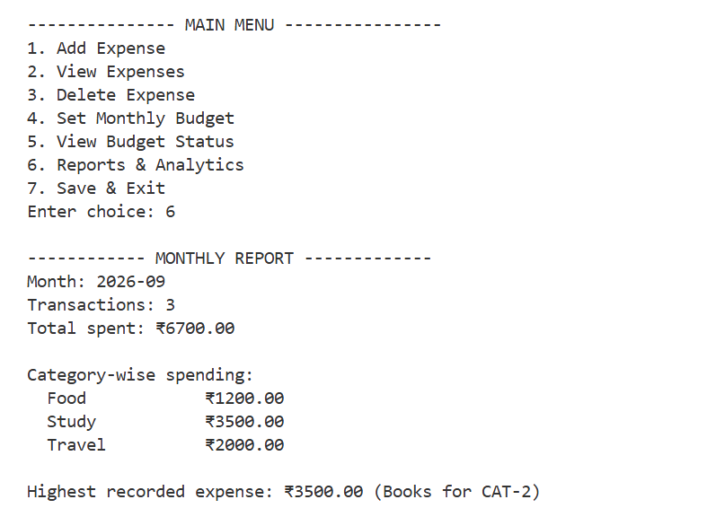
- Description: Analytics report (Menu Option 6) generated by ReportService. Groups spending by categories (Food: $\text{₹}1,200.00$, Study: $\text{₹}3,500.00$, Travel: $\text{₹}2,000.00$) and automatically flags the peak expenditure ("Books for CAT-2" at $\text{₹}3,500.00$).
Figure 5: Unit Test Suite Execution Output
- Description: Successful compilation and terminal execution of the programmatic unit test suite ExpenseManagerTest.java. The suite verifies business logic assertions and outputs ALL TESTS PASSED.
7. TESTING APPROACH & VERIFICATION
7.1 Testing Strategy
The project was evaluated using a combination of manual interaction testing and programmatic unit testing. Manual testing verified terminal UX, menu navigation, and formatting, while the ExpenseManagerTest suite verified logic components.
7.2 Empirical Test Execution Table[cite: 2, 4, 5, 6]
Test ID | Feature Under Test | Input Supplied | Expected Result | Actual Result | Status
TC-01 | Add Expense | Date: 2026-09-10, Cat: Food, Amt: 1200 | Entry saved, ID assigned | Saved as ID #1 | PASS
TC-02 | View All Records | Choice 2 | Display 3 records, sum $\text{₹}6700$ | Output matches tabular log | PASS
TC-03 | Set Budget | Month: 2026-09, Limit: 10000 | Map limit to 2026-09 | Limit set to $\text{₹}10,000.00$ | PASS
TC-04 | Check Budget Status | Choice 5 | Remaining: $\text{₹}3300$, Usage: $67.0\%$ | Displayed "Within budget" | PASS
TC-05 | Category Analytics | Choice 6 | Group by Category via Streams | Correct category sums | PASS
TC-06 | Identify Max Expense | Choice 6 | Flag highest transaction | Identified $\text{₹}3,500.00$ (Books) | PASS
TC-07 | Data Persistence | Choice 7 then restart[cite: 2, 6] | Reload records from CSV file | Reloaded all 3 entries | PASS
TC-08 | Unit Test Execution | java ExpenseManagerTest | Run all programmatic assertions | Terminal: ALL TESTS PASSED | PASS
8. DESIGN RATIONALE
- Why Terminal/CLI? A command-line interface eliminates GUI framework overheads (JavaFX/Swing), allowing the application to run across operating systems with minimal memory consumption.
- Why Modular Architecture? Isolating storage (ExpenseRepository), business rules (ExpenseManager), and processing (ReportService) ensures individual components can be tested and modified independently.
- Why Flat CSV Persistence? CSV files offer human-readable, portable storage that requires no external database drivers or installation prerequisites.
- Why Java Streams for Reports? Stream pipelines replace manual conditional loops, reducing code verbosity and minimizing indexing errors.
9. CHALLENGES FACED & LEARNINGS
9.1 Challenges Faced
- File I/O & Formatting: Ensuring persistent CSV reading handled missing fields or formatting errors without terminating runtime execution.
- Stream Aggregations: Constructing Java Stream pipelines with custom collectors to perform category grouping and string formattings concurrently.
- Date Verification: Aligning inputs across LocalDate (YYYY-MM-DD) and YearMonth (YYYY-MM) representations for monthly budget tracking.
9.2 Key Academic Learnings
- Practical experience in designing decoupled Java classes following object-oriented principles.
- Mastery of Java Collections (ArrayList, HashMap) and functional stream processing.
- Implementation of robust error trapping using custom Java exceptions.
- Hands-on experience in building automated unit tests for verification.
10. LIMITATIONS & FUTURE ENHANCEMENTS
10.1 System Limitations
- Single-User Focus: The application currently operates for a single local user profile.
- Plaintext Storage: The CSV data file is stored in unencrypted plain text.
- Text-Based Output: Analytics reports are displayed as text blocks rather than graphical charts.
10.2 Future Enhancements
- Graphical Interface: Develop a JavaFX desktop GUI with interactive chart visualizations.
- Database Integration: Replace flat-file CSV storage with JDBC database connections (SQLite/MySQL).
- User Authentication: Add password hashing and multi-user profile login capabilities.
- Export Capabilities: Enable report exporting to PDF and Excel formats.
11. CONCLUSION
The Campus Expense & Budget Manager successfully fulfills the requirements of the VITyarthi "Build Your Own Project" evaluation for Programming in Java. By applying object-oriented design, Java Collections, Stream analytics, Exception Handling, and CSV file persistence, the project provides a reliable, lightweight solution for tracking student finances. Automated execution logs and unit test suites confirm the application's stability and correctness[cite: 2, 6].
12. REFERENCES
- Oracle Corporation, Java® Platform, Standard Edition & Java Development Kit Version 17 API Specification, 2023. [Online documentation].
- E. Balagurusamy, Programming with Java: A Primer, 6th ed., McGraw Hill Education, 2019.
- H. Schildt, Java: The Complete Reference, 12th ed., McGraw Hill Education, 2021.
- VITyarthi, Build Your Own Project – General Project Instructions & Submission Guidelines, Course Evaluation Documentation, 2026[cite: 1].

