**Title:**

Microwave spectroscopy of the bistable spin-wave dispersion in thin-film gallium-doped yttrium iron garnet

**Figures:**

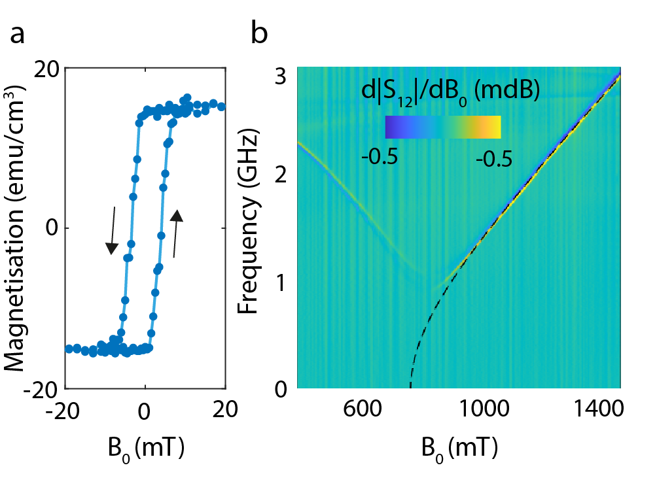

Figure 1 Characterizing the saturation magnetization and anisotropy of a 45-nm-thick Ga:YIG film. (**a**) Hysteresis loop of the magnetisation as a function of out-of-plane magnetic field B0 measured using vibrating sample magnetometry. We extract a saturation magnetisation of 4piMs=191G. (**b**) Broadband flip-chip FMR measurement using an in-plane magnetic field B0 parallel to a 180-um-wide excitation stripline. By fitting the FMR-frequency extracted from the field-derivative of the microwave transmission |S_12| (dashed black line) we determine the out-of-plane magnetocrystalline anisotropy constant Ku=485G.

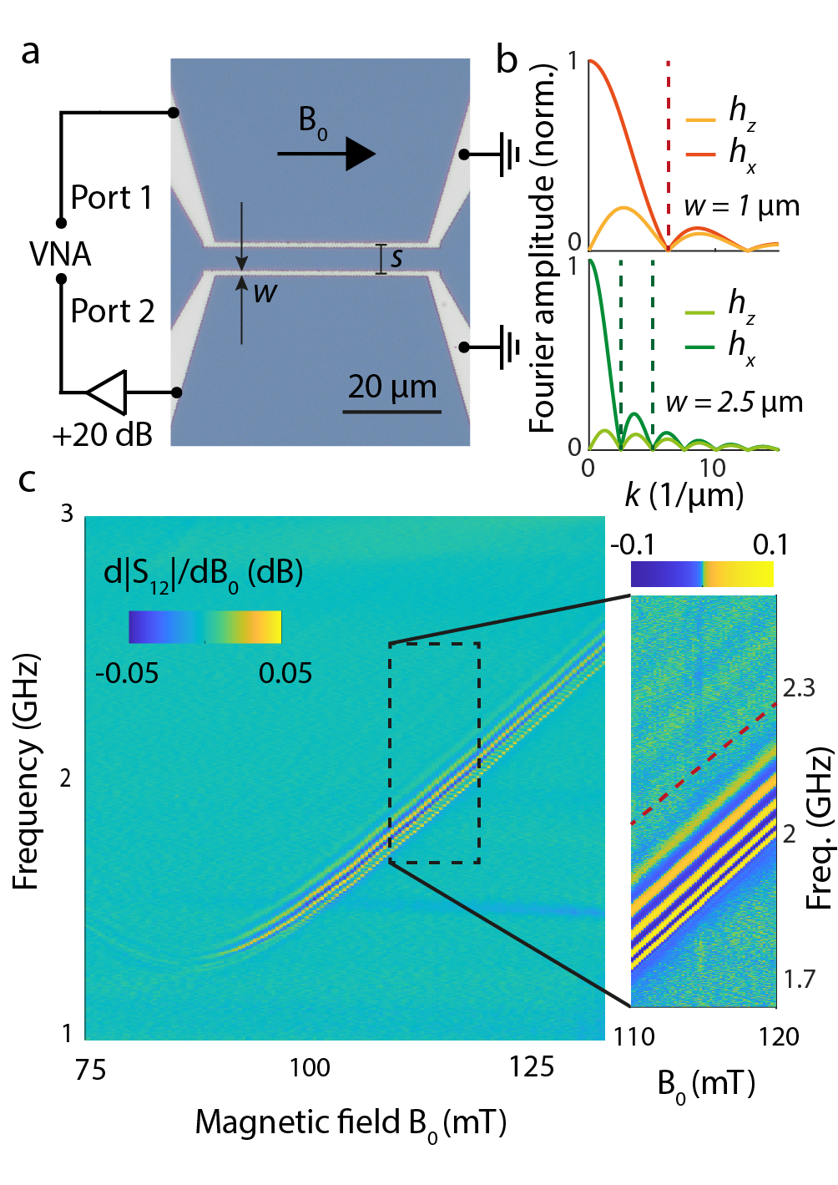

Figure 2 Low-power microwave spectroscopy of spin waves in Ga:YIG. (**a**) Optical micrograph of a measurement device. Two golden striplines are connected to a vector network analyser (VNA). Port 1 applies a microwave current (-35 dBm) that induces a radio-frequency magnetic field h at the first stripline. This field excites propagating spin waves that couple inductively to the second stripline. The generated microwave current is amplified and detected at port 2. A static magnetic field B_0 is applied in the Damon-Eshbach configuration. (**b**) The striplines excite and detect spin waves of wavevector k with an efficiency that scales with the Fourier amplitude of h. The absolute value of the Fourier spectra of the x and z components of h are shown for striplines with a width w=1 um and w=2.5 um. The dashed lines indicate nodes in the Fourier spectra. (**c**) Field-derivative of the microwave transmission |S12| between two 1-um-width striplines as a function of B_0 and microwave frequency. The fringes result from the interference between the spin-wave and direct magnetic field at the position of the second stripline. The colormap of the inset is squeezed, such that low-amplitude fringes of spin waves are visible with wavevectors larger than the first Fourier node of h, which is indicated by the dashed line.

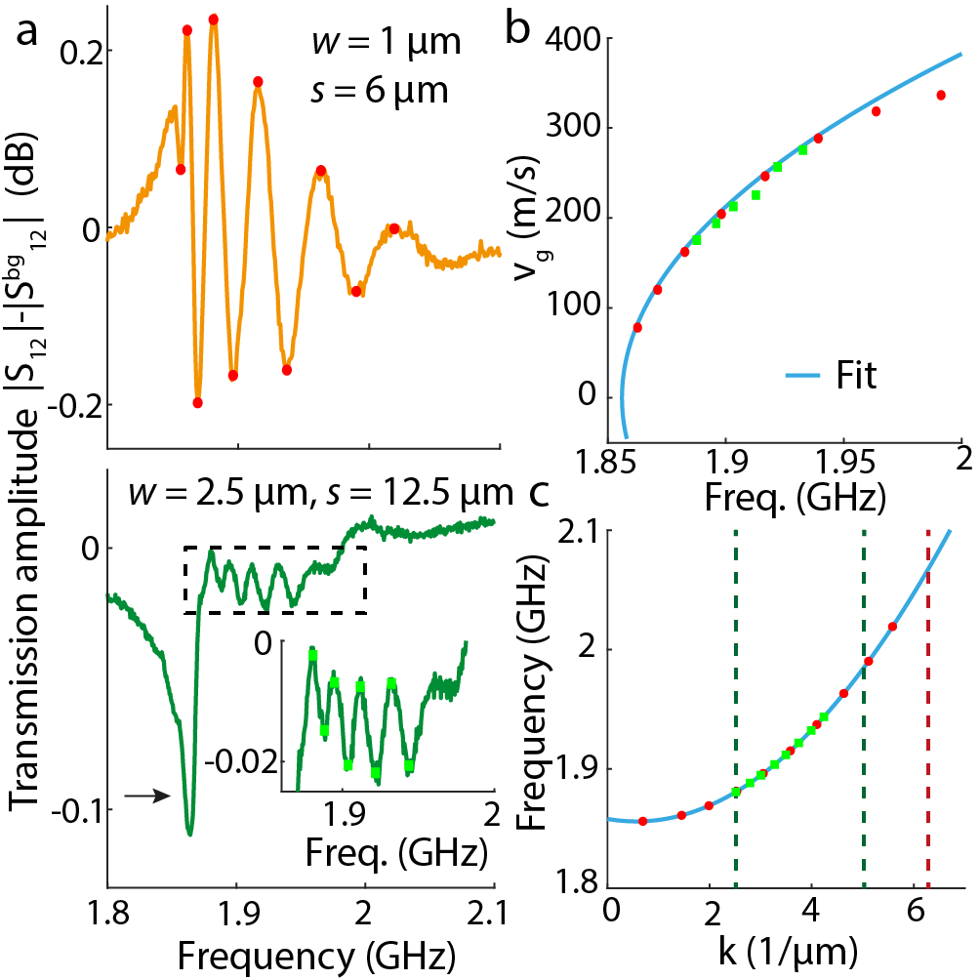

Figure 3 Extracting the spin stiffness from spin-wave transmission spectra. (**a**) Background-substracted linetraces of |S_12| for two sets of striplines (upper: w=1 um, s=6 um, lower: w=2.5 um, s=12.5 um, excitation power -35 dBm). The red circles and green squares in the lower inset mark the extrema of the spin wave-fringes. (**b**) From these extrema we determine the group velocity vg of the spin waves. The blue line fits the datapoints with an expression for v_g derived from the analytical spin-wave dispersion (see main text). From the fit we extract B0=1160G and D=3.3(3)D_YIG. (**c**) Reconstructed spin-wave dispersion based on the fit in (**b**). The datapoints correspond to the frequencies of the extrema in (**a**). The dashed lines indicate the nodes in the Fourier spectra of the excitation fields of striplines (see figure 2b). We conclude that the red dots and green squares correspond to spin waves with wavevectors in respectively the first and second maximum of the stripline-field Fourier spectrum. We attribute the dip in transmission in the lower panel of (**a**), indicated by the arrow, to spin waves in the first Fourier maximum.

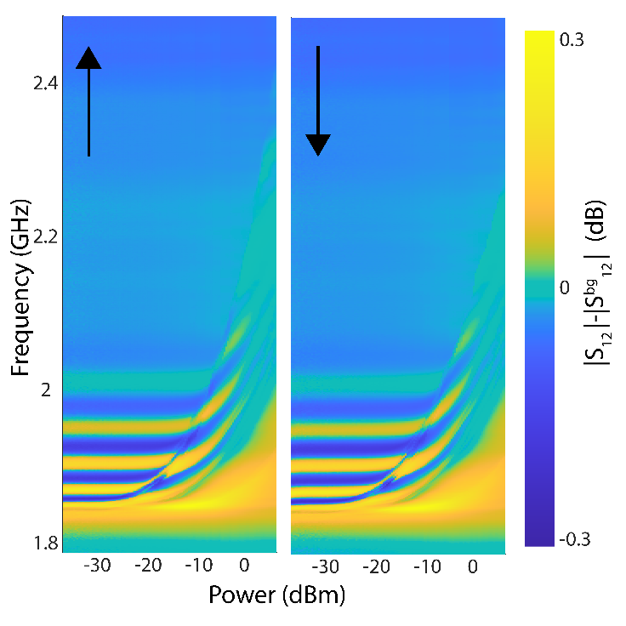

Figure 4 Observation of spin-wave frequency shifts and foldover. The spin-wave fringes in the background-substracted |S_12| are measured as function of microwave excitation power for upward (left) and downward frequency sweeps (right) at B_0=1160 G (w=1 um, s=6 um). Spin waves with a low wavevector shift to higher frequencies when the driving power is increased. A sharp boundary marks the frequency at which the systems falls back to the low-power dispersion. Depending on the sweep direction the boundary is at lower or higher frequencies, demonstrating the foldover of spin-wave modes.