**User story**

Faculty or Staff will be able to view the User section without having to login to view their current inventory sheet. They should be able to filter by asset-Id, name, department, building, serial number, cost, or year.

Faculty or staff will be able to print their inventory sheet onto the official NPS form based on the items selected.

As an Administrator, they will need to login with their credentials. Once the Admin is verified, they should be able to upload a CSV formatted file onto the web app to update the database with current data. Admins can also edit and delete data on the database.

**MockUp**

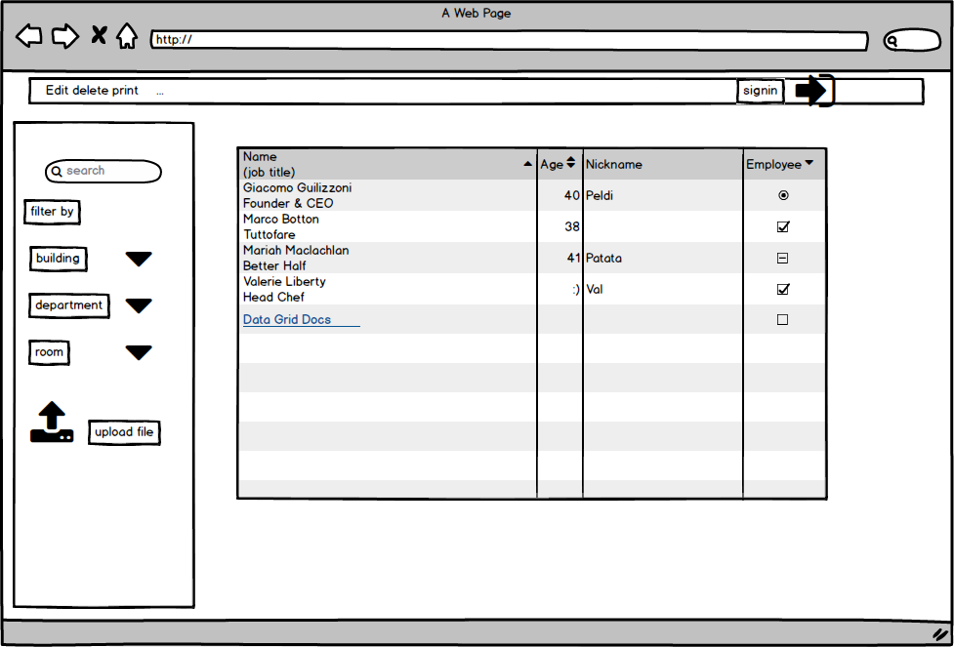

**Database Schema**

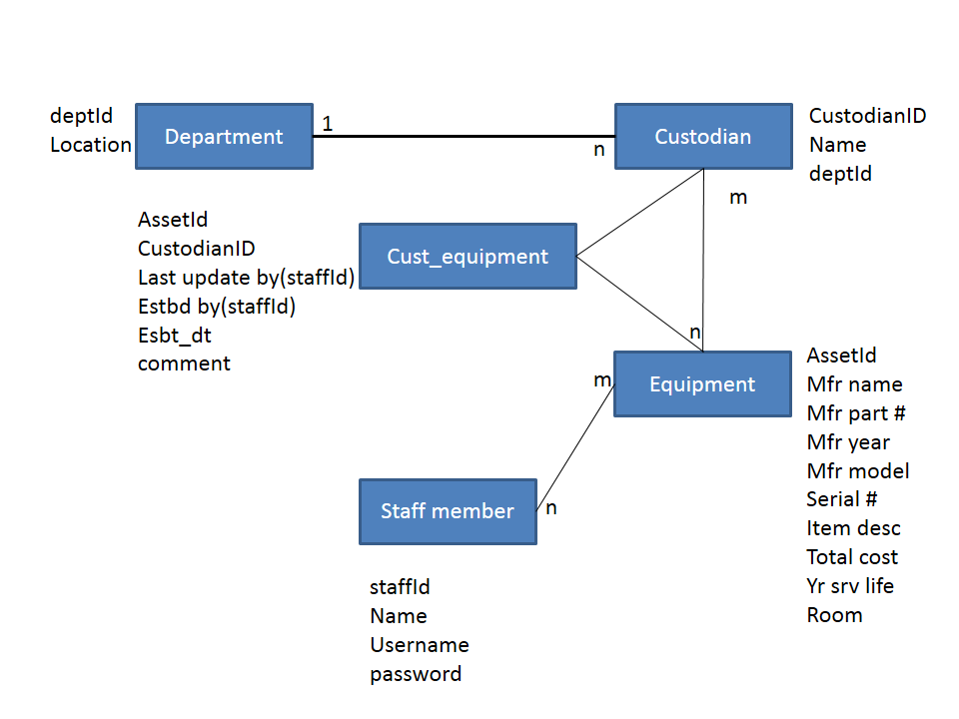

**Screen shot**

