Dr. Joel Slade  
California State University Fresno  
Department of Biology  
2555 E San Ramon Ave.  
M/S SB73  
Fresno, CA 93740

May 29, 2024

Dear Dr. Irene Newton,

We are excited to submit an original research manuscript entitled “16S rRNA Gene Sequencing of Microbiota from the Preen Oil and Cloaca of Chipping Sparrows (*Spizella passerina*)” to *Microbiology Resource Announcements*. This is original work that has not be published or under consideration elsewhere.

This article is relevant to *Microbiology Resource Announcements* as it presents the 16S rRNA gene sequencing of a non-model system. Avian microbial ecology is a growing area of study and adding additional data to the field will provide the opportunity for other interested researchers to work with data in an understudied species, the chipping sparrow.

The results of our study are important for future interspecific comparative studies. These data can provide information on the role of microbial communities in avian chemical communication through preen oil and how the gastrointestinal microbiome can change based on diet, migration, and myriad other ecological and environmental factors. While we observed similarities in microbial communities between the preen oil and cloaca samples, having these data available can allow the avian microbial ecology community the ability to analyze these data in different ways, answering a variety of questions relevant to the field. We believe this makes our manuscript a suitable candidate for publication in *Microbiology Resource Announcements*.

We have no conflicts of interest to declare.

Please address correspondence concerning this manuscript to me (joelslade@csufresno.edu).

Thank you for your consideration of this manuscript.

Sincerely,

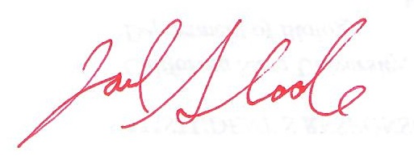

Dr. Joel Slade