Họ và tên: Nguyễn Đức Thành
Mã sinh viên: B21DCCN114
Lớp: E21CNPM02

Question 1:

- Use case diagram for module 1
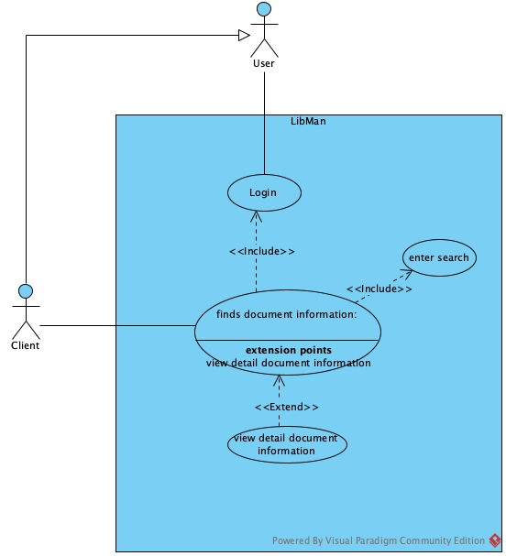

- Use case diagram for module 2
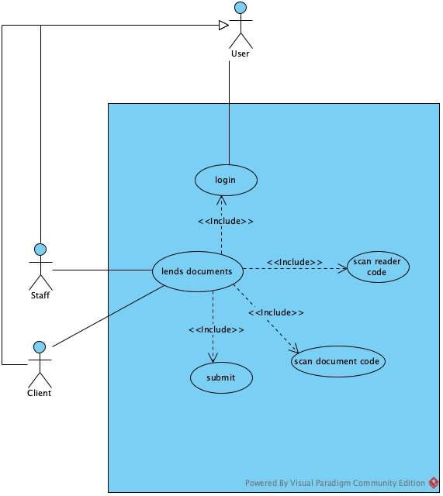

- Module 1

Scenario | Reader finds document information
Actor | Client
Pre-condition | Client has an account
Post-condition | Client view document information
Main events | - ClientA logins with account username=userA, password=1234  - The main client home page appears with option to find documents information  - The client click on button find documents information  - The system display the interface for find documents with:  - A search bar  - A search button  - A result table  - Client enter documents’ name and click search  - The system displays the result in the result table  - The client click on a row to view document detail information  - The system display the interface of the document detail page with:  - Document detail information  - Back button
Exceptions | 2. The system display error message: login failed! Wrong username/password  2.1 The client click on OK button on the message  2.2 The system return to the login interface  2.3 The client change the password to 12345 and click login  2.4 The main interface of client home page appear (step 2)  6. The system display message: no documents found  6.1 The client clicks on OK button on the message  6.2 Back to step 5

- Module 2

Scenario | Library staff lends documents to readers
Actor | Staff, Client
Pre-condition | Staff has an account with role Staff
Post-condition | Staff lends the documents to reader successfully
Main events | - StaffA logins with account username=staffA, password=1234  - The main staff home page appears with option to lend documents  - The staff click select to lend documents  - The system display interface of scan reader card page with:  - A textbox of reader card code input  - A Search button  - Table for displaying result  - The staff ask the reader to provide the reader card  - The client give the card to the staff  - The staff enter the code to the input and click search  - The system show result to the table  - The staff click on the client information on the table  - The system display interface of lend documents page with:  - A textbox of document code input  - An add button  - Table for displaying to be lent documents  - A Confirm button  - The staff ask the client for list of documents the client want to borrowed  - The client provide information to the staff  - The staff enter the document code and click add  - The system display the borrowed document added to the table  - The staff click on confirm  - The system display success message
Exceptions | 2. The system display error message: login failed! Wrong username/password  2.1 The staff click on OK button on the message  2.2 The system return to the login interface  2.3 The client change the password to 12345 and click login  2.4 The main interface of staff home page appear (step 2)  14. The system display message: document out of stock!  14.1 The staff click on OK button on the message and inform to the client that the document is unavailable  14.2 Go back to step 13

Question 2:

- User(username, password, role, fullName)
- Client(age, gender, phone, cardCode)
- Staff()
- Documents(name, code, yearPublished, description)
- Author(name, description)
- Loan(loanDate, expectedReturnDate, actualReturnDate)
- LoanDocument(status)

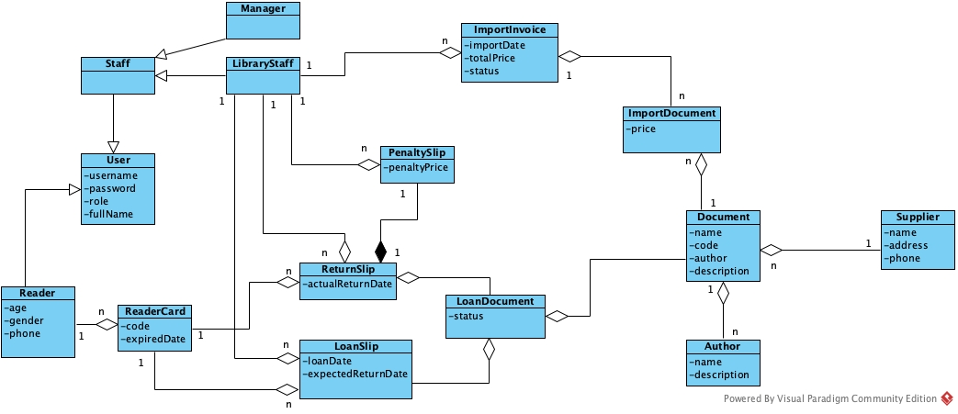

Question 3:
- A
- Module 1:
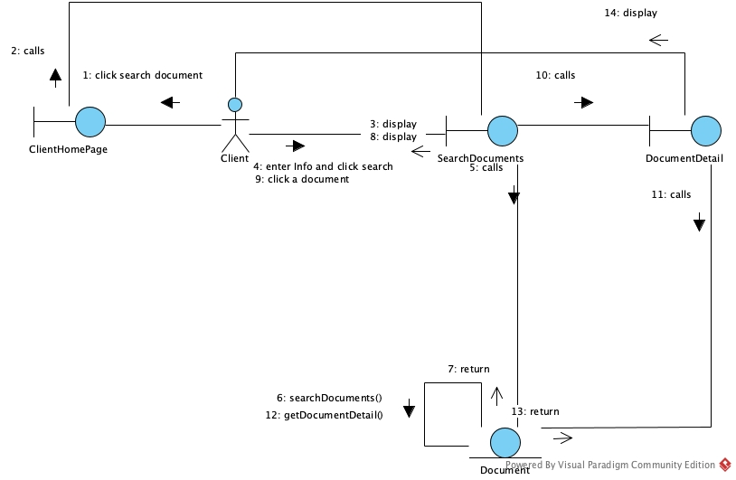

- Module 2
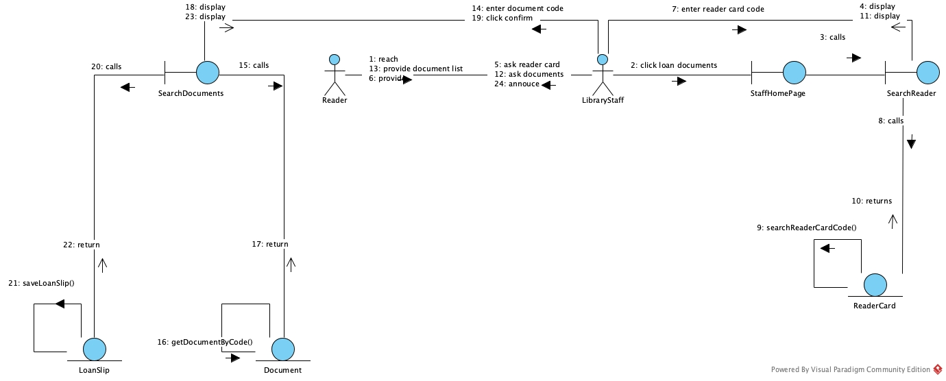

Question 4:
