Họ và tên: Nguyễn Đức Thành
Lớp: E21CNPM02
MSV: B21DCCN114

Câu 1:
- Usecase
- Module 1:
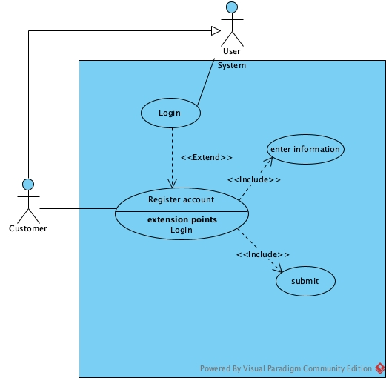
- Module 2:
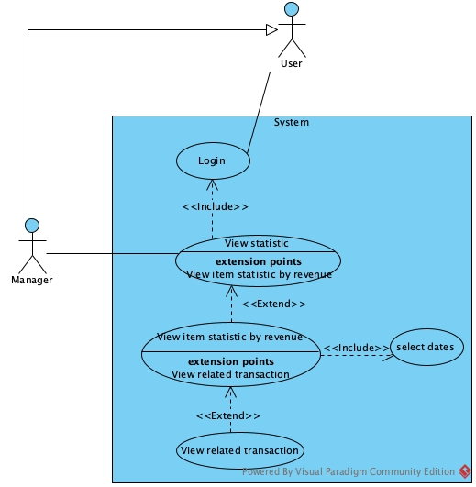
- Scenario
- Module 1:
Scenario | Customer registers as a member
Actor | Customer
Pre-condition | Customer had no account
Post-condition | Customer has a new customer account
Events | - Customer A access the system  - The system display interface of guest page with a selection to register account  - The customer select to register account  - The system display register account interface with:  - Username text field  - Password textfield  - Fullname textfield  - Address textfield  - Phone textfield  - A register button  - The customer enter all information and click register  - The system announce success to the customer
Exception | 5. The system display error message: username have been used by another account  5.1 The customer click OK on the message  5.2 The system returns to register account interface  5.3 The customer choose another username and click register  5.4 Return to Step 6

- Module 2:
Scenario | Management staff views item statistics
Actor | Manager
Pre-condition | Manager has logged in an account with role Manager
Post-condition | Manager view statistic
Events | - Manger A select the view item statistic on the manager home view  - The system display the main interface of search item statistics page with:  - A start date input  - An end date input  - A search button  - A result table  - A return button  - The manager choose Startdate=10/12/2024 and enddate=17/12/2024 and click search  - The system display the result in the table:  - The manager clicks on rice row to view detail  - The system display detail statistic page interface with:  - Item detail information  - A table of list of each transaction  - A back button  - The manager click back button  - The system return to the search item statistic page with previous data  - The manager clicks on return  - The system display the main manager home page
  ID | Name | Price | Unit | Quantity | Total
  1 | Rice | 20.000đ | kg | 50 | 1.000.000đ
  2 | Pork Belly | 130.000d | kg | 200 | 26.000.000
  3 | Carrot | 10.000đ | fruit | 50 | 500.000
  ID | Date | Customer | Customer’s Phone | Quantity | Total
  1 | 11/12/2024 | Nguyen A | 0934254872 | 10 | 200.000
  2 | 12/12/2024 | Le Thi B | 0943275895 | 20 | 400.000
  3 | 15/12/2024 | Nguyen Duc T | 0938754825 | 20 | 400.000
Exception

Câu 2:
- Entity extract
- User(username, password, role, fullName)
- Manager()
- WarehouseStaff()
- Saler()
- Customer(age, phone)
- Item(name, price, unit)
- Supplier(name, phone)
- ImportInvoice(date, totalPrice)
- ImportItem(ammount, importPrice)
- Invoice(date, totalPrice)
- Cart(date, totalPrice)
- CartItem(quantity)
- Entity class
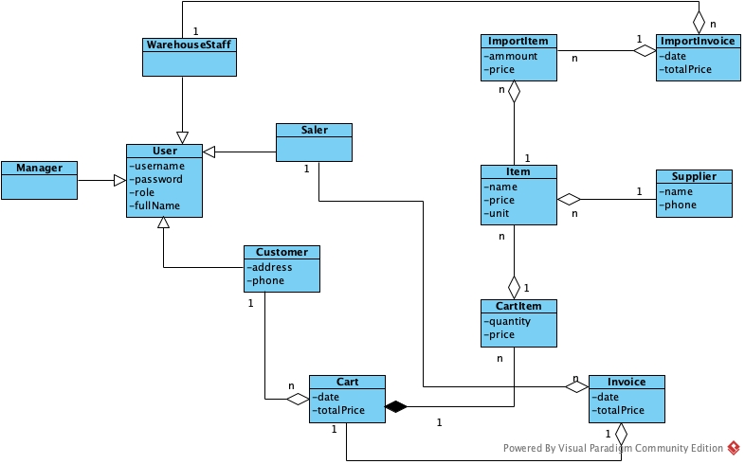
Câu 3:
- Comunication Diagram

- Full class

Câu 4:
- Database
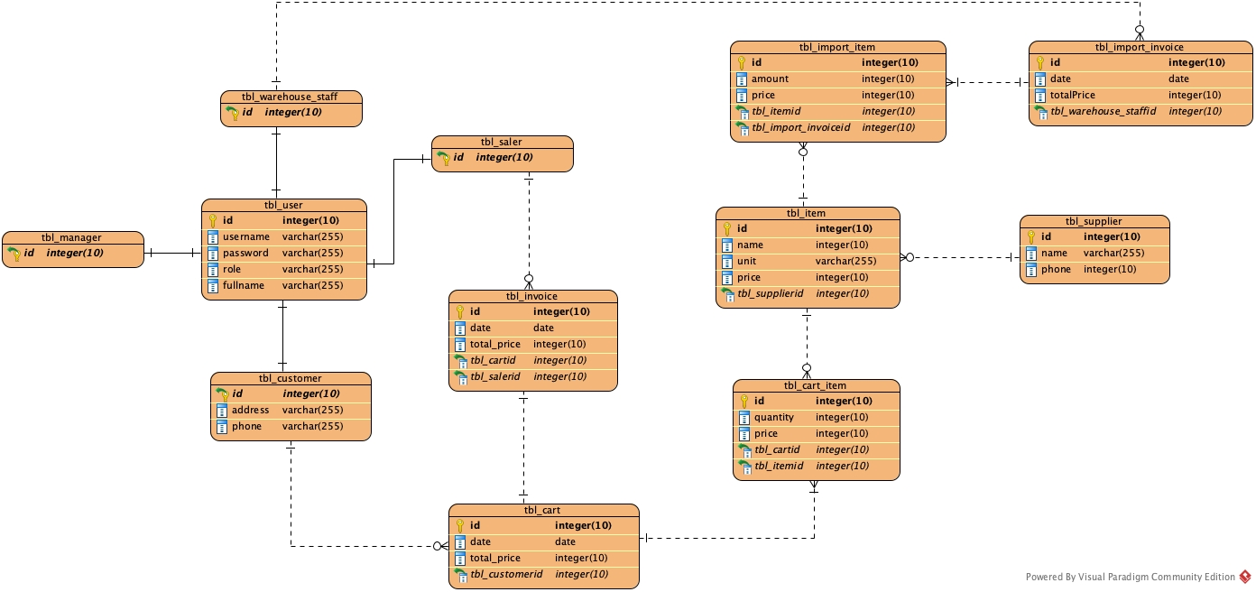
- Java code

Câu 5:

