Họ và tên: Nguyễn Đức Thành
Lớp: E21CNPM02
MSV: B21DCCN114

Câu 1:
- Usecase
- Module 1:
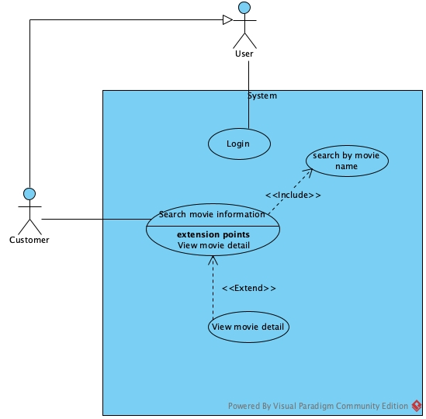
- Module 2:
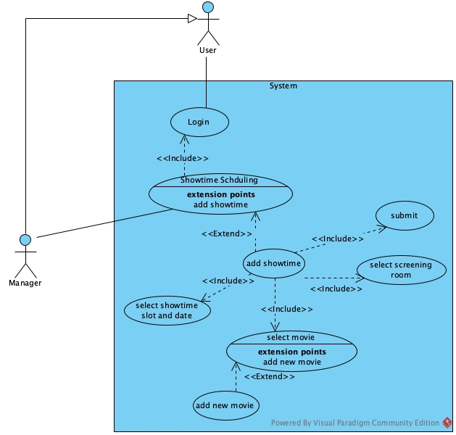
- Scenario
- Module 1:
Scenario | Customer search for movie information
Actor | Customer
Pre-condition | Customer has logged in a customer account
Post-condition | Customer view movie information
Events | - Customer select find movie on customer home page  - The system display the interface of find movie page  - A text search bar  - A search button  - A result table  - A return button  - The customer enter movie name=”Dune” and click search  - The system display search result in the table:  - The customer click on “Dune 1” row  - The system display movie detail interface:  - A Back button  - The customer clicks on back button  - The system return to movie search interface with previous data  - The customer clicks on return button  - The system display customer home screen
  ID | Name | Length | Genre | Restriction | Rating
  1 | Dune 1 | 120 | Action | R18 | 9.0
  2 | Dune 2 | 130 | Action | R18 | 9.2
  Name | Dune 1
  Length | 120
  Genre | Action, Science
  Restriction | R18
  Rating | 9.0
  Description | Dune 1 Description
  Author | John
Exception | 4. The system display error message: No movie name “Dune” found  4.1 The customer clicks on OK button on the message  4.2 The system display interface of find movie page  4.3 The customer enter movie name=”Captain America”  4.4 Return to step 4

- Module 2:
Scenario | Showtimes scheduling
Actor | Manager
Pre-condition | Manager has logged in a manager account
Post-condition | Showtimes schedule save to the database
Events | - Manager A clicks select showtime management menu on the manger home page  - The system display the show time managent menu page with option to add more showtime  - The manager select add more showtime  - The system display the interface of select screening room page with:  - Date dropdown input  - Timeslot dropdown input  - A Search button  - A result table for displaying screen room list  - A next button  - A return button  - The customer choose a date=02/01/2024 in the date dropdown input  - The system show all available timeslot in the selected date in the timeslot dropdown input  - The customer choose timeslot=12:00 and click search  - The system display available screening room in the table:  - The manager clicks on room 101 and click Next  - The system display select movie page with:  - A search bar  - A search button  - A result table  - An add new movie button  - A next button  - A back button  - The manager type moviename=”Dune” and click search  - The system display result in the table:  - The manager clicks on Dune 2 row and click next  - The system display confirmation page  - Date: 02/01/2025  - Timeslot: 12:00  - Movie: Dune 1  - Room: 101  - A confirm button  - A back button  - The manager clicks on confirm button  - The system display success message and return to manager home page
  ID | Room | Capacity
  1 | 101 | 50
  2 | 103 | 60
  ID | Name | Length | Genre | Restriction | Rating
  1 | Dune 1 | 120 | Action | R18 | 9.0
  2 | Dune 2 | 130 | Action | R18 | 9.2
Exception | 12. The system display message: no movie found  12.1 The manager clicks OK on the error message  12.2 The system returns to select movie page  12.3 The manager select add movie button  12.4 The system navigate to add movie usecase

Câu 2:
- Entity extract
- User(username, password, role, fullName)
- Customer(age, phone, address)
- Manager()
- Saler()
- MembershipCard(value, expiredDate)
- Movie(name, length, restriction, rating)
- Genre(name, description)
- MovieGenre()
- Room(name, capacity)
- Timeslot(time)
- ShowtimeSlot(date, type)
- Seat(name, type)
- Ticket(price)
- Invoice(date, totalPrice)
- Entity class
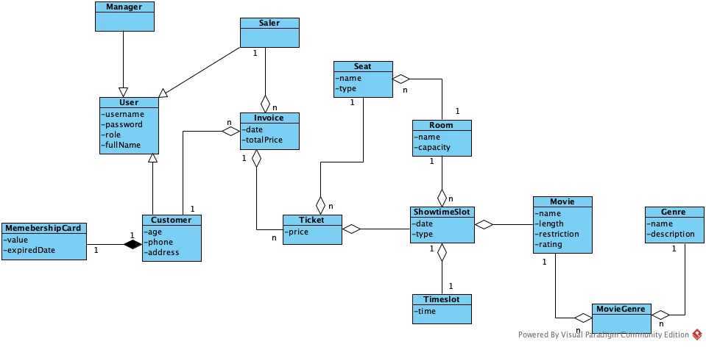
Câu 3:
- Comunication Diagram
- Full class

Câu 4:
- Database
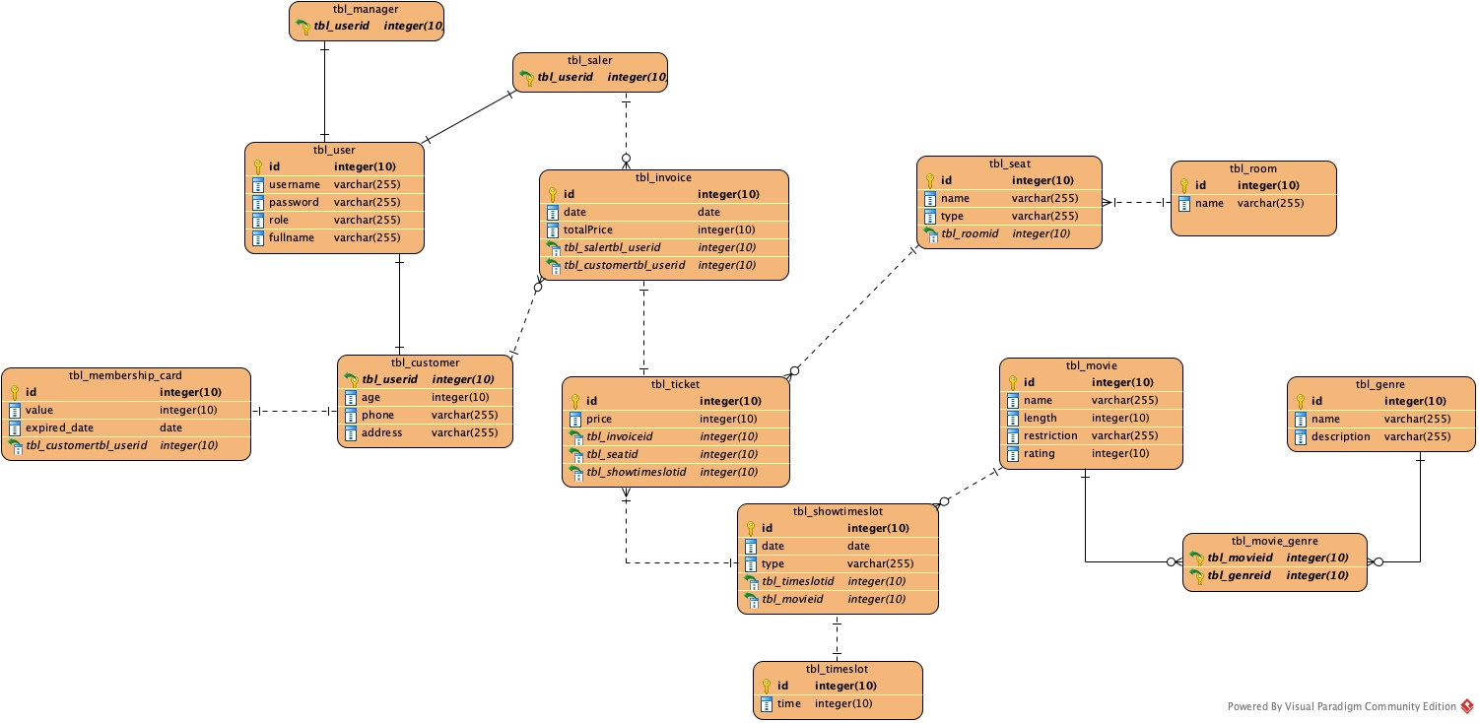
- Java code

Câu 5:

