Họ và tên: Nguyễn Đức Thành
Lớp: E21CNPM02
MSV: B21DCCN114

Câu 1:
- Usecase
- Module 1:
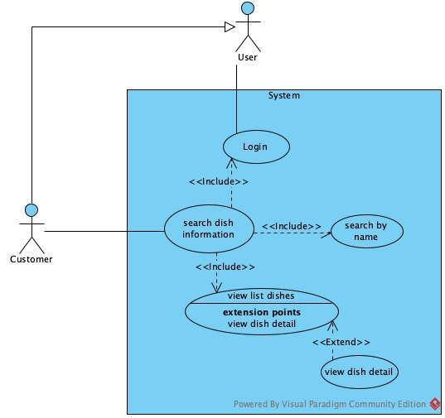
- Module 2:
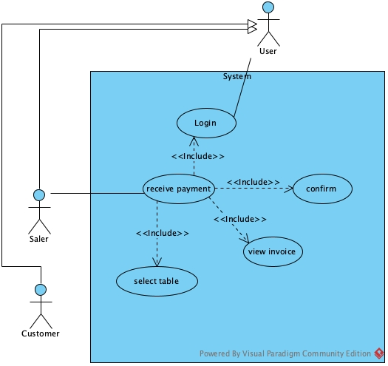
- Scenario
- Module 1:
Scenario | Customer searches for dish information
Actor | Customer
Pre-condition | Customer has logged in a customer account
Post-condition | Customer view dishes information
Events | - Customer select find dish information option on the customer home screen  - The system display search dish page interface with  - A text input  - A search button  - A result table  - A return button  - The customer enter dish name=”Chicken” and click search  - The system display results in the table:  - The customer clicks on the first row of the result table  - The system display the detail page interface contains dish information:  - Name: Fried Chicken  - Price: 100.000  - Unit: 1 half  - Description: abcd  - A back button  - The customer clicks on back button  - The system return to search dishes interface with previous data  - The customer clicks on return button  - The system return back to the customer home page
  No | Name | Price | Unit
  1 | Fried Chicken | 100.000 | 1 half
  2 | Fried Chicken | 180.000 | 1 whole
Exception | 4. The system display error message: No dish found  4.1 The customer clicks on OK button on the message  4.2 The system return back to the search dishes interface  4.3 The customer reenter name=”Fish”  4.4 The system display results in the table  4.5 Return to step 5
  No | Name | Price | Unit
  1 | Grilled Fish | 200.000 | dish

- Module 2:
Scenario | Sale staff receives payment
Actor | Saler, Customer
Pre-condition | Saler logged in with a saler account
Post-condition | Saler finish payment process, save invoices to the database
Events | - The saler A select the payment menu on the saler home page  - The system display search table interface with:  - A text input  - A search button  - A result table  - A return button  - The saler enter tableName=2 and click search  - The system display result in the table:  - The saler clicks on the first row of the table  - The system display the invoice of the table:  - Datetime: 19:00 24/12/2024  - Customer: Nguyen Van A  - Customer’s Phone: 0906227798  - Number of customer: 3  - Items:  - Total price: 800.000  - A confirm button  - A back button  - The saler show the invoice to the customer and ask for confirmation and payment  - The customer pay to the saler  - The saler clicks on confirm button  - The system announce succeed and print invoice  - The saler annouce and give invoice to the customer
  No | Name | Start Time | Number of customer
  1 | 2 | 19:00 24/12/2024 | 4
  2 | 20 | 20:00 24/12/2024 | 5
  No | Name | Type | Quantity | Unit price | Total
  1 | Fried Chicken | Dish | 1 half | 100.000 | 100.000
  2 | Grilled Fish | Dish | 1 dish | 200.000 | 200.000
  3 | Combo A | Combo | 1 | 500.000 | 500.000
Exception | 4. The system display error: No table found  4.1 The saler clicks on OK button on the message  4.2 The system return to search table interface  4.3 The saler enter tableName=3 and click search  4.4 The system display search results in the table:  4.5 Return to step 5
  No | Name | Start Time | Number of customer
  1 | 3 | 19:32 24/12/2024 | 2

Câu 2:
- Entity extract
- User(username, password, role, fullName)
- Manager()
- WarehouseStaff()
- Saler()
- Customer(address, phone)
- Dish(name, price, unit, description)
- Combo(name, price)
- Supplier(name, phone)
- Material(name, unit)
- DishMaterial(description)
- ImportMaterial(ammount, price)
- ImportInvoice(date, totalPrice)
- Table(name, capacity)
- BookedTable(startTime, numberOfCustomer)
- BookedDish(ammount, price)
- BookedCombo(ammount, price)
- Invoice(date, totalPrice)
- MembershipCard(value, expiredDate)
- Entity class
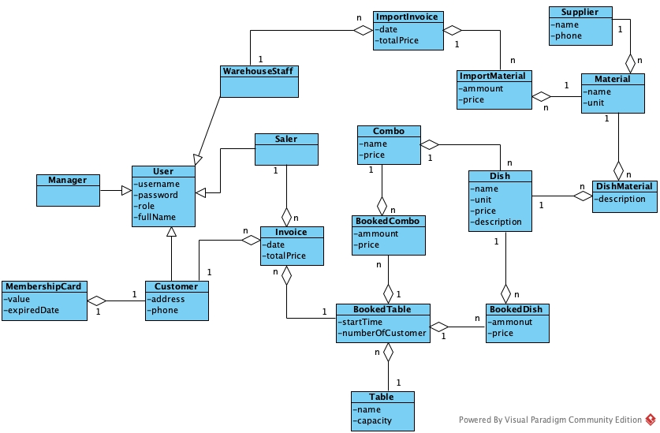
Câu 3:
- Comunication Diagram
- Full class

Câu 4:
- Database

- Java code

Câu 5:

