Họ và tên: Nguyễn Đức Thành
Lớp: E21CNPM02
MSV: B21DCCN114

Câu 1:
- Usecase
- Module 1:
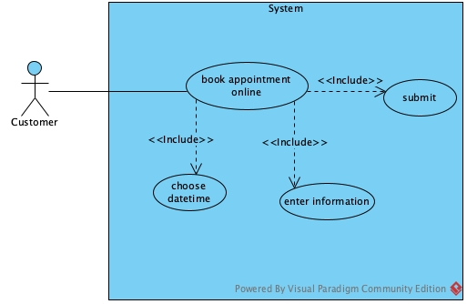
- Module 2:
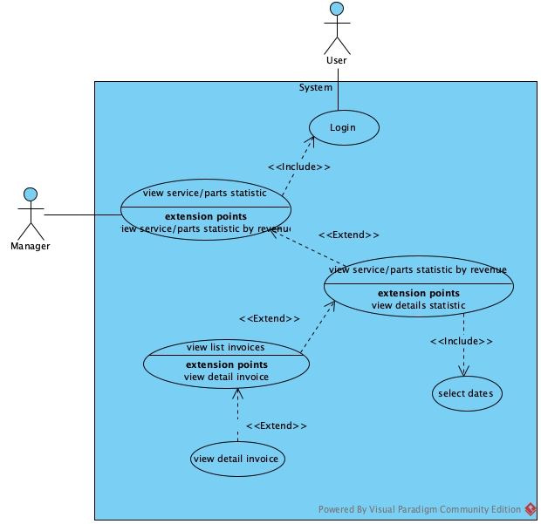
- Scenario
- Module 1:
Scenario | Customer books an appointment
Actor | Customer
Pre-condition | Customer access the application
Post-condition | Customer book appointment successfully
Events | - The customer select book appointment on the customer home page  - The system display the select datetime page with:  - A datetime input  - A name input  - A phone input  - A text input for notes  - A submit button  - The customer select datetime=09:00 03/01/2025, enter name=A, phone=093495482, notes=”car does not work” and click submit  - The system display a confirmation page with all the information the customer have entered and a submit button  - The customer clicks on submit button  - The system show message message
Exception

- Module 2:
Scenario | Manager views service/parts statistic
Actor | Manager
Pre-condition | Manager has logged in with a manager account
Post-condition | Manager view statistic
Events | - The manager select to view statiscal report on the manager home page  - The system display view statiscal report page with option to view service/parts statistic by revenue  - The manager select to view service/parts statistic by revenue  - The system display view statistic by revenue page with:  - A start date input  - A end date input  - A search button  - A result table  - A return button  - The manager select startdate=10/12/2024, endate=14/12/2024 and click search  - The system display the search result to the table  - The manager clicks on Wash car row  - The system display list invoices page with  - Table of all invoice related to the service  - A back button  - The manager clicks on the first row to view the detail of the first invoice  - The system display the detail invoice interface:  - Date: 11/12/2024  - Customer: Nguyen Van A  - Sale Staff: Le Duc Hieu  - Technical Staff: Nguyen Duc Minh  - Services:
  No | Name | Total
  1 | Change tire | 15.000.000
  2 | Wash car | 200.000
  No | Date | Customer | Total Price
  1 | 11/12/2024 | Nguyen Van A | 100.000
  2 | 12/12/2024 | Nguyen Van B | 100.000
  No | Name | Quantity | Unit price | Total
  1 | Wash car | 1 | 100.000 | 100.000
Exception

Câu 2:
- Entity extract

- Entity class

Câu 3:
- Comunication Diagram
- Full class

Câu 4:
- Database

- Java code

Câu 5:

