Mr. Mike Wallace

Professor – GISC9305 February 9, 2016  
Niagara College GISC-9305-D1  
135 Taylor Road  
Niagara-on-the-lake, ON  
L0S 1J0

Dear Mr. Wallace   
 **RE: Submission: GISC9305-D1**

Please accept this letter as our formal submission of Assignment one: GISC9305-D1– CAD and GIS for Travis Vanos. The works were completed with AutoCAD, for required deliverables. The purpose of this assignment is to add a new subdivision development to an existing parcel land base of the City of St. Catharines and create a single line road network with object data containing address information for the streets covered by the drawing. The updated drawing will be in a ‘ready state to export to other GIS formats. The requirements have been met along with the provided drawings. The following procedures to be covered include, but are not limited to:

* To gain a basic practical familiarity with COGO
* To demonstrate an ability to create definition files
* To demonstrate an ability to create and assign Object Classes
* To demonstrate an ability to clean up a drawing
* To demonstrate an ability to create a Layout

Following the assignment procedures, please find the required material attached. Should you have any questions regarding the enclosed documents, please contact Travis Vanos at your convenience at [travis.vanos@gmail.com](mailto:travis.vanos@gmail.com). I eagerly await your comments and suggestions.  
  
Sincerely,

Travis Vanos   
 GIS/GM Candidate, Niagara College  
 T. V.

Enclosures: VanosTGISC-9305-D1.docx

**Technical Memorandum**

|  |  |  |
| --- | --- | --- |
| **Project:** | COGO, Object Classification and Map Standards | |
| **Client:** | Mike Wallace | **Prepared By:** Travis Vanos |
| **Subject:** | ***Subdivision Analysis (Tuscany Court, St. Catharines, ON)*** | |
| **Date:** | February 9, 2016 | GISC9305-D1 |

1. Introduction

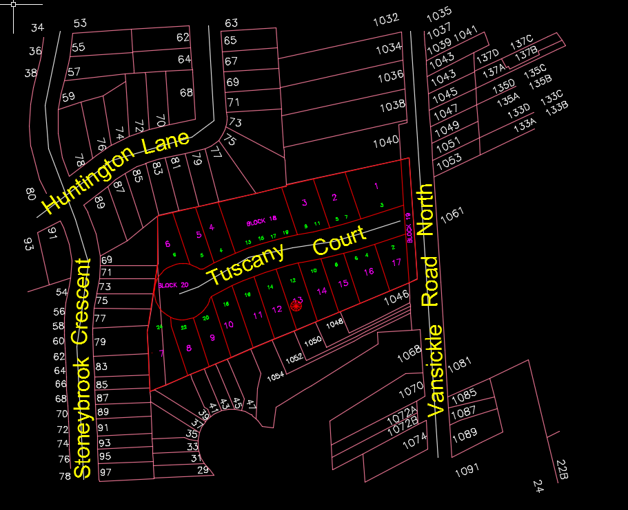This Technical Memorandum is to present the findings and final drawings of the Tuscan Court subdivision completed in AutoCAD. The goal of this assignment is to derive a working ability to report using COGO. An adequate and accurate drawing was created. In this Technical Memorandum, a new subdivision development is added to an existing parcel land base of the City off of St. Catharines and create a single line road network with object data containing addresses.

Figure 1 Tucany Court Subdivision

2. Methodology

The provided base map, Base Drawing GISC9305D1 W16, was brought into AutoCAD and kept in the current projection (NAD 1983 UTM Zone 17). After the base map was opened in the AutoCAD program layers were created in order to properly display the subdivision addition. Layers were created as well as a kept “Unused layer. The layers include: Address, Street Name, Parcel, New Parcel, Lot Number and, Street Single Line. All layers have been assigned appropriate colours for interpretation.

2.1 COGO

The image 30M_409 (field drawing of the Tuscany trail addition) was given, this provided detailed information on the eastings and northings of the benchmark that first needed to be created. In addition, the lines were added with their corresponding directional values as such:

@12.986<s67d08'53"w

@20.793<s67d08'53"w

@14.678<s67d08'53"w

Depending on the direction of the line segment, the directions are adjusted from either east to west or north to south. All line segments were completed first before adding in the arcs of the roadway of Tuscany Court.   
  
 To complete the roads, ‘start end radius’ tool was used within the arc drop down menu. Using the start and end points and placing in the r value the arcs were added depending on the direction of the arc. The start, end tool can be seen in Figure 2.   
  
 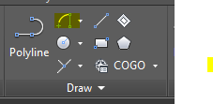

Figure 2 Arc, Start, End Tool

For arcs that did not span two points lines were made first with the directional value and then the arcs were created for the line’s start and end point.   
  
  
  
  
 2.1 Labelling and Parcel Creation

As opposed to traditional labeling, the labels were created for all roads were created by referencing the Single Street Line layer. Using dynamic labeling, first the templates needed to be defined. The command ‘MAPANNTEXT’ was invoked to reference the Street name, Street Suffix and Street Direction for dynamic labeling. Once completed, the block was saved. In the model view, the labels were added using insert and selecting the proper street line. Dynamic labeling provided the proper street name, suffix and direction for each road depending on the added data attached to each Street Line. The object data can be seen in **Figure 3**.  
  
 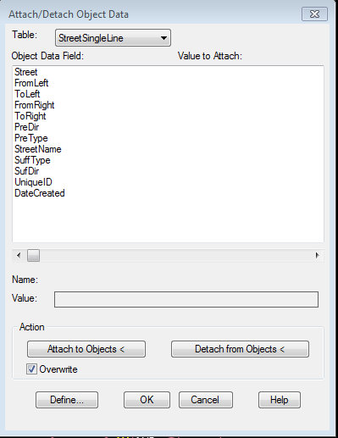

Figure 3 Object Data

After, the metadata can be called by classifying all similar objects and collecting there data into one metadata sheet. The (4) Single Street Line polylines were grouped and classified together.   
  
 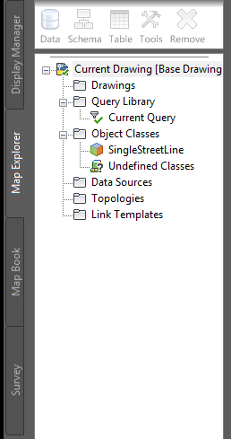

Figure 4 Object Classes

3. Object Class Metadata

Object classes were created and the metadata viewed. The purpose of which would be to hold all of the metadata needed for the report and the street single line data that needs to be attached. Although the full report has been attached in a formal email, an example of the full XML Metadata Report can be seen in **Figure 5.**

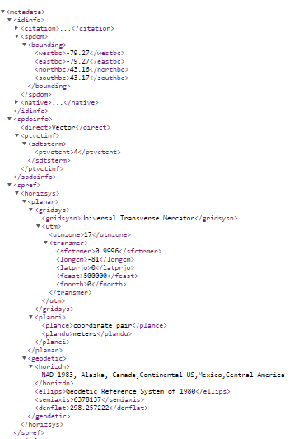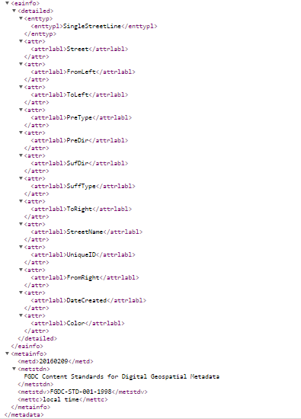

Figure 5 Full XML Metadata Report

4. Conclusion

The main goal of the Technical Memorandum was to complete the Tuscany Court sub-division drawing in AutoCAD from paper. The findings have been presented and a completed map can be seen in **Appendix I**. Assuming the provided surveying drawing is the most accurate, some line segments created left breaks, and these needed to be addressed using the clean-up drawing tool. In addition, the original drawing was difficult to interpret as color choices and sizing were unformatted. Use of more layers and complimenting colours need to be utilized in the future. Furthermore, this project involved many layers and additional data, this caused difficulties for AutoCAD to allocate memory and render models. AutoCAD has proven to be an extremely powerful tool and can be modified and corrected as the years progress. The process of transferring these paper drawings and be seen as a tedious and drawn out one, but necessary.