Mr. Mike Wallace

Professor – GISC9305 March 9, 2016  
Niagara College GISC-9305-D2  
135 Taylor Road  
Niagara-on-the-lake, ON  
L0S 1J0

Dear Mr. Wallace   
 **RE: Submission: GISC9305-D2**

Please accept this letter as our formal submission of Assignment two: GISC9305-D2– Feature Sources / Map Output for Travis Vanos. The works were completed with AutoCAD Map 3D, for required deliverables. The purpose of this assignment is to create and develop an Auto CAD Map drawing using Feature Sources in layout view and in MapBook format. The updated map design will be printed and delivered attached to this letter. The following procedures to be covered include, but are not limited to:

* To gain a basic practical familiarity with Using Raster Images
* To gain a basic practical familiarity with Connecting to Features
* To gain a basic practical familiarity with Styling Images
* To publish a Map Book

Following the assignment procedures, please find the required material attached. Should you have any questions regarding the enclosed documents, please contact Travis Vanos at your convenience at [travis.vanos@gmail.com](mailto:travis.vanos@gmail.com). I eagerly await your comments and suggestions.  
  
Sincerely,

Travis Vanos   
 GIS/GM Candidate, Niagara College  
 T. V.

Enclosures: VanosTGISC-9305-D2.docx

**Technical Memorandum**

|  |  |  |
| --- | --- | --- |
| **Project:** | GISC9305-D2 – CAD and GIS | |
| **Client:** | Mike Wallace | **Prepared By:** Travis Vanos |
| **Subject:** | Feature Sources / Map Output | |
| **Date:** | March 9, 2016 | GISC9305-D2 |

1. Introduction

This Technical Memorandum is to present the findings and map documents for the completed map design for the Elevation of the Redding Region, California in AutoCAD Map 3D. The goal of this assignment is to derive a working ability to attach various feature sources and display the output accurately on a map using AutoCad Map 3D. An accurate map with all cartographic elements drawing was created and attached in Appendix I. In this Technical Memorandum, a new Auto CAD Map drawing using Redding Area DEM (Digital Elevation Model) in layout view and in MapBook format.

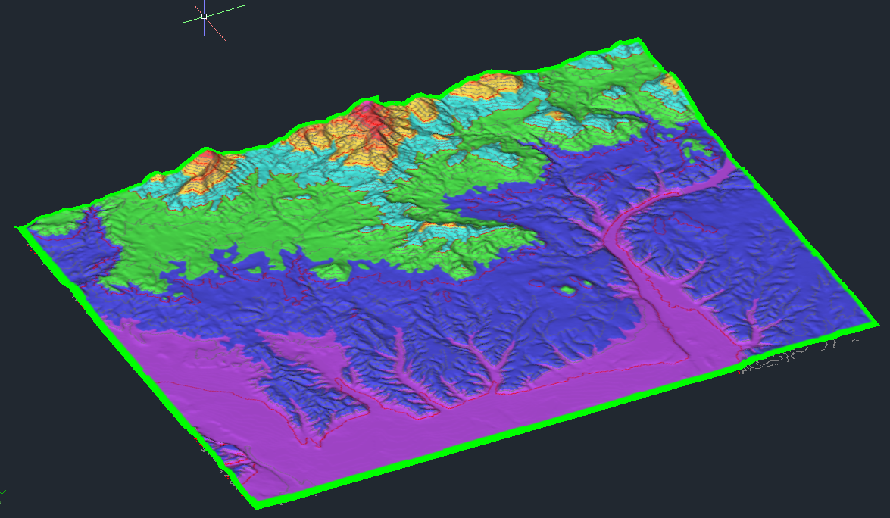

Figure Redding Area DEM with Contour Lines

2. Methodology

The provided DEM Raster image was brought into AutoCAD and assigned the projection of (the NAD27 California State Planes, Zone 1(401) US Foot). Connected as a data source, the raster was opened in the AutoCAD, the view was then switched to the 3D layout to display the 3D attributes visually. A modest exaggeration of 2.25x was used to display the features to some degree of accuracy. The heights of the raster were then divided into 16 level ranging from 0 – 605 for the maximum exhibited elevation.

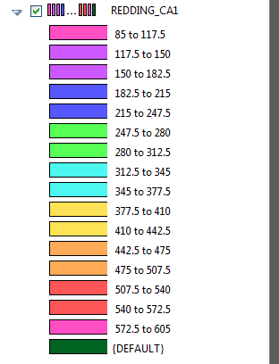

Figure Graticule of DEM heights in Raster

2.1 Contour line Creation

To further increase readability to the DEM model provided, contour lines were added to the image and every 4th contour line was marked as a major contour line. To accurately coincide with the graticule scale for elevation, contour lines were marked at 32.5 ft to provide inline accuracy with the colour scale provided.

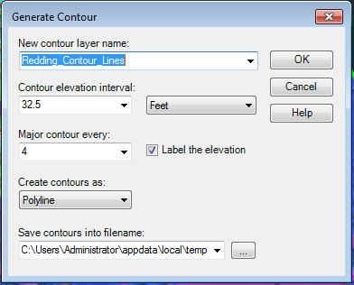

**Figure 3 Contour line creation at specified height**

The resulting contour lines display the elevation change ideally.

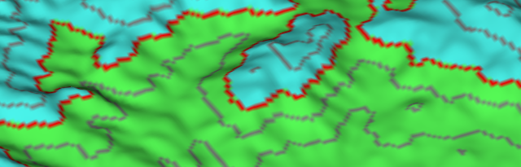

**Figure 4 Contour lines displayed at significat elevation marks**

2.2 Hillshade

To generate the hillshade for the 3D model, the MAPHILLSHADE command was invoked and the settings for the model the then imported to give accurate shading.

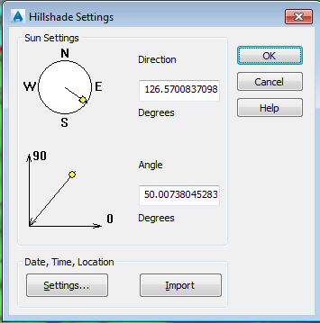

Figure MAPHILLSHADE Settings for DEM

2.3 Road Layer

The road layer was then connected as an SDF data source to be viewed with the drawing.

Figure 6 Road layer as SDF connection

After, the Redding road layer was added on top of the DEM Raster, the vector layer needed to be added on top of the 3D model. Re-drawing or re-ordering the road layer on top of the Raster image results in AutoCAD automatically draping the vector layer over the raster image set to the current extents.   
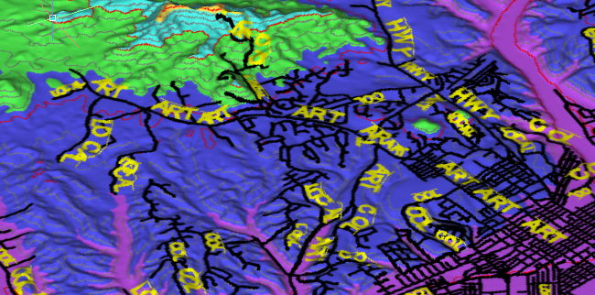

Figure Object Classes

With a hectiv layer, the drawing is cluttered with the road layer at its default. The road were required to stand out so a thicker black line was used. To style the road labels, two rules were created visible for 0:0 to 1:3000 scale ratio and 1:3000 to infinity. Visible from 1:3000 to infinity the ST_Type field was used and ART, HWY, FWY, COL types are displayed. Below 1:3000, the ST_TYPE field ID resized for the map scale. The following suffixes are used for labeling: LOCAL, PVT ROAD, ART, HWY,FWY,COL.

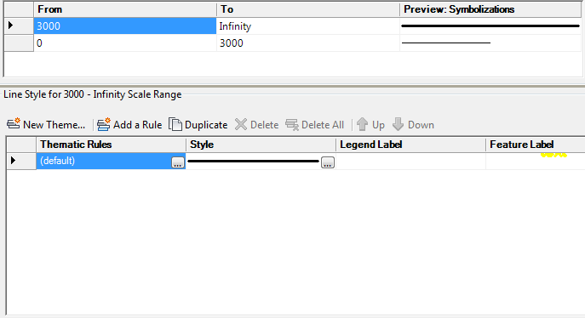

Figure Two viewing ranges from 0 - 3000 and 3000 to infinity

Additionally, labels are not required for UNK or ALLEY Street types so a conditional statement was made to assign no colour to them.

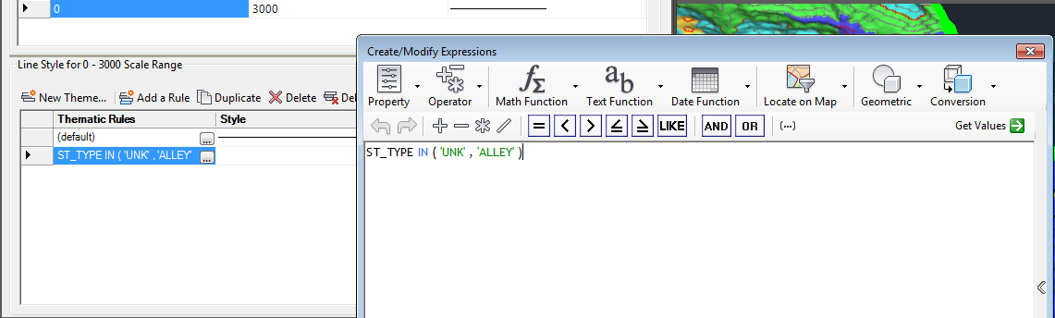

Figure Conditional labelling for 'UNK' and 'ALLEY'

2.4 MAPPING 3D model in Layout view

For learning purposes, AutoCAD was used, solely, to generate a map using the features created in previous steps with all cartographic characteristics. The completed map layout can be seen in Figure 10.

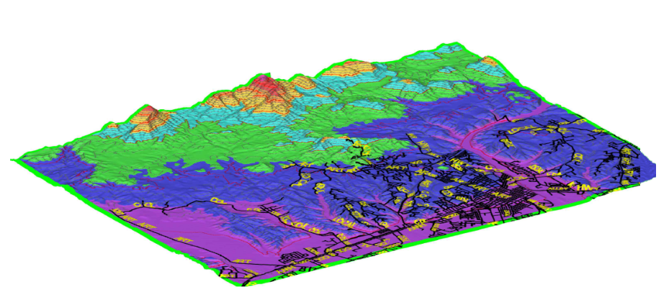

Figure Elevation of Redding Region, California

3. Conclusion

The main goal of the Technical Memorandum was to complete the 3D model of the Redding Region using the provided data sources and DEM (Digital Elevation Model). The findings have been presented and a completed map can be seen in Appendix I. The goal of this assignment was to derive a working ability to attach various feature sources and display the output accurately on a map using AutoCAD Map 3D. Furthermore, this project involved draping map layers over the DEM that AutoCAD is theoretically to do automatically, which, unfortunately, it did not. In closing, AutoCAD Map 3D can prove to be a powerful cartographic tool, but is lacking usability in map creation and editing and would be used alongside other editing tools.

