

Travis Vanos March 22, 2016

# GISC935-D3

# AutoCAD Source Drawing Queries / Reporting

 

Mr. Mike Wallace

Professor – GISC9305 March 22, 2016  
Niagara College GISC9305-D3  
135 Taylor Road  
Niagara-on-the-lake, ON  
L0S 1J0

Dear Mr. Wallace   
 **RE: Submission: GISC9305-D3**

Please accept this letter as our formal submission of deliverable 3: GISC9305- Source Drawing Queries / Report for Travis Vanos. The works were completed with AutoCAD Map 3D with the goal to derive a working ability to report upon the collection of geospatial data and querying of data in a useful manner. The City of Springfield has been conducting an ongoing sanitary sewer inspection and maintenance program for a number of years. The town has had the sanitary sewers inspected for this area and the results indicate the concrete sewers require re-lining and the vitreous clay sewers require replacement.

The sanitary sewer concrete pipes are estimated to cost $102,335.38 and the clay sewers pipe replacements will cost approximately $259,391.16 and finally, the defective PVC piping will cost $105,555.51 for a total of **$437,363.60.** The following will be presented, but not limited to:

* To gain a basic practical familiarity with Source Drawing Queries
* To gain a basic practical familiarity with Using Source Drawings
* To gain a basic practical familiarity with generating reports in Excel from a Source drawing query

Following the assignment procedures, please find the required material attached. Should you have any questions regarding the enclosed documents, please contact Travis Vanos at your convenience at [travis.vanos@gmail.com](mailto:travis.vanos@gmail.com). We eagerly await your comments and suggestions.  
  
Sincerely,

Travis Vanos   
 GIS/GM Candidate, Niagara College  
 T. V.

Table of Contents

GISC935 D3

*1. Introduction* 1

*2. Methodology* 3

2.1 Connecting to Required Data 3

*2.2 Querying Data* 5

*2.3 PVC Replacment Buffer* 7

3.0 Conclusion 9

List of Figures

Figure 1 Study Area: City of Springfield Sewer Maintenance Project 2

Figure 2 Assigned Drives for Drawing Connection 3

Figure 3 Attached Drawings in Browser 4

Figure 4 Successfully Attached Drawings 4

Figure 5 Sewer Material: Concrete 6

Figure 6 Reporting Data 6

Figure 7 Template for Residents Information 7

Figure 8 500M Buffer Around Defective PVC Piping 8

List of Tables

Table 1Concrete Sewer Reline Costs 5

Table 2 Clay and PVC Piping Replacement Costs 5

Table 3 Concrete Replacement Costs 10

Table 4 Clay Replacement Costs 13

Table 5 Defective PVC Piping Replacements 14

# *1. Introduction*

The City of Springfield has employed Equilibrium Consulting to undergo a series of cost estimations for pipe replacements under the Sanitary Sewer Inspection and Maintenance Program for the duration of such a project. On-site testing has revealed the concrete sewers require re-lining and the vitreous clay sewers require replacement. The PVC sewers do not require any maintenance. Equilibrium Consulting has set out to create high-level cost estimation for the Director of Public Works, H. Simpson. As the subsequent report outlines, the total cost is determined to be: $437,363.60. This estimate includes costs for the relining and the defective pipe replacement. Attached in Appendix I, the scope and replacement costs for the PVC replacement, vitreous clay pipe replacement and the concrete pipe reline with by cost/item, pipe size and summaries of the estimated costs for the maintenance can be found. Appendix VII consist of the mailing list of those who are within 500 feet of the PVC pipes that are needing to be replaced. Appendix V contains the maps of the concrete pipes that will be relined. Appendix VI contains a map of the clay pipes that will need to be replaced. Appendix VII contains a map displaying the PVC pipes

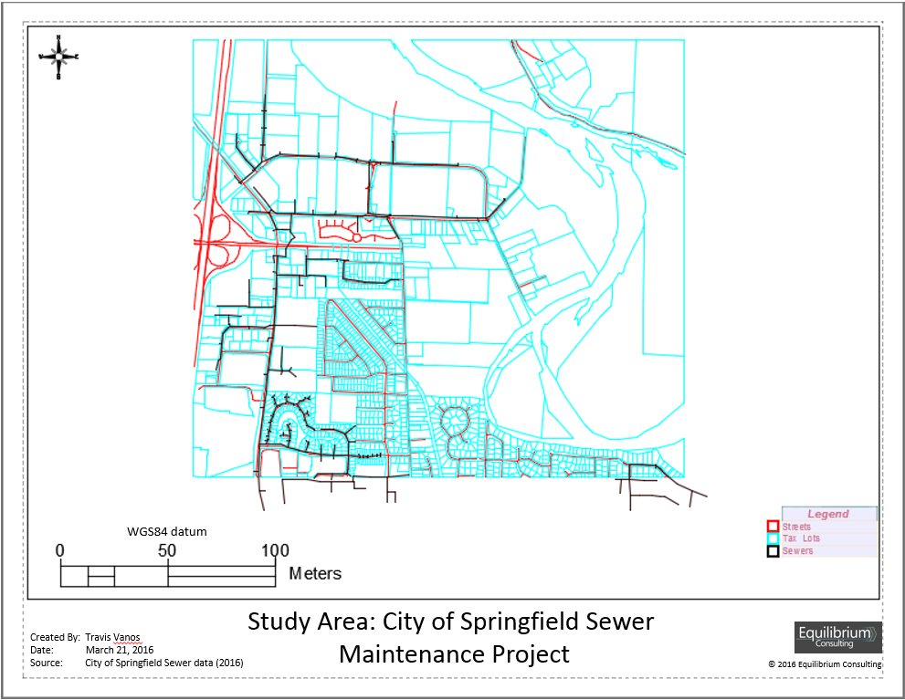

Figure Study Area: City of Springfield Sewer Maintenance Project

# *2. Methodology*

The drawings, as provided, include San_Sewer.dwg, Streets.dwg, and Taxlots OD.dwg for querying. A new map was created using the map2d.dwt template to start a new blank drawing.

In the new drawing, create a drive alias to connect to source drawings file folder.

2.1 Connecting to Required Data

The shared drive, X:GIS_Data was connected to attach the required drawings. A new drive alias was created to attach the content as seen in Figure 2 Assigned Drives for Drawing Connection

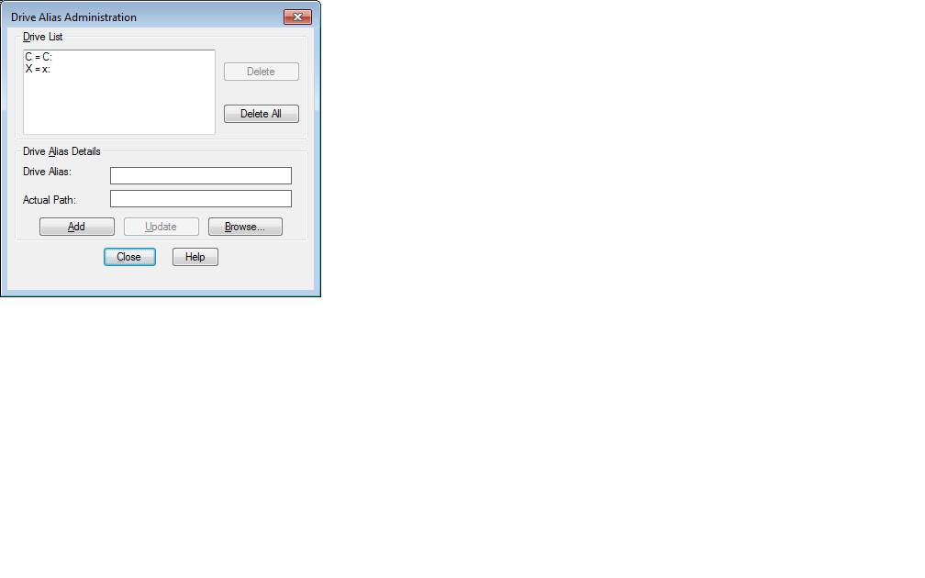

Figure Assigned Drives for Drawing Connection

The San_sewer.dwg, Streets.dwg, and Taxlots.dwg files are then connected, and added to the active drawing. The attached drawing can be seen in Figure 3 Attached Drawings in Browser and the successfully attached drawings in Figure 4 Successfully Attached Drawings

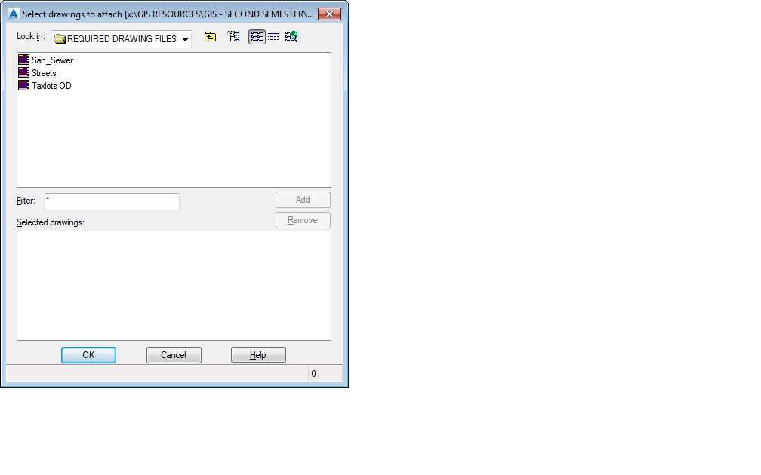

Figure Attached Drawings in Browser

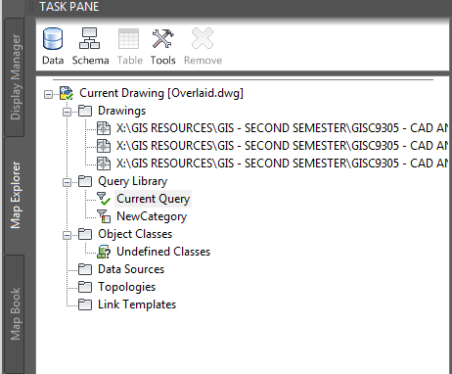

Figure Successfully Attached Drawings

## *2.2 Querying Data*

Table Concrete Sewer Reline Costs

|  |  |
| --- | --- |
| Size | Cost |
| 6" to 8" inclusive | $7.50/ft |
| 10" to 12" inclusive | $10.00/ft |
| 15" to18" inclusive | $15/ft |
| 20” to 24” inclusive | $20.00/ft |

Table Clay and PVC Piping Replacement Costs

|  |  |
| --- | --- |
| Size | Cost |
| 6” | $35/ft |
| 8” | $45/ft |
| 10” | $50/ft |
| 12” | $55/ft |
| 15“ | $65/ft |

The query definition was defined to fulfill the query requirements. First, all concrete pipes are queried to be used in reporting later. As seen in Figure 5 and Figure 6, The data was queried for the concrete material and the required attributes were exported to a report stored as a “.txt” file. This process was then repeated for Clay and PVC Pipes.

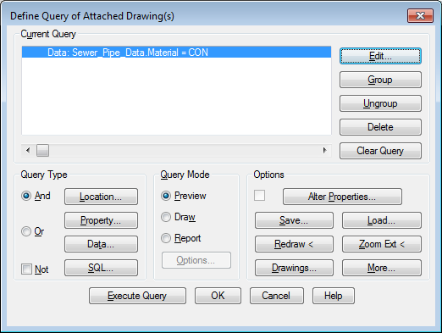

Figure Sewer Material: Concrete

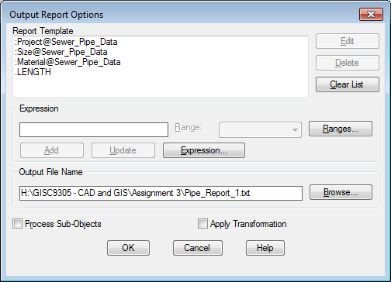

Figure Reporting Data

The results were then imported into a spreadsheet, using commas as the field delimiter to return the final results as seen in Appendix I. This process was then repeated for PVC, Clay and Project #30-142 spreadsheets.

## 2.3 PVC Replacement Buffer

Using the query builder, a 500m buffer was placed around the PVC sewer piping that had the project number as: 30-142 to collect all residence in the vicinity. The full list of residents can be found in Appendix VIII

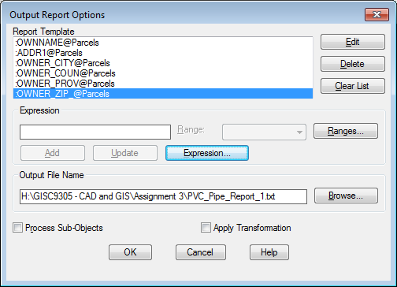

Figure Template for Residents Information

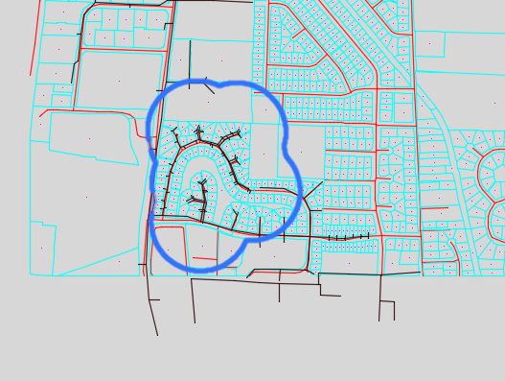

Figure 500M Buffer Around Defective PVC Piping

3.0 Conclusion

The reports generated from the queries were opened in Excel and charts were created to show the appropriate information gathered. The sanitary sewer concrete pipes are estimated to cost $102,335.38 and the clay sewers pipe replacements will cost approximately $259,391.16 and finally, the defective PVC piping will cost $105,555.51. The total that should be considered by the City of Springfield is $437,363.60

Appendix I

Table Concrete Replacement Costs

|  |  |  |  |  |
| --- | --- | --- | --- | --- |
| **Project** | **Size** | **Material** | **Length** | **Cost** |
| 00-000 | 6 | CON | 69.05940285 | $517.95 |
| 00-000 | 6 | CON | 118.3301964 | $887.48 |
| 00-000 | 6 | CON | 35.06626469 | $263.00 |
| 00-000 | 6 | CON | 38.84854845 | $291.36 |
| 00-000 | 8 | CON | 267.421126 | $2,005.66 |
| 00-000 | 8 | CON | 245.2005903 | $1,839.00 |
| 00-000 | 8 | CON | 247.8456989 | $1,858.84 |
| 3-759 | 8 | CON | 123.4376326 | $925.78 |
| 3-041 | 8 | CON | 207.0354418 | $1,552.77 |
| 1-857 | 8 | CON | 187.716974 | $1,407.88 |
| 1-857 | 8 | CON | 144.2407605 | $1,081.81 |
| 1-857 | 8 | CON | 263.7670955 | $1,978.25 |
| 3-041 | 8 | CON | 23.05848117 | $172.94 |
| 00-000 | 8 | CON | 187.6189952 | $1,407.14 |
| 00-000 | 8 | CON | 68.31501427 | $512.36 |
| 00-000 | 8 | CON | 118.0221705 | $885.17 |
| 00-000 | 8 | CON | 110.6350694 | $829.76 |
| 00-000 | 8 | CON | 257.0194784 | $1,927.65 |
| 00-000 | 8 | CON | 84.60761652 | $634.56 |
| 1-864=REF | 8 | CON | 246.3645155 | $1,847.73 |
| 1-864=REF | 8 | CON | 114.3406127 | $857.55 |
| 00-000 | 8 | CON | 68.6926572 | $515.19 |
| 00-000 | 8 | CON | 136.4757748 | $1,023.57 |
| 00-000 | 8 | CON | 100.0449899 | $750.34 |
| 00-000 | 8 | CON | 153.0028576 | $1,147.52 |
| 00-000 | 8 | CON | 179.9417555 | $1,349.56 |
| 1-864=REF | 8 | CON | 209.960019 | $1,574.70 |
| 00-000 | 8 | CON | 70.82227052 | $531.17 |
| 3-759 | 8 | CON | 140.6943379 | $1,055.21 |
| 00-000 | 8 | CON | 125.4822728 | $941.12 |
| 00-000 | 8 | CON | 186.319162 | $1,397.39 |
| 00-000 | 8 | CON | 118.0298374 | $885.22 |
| 00-000 | 8 | CON | 227.4284773 | $1,705.71 |
| 00-000 | 8 | CON | 78.19608938 | $586.47 |
| 00-000 | 8 | CON | 274.8836201 | $2,061.63 |
| 1-864=REF | 8 | CON | 32.64281064 | $244.82 |
| 00-000 | 8 | CON | 325.0000637 | $2,437.50 |
| 00-000 | 8 | CON | 258.9098402 | $1,941.82 |
| 00-000 | 8 | CON | 144.3294658 | $1,082.47 |
| 00-000 | 8 | CON | 239.1103319 | $1,793.33 |
| 1-857 | 8 | CON | 200.7418306 | $1,505.56 |
| 3-041 | 8 | CON | 108.2015704 | $811.51 |
| 00-000 | 8 | CON | 188.2884708 | $1,412.16 |
| 00-000 | 8 | CON | 217.6825279 | $1,632.62 |
| 1-873=REF | 8 | CON | 146.3907426 | $1,097.93 |
| 00-000 | 8 | CON | 342.2130692 | $2,566.60 |
| 00-000 | 10 | CON | 60.07495318 | $600.75 |
| 00-000 | 10 | CON | 73.00179563 | $730.02 |
| 00-000 | 10 | CON | 430.6034624 | $4,306.03 |
| 00-000 | 10 | CON | 272.2318997 | $2,722.32 |
| 00-000 | 10 | CON | 340.0313198 | $3,400.31 |
| 00-000 | 10 | CON | 520.3114452 | $5,203.11 |
| 00-000 | 12 | CON | 77.68939675 | $776.89 |
| 00-000 | 12 | CON | 48.92208438 | $489.22 |
| 00-000 | 12 | CON | 203.0511438 | $2,030.51 |
| 00-000 | 12 | CON | 144.6658328 | $1,446.66 |
| 00-000 | 12 | CON | 61.98259751 | $619.83 |
| 00-000 | 12 | CON | 70.0285656 | $700.29 |
| 00-000 | 12 | CON | 255.8149201 | $2,558.15 |
| 00-000 | 12 | CON | 130.4625768 | $1,304.63 |
| 00-000 | 12 | CON | 404.6387115 | $4,046.39 |
| 00-000 | 12 | CON | 290.6947852 | $2,906.95 |
| 00-000 | 12 | CON | 70.00714249 | $700.07 |
| 00-000 | 12 | CON | 247.8003598 | $2,478.00 |
| 00-000 | 12 | CON | 322.1362175 | $3,221.36 |
| 00-000 | 12 | CON | 131.7868785 | $1,317.87 |
| 00-000 | 12 | CON | 260.3771602 | $2,603.77 |
| 00-000 | 12 | CON | 243.6472861 | $2,436.47 |
| 00-000 | 12 | CON | 75.13826473 | $751.38 |
| 00-000 | 12 | CON | 80.77139461 | $807.71 |
| 00-000 | 12 | CON | 77.23339622 | $772.33 |
| 1-873=REF | 12 | CON | 400.3601332 | $4,003.60 |
| 1-873=REF | 12 | CON | 346.289058 | $3,462.89 |
| 00-000 | 12 | CON | 46.83147686 | $468.31 |
| 00-000 | 15 | CON | 93.17188417 | $1,397.58 |
| 00-000 | 15 | CON | 193.9808869 | $2,909.71 |
| 00-000 | 15 | CON | 348.2944157 | $5,224.42 |
| 3-759 | 15 | CON | 34.5903466 | $518.86 |
| 00-000 | 15 | CON | 294.4791779 | $4,417.19 |
| 00-000 | 15 | CON | 51.92920219 | $778.94 |
| 00-000 | 15 | CON | 142.7091278 | $2,140.64 |
| 00-000 | 15 | CON | 143.1062269 | $2,146.59 |
| 00-000 | 15 | CON | 316.4718874 | $4,747.08 |
| 00-000 | 15 | CON | 247.6252198 | $3,714.38 |
| 00-000 | 18 | CON | 91.31533421 | $1,369.73 |
| 00-000 | 18 | CON | 344.2898247 | $5,164.35 |
| 00-000 | 18 | CON | 329.758274 | $4,946.37 |
| 00-000 | 18 | CON | 410.487515 | $6,157.31 |
| 00-000 | 18 | CON | 363.5006427 | $5,452.51 |
| 00-000 | 18 | CON | 297.5163861 | $4,462.75 |
| 00-000 | 18 | CON | 363.2409669 | $5,448.61 |
| 00-000 | 18 | CON | 297.6995129 | $4,465.49 |
| 1-857 | 24 | CON | 449.2907934 | $8,985.82 |
| 1-857 | 24 | CON | 211.5289975 | $4,230.58 |
| 1-857 | 24 | CON | 449.7821637 | $8,995.64 |
| 1-857 | 24 | CON | 393.6740404 | $7,873.48 |
| 1-969/1857 | 24 | CON | 401.6568682 | $8,033.14 |
| 1-857 | 24 | CON | 243.674974 | $4,873.50 |
| 1-857 | 24 | CON | 317.135149 | $6,342.70 |
| 1-857 | 24 | CON | 111.0809108 | $2,221.62 |
| 1-857 | 24 | CON | 309.3574642 | $6,187.15 |
| Total | | | | $102,335.38 |

Appendix II

Table Clay Replacement Costs

|  |  |  |  |  |
| --- | --- | --- | --- | --- |
| **Project** | **Size** | **Material** | **Length** | **Cost** |
| 10-100 | 6 | Clay | 40.46950785 | $1,416.43 |
| 00-000 | 6 | Clay | 80.66491727 | $2,823.27 |
| 20-100 | 6 | Clay | 153.316634 | $5,366.08 |
| 10-100 | 6 | Clay | 54.9260839 | $1,922.41 |
| 20-100 | 6 | Clay | 69.92091561 | $2,447.23 |
| 10-100 | 8 | Clay | 55.91780638 | $2,516.30 |
| 10-100 | 8 | Clay | 238.6655047 | $10,739.95 |
| 10-100 | 8 | Clay | 150.9162086 | $6,791.23 |
| 10-100 | 8 | Clay | 242.4004955 | $10,908.02 |
| 10-100 | 8 | Clay | 24.74081421 | $1,113.34 |
| 10-100 | 8 | Clay | 188.2246616 | $8,470.11 |
| 10-100 | 8 | Clay | 274.3427595 | $12,345.42 |
| 10-100 | 8 | Clay | 198.6673905 | $8,940.03 |
| 10-100 | 8 | Clay | 167.7994993 | $7,550.98 |
| 10-100 | 8 | Clay | 36.43426081 | $1,639.54 |
| 10-100 | 8 | Clay | 400.2811512 | $18,012.65 |
| 10-100 | 8 | Clay | 42 | $1,890.00 |
| 20-100 | 8 | Clay | 336.7305002 | $15,152.87 |
| 20-100 | 8 | Clay | 142.9998348 | $6,434.99 |
| 20-100 | 8 | Clay | 66.45017085 | $2,990.26 |
| 20-100 | 8 | Clay | 238.0607934 | $10,712.74 |
| 20-100 | 8 | Clay | 82.64156386 | $3,718.87 |
| 10-100 | 10 | Clay | 301.6542946 | $15,082.71 |
| 10-100 | 10 | Clay | 354.8922744 | $17,744.61 |
| 10-100 | 10 | Clay | 380.0328933 | $19,001.64 |
| 10-100 | 12 | Clay | 90.00555538 | $4,950.31 |
| 10-100 | 12 | Clay | 87.56381255 | $4,816.01 |
| 10-100 | 15 | Clay | 240.8754865 | $15,656.91 |
| 10-100 | 15 | Clay | 384.2668344 | $24,977.34 |
| 10-100 | 15 | Clay | 203.9828424 | $13,258.88 |
| Total | | | | $259,391.16 |

Appendix III

Table Defective PVC Piping Replacements

|  |  |  |  |  |
| --- | --- | --- | --- | --- |
| **Project** | **Size** | **Material** | **Length** | **Cost** |
| 30-142 | 6 | PVC | 38.62194771 | $1,351.77 |
| 30-142 | 6 | PVC | 40.31128874 | $1,410.90 |
| 30-142 | 6 | PVC | 37.56543065 | $1,314.79 |
| 30-142 | 6 | PVC | 29.69522497 | $1,039.33 |
| 30-142 | 6 | PVC | 52.13510919 | $1,824.73 |
| 30-142 | 6 | PVC | 21.13147564 | $739.60 |
| 30-142 | 6 | PVC | 53.62559128 | $1,876.90 |
| 30-142 | 6 | PVC | 54.0794803 | $1,892.78 |
| 30-142 | 6 | PVC | 59.94370976 | $2,098.03 |
| 30-142 | 6 | PVC | 41.76122604 | $1,461.64 |
| 30-142 | 6 | PVC | 33.25185552 | $1,163.81 |
| 30-142 | 6 | PVC | 17.93689579 | $627.79 |
| 30-142 | 6 | PVC | 38.54667261 | $1,349.13 |
| 30-142 | 6 | PVC | 37.09018379 | $1,298.16 |
| 30-142 | 6 | PVC | 19.64605591 | $687.61 |
| 30-142 | 6 | PVC | 26.301949 | $920.57 |
| 30-142 | 6 | PVC | 39.01640876 | $1,365.57 |
| 30-142 | 6 | PVC | 18.14199145 | $634.97 |
| 30-142 | 6 | PVC | 36.2062752 | $1,267.22 |
| 30-142 | 6 | PVC | 27.59907135 | $965.97 |
| 30-142 | 6 | PVC | 46.29351799 | $1,620.27 |
| 30-142 | 8 | PVC | 113.7000722 | $5,116.50 |
| 30-142 | 8 | PVC | 8.466588384 | $381.00 |
| 30-142 | 8 | PVC | 86.23725033 | $3,880.68 |
| 30-142 | 8 | PVC | 81.61494961 | $3,672.67 |
| 30-142 | 8 | PVC | 107.9816759 | $4,859.18 |
| 30-142 | 8 | PVC | 51.00188019 | $2,295.08 |
| 30-142 | 8 | PVC | 55.40859463 | $2,493.39 |
| 30-142 | 8 | PVC | 68.64885566 | $3,089.20 |
| 30-142 | 8 | PVC | 95.68912537 | $4,306.01 |
| 30-142 | 8 | PVC | 129.627399 | $5,833.23 |
| 30-142 | 8 | PVC | 106.8938997 | $4,810.23 |
| 30-142 | 8 | PVC | 83.39126187 | $3,752.61 |
| 30-142 | 8 | PVC | 126.8264285 | $5,707.19 |
| 30-142 | 8 | PVC | 46.12744532 | $2,075.74 |
| 30-142 | 8 | PVC | 72.93923765 | $3,282.27 |
| 30-142 | 8 | PVC | 102.8821702 | $4,629.70 |
| 30-142 | 8 | PVC | 116.6728566 | $5,250.28 |
| 30-142 | 8 | PVC | 105.4130403 | $4,743.59 |
| 30-142 | 8 | PVC | 138.8120075 | $6,246.54 |
| 30-142 | 8 | PVC | 49.30881157 | $2,218.90 |
| Total | | | | $105,555.51 |

Appendix IV

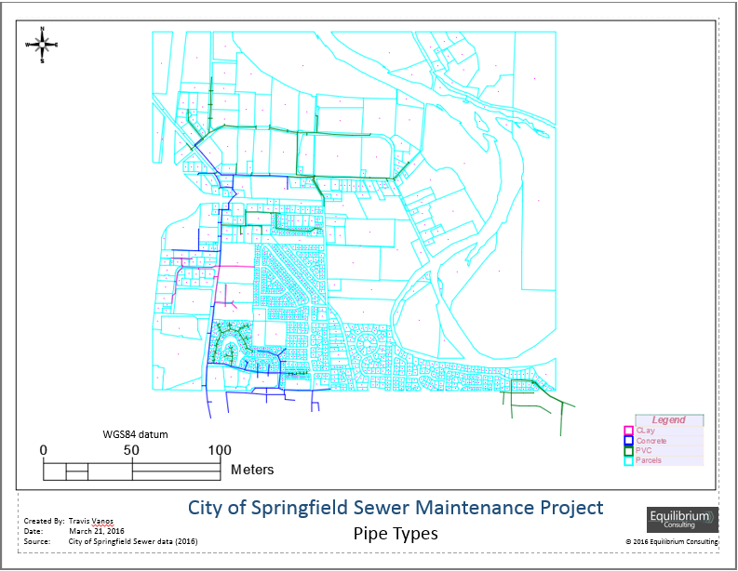

Appendix V

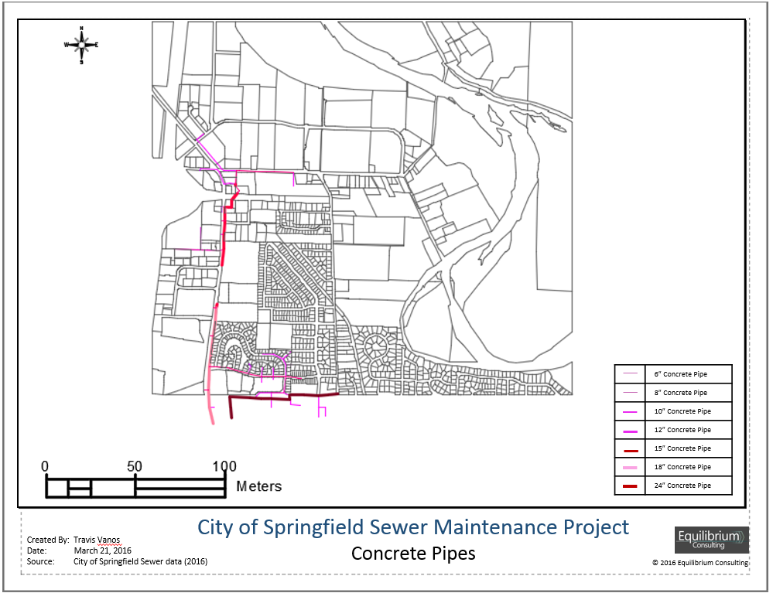

Appendix VI

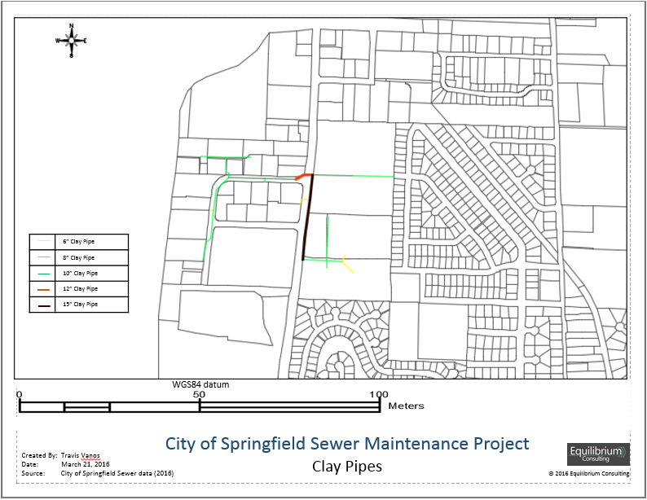

Appendix VII

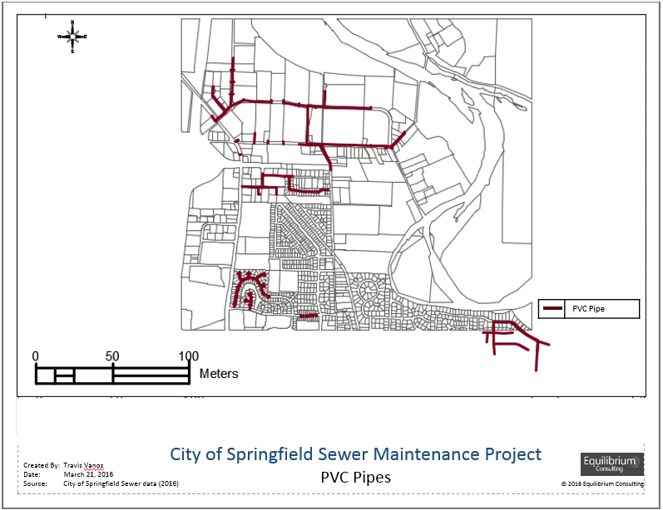

Appendix VIII

|  |  |  |  |
| --- | --- | --- | --- |
| Name | Address | Street Name | Country |
| SEIDEL FAMILY REVOC JOINT LIVING TRUST | 15920 CURTIS CRT | SONORA | United States |
| SHEPARD CHARLES N TE | PO BOX 8516 | COBURG | United States |
| SHEPARD CHARLES N TE | PO BOX 8516 | COBURG | United States |
| BESS PROPERTIES LLC | PO BOX 5241 | EUGENE | United States |
| KAY RICHARD A & MARIANN L | 3180 GARDENIA WAY | EUGENE | United States |
| SHEPARD CHARLES N TE | PO BOX 8516 | COBURG | United States |
| SHEPARD CHARLES N | PO BOX 8516 | EUGENE | United States |
| LANE COUNTY OWNED LAND | 125 E 8TH AVE | EUGENE | United States |
| SIMMONS VERN L & BETTY L TR | PO BOX 1307 | RANCHO SANTA FE | United States |
| SHEPARD CHARLES N TE | PO BOX 8516 | COBURG | United States |
| SHEPARD CHARLES N TE | PO BOX 8516 | COBURG | United States |
| SHEPARD CHARLES N | PO BOX 8516 | COBURG | United States |
| SHEPARD CHARLES N TE | PO BOX 8516 | COBURG | United States |
| LEFRANCQ KAYE A | 3351 BUCKINGHAM AVE | EUGENE | United States |
| NICHOLS DAVID ALAN | 88608 ERMIBEE | SPRINGFIELD | United States |
| BLOOD KENNETH W | 5360 TAHSILI ST | EUGENE | United States |
| MENDIGUREN JAMES & SALLY | 133 HOWARD AVE | EUGENE | United States |
| SHEPARD CHARLES N TE | PO BOX 8516 | COBURG | United States |
| SHEPARD CHARLES N TE | PO BOX 8516 | COBURG | United States |
| JACOBSON INA C | 26 RUSTIC PLACE | EUGENE | United States |
| BOUR CARL A & JUNE M | 345 V STREET | SPRINGFIELD | United States |
| SHEPARD CHARLES N | PO BOX 8516 | COBURG | United States |
| SHEPARD CHARLES N TE | PO BOX 8516 | COBURG | United States |
| MEYER PETER C | 444 BRICKELL AVE STE 51-265 | MIAMI | United States |
| PARADISE JANE M | 2810 ROSEDALE AVE | SOQUEL | United States |
| LEFRANCQ KAYE A TE | 3351 BUCKINGHAM | EUGENE | United States |
| LAFRANCQ KAYE A TE | 3351 BUCKINGHAM | EUGENE | United States |
| SPILLER EARL WAYNE TE | 88594 COLLARD LOOP | FLORENCE | United States |
| NARAIN MUKESH K & USHA K | 4449 IVY ST | SPRINGFIELD | United States |
| DATT BISHUN & BASMATI | 338 70TH ST | SPRINGFIELD | United States |
| WILDE SUSANNA | 2484 BENSON LN | EUGENE | United States |
| SHEPARD CHARLES N | PO BOX 8516 | COBURG | United States |
| LEFRANCQ KAYE A TE | 3351 BUCKINGHAM AVE | EUGENE | United States |
| CHRISTENSEN CARLA JEAN | 3351 BUCKINGHAM AVE | EUGENE | United States |
| WATTS LARRY A & JULIE L | 37787 WORTH RD | SPRINGFIELD | United States |
| PIERCE WILLIAM M & MATTIELLO FERDINANDO | 755 W 40TH AVE | EUGENE | United States |
| DICKSON SHIRLEY V | 303 S BROADWAY STE 200-440 | DENVER | United States |
| HARGROVE MICHAEL K | 1085 WOODSIDE DR | EUGENE | United States |
| SANDOVAL BASILIO & MARTHA | 744 OAKDALE AVE | SPRINGFIELD | United States |
| COTA DOLORES J TE | 86 NICHOLAS CRT | COTATI | United States |
| BATCHELOR CHRISTINE M | 34238 MATHEWS RD | EUGENE | United States |
| THOMASON BURKE C | 2299 LARIAT DR | EUGENE | United States |
| SHEPARD CHARLES N TE | PO BOX 8516 | COBURG | United States |
| DAVIS STEPHEN L | 1740 MINDA DR | EUGENE | United States |
| ART JOHNSTONE & TERRI | 4330 SE OAK ST | PORTLAND | United States |
| SHEPARD CHARLES N TE | PO BOX 8516 | COBURG | United States |
| LEFRANCO KAYE A TE | 3351 BUCKINGHAM AVE | EUGENE | United States |
| PRATT BRUCE W TE | 42000 HOLDEN CREEK LN | SPRINGFIELD | United States |
| PRASAD RAJENDRA & VINUKA | 3328 NW BLACKCOMB DR | PORTLAND | United States |
| MORAN EILEEN M | 2575 WASHINGTON ST | EUGENE | United States |
| CHANE MING E TE | 2938 TOLLIVER DR | SAN JOSE | United States |
| TRAN LONG DINH | 754 OAKDALE CRT | SPRINGFIELD | United States |
| CHRISTENSEN CARLA JEAN | 3351 BUCKINGHAM AVE | EUGENE | United States |
| DAMMEN PAUL | 3991 ROYAL AVE | EUGENE | United States |
| WHITTED GREGG W | 3272 STARK CT | EUGENE | United States |
| HINES WILLIAM W TE | 00160 JULIA WAY | BROOKINGS | United States |
| HINES WILLIAM W TE | 160 JULIA WAY | BROOKINGS | United States |
| HINES WILLIAM W TE | 160 JULIA WAY | BROOKINGS | United States |
| HINES WILLIAM W TE | 160 JULIA WAY | BROOKINGS | United States |
| SMEJKAL ROBERT A | PO BOX 654 | EUGENE | United States |
| LI SIU KONG & CHI LING | 2783 RIVERWALK LP | EUGENE | United States |
| WHITMER RONALD L & CINDY L | 2720 GAME FARM RD | SPRINGFIELD | United States |
| SHEPARD CHARLES N TE | PO BOX 8516 | COBURG | United States |
| MART GORDON E | 2876 FIESTA DR | SPRINGFIELD | United States |
| MONROE M W & LANITA K | 4284 HYACINTH ST | EUGENE | United States |
| SHEPARD CHARLES N TE | PO BOX 8516 | COBURG | United States |
| CHAPMAN MATTHEW G | 5532 DONOHOE | EUGENE | United States |
| LANE COUNTY OWNED LAND | 125 E 8TH AVE | EUGENE | United States |
| SCHOEPKE DOROTHY M | PO BOX 71362 | EUGENE | United States |
| SOLEMN LLC | PO BOX 265 | SAGINAW | United States |
| ENGELMANN THERESE | 2185 TYLER | EUGENE | United States |
| SUMMERS JOYCE D TE | 2585 CHUCKANUT | EUGENE | United States |
| LEE YUEN | 90790 COBURG RD | EUGENE | United States |
| MOOSBRUGGER KURT H TE | 2411 OTTO ST | SPRINGFIELD | United States |
| HUDMAN LAND LLC | 604 N CLOVERLEAF LP | SPRINGFIELD | United States |
| BELL HELEN L | 4460 ALTURA ST | EUGENE | United States |
| BELL HELEN L TE | 4460 ALTURA ST | EUGENE | United States |
| NEWCOMBE ARTHUR LEE | 45114 MCKENZIE HWY | LEABURG | United States |
| AUSTIN CLAYTON W | 90031 ROYSTER RD | EUGENE | United States |
| AUSTIN CLAYTON W | 90031 ROYSTER RD | EUGENE | United States |
| HARRIS INVESTMENTS LLC | 29141 GIMPL HILL RD | EUGENE | United States |
| VARNER CHARLES L | 239 WEDGEWOOD DR | EUGENE | United States |
| YOUNG WILLIAM D & DIANA K | 86673 LORANE HWY | EUGENE | United States |
| HUSER TIMOTHY C & LINDA G | PO BOX 782 | PLEASANT HILL | United States |
| SINGLER TIMOTHY W | 851 & 853 N CLOVERLEAF LOOP | SPRINGFIELD | United States |
| SHEPARD CHARLES N TE | PO BOX 8516 | COBURG | United States |
| SHEPARD CHARLES N TE | PO BOX 8516 | COBURG | United States |
| RAMAN SHIRI | 3949 W 188TH ST | TORRENCE | United States |
| SHEPARD CHARLES N TE | PO BOX 8516 | COBURG | United States |
| SHEPARD CHARLES N TE | PO BOX 8516 | COBURG | United States |
| NELSON ROBERT W & KATHLEEN RENE | 3130 BEECH ST | EUGENE | United States |
| EARP-THOMAS GEORGE L TE | 2431 CITY VIEW ST | EUGENE | United States |
| SHEPARD CHARLES N TE | PO BOX 8516 | COBURG | United States |
| BRAY WALTER H | 3800 WESTLEIGH #323 | EUGENE | United States |
| SMITH JERE S & JULIE W | 2083 STONECREST DR | EUGENE | United States |
| CORNELIUS VERN FREDRICK TE | 36400 BRAND S RD | SPRINGFIELD | United States |
| CHIPMAN JOAN VADELL TE | 650 SKY PARK CT | EUGENE | United States |
| SCHOOL DIST 19 | 525 MILL ST | SPRINGFIELD | United States |
| ISOM SAMPSON LEE & CAROL ANN | 4243 SHANNON ST | EUGENE | United States |
| SHEPARD CHARLES N TE | PO BOX 8516 | COBURG | United States |
| MEYER PETER C | 444 BRICKELL AVE STE 51-265 | MIAMI | United States |
| SHEPARD CHARLES N TE | PO BOX 8516 | COBURG | United States |
| RAMBO AMANDA/RAMBO SARAH | 864 N CLOVERLEAF LOOP | SPRINGFIELD | United States |
| CHRISTENSEN CARLA JEAN | 3351 BUCKINGHAM AVE | EUGENE | United States |
| SHEPARD CHARLES N | PO BOX 8516 | COBURG | United States |
| SHEPARD CHARLES N TE | PO BOX 8516 | COBURG | United States |
| SIMMONS VERN L & BETTY L TR | PO BOX 1307 | RANCHO SANTA FE | United States |
| FRANCONE WILLIAM G & T J | 4465 SKY PARK WAY | EUGENE | United States |
| WILLAMALANE PARK & | 200 S MILL ST | SPRINGFIELD | United States |
| KKMH PROPERTIES LLC | 15450 SW BOONS FERRY #9-140 | LAKE OSWEGO | United States |
| DRIFTWOOD VILLA HOMEOWNERS | 2727 GATEWAY | SPRINGFIELD | United States |
| CLOVERDALE LLC | 840 BELTLINE RD STE 202 | SPRINGFIELD | United States |
| SUMMERS JOYCE D TE | 2585 CHUCKANUT | EUGENE | United States |
| FITZGERALD REUBEN E & MARY K | 1358 WINDSOR CRT | SPRINGFIELD | United States |
| CLOVERDALE LLC | 840 BELTLINE RD STE 202 | SPRINGFIELD | United States |
| OGLE CHARLES L & DONNA V | 15223 SE 176TH ST | RENTON | United States |
| WEISER JOHN W & BERNARDINE A | 1170 PRESIDENT | EUGENE | United States |
| SHEPARD CHARLES N TE | PO BOX 8516 | COBURG | United States |
| SHEPARD CHARLES N TE | PO BOX 8516 | COBURG | United States |
| COCHRAN LAND COMPANY LLC | 92081 SHAREWATER LN | CHESHIRE | United States |
| FINCH NICOLE MARIE | 4506 SOUZA ST | EUGENE | United States |
| SATTLER RICHARD JAMES | 686 OAKDALE AVE | SPRINGFIELD | United States |
| NICHOLS RONALD E & RUTH D | PO BOX 735 | SPRINGFIELD | United States |
| OLSON ERIC G & SHERI L | 32815 E THOMAS | COBURG | United States |
| HUNT MAUREEN E | PO BOX 71882 | SPRINGFIELD | United States |
| CHAN TOM D | 2095 BUCK ST | EUGENE | United States |
| HARGROVE MICHAEL K | 1085 WOODSIDE DR | EUGENE | United States |