

Travis Vanos

Group 3

# GISC9216 – Digital Image Processing

GISC9216-D2



Mrs. Janet Finlay

Professor – GISC9301 February 12, 2016  
Niagara College GISC9216-D2  
135 Taylor Road  
Niagara-on-the-lake, ON  
L0S 1J0

Dear Mrs. Janet Finlay   
 **RE: Submission: GISC9216-D2**

### Please accept this letter as our formal submission of Assignment two: GISC9216-D2: ArcGIS Applications for Travis Vanos. The works were completed with ERDAS image processing software. The purpose of this assignment to utilize the fundamentals of PCA (Principal Component Analysis). This transformation will be completed on a subset image the classification process and compare the obtained results. An unsupervised classification was performed on both the Principal Components and original image subset. The following sections will be fulfilling the deliverables as outlined in the GISC9216-D2.

Following the assignment procedures, please find the required material attached. Should you have any questions regarding the enclosed documents, please contact Travis Vanos at your convenience at [travis.vanos@gmail.com](mailto:travis.vanos@gmail.com). We eagerly await your comments and suggestions.  
  
Sincerely,

Travis Vanos   
 GIS/GM Candidate, Niagara College  
 T. V.

Enclosures: VanosT\_GISC9216-D2.docx

Executive Summary

# Abstract

Given the original subset image of the Greater Orilla area, a Principal Component analysis (PCA) was completed to better interpret and understand the features of interest in the data-set. Attempting to better identify land features, the PCA is undertaken in hopes to better classify the areas of interest by reducing redundancy in the LANDSAT bands. With modern day computers it is up to GIS professionals to classify pixels in a set of raster image. With the aid of software the analysis of the areas takes place to attempt to properly classify types of terrain and features. There are two classifications used in this report: unsupervised of the original image and unsupervised classification of the three Principal Components. The objective of this report is to outline both methods and outline the effectiveness of each. The methodology is then presented to describe the process in which to perform the two classification methods were produced. Finally, the two methods are scrutinized for the effectiveness of classifying features in the Orilla area. The subsequent figures and maps are included.

Table of Contents

[Abstract i](#_Toc443037744)

[1. Introduction 1](#_Toc443037745)

[2.1 Principal Component Analysis (PCA) 2](#_Toc443037746)

[2.2 The Correlations of LANDSAT Bands 3](#_Toc443037747)

[2.2 PCA Channels vs. Original Image Correlation 9](#_Toc443037748)

[3. Conclusion and Findings 13](#_Toc443037749)

[Bibliography 14](#_Toc443037750)

List of Figures

[Figure 1 Study Area for Classification (512 x 512 pixel) image subset (Landsat, 1999) 1](#_Toc443037759)

[Figure 2 EXAMPLE: 15 levels of Classification for desired features 2](#_Toc443037760)

[Figure 3 Feature Space Properties and Band Comparison 3](#_Toc443037761)

[Figure 4 Result of PCA using 3 channels 10](#_Toc443037762)

[Figure 5 Comparison of Unclassified Supervisions 12](#_Toc443037763)

[Figure 6 Comparison of Unsupervised Classifications 12](#_Toc443037764)

[Figure 7 Seemingly Identical Image Portions 13](#_Toc443037765)

List of Tables

[Table 1 Image Band Correlations 4](#_Toc443037766)

[Table 2 Summary of Band Correlations 9](#_Toc443037767)

[Table 3 Eigenvalues of Bands 9](file:///C:\Users\Travis\Desktop\Assignment%20%232%20-%20Principle%20Component%20Analysis\PCA3\9216-D2-Start.docx#_Toc443037768)

# 1. Introduction

Given the original subset image of the Greater Orilla area, a Principal Component analysis (PCA) was completed to better interpret and understand the features of interest in the data-set. A Principal Component Analysis (PCA) is completed for the subset image. PCA is a mathematical technique which transforms the original image data, typically highly correlated, to a new set of uncorrelated variables called principal components. The reason for this Principal Component Analysis is to observe the given data and to identify and find patterns to reduce the dimensions of the dataset with minimal loss of information (Sebastianraschka.com). After which, a comparative analysis between an unsupervised classification and an unsupervised classification of Principal Components is undertaken. The original unsupervised classification of the subset is then compared with the new unsupervised classification of the PCA to determine differences in the level of feature detection in both cases.

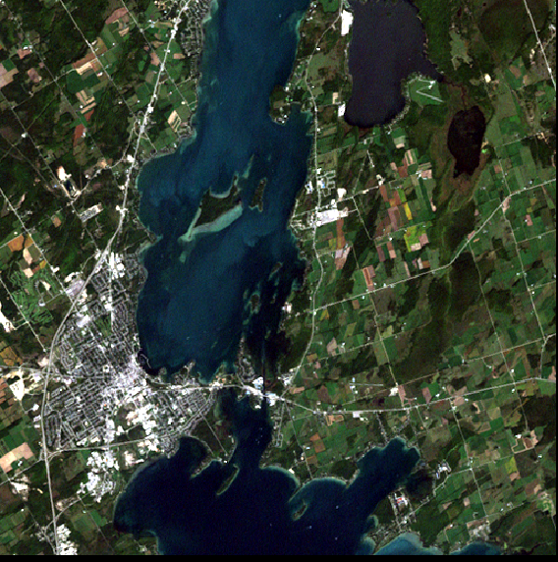

Figure 1 Study Area for Classification (512 x 512 pixel) image subset (Landsat, 1999)

## 2.1 Principal Component Analysis (PCA)

A 512 x 512 pixel area of the LANDSAT imagery was chosen for a study area as it contains all categories of Points of Interest (POI). An analysis was undertaken and the new set of uncorrelated variables, called principal components, an unsupervised classification can be created and compared to earlier classification results on the normal image subset. Within the original image there is a significant amount of correlation between bands. With PCA, the bands become uncorrelated as it takes the (6) bands from the original LANDSAT imagery and produces an image with 3 channels. Figure 2 shows an example of an unsupervised classification with 15 classes for later identification.

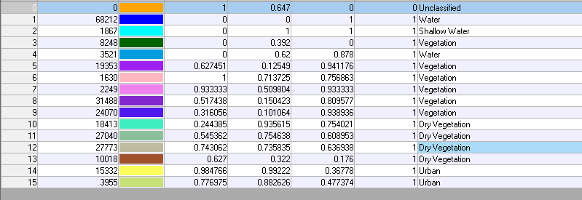

Figure 2 EXAMPLE: 15 levels of Classification for desired features

## 2.2 The Correlations of LANDSAT Bands

Using ERDAS’ Feature Space Info the different layers of the original subset image are compared to analyse the correlation of the different LANDSAT bands. Transforming the original bands to the Principal Components in order is required to reduce the amount of the unused data within a multispectral image. Interband Correlation in Subset Image In order to explore the original subset image and determine which bands have a strong correlation. Figure 3 shows the Feature Space Creation.   
  
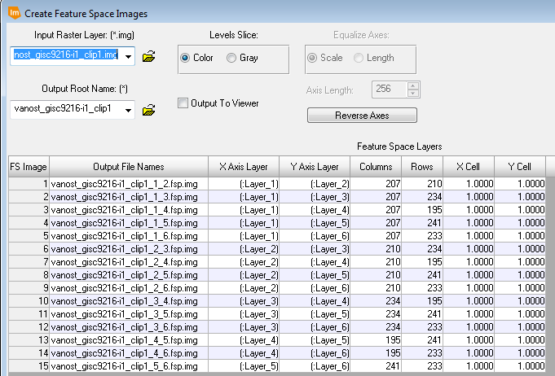

Figure 3 Feature Space Properties and Band Comparison

Table 1 Image Band Correlations

|  |  |  |
| --- | --- | --- |
| Feature Space Image | *Band Numbers* | *Correlation* |
| C:\Users\Administrator\Pictures\Bands1_2.PNG | 1,2 | Strong |
| C:\Users\Administrator\Pictures\Bands1_3.PNG | 1,3 | Moderate |
| C:\Users\Administrator\Pictures\Bands1_4.PNG | 1,4 | No correlation |
| C:\Users\Administrator\Pictures\Bands1_5.PNG | 1,5 | No correlation |
| C:\Users\Administrator\Pictures\Bands1_6.PNG | 1,6 | No correlation |
| C:\Users\Administrator\Pictures\Bands2_3.PNG | 2,3 | Strong |
| C:\Users\Administrator\Pictures\Bands2_4.PNG | 2,4 | No correlation |
| C:\Users\Administrator\Pictures\Bands2_5.PNG | 2,5 | No correlation |
| C:\Users\Administrator\Pictures\Bands2_6.PNG | 2,6 | No correlation |
| C:\Users\Administrator\Pictures\bands3_4.PNG | 3,4 | No correlation |
| C:\Users\Administrator\Pictures\bands3_5.PNG | 3,5 | No correlation |
| C:\Users\Administrator\Pictures\bands3_6.PNG | 3,6 | Moderate |
|  | 4,5 | No correlation |
| C:\Users\Administrator\Pictures\bands4_6.PNG | 4,6 | No correlation |
| C:\Users\Administrator\Pictures\bands5_6.PNG | 5,6 | Moderate |

In summary, the results can be seen in table BSASSVSV

Table 2 Summary of Band Correlations

|  |  |  |  |  |  |  |
| --- | --- | --- | --- | --- | --- | --- |
|  | **Band 1** | **Band 2** | **Band 3** | **Band 4** | **Band 5** | **Band 6** |
| **Band 1** | - | Strong | Moderate | No correlation | No correlation | No correlation |
| **Band 2** | - | - | Strong | No correlation | No correlation | No correlation |
| **Band 3** | - | - | - | No correlation | No correlation | Moderate |
| **Band 4** | - | - | - | - | No correlation | No correlation |
| **Band 5** | - | - | - | - | - | Moderate |
| **Band 6** | - | - | - | - | - | - |

Very strong band correlation between bands 2 and 3 exists prior to PCA. With the desired study area obtained, both classifications, unsupervised and unsupervised of the Principal Components, are attempted to identify desired features. Figure 4 displays the areas before the unsupervised classification occurs.

## 2.3 PCA Channels vs. Original Image Correlation

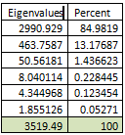  
  
For the original LANDSAT data, six bands are used. The correlation of these bands can be strong, moderate or no correlation. When a strong correlation occurs the data is redundant as two bands contain the similar information. Comparing the bands there are 2 strongly correlated, 3 moderately correlated and 10 bands that show no correlations between them. This would indicate some data is redundant and should be made easier to classify specific features within the new unsupervised classification image. When comprising the PCA, the data is reduced to 3 channels of Principal Components rather than the 6 bands originally compared. In theory, this would allow for a better result in classification. However, as we will see, this effect is minimal and no noticeable change has occurred.   
  
Eigenvalues are produced for the PCA. The eigenvalues display the total variance in the original six bands. The first eigenvalue contains 85% of the variation; the second contains 13% of the variation and the third only 1.4% of the variation. The first three bands are used, thus comprising over 99% of the values.

Table 3 Eigenvalues of Bands

After which, an Image subset is created from the newly made channels. The result of the Principal Components can be seen in Figure 4.

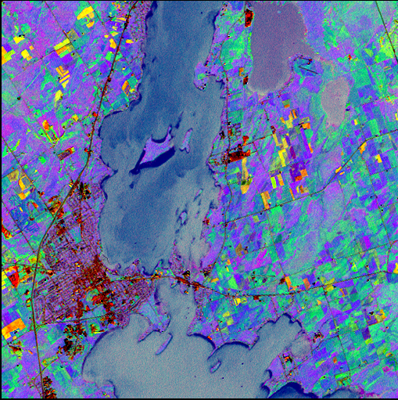

Figure 4 Result of PCA using 3 channels

|  |  |  |
| --- | --- | --- |
|  |  |  |
| C:\Users\Administrator\Pictures\bands3_6.PNG | C:\Users\Administrator\Pictures\bands4_6.PNG | C:\Users\Administrator\Pictures\bands5_6.PNG |
| PCA  Layer 1 vs Layer 2 | PCA  Layer 1 vs Layer3 | PCA  Layer 1 vs Layer3 |

Looking at the 1st and 2nd channel the correlation is not strong but there does appear to be some correlation in the layers. Although successful, The PCA in created channels that are uncorrelated, but not to the effect as desired.   
  
The variance shown comparing the 1st and 3rd channels has the weakest of correlations. The correlation of these bands is the desired effect of the PCA.

The correlation shown with the 2nd and 3rd channels is a moderate correlation. One can see the pixels generally sticking to the line of best fit. Creating channels that do not correlate would reduce the redundancy for classification. These moderately correlated models can be an indication of why the unsupervised classification did not yield the desired results on the PCA image subset.

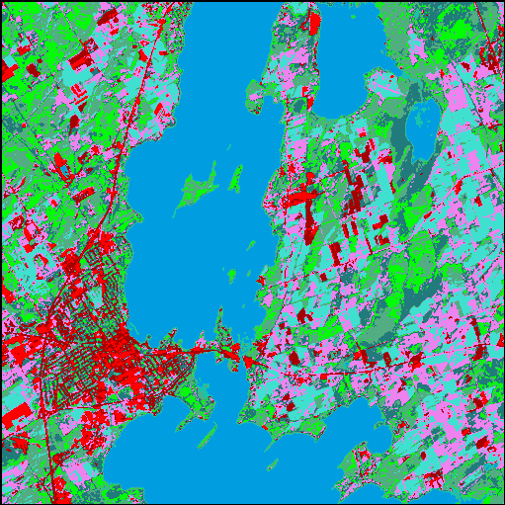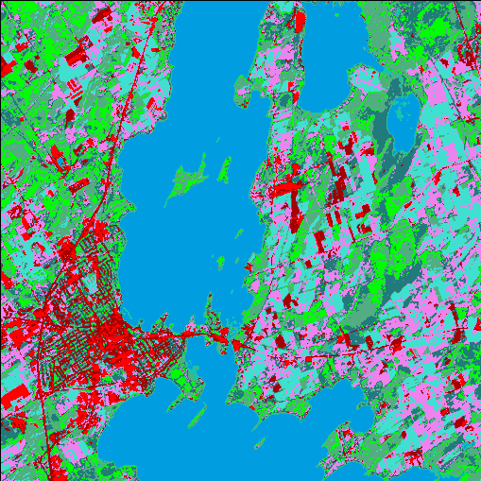

Figure 5 Comparison of Unclassified Supervisions

In the Unsupervised Classifications, both Image subsets look almost identical with the exception of some seemingly arbitrary pixels changing. However, looking at the histogram of occurrences of each classification we can see there is a change, although very minute, it the two classification methods. A histogram of the pixel occurrences can be seen in Figure 5.

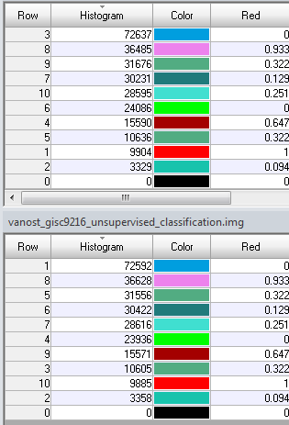

Figure 6 Comparison of Unsupervised Classifications

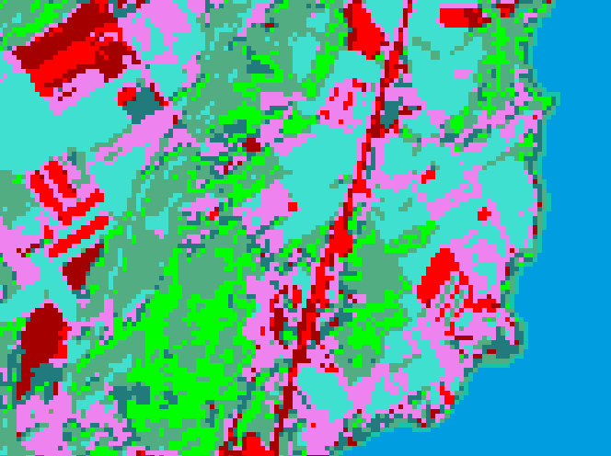

Figure 7 Seemingly Identical Image Portions

# 3. Conclusion and Findings

In conclusion, the unsupervised classification of PCA and the unsupervised classification of the original image subset did not yield the desired results in better classifying the areas of interest. Side by side the classification techniques are seemingly identical. For better analysis the PCA did not yield better results and would not be chosen in opposition to the unsupervised classification of the original image subset. Moving forward, methodology of the Principal Component Analysis can be revisited or the unsupervised classification of the features can be used as it was the provided the best result in the least amount of time.

# Bibliography

Sebastianraschka.com,. "Principal Component Analysis Step By Step". N.p., 2016. Web. 12 Feb. 2016.

Learningzone.rspsoc.org.uk,. "10.2. Principal Components | Image Processing For ERDAS | Learning Materials". N.p., 2016. Web. 12 Feb. 2016.

APPENDIX I

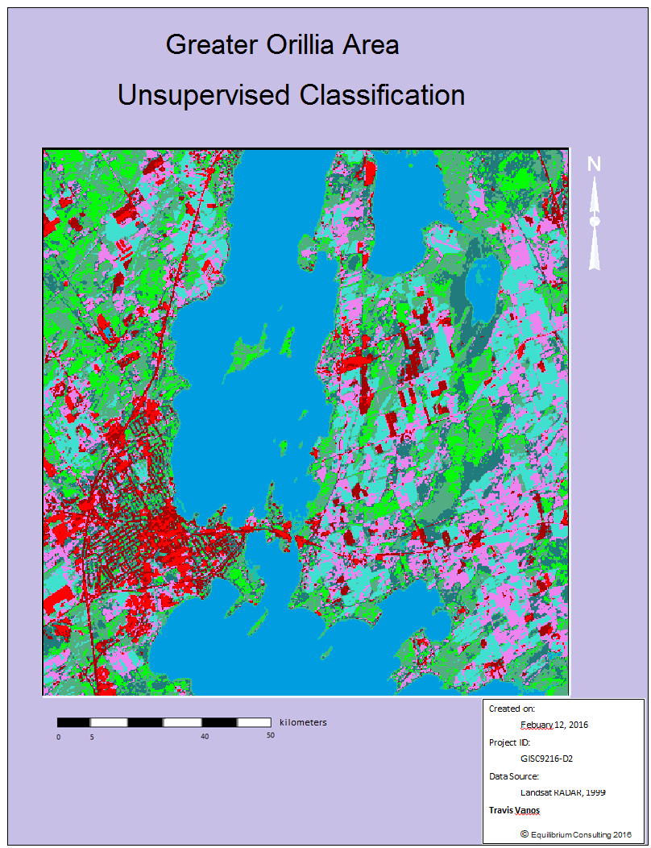

APPENDIX II

