

Travis Vanos

VANOS-GISC9118-D1

**Multivariate Mapping**



Mr. Mike Wallace

Professor – GISC9302 October 20, 2015  
Niagara College GISC9118-D1   
135 Taylor Road  
Niagara-on-the-lake, ON  
L0S 1J0

Dear Mr. Wallace

Please accept this letter as my formal submission of Assignment one: GISC9118-D1: Multivariate Mapping. The purpose of this assignment is create a multivariate map using skills we have discussed in MapInfo v15.0. More specifically, to create a multivariate map showing the population density for the United States as change from 1980 to 1990. The map features two means of multivariate mapping, choropleth and proportional symbolization. Highlights of this assignment include:

* Informative map with all proper elements discussed in previous classes
* Creating proper symbolization and graphing for data change
* Calculating both the density of the state as well as the percentile of change in the given state

Following the according steps please find the required material sent electronically and in hard copy. Should you have any questions regarding the enclosed documents, or if there are technical issues regarding the files please contact me at your convenience at (937)647 3746 or email at travis.vanos@gmail.com. I eagerly await your comments and suggestions.  
  
Sincerely,

Travis Vanos CCNA, CISSP, A+  
 GIS-GM candidate, Niagara College   
 T. V

Enclosures: VANOS-GISC9118-D1

# Executive Summary

The entirety of the works has been summarized into this Technical Memorandum. The purpose of this assignment is understand multivariate mapping and displaying calculated data in an accurate and useful manner. The works include:

* Using provided data to use for later calculations and mapping
* Determining the proper multivariate mapping method for each dataset
* Querying the aforementioned datasets to produce informative representation
* Visually organizing the information in a clean, legible manner

The tasks outlined in the deliverables were completed in MapInfo v15.0 and a printed copy can be found alongside this Technical Memorandum.

# Multivariate Mapping Methods

## **Choropleth vs Proportional Symbolization**

As discussed in class there a variety of ways to visualize datasets in MapInfo. In this assignment two types were displayed on the map; Ranged Thematic Map (Choropleth) and Proportional Symbolization. Choropleth for percent of population change between the years 1980 to 1990 and Proportional Symbolization was used for the calculation of population density by state (people/mi2) and.

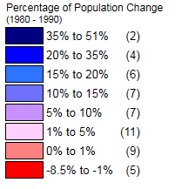 A range of (8) colours were used to represent the data in an accurate manner due to the closeness of data in the lower tiers. The colour is to provide a visual representation of the hue ranging from a more vibrant red to a subtle and then strong shade of blue. With many economic and growth models, negative growth is general associated with a negative impact.

Figure Percentage of Population Change (1980 - 1990)

The intended use of this data has not been mentioned, however, red has been used to clearly denote a state that has a population change in the negative values.

Proportional Symbolization was used to show population density of each state as person per square mile. The graduated symbols in MapInfo show the range in proportion to the text size chosen for the given symbol.

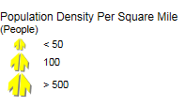The purpose of this method is for the reader to easily be able to determine is the state **a)** has a large number of inhabitants per square mile with a large percent of growth **b)** a large number of inhabitants per square mile with a low percentage of growth **c)** a low number of inhabitants per square mile with a high percentage of growth or **d)** a low number of inhabitants per square mile with a low percentage of growth.

Figure Proportional Symbolization for Population Map

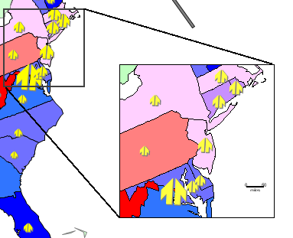An inset map was used for the eastern region of the Continental United states because of the smaller state size and large proportional symbols denoting a high density population.

Figure Inset Map of Eastern United States of America

The method assumes there are 6 productive hours in a day where anything longer than that time would be completed into the next day and the pessimistic option (p) never allotting exactly (1) day. Equilibrium Consulting has determined the expected time for the completion of the tasks is approximately 150 hours with a contingency in place as a pessimistic completion time. In order to account for personal inexperience, a larger gap has been estimated between the optimistic and pessimistic to account for the lack of knowledge.

|  |  |  |  |  |  |  |  |
| --- | --- | --- | --- | --- | --- | --- | --- |
| |  |  | | --- | --- | | 1. Analogous | 1. Delphi | | 1. Historical Data | 1. Three-point Technique | | 1. Expert Judgment | 1. PERT | | C:\Users\Administrator\Pictures\types of estimates.PNG  Figure Informatica Economică http://revistaie.ase.ro/content/47/16Marius%20Vetrici.pdf |

## **Applying Estimation Methods**

|  |  |  |  |
| --- | --- | --- | --- |
| # | Activity name | Expected time (PERT Calculations) (hr) | Method Used |
| **1** | **To find and review a journal article.** | **0.92** | **1, 6** |
| **2** | **To research and write a 2 page literature review** | **6.33** | **1, 6** |
| **3** | **To set up a public meeting.** | **8.33** | **3, 6** |
| **4** | **To organize an agency review meeting to review a spatial data set involving 8 agencies.** | **10.17** | **3, 6** |
| **5** | **To prepare a public notice for a newspaper.** | **6.67** | **3, 6** |
| **6** | **To establish a base map using ArcGIS.** | **5** | **5, 6** |
| **7** | **To undertake a GPS survey of 5 acres of farmland boundary needing vertical resolution of one foot.** | **61.67** | **3, 6** |
| **8** | **To prepare a draft report (30 to 40 pages) after all research is complete.** | **38.33** | **1, 6** |
| **9** | **To prepare for a 10 minute PowerPoint presentation.** | **5.83** | **1, 6** |
| **10** | **To prepare a two page letter responding to issues raised by an agency about a project you are involved with understanding.** | **5.83** | **3, 6** |
|  | **TOTAL:** | **149.08** |  |

An attempt was made use methods in combination that would produce something that was both calculated and experience based. This ensures a proper contingency

is in place for the scope of the project mitigating any risk that will prevent the optimistic estimate to come to fruition.

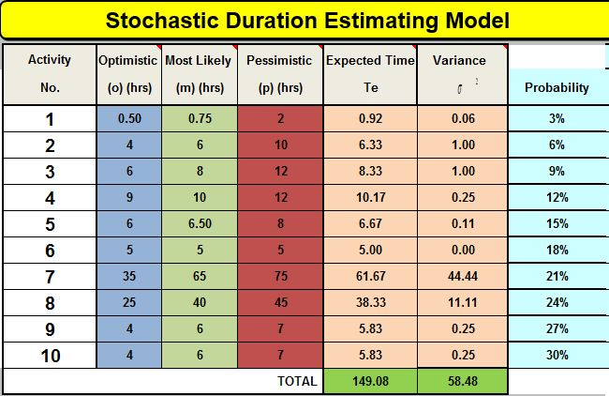

**References**

Roberts, F. (n.d.). How to: Hold a public meeting. Retrieved October 13, 2015, from <http://www.foe.co.uk/sites/default/files/downloads/cyw_33_hold_public_meeting.pdf>

Holding Effective Public Meetings. (2014, October 1). Retrieved October 13, 2015, from <http://plannersweb.com/2014/10/holding-effective-public-meetings/>

Vetrici, M. (2008). Software Project Duration Estimation Using Metrix Model. Retrieved October 13, 2015, from http://revistaie.ase.ro/content/47/16Marius Vetrici.pdf