Mr. Ian D. Smith, B.Sc., R.P.Bio

Professor – GISC9305 February 26, 2016

Save the Ficticious Fern (StFF) GISC-9308-D1  
235 Veggie Way

Veg ciry, ON

LOS 1R0

Dear Mr. Smith   
**RE: Submission: GISC9308-D2**

On behalf of Equilibrium Consulting, please accept this letter as the completion of the spatial analysis undertaken for the Re-Habitation of Finlay Fictitious Fern (*Osmunda Finlayensi)* Project***.*** The purpose of this analysis was to display suitable growth areas for the Finlay Fictitious Fern based on a Multi-Cretieria Evaluation (MCE) based on four weighted factors; slope, hill aspect, hill shade and soil type. Using available data, Niagara Region Soil Analysis (2002), Niagara College Horticulture Division Fern Analysis (2005), Niagara Region IKONOS Areal Imagery (2003) and The Endangered Ficticious Fern Review, Botany, R. J. (2011), an accurate model has been built displaying the suitable locations, primarily on the Glendale Campus escarpment. The Analysis has determined **96**, 4m by 4m, plots ideal for planting and over **300** potential plots for in-introduction.

The results of the findings can be found in the Technical Memorandum attached and in the attached Map documents. Following the assignment procedures, please find the required material attached. Should you have any questions regarding the enclosed documents, please contact Travis Vanos at your convenience at [Travis.vanos@gmail.com](mailto:travis.vanos@gmail.com). We graciously accept your comments and feedback.

Sincerely,

Travis Vanos

GIS/GM Candidate, Niagara College

T. V.

Enclosures: VanosTGISC-9305-D1.docx

**Technical Memorandum**

|  |  |  |
| --- | --- | --- |
| **Project:** | Introduction to ArcGIS Spatial Analyst extension | |
| **Client:** | Mr. Ian D. Smith | **Prepared By:** Travis Vanos |
| **Subject:** | GISC9308 – Spatial Analysis | |
| **Date:** | February 26, 2016 | GISC93058-D2 |

1. Introduction

This Technical Memorandum presents the findings and final map set of the spatial analysis undertaken for the Re-introduction of the Finlay’s Fabulous Fictitious Fern (*Osmunda Finlayensis*). Niagara College’s horticultural group, along with the environmental restoration group had the foresight to collect specimens of the fern for propagation and eventually re-introduce the species into its natural habitat. Equilibrium consulting has undertaken a spatial analysis to determine the ideal placement for introduction. The spatial analysis was completed as a Multi-criteria Evaluation (MCE) of four quintessential factors determining the growth of the fern species. The criteria is as follows: Slope, Aspect, Hill shade and Soil composition.

* 1. Study Area

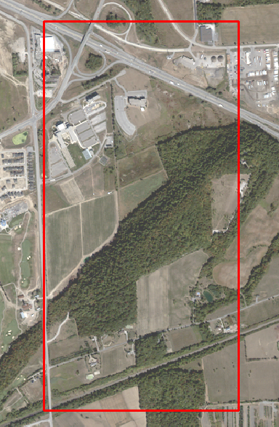

Figure 1: Study Area of Finlay’s Fern Re-Introduction

2. Methodology

The data, when presented, needed adjustments to display the accurate information and slight modification. The soil layer (GC_Soil) was moved in relation to the IKONOS Areal imagery provided. Furthermore, the projection was using NAD 1927 and this was corrected to NAD 1983 Zone 17N. The provided base map, Niagara Region IKONOS Imagery (2003) was imported and can be seen on all layouts for personal reference. After the data was corrected, all applicable files were added to a file geo-database that was used for further use. This database was used as the default workspace. Finally, the resolution was adjusted to 4m by 4m to account for the plotting area of the fern species.

2.1 Multi-criteria Evaluation

Using the tools available in ArcGIS 10.3 the analysis of the fern introduction was mapped in Model Builder under a new toolbox in spatial analysis called “Fern Spatial Analysis Tools”. There were two models used for the assessment, **Fern_MCE_Overlay** and **Fern_Fuzzy_Overlay**. The models of these can be seen in figure 2 and figure 3 respectively.

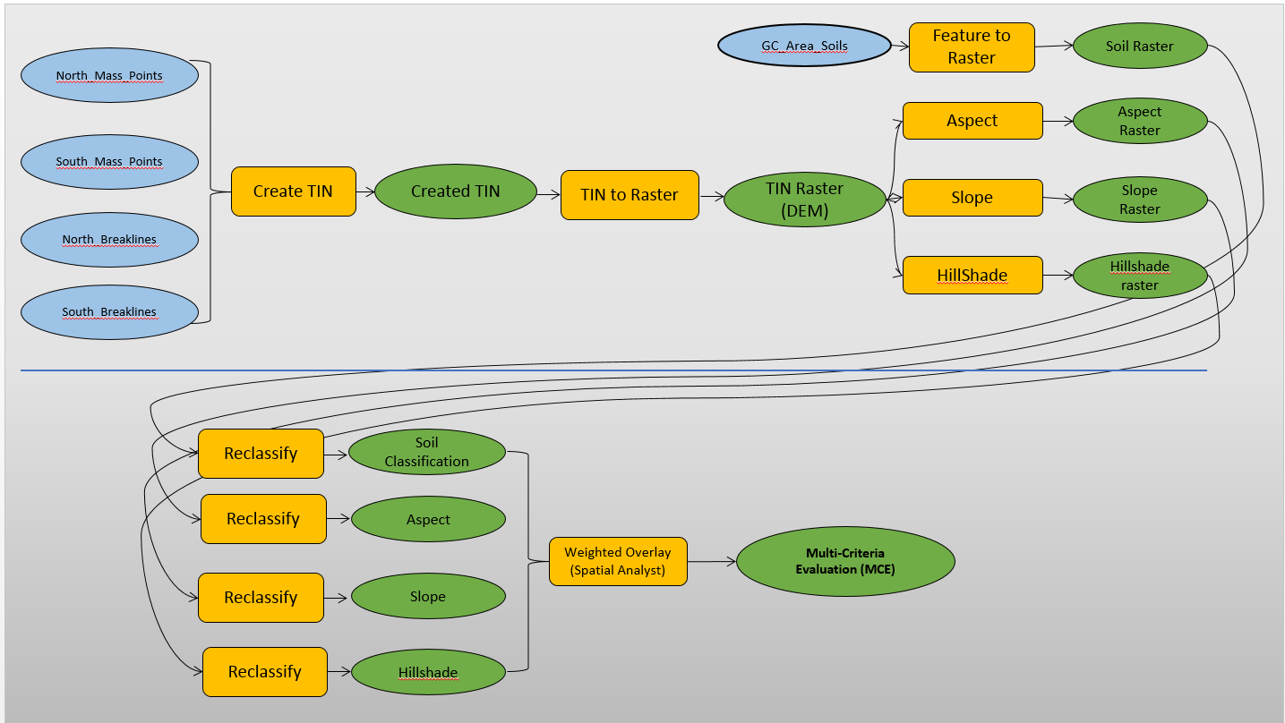

Figure 2: Multi-Criteria Evaluation Model

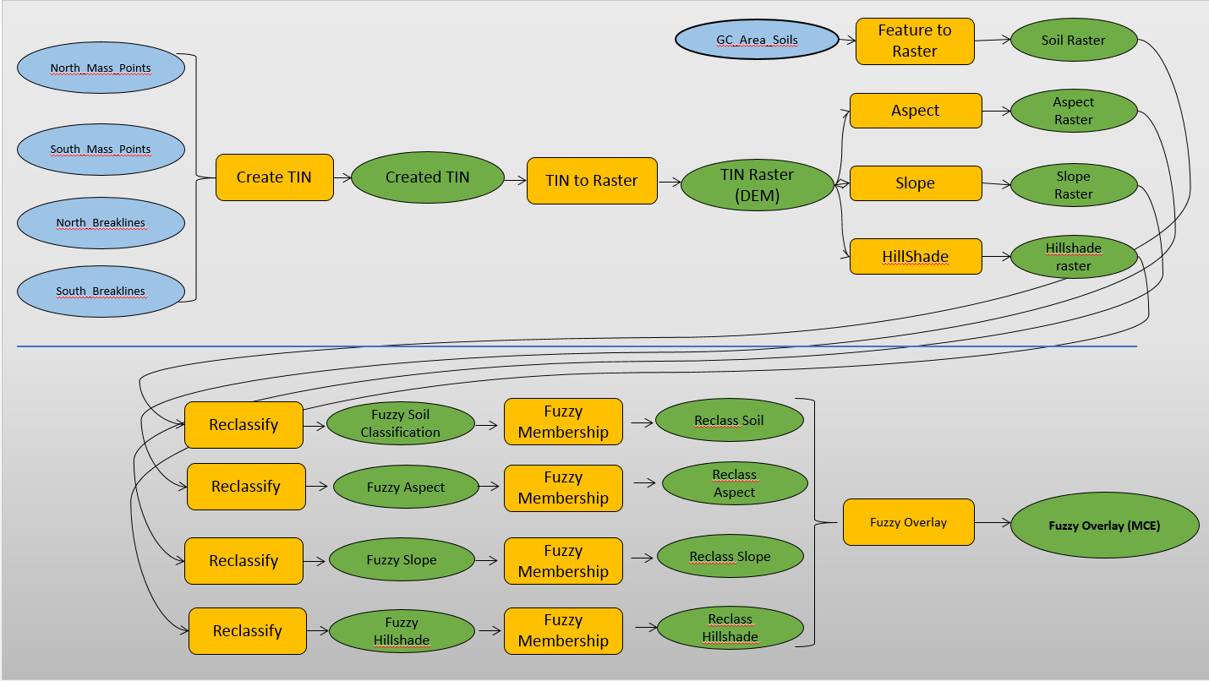

Figure 3: Fuzzy Overlay Model

2.2 Criteria for Analysis

The Niagara College horticultural group, along with the environmental restoration group had the foresight to collect specimens of the fern for propagation and eventual reintroduction into its natural habitat. The following criteria was taken into account for the evaluation of the weighted models: Slope, Aspect, Hill shade and Soil type. These criteria elements were obtained through the research and experimentation of the Niagara College Horticulture group as well as Dr. Botany Bob, The Endangered Fictitious Fern Review. The following tables outline the suitability for each of the criteria elements.

Table 1 Hill Shade Suitability

|  |  |
| --- | --- |
| **Degree of inclination** | **Suitability** |
| 0 ° - 180 ° | No Growth |
| 180 ° - 195 ° | Sparse Growth |
| 195 ° - 220 ° | Thriving |
| 220 ° - 235 ° | Sparse Growth |
| 235 ° - 255 ° | No Growth |

Table 2 Aspect Suitability

|  |  |
| --- | --- |
| **Degree of inclination** | **Suitability** |
| 247 ° - 292.5 ° | Sparse Growth |
| 292.5 ° - 337.5 ° | Thriving |
| 337.5 ° - 360° | Sparse Growth |

Table 3 Slope Suitability

|  |  |
| --- | --- |
| **Slope** | **Suitability** |
| 0 ° - 20 ° | No Growth |
| 20 ° - 35 ° | Sparse Growth |
| 35 ° - 45 ° | Will Grow |
| 45 ° - 55 ° | Thriving |
| 55 ° - 65 ° | Sparse Growth |
| 65 ° - 90 ° | No Growth |

Table 4 Soil Type Suitability

|  |  |
| --- | --- |
| **Soil Type** | **Suitability** |
| Escarpment | Thrive |
| Toledo | Will Grow |
| Cashel | Will Grow |
| Beverly | Sparse Growth |
| Peel | Sparse Growth |
| Haldimand | No Growth |
| Lincoln | No Growth |
| Not Mapped | No Growth |

Using the suitability categories above, the according Raster Images were created that show the potential growth for each category and areas are outlined for suitability of. The Suitability for each criteria element can be seen in Figure 4. The subsequent raters were used in the weighted overlay based on the weight assigned to each Suitability category.   
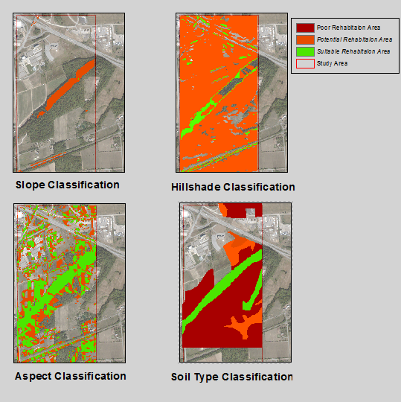

Figure 4 Suitability for Criteria Elements

2.3 Multi-criteria Results

Using the criteria for classification, a weighted matrix was created for the approximate weighting of each category, “The Slope criterion is twice as important as Slope direction, while Slope is three times as important as Soil Type. Soil Type and Hillshade share the same importance” (Smith, 2015).

Table 5 Criteria Weighting Matrix

|  |  |  |  |  |
| --- | --- | --- | --- | --- |
|  | Slope | Aspect | Hill Shade | Soil |
| Slope | 1 | 2 | 3 | 3 |
| Aspect | 1/2 | 1 | 1 2/3 | 1 2/3 |
| Hill Shade | 1/3 | 3/5 | 1 | 1 |
| Soil | 1/3 | 3/5 | 1 | 1 |
|  | 2.17 | 4.18 | 6.70 | 6.70 |

Using the values above, another matrix was created using the initial weight divided by the column total to achieve a final set of values. However, the values seen in Table 6 must be adjusted as ArcMap does not accept as many decimal values as stated below.

Table 6 Corrected Matrix - Final Values

|  |  |  |  |  |  |
| --- | --- | --- | --- | --- | --- |
|  | Slope | Aspect | Hill Shade | Soil |  |
| Slope | 0.4615 | 0.4789 | 0.4478 | 0.4478 | 1.00 |
| Aspect | 0.2308 | 0.2394 | 0.2537 | 0.2537 | 1.00 |
| Hill Shade | 0.1538 | 0.1408 | 0.1493 | 0.1493 | 1.00 |
| Soil | 0.1538 | 0.1408 | 0.1493 | 0.1493 | 1.00 |
|  | 1.00 | 1.00 | 1.00 | 1.00 |  |

The final values used in the criteria are:

|  |  |
| --- | --- |
| Slope | 46% |
| Aspect | 24% |
| Hill Shade | 15% |
| Soil | 15% |
| total | 100% |

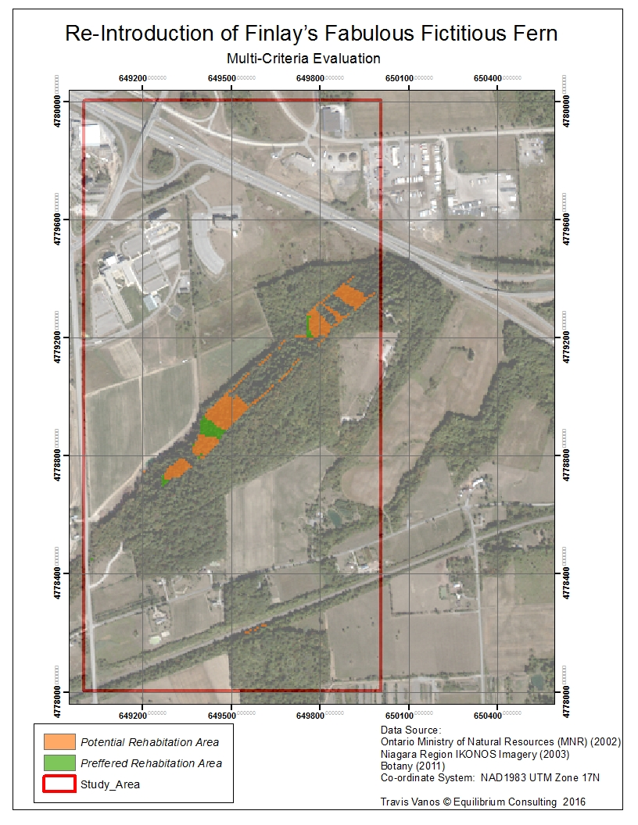

Figure 5 Re-Introduction of Finlay’s Fabulous Fictitious Fern

2.4 Fuzzy Overlay analysis

Looking for more accurate modelling, a Fuzzy Overlay was created after re-classifying the created raster data-sets from the TIN Digital Elevation Model (DEM). Each criteria element was reclassified in a ***Fuzzy Membership.*** The slope Fuzzy Membership used a Gaussian membership type as this method most accurately descripted the “wave” pattern of the slope classification. A slope of 0- 20 ˚is deemed unsuitable to grow the fern (Smith, 2015), as is a slope that is too steep, so either side of the model are deemed unusable.

Aspect and Hill Shade used a near-membership classification. Both criteria were accepted with default values as they were suitable for the accuracy of the model. Lastly, the soil uses a Linear-membership type for the soil types.

After the Fuzzy re-classification, the layers were assigned unique values to display the areas of each category that were found suitable as seen in Figure 6.

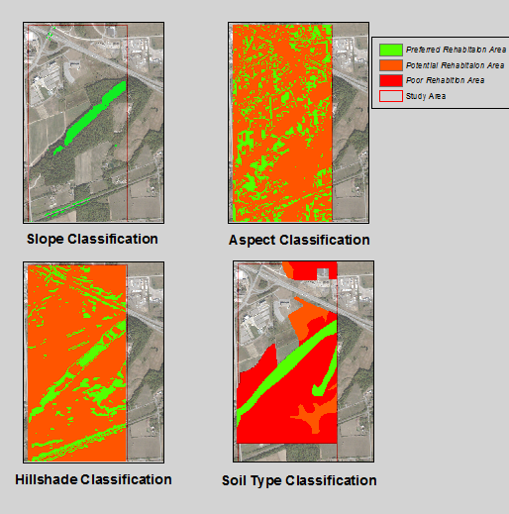

Figure 6 Fuzzy Re-Classification of Criteria Elements

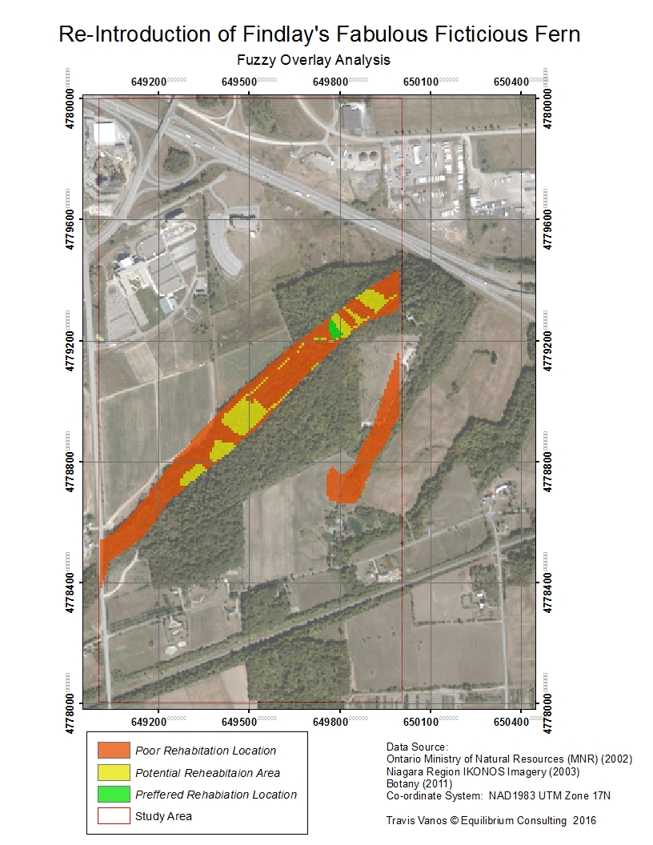

Figure 7 Re-Introduction of Finlay's Fabulous Fictitious Fern

3. Conclusion

The results have been presented and Equilibrium Conculting has found enough suitable locations for re-introduction of the Finlay’s Fabulous Fictitious Fern (Osmunda Finlayensis). Equilibrium Consulting set out to find potential plots for **110** fern plants. Using both Weighted overlay and Fuzzy Overlay methods, the mothods have both yielded similar results in the location of applicable plots for re-introduction. There is **110** ferns to be planted. Of the data presented there are **96** preferred plots for planting the species and over **300** potential planting location. Maps of the re-habitation analysis can be found in Appendix I and II.

4. Bibliography

Botany, R. J. (2011). The Life Cycle of Osmunda Finlayensis and associated fern assemblages. The

Endangered Ficticious Fern Review, 19-31.

Smith, I. D. (2015). GISC308 Deliverable D2: Introduction to ArcGIS Spatial Analyst extension (Terms of Reference). Niagara College: Niagara-on-the-Lake, Ontario.