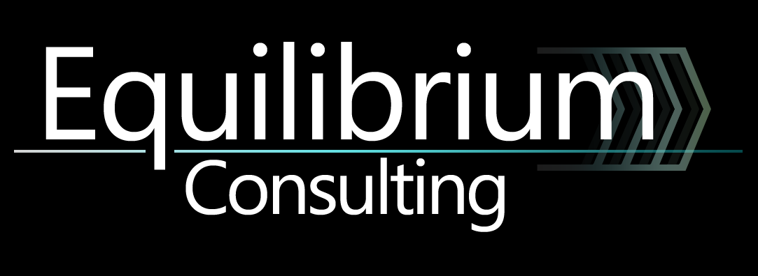

Travis Vanos

Group 3

GISC9314-D2

Compass Traverse Survey



Mr. Xinxia Jiang

Professor – GISC9314 October 22, 2015  
Niagara College GISC9314-D2   
135 Taylor Road  
Niagara-on-the-lake, ON  
L0S 1J0

Dear Mr. Xinxia Jiang   
  
Please accept this letter as our formal submission of Assignment two: GISC9314-D2 Pace and Compass Traverse Survey – Group 3 for Travis Vanos and David Toews – Travis Vanos (45% Contribution), David Toews (55% Contribution). The works were completed with Travis Vanos as the Party chief/Pacer, David Toews as Pacer/Compass Observer and Barbara Tomczyk as Pacer/Reader. The purpose of this assignment is to successfully gain the required skills to preform, map and calculate corrections for a completed Compass Traverse Survey. The following sections will be fulfilling the deliverables as outlined in the GISC9314-D2 requirements. The following procedures to be covered include, but are not limited to:

* Practicing the proper surveying principles and field not booking standards
* Preforming a controlled loop traverse survey, and plotting a map from raw data
* Correcting the raw data and plotting a final map

Following the assignment procedures, please find the required material attached. Should you have any questions regarding the enclosed documents, please contact Travis Vanos or David Toews at your convenience at [travis.vanos@gmail.com](mailto:travis.vanos@gmail.com) or david.toews@gmail.com. We eagerly await your comments and suggestions.  
  
Sincerely,

Travis Vanos, David Toews  
 Party Chief - GIS/GM Candidate, Niagara College  
 T. V., D.T.

Enclosures: VANOS_TOEWS-GISC9314-D2

# Executive Summary

**The purpose of this assignment is to successfully gain the required skills to preform and map a Compass Traverse Survey (CTS). The work encompasses the data collected using proper surveying methods discussed in class and following the Compass Traverse Survey procedures as outlined in the GISC9314-D2 deliverables. The following procedures will be covered, including, but not limited to:**

* **Practicing the proper surveying principles and field note booking standards**
* **Preforming a controlled loop traverse survey, and plotting a map from raw data**
* **Correcting the raw data and plotting a final map**

**The outcome will be a foundation of skills needed to perform a Compass Traverse Survey and build upon skills such as team working, preparing and planning, decision-making, measuring angles and distances of traverses, establishing control points, performing checks for accuracy, recording field notes, and reducing errors in measurements.**

Table of Contents

Contents

Executive Summary i

List of Figures iii

1.1 Introduction 1

1.1.1 Raw Collected Data 2

1.2 Raw Collected Pacing Data 3

1.2.1 Member’s Pacing Length 3

1.3 Degree of Error of Interior Angles 5

1.3.1 Raw Data Pacing Lengths 5

1.3.2 Balanced Interior Angle Corrections 7

1.3.3 Angle and Azimuth Corrections 8

1.3.4 Corrected Bearings 8

1.3.5 Error of Closure and Latitudes/Departures Corrections 9

1.4 Results 12

1.4.1 Final Coordinates (UTM) (Cartesian) 12

1.4.2 Interior Angles Verification 12

1.5 Conclusions 15

1.5.1 Final Corrected Data and Plot 15

1.5.2 Closing 16

## List of Figures

*Figure 1 Closed Traverse Survey of Niagara Grounds (Raw Data) 2*

*Figure 2 Member's Pacing Length (avg) 3*

*Figure 3 Each Member's Pacing 4*

*Figure 4 Results from Field Note Booking for Each Member's Pacing 4*

*Figure 5 Calculate Average Azimuth and Length of Each Traverse Leg 6*

*Figure 6 Traverse Leg Length 6*

*Figure 7 Degree of Interior Angle Error 7*

*Figure 8 Correct Interior Angles 8*

*Figure 9 Corrected Azimuths 8*

*Figure 10 Corrected Bearing (o) 8*

*Figure 11 Calculated latitudes and Departures 9*

*Figure 12 Calculated Latitude/Departure/Closure Errorr 9*

*Figure 13 New Latitude and Departure Corrections 10*

*Figure 14 Calculated latitude & departure with corrections 10*

*Figure 15 Calculated Coordinates of Points A, B, C, D, & E 11*

*Figure 16 Final Calculated Coordinates for traverse 12*

*Figure 17 ΔBMAB 13*

*Figure 18 ΔBMBC 13*

*Figure 19 ΔBMCD 14*

*Figure 20 ΔBMDE 14*

*Figure 21 Comparison of ArcMap and Corrected Interior Angles 14*

*Figure 22CLOSED TRAVERSE SURVEY OF NIAGARA COLLEGE (CORRECTED DATA) 15*

# Introduction

The members of Equilibrium Consulting Ltd. surveying team have completed a Compass Traverse Survey (CTS) and consolidated the results in this report. Following proper surveying principles and field note booking, data has been collected and corrected for proper measurements in reference to the Benchmark Point (BM). The benchmark has a known coordinate position, as seen in Figure *1* Closed Traverse Survey of Niagara Grounds (Raw Data), which corresponds to the south-east corner of the residence building at ground level.  
  
The raw and collected data has been overlaid atop of panchromatic imagery from 2006 (10cm) by the Municipality of Niagara. The spatial reference system is UTM NAD 83, 17N, estimated to the nearest centimeter from the digital aerial photography.

## 1.1.1 Raw Collected Data

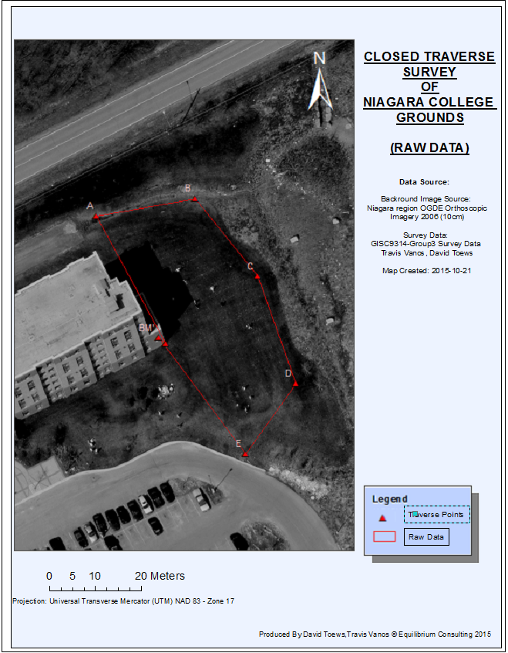

Figure Closed Traverse Survey of Niagara Grounds (Raw Data)

# 1.2 Raw Collected Pacing Data

## 1.2.1 Member’s Pacing Length

In the field, the team member’s paces were measured as an average length per pace calculated by measuring the length the fiberglass tape after 15 paces and dividing by 15 to get the average length of each pace. *Figure 2* Member's Pacing Length (avg) shows the calculated length of the average to be used for the pacing to measure the distance between the two traverse stations.

|  |
| --- |
| Figure Member's Pacing Length (avg) |

Once the preliminary, average pace length was established, each member rotated in pacing forwards and backwards between the two traverse stations (traverse Leg (L)) after measuring the azimuth. The paces were measured to the nearest half pace, and the azimuths were measured to the nearest degree. The recorded measurements are shown in

|  |
| --- |
| Figure Each Member's Pacing |

|  |
| --- |
| Figure Results from Field Note Booking for Each Member's Pacing |

# 1.3 Degree of Error of Interior Angles

## 1.3.1 Raw Data Pacing Lengths

After the average pacing length has been recorded for each member, pacing could commence on the lengths between the traverse stations. *Figure* *4* shows the lengths of the traverse leg both forwards and backwards for each member.

|  |
| --- |
| *Figure 5 Calculate Average Azimuth and Length of Each Traverse Leg* |

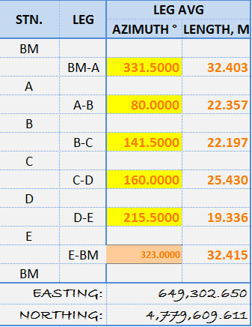Figure *5* Traverse Leg Length shows the averaged values of both the leg length and azimuth to give us our full polygon feature. From traverse station E to the Benchmark (BM), there is a known error of 13° between the forward and backward azimuth, so we have chosen to use only the forward azimuth. This is due to the fact that the forward measurement method gives much greater confidence.

Figure 6 Traverse Leg Length

## 1.3.2 Balanced Interior Angle Corrections

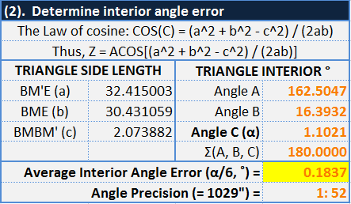The interior angles of our raw data were determined under the assumption that the traverse ended at the same place it started. The traverse was then plotted in ArcMap, and the sides of the error triangle were measured. Using inverse triangle trigonometry of COS, (ACOS[(a2 + b2 – c2) / (2ac)] ) we can then determine the margin of error **“C” (α)**, as shown in Figure *6* Degree of Interior Angle Error. Distributing the margin of error to the 6 angles of the polygon yields the angle error as 0.1837 ˚ to correct the traverse, as calculated in *Figure 7* Degree of Interior Angle Error***.***. Since our actual interior angles were larger than 720°, the correction had to be subtracted from each interior angle. In *Figure 8* Correct Interior Angles**.**, the azimuth from BM to A is set, and the error is accounted at each successive vertex. Since the error had to be subtracted from the interior angles, the error had to be added to the azimuths because the azimuths are on the outside of the polygon. The error measurement also compounds at each succeeding vertex because the azimuth must be corrected for each preceding correction.

Figure 7 Degree of Interior Angle Error

## 1.3.3 Angle and Azimuth Corrections

|  |  |
| --- | --- |
| Figure Correct Interior Angles | Figure Corrected Azimuths |

## 1.3.4 Corrected Bearings

The correct bearing can now be calculated with the corrected azimuth degree, as shown in Figure *9* Corrected Bearing (o).

|  |
| --- |
| Figure Corrected Bearing (o) |

## 1.3.5 Error of Closure and Latitudes/Departures Corrections

The latitudes and departures are calculated by projecting the line segment between the two points onto both a horizontal and vertical axis. The horizontal portion is the departure and the vertical portion is the latitude. The results of these projections is in Figure *10* Calculated latitudes and Departures. Figure *11* Calculated Latitude/Departure/Closure Error shows the total difference between the latitude measurements in opposite directions, as well as the departure measurements. This is the error contained in the leg length measurements taken, and so each leg must be corrected proportionally to its length. These distributed corrections are shown in Figure *12* New Latitude and Departure Corrections. Finally, these corrections are applied to the legs to produce the balanced latitudes and departures in Figure *13* Calculated latitude & departure with corrections. Finally, beginning with the known location of the benchmark, the UTM coordinates of each point can be calculated using the latitudes and departures, as shown in Figure *14* Calculated Coordinates of Points A, B, C, D, & E.

|  |  |
| --- | --- |
| **2) Calculated latitudes and Departures**  Calculated Latitude and Departures to show our displacement, in our case, too far North and West. | Figure Calculated latitudes and Departures |
| **3) Calculated Latitude/Departure/Closure**  **Errors & Precision** ELat & EDep values show too much North & West  (+N +(-S)) & (+E+(-W)) | Figure Calculated Latitude/Departure/Closure Errorr |
| **4) New Latitude and Departure with Corrections**  Distributed error correction  South and North (=LegLen/TraversePerimeter)*Elat  East and West CorrectionDep (=LegLen/TraversePerimeter)*Edep | Figure New Latitude and Departure Corrections |
| **5) Calculated latitude & departure with corrections** | Figure Calculated latitude & departure with corrections |

|  |
| --- |
| **Final Points A, B, C, D, & E** Benchmark (BM) is known (649302.650, 4779609.611)  Figure Calculated Coordinates of Points A, B, C, D, & E |

# 1.4 Results

## 1.4.1 Final Coordinates (UTM) (Cartesian)

|  |
| --- |
| Figure 16 Final Calculated Coordinates for traverse |

*Figure 16* Final Calculated Coordinates for traverse displays the final UTM coordinates, as well as the meter-based latitude and departures from the benchmark.

## 1.4.2 Interior Angles Verification

The final traverse was mapped in ArcGIS and divided into 4 triangles, whose interior angles are calculated in: Figure *17* ΔBMAB, Figure *18* ΔBMBC, Figure *19* ΔBMCD, and Figure *20* ΔBMDE. These triangle interior angles are collected to equal the interior angles of the traverse, and compared to the corrected interior angles in Figure *21* Comparison of ArcMap and Corrected Interior Angles.

|  |
| --- |
| Figure ΔBMAB |
| Figure ΔBMBC |

|  |
| --- |
| Figure ΔBMCD |
| Figure ΔBMDE |
| Figure Comparison of ArcMap and Corrected Interior Angles |

# 1.5 Conclusions

## 1.5.1 Final Corrected Data and Plot

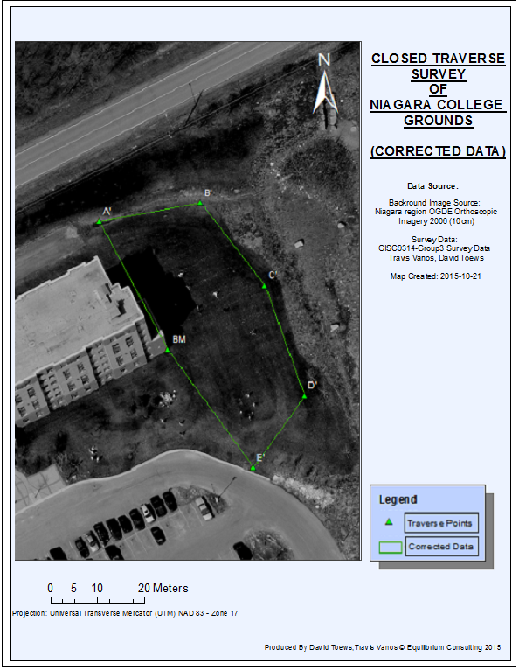

Figure CLOSED TRAVERSE SURVEY OF NIAGARA COLLEGE (CORRECTED DATA)

## 1.5.2 Closing

The completed findings of the Compass Traverse Survey (CTS) has been presented. Following proper surveying principles and field note booking, data has been collected and corrected for proper measurements in reference to the Benchmark Point (BM). The method of calculation by pace length proved to be prone to a degree of error that would skew the final traverse perimeter. Distributing the margin of error using the Compass Rule and applying the corrections has yielded a final map as shown in Figure *22CLOSED* TRAVERSE SURVEY OF NIAGARA COLLEGE (CORRECTED DATA).