

Travis Vanos

VANOS-GISC9301-D1

Using ArcMap and ArcCatalog



Mrs. Janet Finlay

Professor – GISC9301 October 9, 2015  
Niagara College GISC9301-D1   
135 Taylor Road  
Niagara-on-the-lake, ON  
L0S 1J0

Dear Mrs. Finlay  
Re: Submission GISC GISC9301-D1

Please accept this letter as my formal submission of Assignment One: GISC9301-D1 Using ArcMap and ArcCatalog. The purpose of this assignment is to successfully gain the basic knowledge of both ArcMap and ArcCatalog components of ArcGIS. The following questions will be referencing the assigned chapters 3, 4 and 7 of “Getting to Know ArcGis” by Michael Law and Amy Collins. Several tasks common in the ArcMap and ArcCatalog workflow will be covered including, but not limited to:

* To understand the concepts of layer, attribute,
* To be familiar with map navigation,
* To browse and search for map data,
* To add data to a map.

Following the according steps please find the required material sent electronically. Should you have any questions regarding the enclosed documents, or if there are technical issues regarding the files please contact me at your convenience at (937)647 3746 or email at travis.vanos@gmail.com. I eagerly await your comments and suggestions.  
  
Sincerely,

Travis Vanos CCNA, CISSP, A+  
 GIS/Operations Specialist  
 T. V

Enclosures: VANOS-GISC9301-D1

Table of Contents

Contents

Executive Summary ii

Chapter 3 1

a. What type of feature does the ‘Cities’ layer Contain? 1

b. What country is Quito in? 2

c. What is one procedure to make the city labels available when the scale is larger than a given ratio? 3

d. What type of feature is contained in the ‘Countries’ layer? 4

e. How many records are contained, in total, in the table ‘Attributes of Cities > 1 Million’? 4

f. How many fields are there in the table ‘Attributes of Cities> 1 Milliion’? 5

g. Describe (in no more than one paragraph) how you could determine the mean precipitation (cont.) 5

Chapter 4 …………………………………..6

a. What type of file (what type of data) is the file World.mdb ………………………………………………………………….6

b. What is the countries component of World.mdb known as (generically)? 6

c. What type of file (what type of data) is the file ex04c.mxd? 7

d. What coordinate system is used for the ‘countries’ personal geodatabase (hint: properties)? 7

e. What sorts of AutoCAD file types can ArcCatalog ‘recognize’? 8

f. What type of file is US_Cities_PM? 8

g. What do you suppose ArcMap and/or ArcCatalog would do if you attempted (cont.) 8

Chapter 7 9

a. At a scale of 1:1,000,000 what would be the most appropriate symbol (cont.) 9

b. At a scale of 1:200 what would be the most appropriate symbol to represent (cont.) 9

c. You are given a map of the Niagara Region that is divided into 12 distinct areas (cont.). 9

d. You are retained by Niagara College’s Landscape Design team to assist with the visualization of new facilities to be constructed at the Glendale Campus in Niagara-On-The-Lake. (cont.) 10

Figure One: . 11

Figure Two: 11

# Executive Summary

**The purpose of this assignment is to successfully gain the basic knowledge of both ArcMap and ArcCatalog components of ArcGIS. The following questions will be referencing the assigned chapters 3, 4 and 7 of “Getting to Know ArcGis” by Michael Law and Amy Collins. Several tasks common in the ArcMap and ArcCatalog workflow will be covered including, but not limited to:**

* **To understand the concepts of layer, attribute,**
* **To be familiar with map navigation,**
* **To browse and search for map data,**
* **To add data to a map.**
* **To gain the ability change existing symbology in ArcGIS,**
* **To symbolize features by attribute (categorically),**
* **To use ‘styles’,**
* **To create layer (*.lyr) files,**
* **To symbolize Rasters effectively.**

**The end result will be a foundation of skills needed to develop and operate the ArcGIS suite at a proficient working level.**

# Chapter 3

## **What type of feature does the ‘Cities’ layer Contain?**

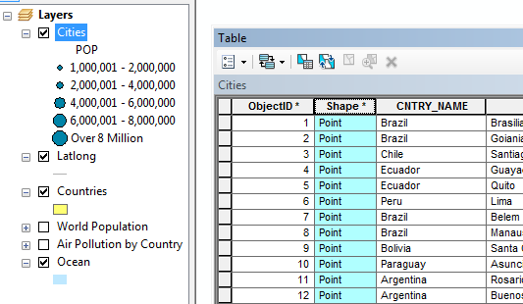

Figure

**The ‘Cities’ layer contain point features representing world countries including demographic data.**

## **What country is Quito in?**

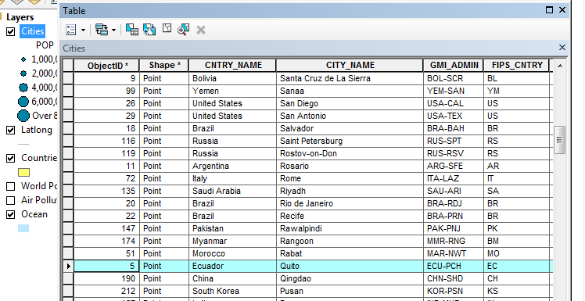

Figure

**The city Quito is in Equator. This was discovered by selecting by attribute and querying “city name = “Quito” “ in countries layer.**

## **What is one procedure to make the city labels available when the scale is larger than a given ratio?**

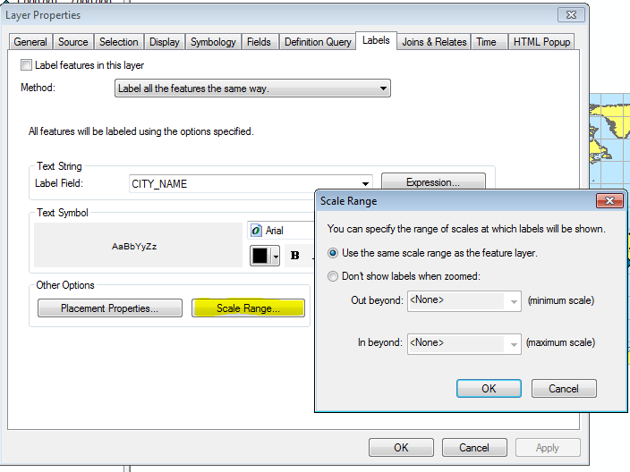

Figure

**To make city labels available with a larger scale you can select Layer properties > scale range labels will be visible only at scales larger than the given ratio.**

## **What type of feature is contained in the ‘Countries’ layer?**

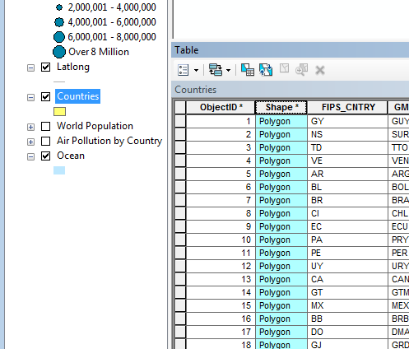

Figure

**Countries are a polygon feature as they require borders**

## **How many records are contained, in total, in the table ‘Attributes of Cities > 1 Million’?**

**After running the query there are 256 cities. This can be noted at the bottom of the attribute table when looking at the records and the number shown ( x out of 256 selected).**

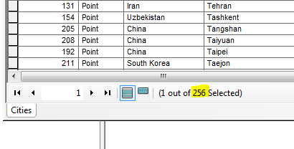

Figure

## **How many fields are there in the table ‘Attributes of Cities> 1 Milliion’?**

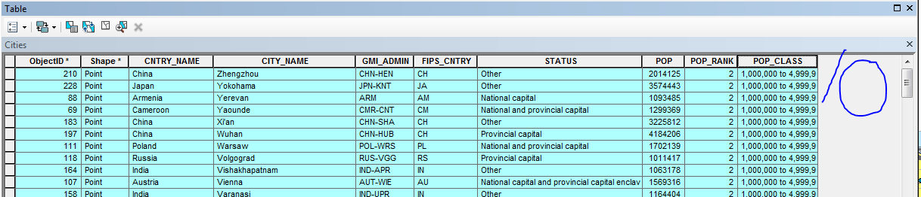

Figure

**Within the table there are 10 fields (columns)**

## **Describe (in no more than one paragraph) how you could determine the mean precipitation for the cities in just Australia using ArcMap.**

**Cities will be point features with attributes corresponding to each. With a table created with attributes, assuming we are already looking at cities contained within the borders of Australia, we then select the desired field to use for our field calculation. After the field has been chosen (Precipitation), select all the rows and right click > select Statistics. This statistic window will show various mathematical calculations (Minimum, maximum, mean, sum and standard deviations) for reference of our desired result.**

# Chapter 4

## **What type of file (what type of data) is the file World.mdb?**

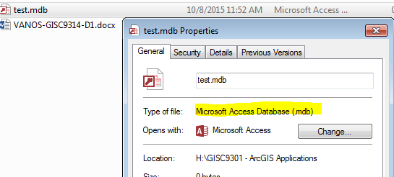

Figure

**The .mdb is a database file (MS Access). This file extension can contain geographic datasets or on-geographic information,**

## **What is the countries component of World.mdb known as (generically)?**



Figure

**The country component of World.gdb is a Feature Class.**

## **What type of file (what type of data) is the file ex04c.mxd?**

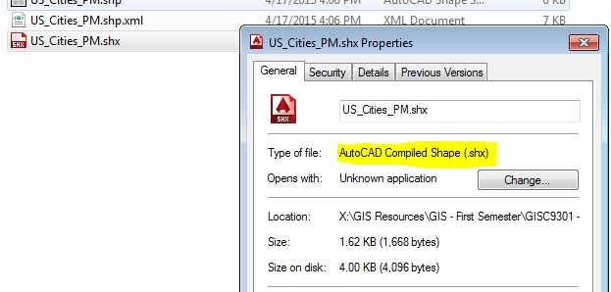

Figure

**The (.mxd) file type or map document file, contains the data referenced, no actual data, by the layer it contains.**

## **What coordinate system is used for the ‘countries’ personal geodatabase (hint: properties)?**

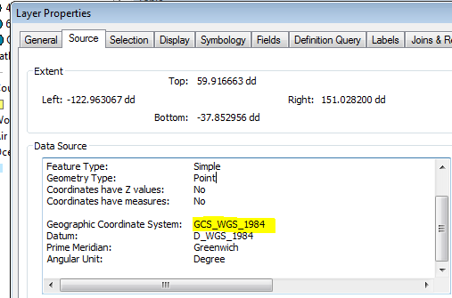

Figure

**The X, Y co-ordinate System used is GCS_WGS_1984 in this instance.**

## **What sorts of AutoCAD file types can ArcCatalog ‘recognize’?**

**AutoCAD can recognize DWG/DXF/DGN file extensions.**

## **What type of file is US_Cities_PM?**

**.Using ArcCatalog you can see US_Cities_PM is a shape file (.shp)**

## **What do you suppose ArcMap and/or ArcCatalog would do if you attempted to add data of a projection different from that of the data you have been working with (note that this is a question of pure speculation, as you have not been asked to do this. Do note, that ArcGIS was capable of managing reprojection to some extent – see the PowerPoint lecture 2 notes)?**

**ArcMap can temporarily project layers that have different co-ordinate systems, although the same is preferred, as long as they both have defined coordinate systems previously. This is known as “On-the-fly” projecting. Although this method is suitable for general mapping purposes, it is best to covert two to a common projection before you conduct any spatial or data queries.**

# Chapter 7

## **At a scale of 1:1,000,000 what would be the most appropriate symbol to represent (point, line or polygon) the Niagara College Glendale Campus? Why?**

**A point would be best to represent the college at this scale because no features can be seen from such a far distance and would be adequate to determine the general location.**

## **At a scale of 1:200 what would be the most appropriate symbol to represent (point, line or polygon) the Niagara College Glendale Campus? Why?**

**At the scale of 1:200 Niagara College can now be presented as a polygon feature as distinct forms and patterns can be recognized of the campus. At the scale we can notice much more detail and can achieve a reasonable level of accuracy.**

## **You are given a map of the Niagara Region that is divided into 12 distinct areas, known as ‘Area Municipalities’ (Niagara-On-The-Lake, Welland, St. Catharines, etc.) by the Governmental Health Department…. suggest a strategy for symbolizing and ultimately mapping the data given to you as listed above (no more than four paragraphs required to do so).**

**Having a layer already defined for the borders with the municipalities defined, we can then choose the appropriate scale for viewing. Looking at the ratio of blue jays to crows in the area I would look at the minimum and maximum of both and create a range according to the data. A pie chart of 2-bar bar graph can be used to show an obvious contrast to the two datasets. The chart of choice would include the data and two colours (blue for blue jays and red for crows for example) showing the number of infected for each species. Simply looking at the size and contrast between the two sets would give a good indicator, without even seeing the data, as to which area needed the attention.**

## **You are retained by Niagara College’s Landscape Design team to assist with the visualization of new facilities to be constructed at the Glendale Campus in Niagara-On-The-Lake. At the first meeting, one of the Landscape Architects ‘casually’ mentions to you that his firm paid for the creation of a digital photograph, 256 levels of grey scale (white through grey to black), of the campus. The aerial photography company expects to fly the mission to photograph the campus immediately. The landscape architect has already created an AutoCAD drawing with polygons for the new buildings (3 in all, all roughly the same size and shape) and lines for the new irrigation system. Two of the buildings are single story while the third is three stories in height. The irrigation system pipes are all 2 inches, 1 inch or 0.5 inches in diameter. As the College’s GIS consultant, suggest a strategy for symbolizing and ultimately mapping the data given to you as listed above (no more than four paragraphs required to do so).**

**As a first step, I would create a layer of the orthographic imagery to be used as an identifier for any obstacles or obvious challenges that may be faced when planning the new facilities. After this step and the best course of action has been set, the AutoCAD drawings (polygon feature class) with included polygons can be superseded over the Aerial imagery. A color scheme can be used for each of the buildings but, more pressing, is the symbology that would be used to determine the varying thickness of pipes.**

**Three different line features can be used to the different thicknesses for ease of identification for any engineers or project member. With a greyscale background used, bright colours such as yellow, blue and red would stand out quite visibly for easy identification due to the contrast.**

## **e.** **Look at the following historical map and discuss the following:**

### Figure One: Map dated circa 1801, entitled an “Indian Map of the Upper Missouri”; map was created by Europeans depicting the spatial knowledge of the aboriginal people within the headwaters of the Missouri River watershed

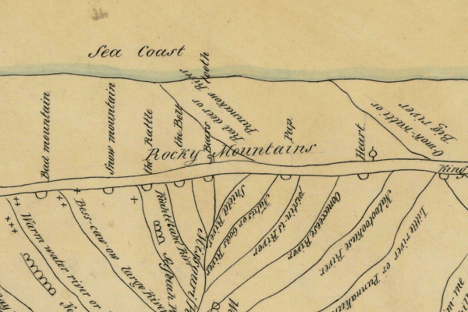

### Figure Two: Detail of the map noted in Figure One, above. The red polygon in Figure One is the area shown in Figure Two.

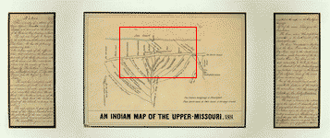

**Had the European explorers that created the map shown as Figures One and Two had access to ArcGIS, what ‘improvements’ for map symbology would you suggest that they have used? Please, only suggest symbology improvements for the data shown in the detailed map portion of Figure Two. Limit your answer to 3 paragraphs.**

**At first glance of this map you can spot many things that would be unacceptable in today’s technical age. The majority of river and roads are inconsistently labelled to cause the appearance of the map to be confusing to say the least. With no standard nomenclature or formatting the naming is illegible and unappealing. In addition, a scale is missing and knowing and distance and relationships would be a nightmare. After a scale is added there would be many changes with the feature’s sizes. The Rocky Mountains would appear much more diverse than the seeming even and narrow range assumed by this map.   
  
The native settlements on the map appear as single crosses with no legend of meaning or size for the settlement. Unbeknownst to the reader weather the crosses represent size or individual settlements.**

**To begin to rectify the readability of the area, names should be written with an equal direction and some sort of indication must be used to denote change in elevation. The settlements, the apparent reasoning behind the map, should show a reference of scale noting a larger symbol for a larger population or simply an individual cross for each settlement.**