Mb blubs had enough / MOOD

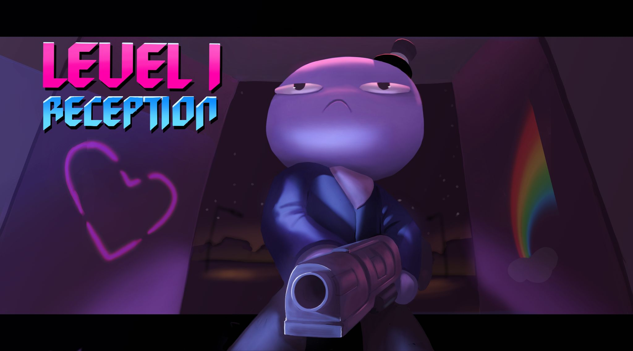

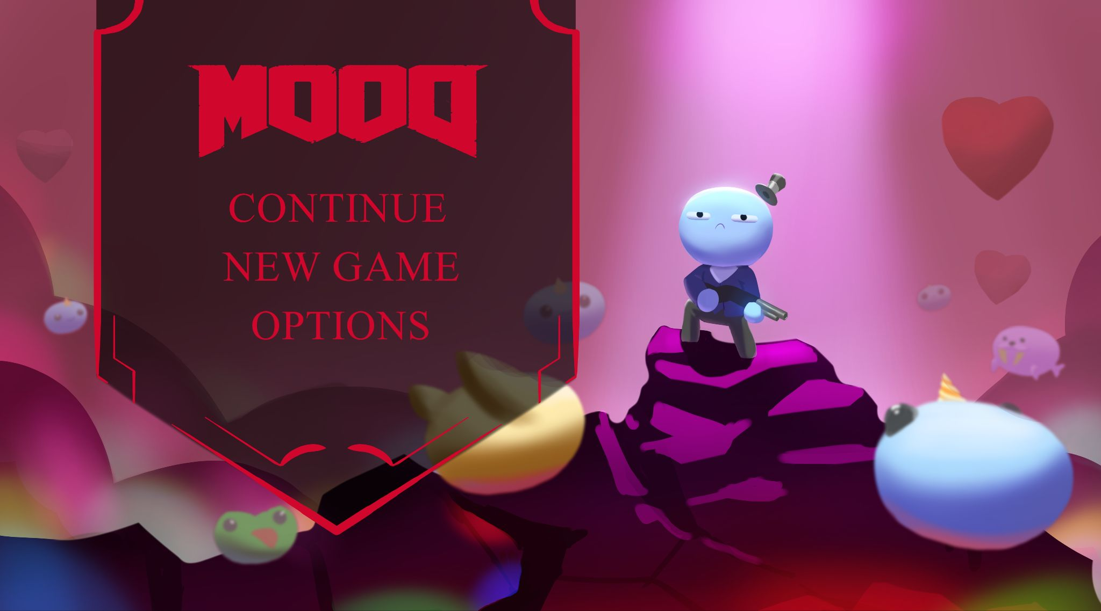

Rainbow factory spread happiness across the world, Mr Blubs isn’t having any of it

A top-down bullet-hell

Eldritch

An angel is sent by god to guard mortals from hell. It is sent to a forest rave where the music is spreading it’s influence. The mortals have turned into dark neon monsters addicted to blood. Battling through monsters, the angel follows the influence into a cave and instead of Satan, it is revealed to be an eldritch being from another world. The angel was sent there as a sacrifice.

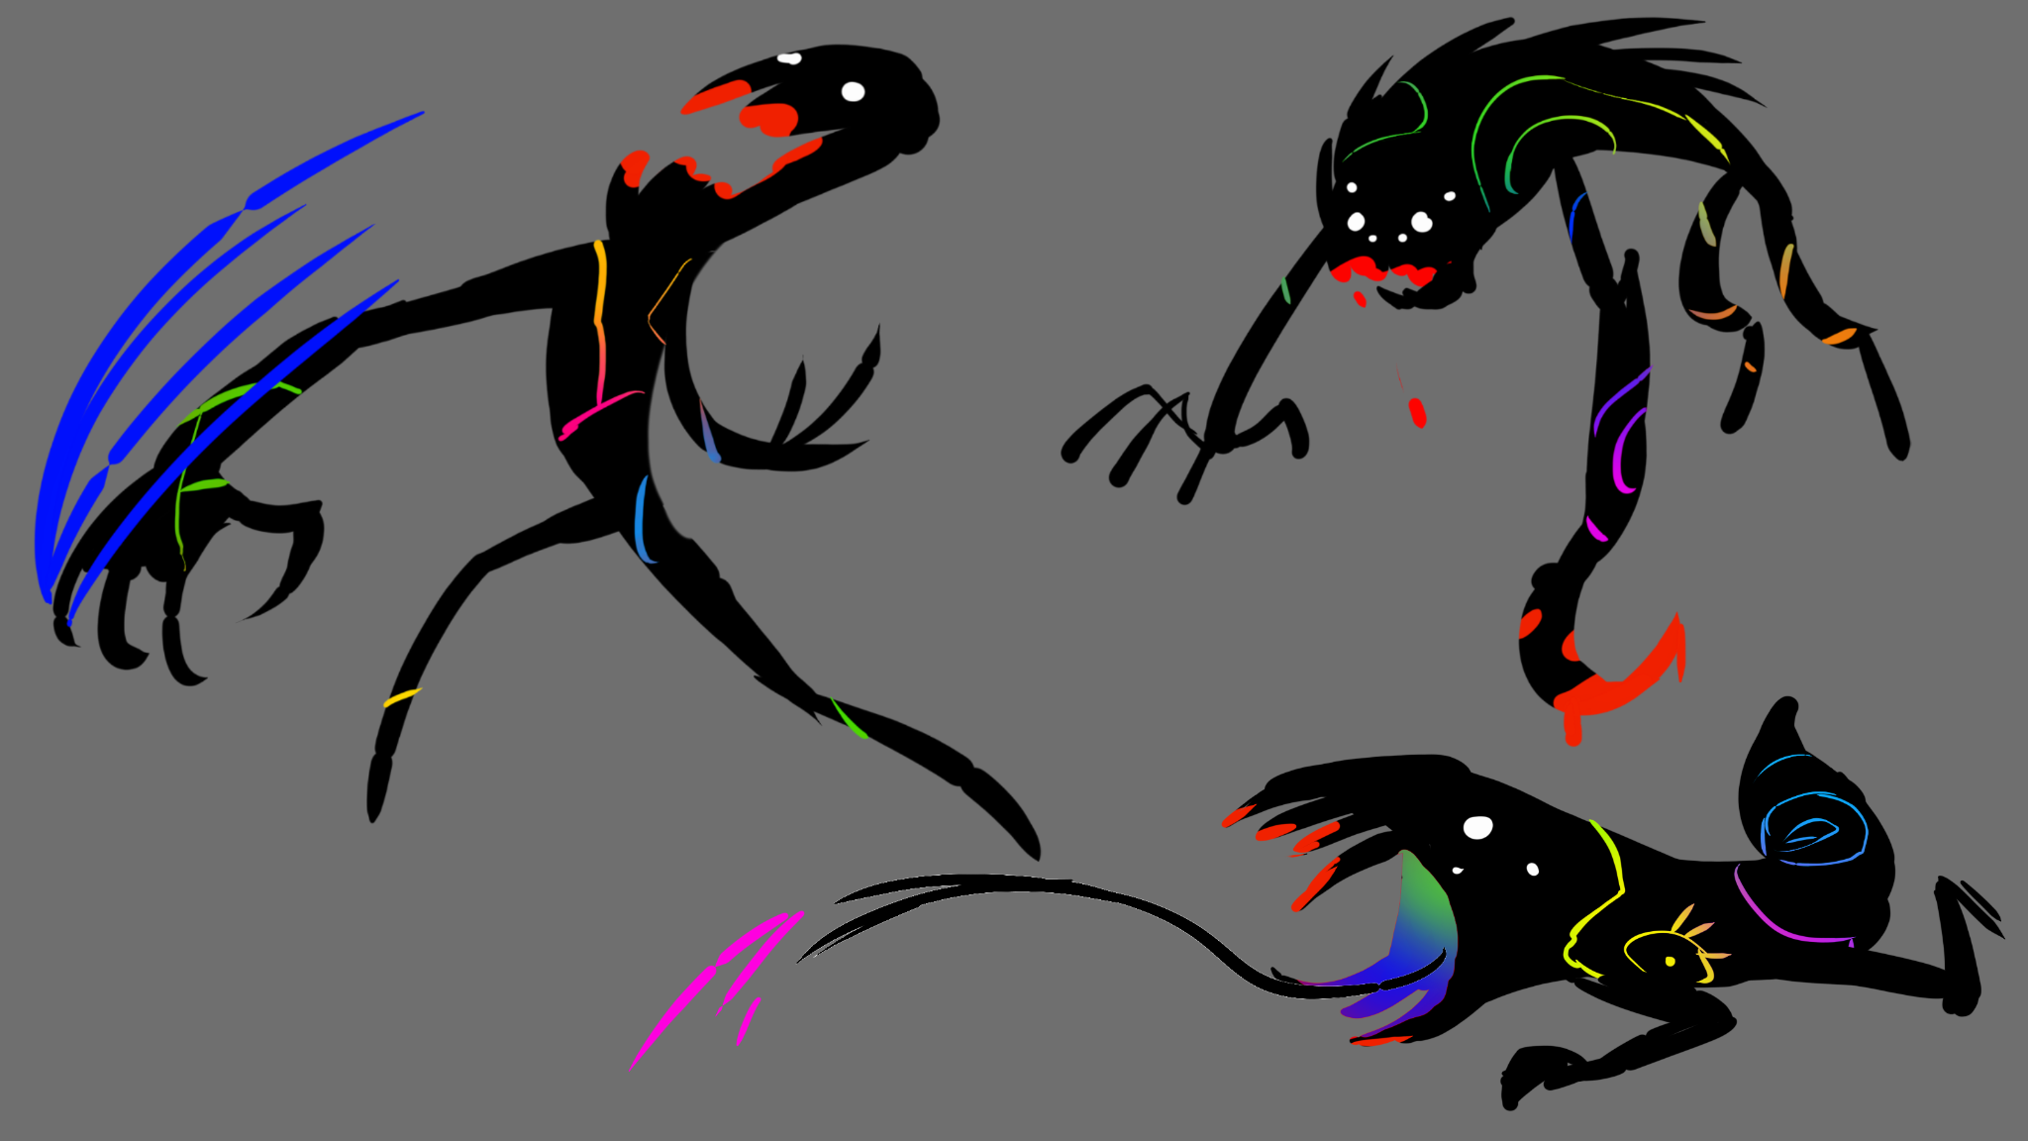

Wings

A puzzle platformer where the player is a small bird, when it climbs to the top of the tree it spreads its wings and flies.

