Contents

ADO.NET 2

1.1 Data model 2

1.2 SqlServer data provider 8

1.2.1 Aanmaken project 8

1.2.2 Connection 9

1.2.3 Command en Parameters 10

1.2.4 Adapter en CommandBuilder 12

1.2.5 Transaction 14

1.3 Generic 15

1.3.1 Aanmaken project 15

1.3.2 DbProviderFactory 15

1.3.3 Connection 15

1.3.4 Command en Parameters 16

1.3.5 Adapter en CommandBuilder 17

1.3.6 Transaction 18

1.4 DataSet 19

1.5 Opgave – adressen lezen en opslaan 20

# ADO.NET

## Data model

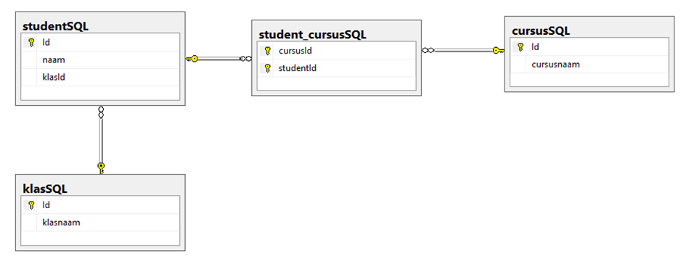

Stap 1 – aanmaken databank (Microsoft SQL Server Management Studio)

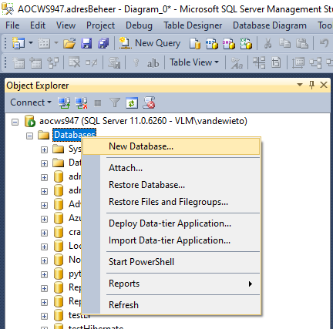

Stap 2 – Voeg connectie toe naar databank

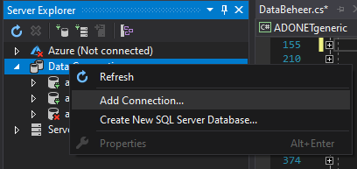

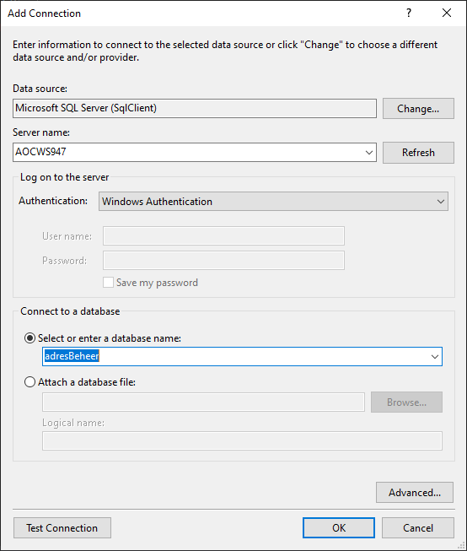

Stap 3 – design tabellen

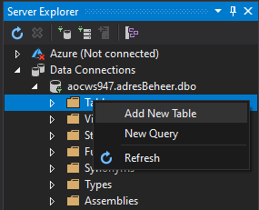

Opmerking identity column !

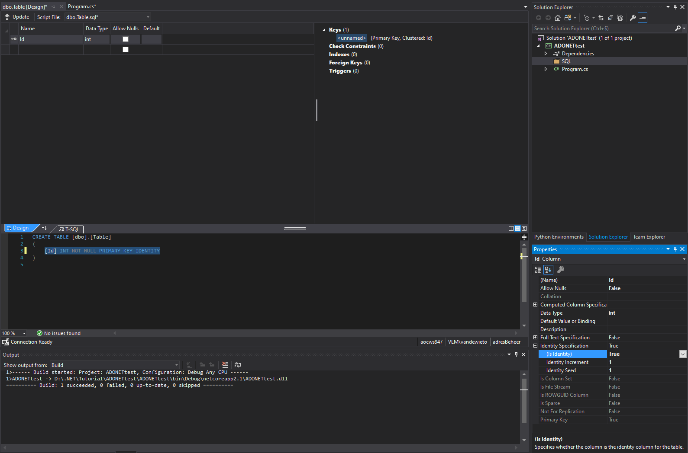

SQL statements

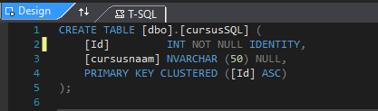

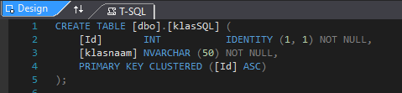

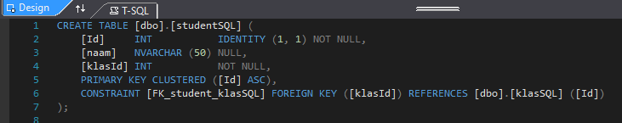

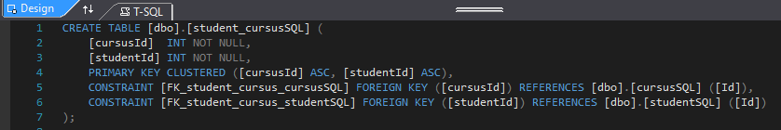

Opmerking : composite Key

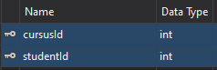

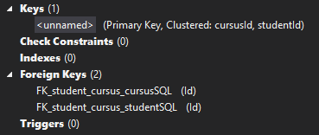

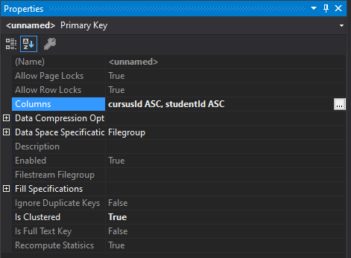

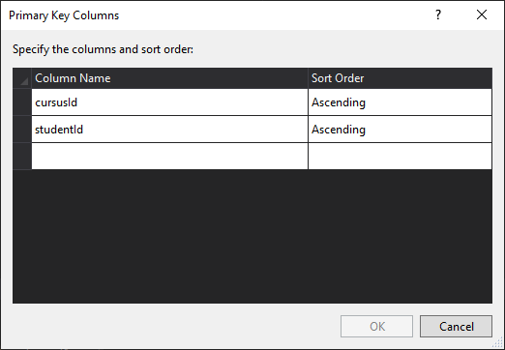

Opslaan SQL statements

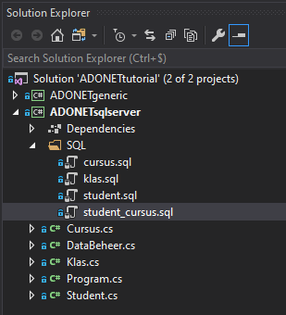

Stap 4 – aanmaken tabellen in SQL Server

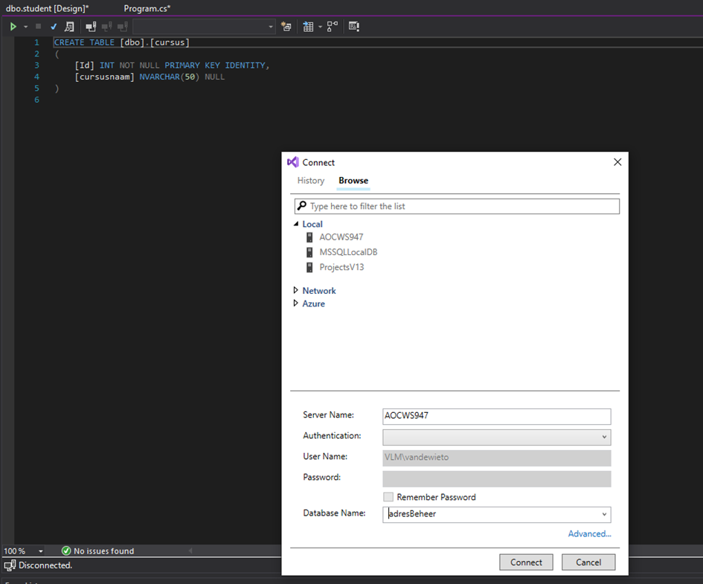

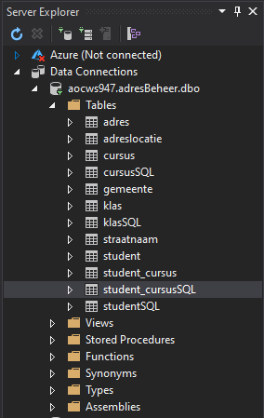

## SqlServer data provider

### Aanmaken project

* Add .Net Core project
* Dependencies

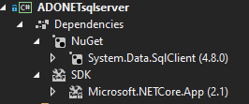

* Klassen

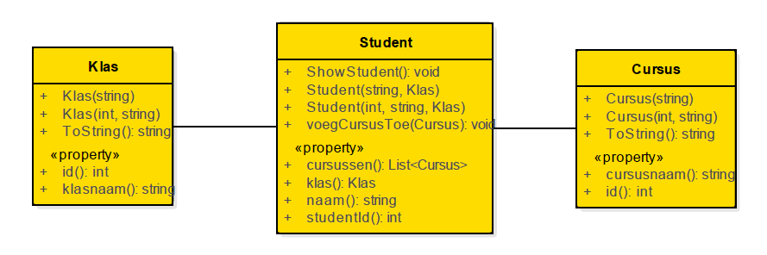

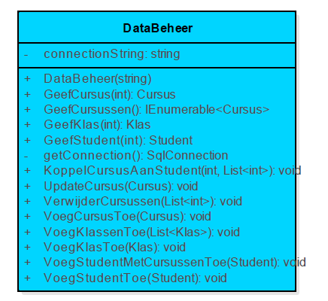

### Connection

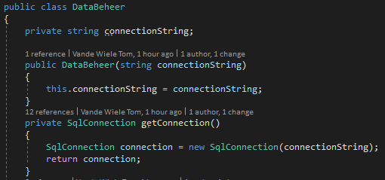

ConnectionString – selecteer properties in server beheer

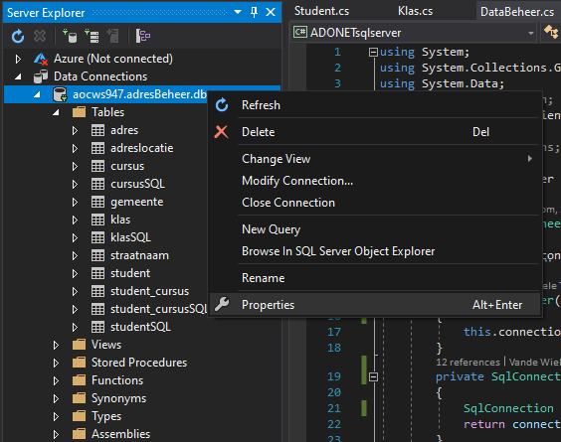

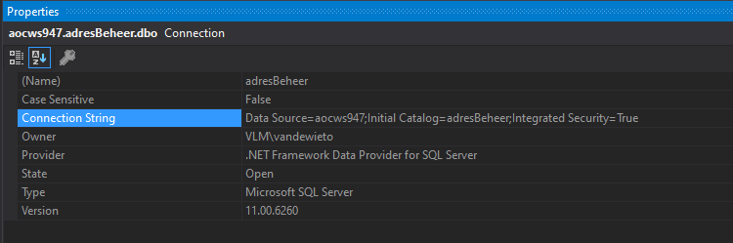

### Command en Parameters

#### Insert

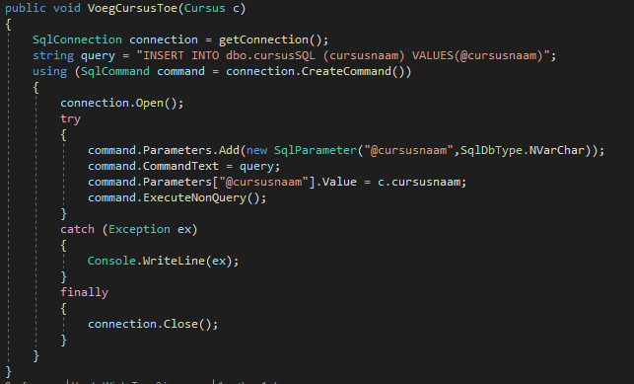

#### Datareader

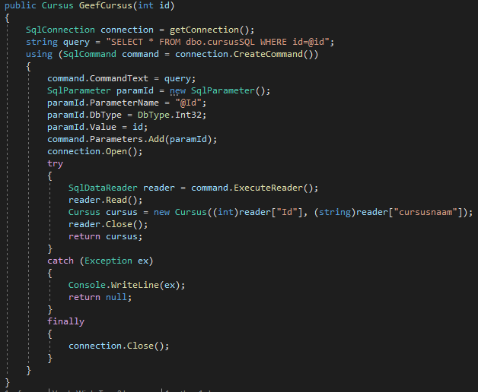

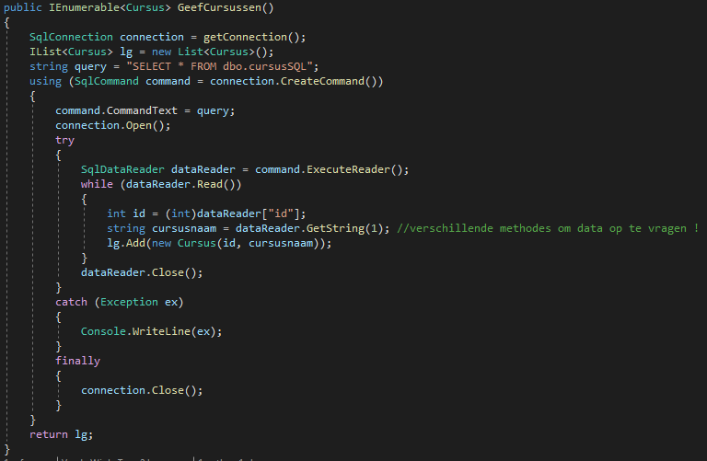

#### Query over meerdere tabellen

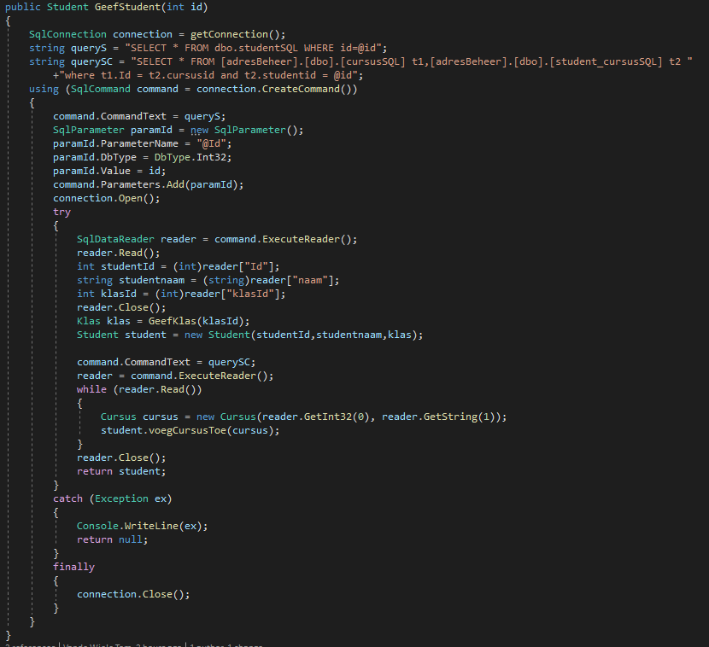

### Adapter en CommandBuilder

#### Update

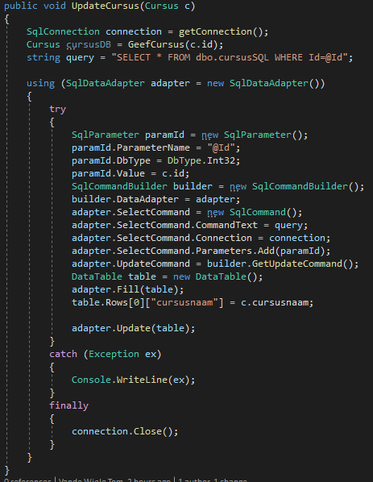

#### Delete

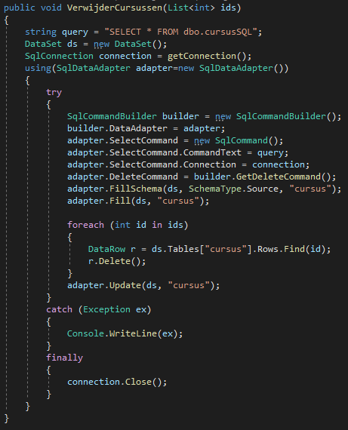

### Transaction

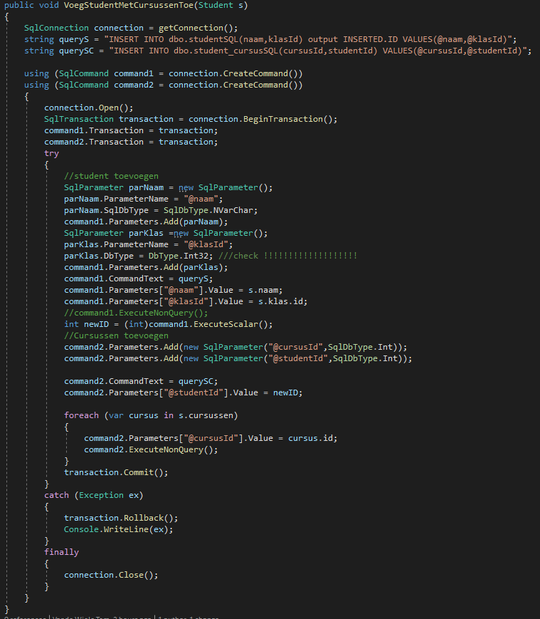

Opmerking : insert over meerdere tabellen met identity column !

## Generic

### Aanmaken project

* Add .Net Core project
* Dependencies

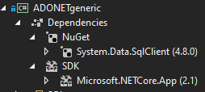

### DbProviderFactory

* Registreren van SqlClientFactory

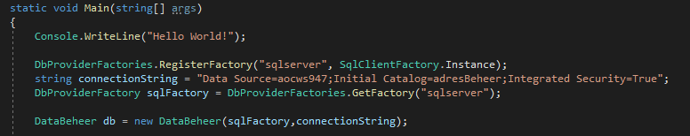

* Factory als parameter in constructor

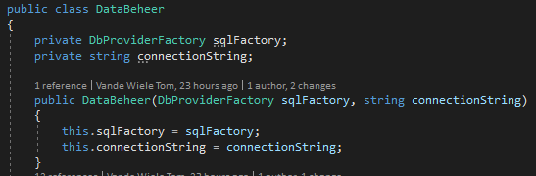

### Connection

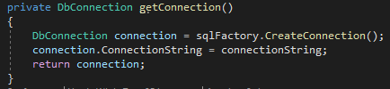

### Command en Parameters

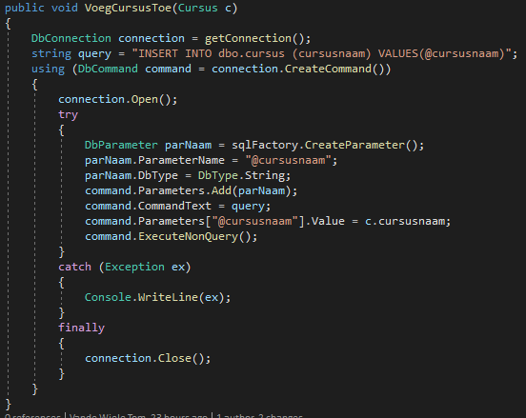

### Adapter en CommandBuilder

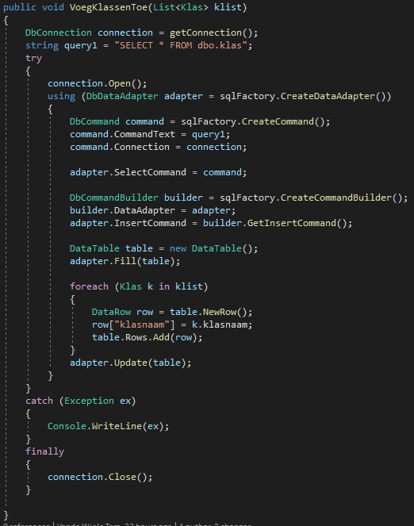

### Transaction

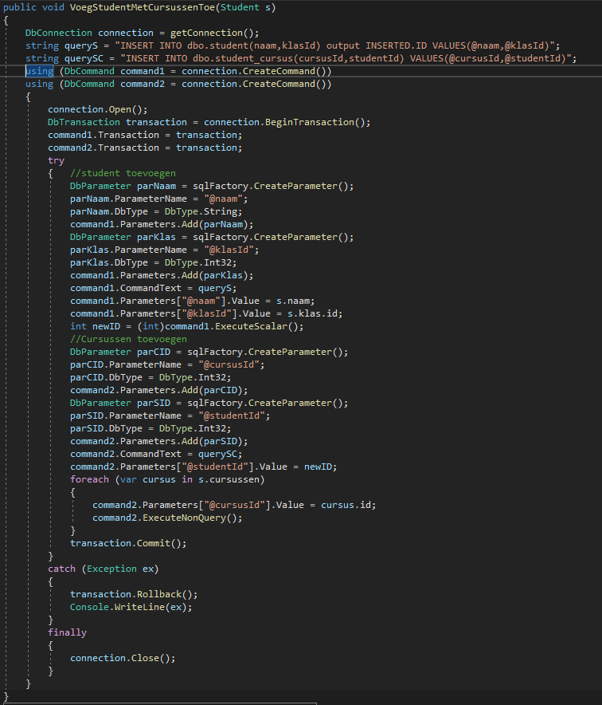

## DataSet

(<https://docs.microsoft.com/en-us/dotnet/framework/data/adonet/ado-net-architecture>)

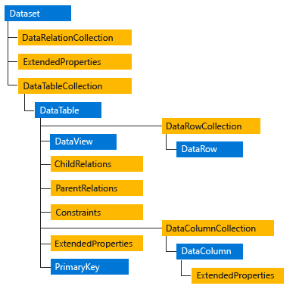

## Opgave – adressen lezen en opslaan

