**CSC175 Assignment 1 Spring 2019 Name ________Donald Tvedt_______________   
Directions:** Download this file and save as lastnameAssignment1SP19. Type all solutions on this document. Use equation editor when necessary. Upload Word document to Blackboard by **Monday at 11:59 PM.**  
Hot key for equation editor: Hold Alt and = at same time. Points in [brackets]. Total: 60 points

[4] points for a professional looking document (directions, organization, neatness, equation editor, etc.)

1) [16] Let the universal set be $U=\left\{1,2,3,…,14,15,16\right\}, A=\left\{x∈U\right|x=2n+3, n∈Z\},$ $$B=\left\{x∈U\right|x is a perfect square\}, D=\left\{2, 5, 8, 11, 14\right\}, and E=\{3, 6, 9, 12, 15\}$$ a) List the elements of $A$. **A = {1,3,5,7,9,11,13,15}**  
b) List the elements of $B$. **B = {8,16} perfect square = x2 +4x + 4**  
c) List the elements of $A^{c}$. $A^{c}$**= {2,4,6,8,10,12,14,16}**d) Write {5,10,15} in set-builder notation. $A=\{x ∈ U |x=5n, n ∈ Z\}$  
e) List the elements of $E∩D$. **NO elements so empty Set $∅$**   
f) List the elements of $B∪E$. $B∪E$ = **{3,6,8,9,12,15,16}**  
g) List the elements of $A^{c}∩D$. $A^{c}$**={2,4,6,8,10,12,14,16} so $A^{c}∩D$**  =**{2,8,14}**  
h) List the elements of $D-A$. = $D-A$. **={2,8,14}**  
i) List the elements of $B⨁E$. $B⨁E$**= {3,6,8,9,12,15,16}**  
j) True or False: $∅⊆E$. Why? **FALSE**, **since** **empty Set $∅$ not subset of E**  
k) True or False: $\{4, 8\}⊆D$. Why? **FALSE, 8 is an element of D but not 4**  
l) True or False: $25∈B$. Why? **FALSE, 25 is not an element of B**  
m) True or False: $(14,3)∈D×E$. Why? **FALSE, 3 is not an element of D and I’m not even sure how FALSE X E would even work.**   
n) Find $|D×E|$. Why? (Don’t list all of the elements) **5X5 = 25 multiply the elements of each to get total**  
o) List the elements of $B∪(E∩D)$. $B∪(E∩D)$. = **{8,16}**  
p) List the elements of $(B∪E)∩D$. $(B∪E)∩D$**= {2,5,8,11,14}**

2) [7] A leading calculator manufacturer advertises its products in three magazines: Calculus, Math Today, and the Love of Math Journal. A survey of 502 customers by the manufacturer reveals the following information: 180 learned of its products from Calculus, 200 learned of its products from Math Today, 192 learned of its products from the Love of Math Journal, 84 learned of its products from Calculus and Math Today, 52 learned of its products from Calculus and the Love of Math Journal, 64 learned of its products from Math Today and the Love of Math Journal, and 38 learned of its products from all three magazines.

**Prepare data for VENN**

**C + MT + MJ = 38**

**C + MT = 84 – 38 = 46**

**C + MJ = 52 – 38 = 14**

**MT + MJ = 64 – 38 = 26**

**C = 180 – 38 – 46 – 14 = 82**

**MT = 200 – 38 – 46 – 26 = 90**

**MJ = 192 – 38 – 14 – 26 = 114**

**Customers complement = 502 – 404 = 98**

a) Create a Venn diagram (create your own or edit the attachment in Blackboard using Paint)  
b) How many of the customers saw the manufacturer’s advertisement in Calculus but not Math Today? **82+14=96**  
c) How many of the customers saw the manufacturer’s advertisement in at least one magazine? **38+46+14+26+82+90+114=404**  
d) How many of the customers saw the manufacturer’s advertisement in exactly one magazine? **82+90+114=286**

3) [4] Edit the attachment in Blackboard using Paint to shade each region:

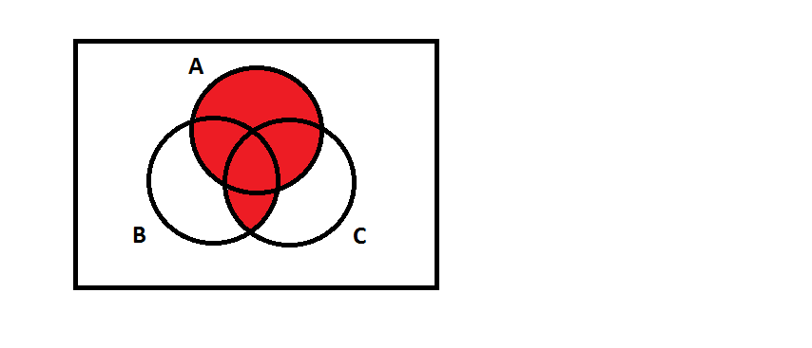a) b)

4) [2] Given the figure to the right, express the area in set notation.

5) [9] Make the following conversions. Show work for credit.  
a) Convert 11867 to hexadecimal.

**List = dec = hex**

**11867 = 16 x 741 + 11 list = 11 = B**

**741 = 16 x 46 + 5 list = 5 = 5B**

**46 = 16 x 2 + 14 list = 14 = E5B**

**2 = 16 x 0 + 2 answer = 2E5B**

b) Convert the hexadecimal number 45CA to an integer. . **16^3=4096 16^2=256 16^1=16 16^0=1**

**4x4096 + 5x256 + 12x16 + 10x1 = 17866**

c) Convert the binary number 100010101 to an integer. **2^8=256** **2^7=128 2^6=64 2^5=32 2^4=16 2^3=8 2^2=4 2^1=2 2^0=1**

**1x256 + 0 + 0 + 0 + 1x16 + 0 + 1x4 + 0 + 1 = 277**  
d) Use the algorithm (Ex 1.4.1) on page 24 of the textbook to find the binary representation of 123. (Show each step of the algorithm)

**K = 2 x q + r 🡪 add r to the list**

**123 = 2 x 61 +1 list = 1**

**61 = 2 x 30 + 1 list = 11**

**30 = 2 x 15 + 0 list = 011**

**15 = 2 x 7 + 1 list = 1011**

**7 = 2 x 3 + 1 list = 11011**

**3 = 2 x 1 + 1 list = 111011**

**1 = 2 x 0 + 1 answer = 1111011**

6) [9] Calculate each expression (show work)  
a) $\sum_{k=1}^{3}{ (5k-7)}$ = **(5x1 -7) + (5x2 - 7) + (5x3 – 7) = 9**

b) $\sum_{k=0}^{n}{ (2^{k}+4)}for n=2,4$

**n = 2 (2^0 +4) + (2^1 + 4) + (2^2 + 4) = 19**

**n=4 (2^0 +4) + (2^1 + 4) + (2^2 + 4) + (2^3 + 4) + (2^4 + 4) = 51**

c) $\bigcup_{i=2}^{5}{\left\{x∈Q | 0<x<1/i\right\}}$ **= {0 < x < 1/2} {0 < x < 1/3} {0 < x < 1/4} {0 < x < 1/5} = {$x∈Q |$ 0 < x < 1/2}**

d) $\bigcap_{i=2}^{5}{\left\{x∈Q | 0<x<1/i\right\}}$ = **{0 < x < 1/2} {0 < x < 1/3} {0 < x < 1/4} {0 < x < 1/5} = These don’t intersect = Empty set**

e) $\prod_{k=0}^{2}{(7k-5)}$**= (7x0 - 5) x (7x1 – 5) x (7x2 - 5) = -90**

7) [7] Read problem #11 on page 30 (or watch a Khan Academy video) to learn how to add binary numbers. Use the method to add 1110011 and 110010. Then convert the three binary numbers (two original and the binary answer) to integers to check your work. Show work.

**Carry place 11 1 conversion to decimal**

**First number 1110011 = 1 + 2 + 16 +32 + 64 = 115**

**Second number +110010 = 2+ 16 + 32 = + 50**

**Answer 10100101 = 128+32+4+1 = 165**

**Verify** . **2^8=256** **2^7=128 2^6=64 2^5=32 2^4=16 2^3=8 2^2=4 2^1=2 2^0=1**

8) [2] How do you determine if a binary number is even or odd? Explain thoroughly.

**To see if a binary number is odd or even all you have to do is look at the last digit if zero the number is even if one the number is odd.**

**EX: 10100010 🡨 last digit is 0 this will be an even number**

**EX: 10101101 🡨 last digit is 1 this will be an odd number**