**CSC175 Assignment 4 Spring 2019 Name ________Donald Tvedt____________   
Directions:** Download this file and save as lastnameAssignment4SP19. Type all solutions on this document. Use equation editor when necessary. Upload Word document to Blackboard by **Monday at 11:59 PM.**  
Points in [brackets]. Total: 60 points Show work and explain concepts thoroughly!  
  
[4] points for a professional looking document (organization, neatness, tables, etc.)  
  
1) [4] Let . Let $R$ be a relation on $A$ defined by $\left(a,b\right)∈R$ if and only if $a≥b$. Are the following elements of $R?$ Why or why not?

a) (3,3) **= yes, 3 is equal to itself** b) (4,1) **= no, 1 is not in the set A** c) (2,4) **= no, 2 is less than 4** d) (4,3) **= yes, 4 is greater then 3**

2) [9] Let . Let $S$ be a relation on $C$ defined by $\left(a,b\right)∈S$ if and only if $a|b$ (a divides b).

1. List the elements of $S$. $S=$ **{(1,1), (1,2), (1,3), (1,4), (1,5), (2,2), (2,4), (3,3), (4,4), (5,5)}**
2. Is $S$ reflexive? Why or why not? **= Yes, every vertex has a loop**
3. Is $S$ symmetric? Why or why not? **= No, there are single arrows**
4. Is $S$ antisymmetric? Why or why not? **= No, there are loop double arrows**
5. Is $S$ transitive? Why or why not? **= No, the data sets can ARB BRC do not work out**
6. Is $S$ a partial ordering? Why or why not? **= No, it’s not transitive and not antisymmetric**
7. Is $S$ an equivalence relation? Why or why not? **= No, it’s not symmetric and not transitive**

3) [10] Let , be a relation on $B$ such that $aRb$ if and only if $a=b+2$, and $S$ be a relation on $B$ such that $aSb$ if and only if $a=b-1$.

a) List the element of $R$. $R=$ **{(0,-2), (1,-1), (2,0)}** b) List the element of $S$. $S=$ **{(-2,-1), (-1,0), (0,1), (1,2)}** c) List the element of $RS$. $RS=$ **{(0,-1), (1,0), (2,1)}** d) List the element of $SR$. $SR=$ **{(-1,-2), (0,-1), (1,0)}** e) Is $S$ antisymmetric? Why or why not? **= Yes, no loops and no double arrow** f) Is $S$ transitive? Why or why not?  **= No, using the formula $aRb and bRc then aRc$ = false**

4) [4] Let and $S$ be relations on $Z$ where $R=\left\{\left(1,n\right)\right| n∈Z\}$ and $S=\left\{\left(n,1\right)\right| n∈Z\}$. Hint: write out some of the terms of $R$ and $S$ for insight into the problem.

$R=$**{…, (1,-2), (1,-1), (1,0), (1,1), (1,2), …} $S=$ {…, (-2,1), (-1,1), (0,1), (1,1), (2,1), …}**

a) Find $RS$. $RS=$ **{(1,1)}** b) Find $SR$. $SR=$ **{…, (-2,-2), (-1,-1), (0,0), (1,1), (2,2), …}**

5) [7] Let be the relation on a set $C$ whose digraph is given to the right.   
a) List the elements of $T$.

$T=$**{(1,1), (1,2), (1,3), (2,1), (2,5), (4,4), (4,2), (4,5), (5,3)}**  
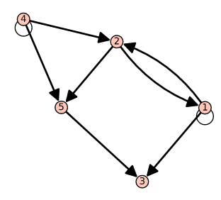b) List the outdegree and indegree of each vertex of the digraph in a table.

|  |  |  |
| --- | --- | --- |
| $$V$$ | $$indegree$$ | $$outdegree$$ |
| **1** | **2** | **3** |
| **2** | **2** | **2** |
| **3** | **2** | **0** |
| **4** | **1** | **3** |
| **5** | **2** | **1** |

6) [9] Let . Define the relation $R$ on $A$ by $aRb$ if and only if $b-a$  
 is odd.

|  |  |  |  |  |  |  |  |  |  |
| --- | --- | --- | --- | --- | --- | --- | --- | --- | --- |
| 1,1 | 0 | 2,1 | -1 | 3,1 | -2 | 4,1 | -3 | 5,1 | -4 |
| 1,2 | 1 | 2,2 | 0 | 3,2 | -1 | 4,2 | -2 | 5,2 | -3 |
| 1,3 | 2 | 2,3 | 1 | 3,3 | 0 | 4,3 | -1 | 5,3 | -2 |
| 1,4 | 3 | 2,4 | 2 | 3,4 | 1 | 4,4 | 0 | 5,4 | -1 |
| 1,5 | 4 | 2,5 | 3 | 3,5 | 2 | 4,5 | 1 | 5,5 | 0 |

$R=$**{(1,2), (1,4), (2,1), (2,3), (2,5), (3,2), (3,4), (4,1), (4,3), (4,5), (5,2), (5,4)}**

1. Use technology to create a digraph. (6 points)

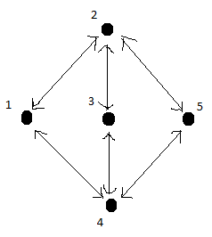

1. Is $R$ antisymmetric? Why or why not? **= No, all lines have double arrow**
2. Is $R$ transitive? Why or why not? **= No, using formula $aRb and bRc then aRc$ data is not odd**
3. Is $R$ reflexive? Why or why not? **= No, no vertices have a loop**

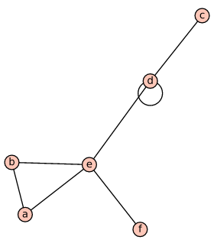7) [6] Consider the undirected graph to the right.   
a) List the vertices. $V=$ **a, b, c, d, e, f**  
b) List the edges. $E=$**{{a,b}, {a,e}, {b,e}, {c,d}, {d,d}, {d,e}, {e,f}}**  
c) List the degree of each vertex in a table.

|  |  |
| --- | --- |
| $$V$$ | $$degree$$ |
| **a** | **2** |
| **b** | **2** |
| **c** | **1** |
| **d** | **4** |
| **e** | **4** |
| **f** | **1** |

d) Is it a simple graph? Why or why not? **= No, vertex d has a loop**

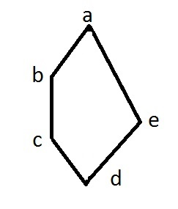8) [4] The partial ordering relation $S$ is shown with the Hasse diagram  
to the right. List the elements $S$.

$S=$**{{a,b}, {a,e}, {b,c}, {c,d}, {d,e}}**

9) [3] Let . List the elements of relation $≡_{3}$ (congruence mod 3) on $A$.

|  |  |  |  |  |  |  |  |  |  |
| --- | --- | --- | --- | --- | --- | --- | --- | --- | --- |
| $$a-b$$ | $$≡_{3}$$ | $$a-b$$ | $$≡_{3}$$ | $$a-b$$ | $$≡_{3}$$ | $$a-b$$ | $$≡_{3}$$ | $$a-b$$ | $$≡_{3}$$ |
| 2,2 | 0 | 4,2 | 2 | 6,2 | 4 | 8,2 | 6 | 10,2 | 8 |
| 2,4 | -2 | 4,4 | 0 | 6,4 | 2 | 8,4 | 4 | 10,4 | 6 |
| 2,6 | -4 | 4,6 | -2 | 6,6 | 0 | 8,6 | 2 | 10,6 | 4 |
| 2,8 | -6 | 4,8 | -4 | 6,8 | -2 | 8,8 | 0 | 10,8 | 2 |
| 2,10 | -8 | 4,10 | -6 | 6,10 | -4 | 8,10 | -2 | 10,10 | 0 |

$R=$**{(2,2), (2,8), (4,4), (4,10), (6,6), (8,2), (8,8), (10,4), (10,10)}**