**CSC175 Assignment 5 Spring 2019 Name __________Donald Tvedt_____________   
Directions:** Download this file and save as lastnameAssignment5SP19. Type all solutions on this document. Use equation editor when necessary. Upload Word document to Blackboard by **Monday at 11:59 PM.**  
Points in [brackets]. Total: 60 points **Show work** and explain concepts thoroughly! You will receive half credit for hand-drawn, scanned, and inserted graphs. I would like to see you create computer generated graphs.  
  
[4] points for a professional looking document (directions, organization, neatness, etc.)  
  
[7 each] For each graph given in numbers 1 and 2,   
a) Create a computer generated graph of each, clearly labeling the vertices.   
b) Is the graph unconnected, connected, strongly connected, or weakly connected? Why?  
c) Does it have a circuit path? If so, give it. If not, say why.   
d) List the degrees, in-degrees, and/or out-degrees (where applicable) for each vertex in a table.

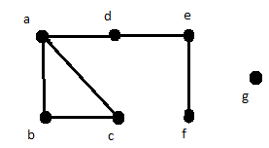1. G1 = (V1, E1), where V1 = {a, b, c, d, e, f, g} and E1 = {{a,b}, {a,c}, {a,d}, {b,c}, {d,e}, {f,e}}.

a) **Graph to the right**

b) **Unconnected we have G as an isolated vertex, and this graph is weakly connected can’t get to each of the vertices.**

c) **ABCA**

|  |  |
| --- | --- |
| $$V$$ | $$degree$$ |
| **A** | **3** |
| **B** | **2** |
| **C** | **2** |
| **D** | **2** |
| **E** | **2** |
| **F** | **1** |
| **G** | **0** |

d)

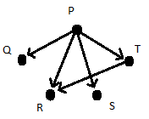2. G2 = (V2, E2), where V2 = {P, Q, R, S, T} and E2 = {(P,Q), (P,R), (P,S), (P,T), (T,R)}.

a) **Graph to the right**

b) **Unconnected there isn’t a path between a few vertices like (Q,R), (T,S), and this graph is weakly connected there are not directed edges on (Q,R), (T,S)**

c) **This does not have a circuit path as nothing points back to vertex P**

|  |  |  |
| --- | --- | --- |
| $$V$$ | $$indegree$$ | $$outdegree$$ |
| **P** | **0** | **4** |
| **Q** | **1** | **0** |
| **R** | **2** | **0** |
| **S** | **1** | **0** |
| **T** | **1** | **1** |

d)

[4 each] For numbers 3 and 4,  
a) Give a Hamiltonian path, if it exists. If not, state why.

b) Give a Hamiltonian circuit, if it exists. If not, state why.

c) Give an Euler path, if it exists. If not, state why.

d) Give an Euler circuit, if it exists. If not, state why.

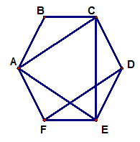 3. 4. A B

E D C

|  |  |
| --- | --- |
| 3a) **ABCDEF** | 4a) **D,E,A,B,C** |
| 3b) **ABCDEFA** | 4b) **No hamiltonian circuit, the direction of the graphs does not allow one to start and end at the same vertex without using that vertex more then once** |
| 3c) **DFACEABCDEF** | 4c) **EBDEABCE** |
| 3d) **No Euler Circuit, unable to hit every edge without going back over and edge.** | 4d) **EBDEABCE** |

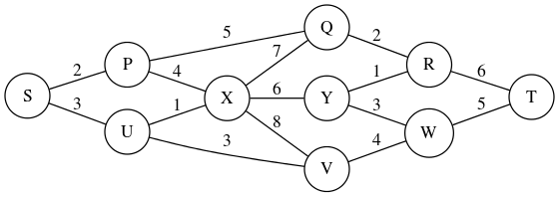5. [6] Use Dijkstra’s Algorithm to find the shortest  
path for each pair of vertices below.   
Be sure to list the edges in order and give the sum  
 of the shortest path for each answer.  
a) Q to V

**{{V, W}, {W, Y}, {Y, R}, {R, Q}}**

**4+3+1+2=10**  
b) X to T (Hint: there are two answers for this one, give both!)

|  |  |
| --- | --- |
| **{{X, Y}, {Y, R}, {R, T}** | **{{X, U}, {U, V}, {V, W}, {W, T}}** |
| **6 + 1 + 6 = 13** | **1 + 3 + 4 + 5 = 13** |

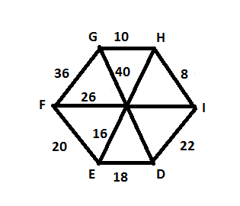6. [8] For each problem below, use the weighted graph to the right.  
Copy and paste the graph first so you have two copies to highlight,   
one for part a and one for part b. Note: No vertex in the middle.

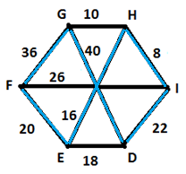

a) Use the Nearest Neighbor Algorithm to find a   
Hamiltonian circuit starting at the vertex E.  
Highlight the edges, list the vertices in order, and  
give the weight.

**EHIDGFE**

**16+8+22+40+36+20= 142**

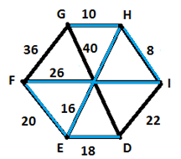

b) Use the Sorted Edges Algorithm to find a   
Hamiltonian circuit. Highlight the edges, list   
the edges in order, and give the weight.

**{{I, H}, {H,G}, {E,H}, {E, D}, {E, F}, {F, I}}**

**8 + 10 + 16 + 18 + 20 + 26 = 98**

7. [8] Use Kruskal’s Algorithm to find the minimum spanning tree for each weighted graph.   
Highlight the spanning tree on each graph. List the edges found **in order** using the algorithm. What is the sum?

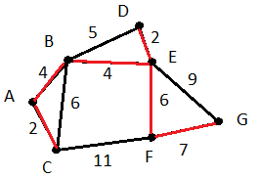a) b)

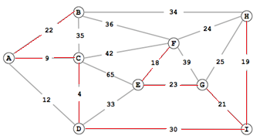

|  |  |
| --- | --- |
| **{{d,c}, {a,c}, {e, f}, {h, i}, {i, g}, {a,b}, {e, g}, {d, i}}** | **{{a,c}, {d,e}, {a,b}, {b,e}, {e,f}, {f,g}}** |
| **4 + 9 + 18 + 19 + 21 + 22 + 23 + 30 = 146** | **2 + 2 + 4 + 4 + 6 + 7 = 25** |

8. Look up Prim’s Algorithm.   
a) [2] Provide the name of the author and a hyperlinked URL of your source.

Vojtech Jarnik

<https://en.wikipedia.org/wiki/Talk%3APrim's_algorithm>

<https://coderbyte.com/algorithm/find-minimum-spanning-tree-using-prims-algorithm>

b) [3] Give an overview of the algorithm **in your own words** so a classmate could use it to find a minimum spanning tree.

Prim’s Algorithm: Basically you pick any vertex to start with, then check all edges coming off your vertex and pick the cheapest one. Don’t move to the next vertex, your now evaluating all edges coming off all vertex’s that are linked by the edge you have selected. Then pick the smallest weight from those without making a circuit. Rince and repeat.   
c) [3] Use Prim’s Algorithm to find the minimum spanning tree for the graph in 7a above using E as the starting vertex. List the edges found **in order** using this new algorithm but you do not need to copy the graph and highlight the spanning tree. What is the sum?

**{{e,f}, {e,g}, {g,i}, {i,h}, {i,d}, {d,c}, {c,a}, {a,b}}**

**18 + 23 + 21 + 19 + 30 + 4 + 9 + 22 = 146**  
d) [3] Use Prim’s Algorithm to find the minimum spanning tree for the graph in 7b above using G as the starting vertex. List the edges found **in order** using this new algorithm but you do not need to copy the graph and highlight the spanning tree. What is the sum?

**{{g,f}, {f,e}, {e,d}, {e,b}, {b,a}, {a,c}}**

**7 + 6 + 2 + 4 + 4 + 2 = 25**  
e) [1] Are your answers different from number 7? **They are the same**