**CSC175 Practice Assignment 4 Spring 2019 Name ________Donald Tvedt____________   
Directions:** Download this file and save as lastnamePracticeAssignment4SP19. Type all solutions on this document. Upload Word document to Blackboard by **Saturday at 11:59 AM.** You can use drawing tools in the word processor to create the graphs, or use drawing software such as [Draw.io](http://draw.io/) or Paint. You can copy and paste images created in a separate application into the document, but make sure that each image is sized appropriately for the document so that it fits entirely within the page margins and is large enough to be easily read. (The [Snipping Tool](http://windows.microsoft.com/en-us/windows/use-snipping-tool-capture-screen-shots#1TC=windows-8) in Windows makes it easy to capture only part of a window, which can then be pasted into another document. If you are using a Mac, SHIFT-COMMAND-4 allows you to capture a portion of the screen, saved as a PNG file on the desktop by default.) Alternatively, you may draw the graphs on paper, then scan the image or take a picture that you can embed in the word processing document, but the image should be very clear and easy to read. (This should be used as a last result. I would expect more from my IT department or software developers.)

1) Let . Let $R$ be a relation on $A$ defined by $\left(a,b\right)∈R$ if and only if $a<b$. Are the following elements of $R?$ Why or why not?

a) (3,3) **= No, 3 is not less then 3**  
 b) (2,5) **= Yes, 2 is less than 5 and both are elements of A**  
 c) (4,6) **= No, 6 is not an element of A**  
 d) (4,3) **= No, 4 is not less than 3**

2) Let and $B=\{14, 15, 16, 17\}$. Let $R$ be a relation from $A$ into $B$ defined by $\left(a,b\right)∈R$ if and only if $a|b$. Find all elements of $R$.

$R=$**{(2,14), (2,16), (3,15), (4,16), (5,15)}**

3) Let and $A=\{2,3,4,5,6\}$. Let $S$ be a relation from $B$ into $A$ defined by $\left(b,a\right)∈S$ if and only if $b$ is a multiple of *a*. Find all elements of $S$.

$S=$**{(14,2), (15,3), (15,5), (16,2), (16,4)}**

4) Given the relations $R and S$ in numbers 2 and 3, find:  
a) $RS$. $RS=\{($**2,2), (3,3), (4,4), (5,5)}**   
b) $SR$. $SR=$ **{(14,14), (15,15), (16,16)}**

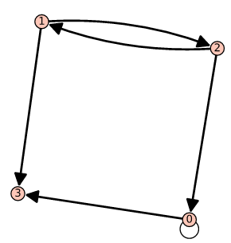5) Let $T$ be the relation on a set $C=\{1,2,3,4\}$ whose digraph is given to the right.   
a) List the elements of $T$. (Don’t have to show work.)

$T=$**{(1,2), (1,3)}**

b) List the outdegree and indegree of each vertex of the digraph in a table.

|  |  |  |
| --- | --- | --- |
| **Vertex** | **indegree** | **outdegree** |
| **0** | **2** | **2** |
| **1** | **1** | **2** |
| **2** | **1** | **2** |
| **3** | **2** | **0** |

6) Let . Define the relation $R$ on $A$ by $aRb$ if and only if $b-a$  
 is even. (Remember, 0 and -2 are also even numbers!)  
Use technology to create a digraph.

$R=$**{(1,1), (1,3), (2,2), (2,4), (3,1), (3,3), (4,2), (4,4)}**

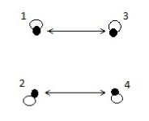

7) Consider the relation $R$ on $A$ in number 6.  
a) Is $R$ reflexive? Why or why not? **= yes, every vertex has a loop**  
b) Is $R$ antisymmetric? Why or why not? **= no, every arrow is a double arrow**  
c) Is $R$ symmetric? Why or why not? **= yes, every arrow is a double arrow**  
d) Is $R$ transitive? Why or why not? **= yes, doing the formula $aRb and bRc then aRc$ true**  
e) Is $R$ an equivalence relation? Why or why not? **= yes, its reflexive, symmetric and transitive**  
f) Is $R$ a partial ordering? Why or why not? **= no, its not antisymmertic**

8) Let . List the elements of the relation $a≡_{3}a$ (congruence mod 3). (Don’t have to show work.)

**{(2,2), (3,3), (4,4), (5,5), (6,6), (7,7), (8,8)}**

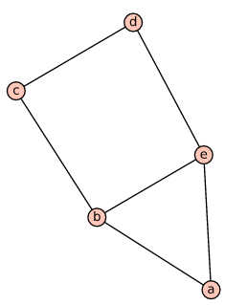9) Consider the undirected graph to the right.   
a) List the vertices.

$V=$**a, b, c, d, e**

b) List the edges.

$E=$**{(a,b), (a,e), (b,c), (b,e), (c,d), (d,e)}**

c) List the degree of each vertex in a table.

|  |  |
| --- | --- |
| $$V$$ | $$degree$$ |
| **a** | **2** |
| **b** | **3** |
| **c** | **2** |
| **d** | **2** |
| **e** | **3** |

d) Is it a simple graph? Why or why not? **= Yes, it has no loops or no multiple edges**