**CSC175 Practice Assignment 5 Spring 2019 Name _______**Donald Tvedt**___________   
Directions:** Download this file and save as lastnamePracticeAssignment5SP19. Type all solutions on this document. Upload Word document to Blackboard by **Saturday at 11:59 AM.** You will need to use graphics tools this week. Let me know if you have any questions.

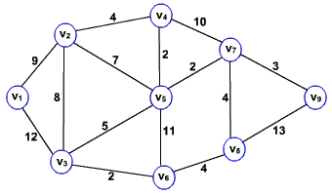1) For the weighted graph to the right, use Dijkstra’s Algorithm to   
find the shortest path for each pair of vertices below. For each,  
**list the edges** in order used for your path and then the **sum**   
of that path.

a) v1 to v9 **= 3+2+2+4+9 = 20**

**{{V9, V7}, {V7, V5}, {V5, V4}, {V4, V2}, {V2, V1}}**  
b) v4 to v6 **= 2+5+2= 9**

**{{V6, V3}, {V3, V5}, {V5, V4}}**  
c) v3 to v9 **= 3+2+5 =10**

**{{V9, V7}, {V7,V5}, {V5, V3}}**

2) For the same weighted graph to the right, use Kruskal’s  
algorithm to find the minimum spanning tree. Copy  
and paste the graph into your solution and highlight the minimum spanning tree. **List the edges**, in the order you found them using the algorithm. Finally, give the sum (length or weight) of the minimum spanning tree.

**minimum spaning tree is V-1 = 8 edges** 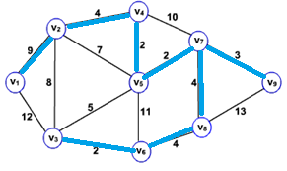

**{{v3,v6}, {v7,v5}, {v4,v5}, {v7,v9}, {v7,v8}, {v6,v8}, {v2,v4}, {v1,v2}}**

**2+2+2+3+4+4+4+9 = 30**

3) For the graph to the right,  
a) Give an Euler path, if it exists. If not, state why.

**HECIBHGFEDCBAJIH**  
b) Give an Euler circuit, if it exists. If not, state why.

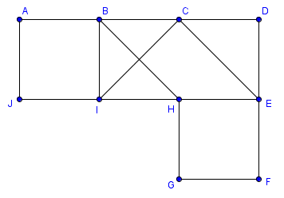**HECIBHGFEDCBAJIH**   
c) List the degrees for each vertex in a table.

|  |  |
| --- | --- |
| $$V$$ | $$degree$$ |
| **A** | **2** |
| **B** | **4** |
| **C** | **4** |
| **D** | **2** |
| **E** | **4** |
| **F** | **2** |
| **G** | **2** |
| **H** | **4** |
| **I** | **4** |
| **J** | **2** |

4) For the directed graph to the right,  
a) Give a Hamiltonian path, if it exists. If not, state why.

**EABDC**  
b) Give a Hamiltonian circuit, if it exists. If not, state why.

**Unable to create a circuit because nothing goes back to E**  
c) List the in-degrees and out-degrees for each vertex in a table.

|  |  |  |
| --- | --- | --- |
| $$V$$ | $$indegree$$ | $$outdegree$$ |
| **A** | **1** | **1** |
| **B** | **2** | **2** |
| **C** | **2** | **0** |
| **D** | **2** | **1** |
| **E** | **0** | **3** |

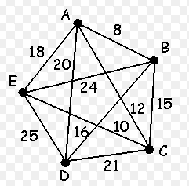5) For each problem below, use the weighted graph to the right.  
Copy and paste the graph first so you have two copies to  
highlight, one for part a and one for part b.

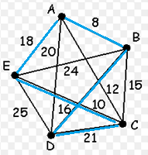

a) Use the Nearest Neighbor Algorithm to find a   
Hamiltonian circuit starting at the vertex C.  
Highlight the edges, list the vertices in order, and  
give the weight.

**CEABDC**

**10+18+8+16+21=73**

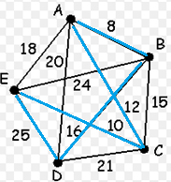b) Use the Sorted Edges Algorithm to find a   
Hamiltonian circuit. Highlight the edges, list   
the edges in order, and give the weight.

**{{A,B}, {C,E}, {A,C}, {B,D}, {D,E}}**

**8+10+12+16+25= 71**

For #6 and #7 below,  
a) Create a computer generated graph of each, clearly labeling the vertices. Pay attention if it is directed or undirected!  
b) List the degrees, in-degrees, and/or out-degrees (where applicable) for each vertex in a table.

6) G1 = (V1, E1), where V1 = {v, w, x, y, z} and E1 = {{v,v}, {v,x}, {z,y}, {z,z}, {x,x}, {w,x},{w,v}.

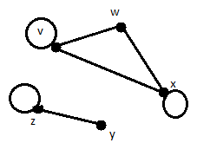

|  |  |
| --- | --- |
| $$V$$ | $$degree$$ |
| **V** | **4** |
| **W** | **2** |
| **X** | **4** |
| **Y** | **1** |
| **Z** | **3** |

7) G2 = (V2, E2), where V2 = {a,b,c,d,e,f} and E2 = {(a,c),(a,f),(b,b),(b,c),(c,a),(c,d),(d,c),(e,f),(f,d)}.

|  |  |  |
| --- | --- | --- |
| $$V$$ | $$indegree$$ | $$outdegree$$ |
| **A** | **1** | **2** |
| **B** | **1** | **2** |
| **C** | **3** | **2** |
| **D** | **2** | **1** |
| **E** | **0** | **1** |
| **F** | **2** | **1** |

