A Shot at Reproducible Data Analysis

Toni Verbeiren

10/9/2014

# Introduction

In this talk/document/presentation I showcase some of the possibilities that a combination of *tools* provides:

* [Markdown](http://daringfireball.net/projects/markdown/)
* [RMarkdown](http://rmarkdown.rstudio.com/)
* [Knitr](http://yihui.name/knitr/)
* [Pandoc](http://johnmacfarlane.net/pandoc/)
* [Reveal.js](http://lab.hakim.se/reveal-js/#/)
* [Latex](http://www.latex-project.org/)

In order to make sure things look good from the first start, you might check out some additional projects and files:

* Bootstrap template for Pandoc: <https://github.com/tonyblundell/pandoc-bootstrap-template>
* Alternative LaTeX templates: <https://github.com/kjhealy/latex-custom-kjh>
* Alternative Pandoc template: <https://github.com/kjhealy/pandoc-templates>

# Idea

This is the general idea of the production workflow:

1. Write data generation, data manipulation and discussion in **one text file**.
   * Syntax for text is Markdown.
   * Code lines start with tab or delimited by ```
   * Call this file file.Rmd, even if it includes more than R code.
2. Call knitr on the .Rmd file in order to **execute** the code blocks and **include** the output of the code in one file. The output is a .md file.
3. Call Pandoc on the file, given suitable options (see below). Pandoc is responsible for translating the .md file to **any format** you want.

A simple and a more involved example of running Pandoc:

pandoc file.md -o $(FILE).docx  
  
pandoc $(FILE).md -o $(FILE).html \  
 -t html5 \  
 --template $(THTML)/template.html \  
 --css $(THTML)/template.css \  
 --highlight-style=tango --mathjax \  
 --toc --toc-depth 2

# Some Examples

## Simple example

The first example is in R. Let's say I want to plot a function

$$f(x)=\frac{log(x^{2}+x+1)}{2x}$$

We first define $x$ and the function value $y$ (in doing so we have used some inline equations as well):

x <- seq(from=-5,to=10,by=.01)  
y <- (log(x*x + x + 1))/(2*x)

Then we can plot the function. We use the ggplot2 package.

library(ggplot2)  
qplot(x,y,geom="line")

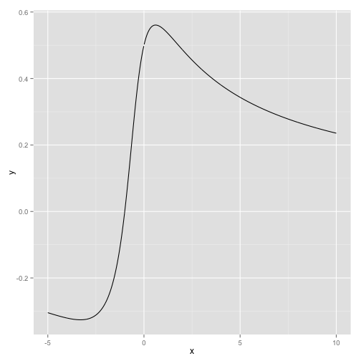

Plot of the very special function defined above.

See the figure for the result.

## Working with data

Let us take a look at a dataset that comes with R, mtcars:

summary(mtcars)

## mpg cyl disp hp   
## Min. :10.4 Min. :4.00 Min. : 71.1 Min. : 52.0   
## 1st Qu.:15.4 1st Qu.:4.00 1st Qu.:120.8 1st Qu.: 96.5   
## Median :19.2 Median :6.00 Median :196.3 Median :123.0   
## Mean :20.1 Mean :6.19 Mean :230.7 Mean :146.7   
## 3rd Qu.:22.8 3rd Qu.:8.00 3rd Qu.:326.0 3rd Qu.:180.0   
## Max. :33.9 Max. :8.00 Max. :472.0 Max. :335.0   
## drat wt qsec vs   
## Min. :2.76 Min. :1.51 Min. :14.5 Min. :0.000   
## 1st Qu.:3.08 1st Qu.:2.58 1st Qu.:16.9 1st Qu.:0.000   
## Median :3.69 Median :3.33 Median :17.7 Median :0.000   
## Mean :3.60 Mean :3.22 Mean :17.8 Mean :0.438   
## 3rd Qu.:3.92 3rd Qu.:3.61 3rd Qu.:18.9 3rd Qu.:1.000   
## Max. :4.93 Max. :5.42 Max. :22.9 Max. :1.000   
## am gear carb   
## Min. :0.000 Min. :3.00 Min. :1.00   
## 1st Qu.:0.000 1st Qu.:3.00 1st Qu.:2.00   
## Median :0.000 Median :4.00 Median :2.00   
## Mean :0.406 Mean :3.69 Mean :2.81   
## 3rd Qu.:1.000 3rd Qu.:4.00 3rd Qu.:4.00   
## Max. :1.000 Max. :5.00 Max. :8.00

Now the fun starts. Let's fit a model relates how many Miles/Gallon are consumed, given a weight.

model <- lm(mpg ~ wt, data=mtcars)  
summary(model)

##   
## Call:  
## lm(formula = mpg ~ wt, data = mtcars)  
##   
## Residuals:  
## Min 1Q Median 3Q Max   
## -4.543 -2.365 -0.125 1.410 6.873   
##   
## Coefficients:  
## Estimate Std. Error t value Pr(>|t|)   
## (Intercept) 37.285 1.878 19.86 < 2e-16 ***  
## wt -5.344 0.559 -9.56 1.3e-10 ***  
## ---  
## Signif. codes: 0 '***' 0.001 '**' 0.01 '*' 0.05 '.' 0.1 ' ' 1  
##   
## Residual standard error: 3.05 on 30 degrees of freedom  
## Multiple R-squared: 0.753, Adjusted R-squared: 0.745   
## F-statistic: 91.4 on 1 and 30 DF, p-value: 1.29e-10

This is verbatim output, we can use some R package magic to get proper tables as output as well using the pander package:

library(pander)  
pander(model)

|  |  |  |  |  |
| --- | --- | --- | --- | --- |
|  | Estimate | Std. Error | t value | Pr(>|t|) |
| **wt** | -5.344 | 0.5591 | -9.559 | 1.294e-10 |
| **(Intercept)** | 37.29 | 1.878 | 19.86 | 8.242e-19 |

Fitting linear model: mpg ~ wt

We can also plot this information using the code below.

qplot(x=wt, y=mpg, data=mtcars, xlab="Weight (lb/1000)", ylab="Miles per Gallon",  
 geom=c("point","smooth"), method="lm")

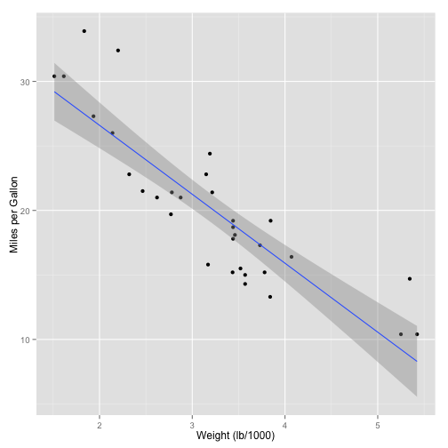

A scatterplot of the fuel consumption versus the weight of the car, along with the results of a linear regression. See the text for more information.

## Scraping the web

This script parses the Wikipedia page with Belgian Beers in order to get the data out. It then does some cleaning up and converts the data to different formats. The result can be stored in a file, but just display the first 10 rows.

library(XML)  
rawBeers <- readHTMLTable(doc="http://nl.wikipedia.org/wiki/Lijst_van_Belgische_bieren")  
beers <- NULL  
  
# The first table is not relevant, the rest is:  
for (i in seq(2,28)) {  
 beers <- rbind(beers,rawBeers[[i]])  
}  
  
# Remove the percentage sign and convert to numbers:  
beers$Percentagealcohol <- gsub("%","",beers$Percentagealcohol)  
beers$Percentagealcohol <- gsub(",",".",beers$Percentagealcohol)  
beers$Percentagealcohol <-as.numeric(beers$Percentagealcohol)

## Warning: NAs introduced by coercion

# A few entries do not have a percentage entry  
nas <- length(beers[is.na(beers$Percentagealcohol),])

The number of entries without percentage entry is: 4.

We use pander again for displaying the top-10 of beers with the highest amount of alcohol:

pander(  
 head(  
 beers[order(beers$Percentagealcohol,decreasing=TRUE),  
 c("Merk","Percentagealcohol")],  
 10)  
 )

|  |  |  |
| --- | --- | --- |
|  | Merk | Percentagealcohol |
| **194** | Black Damnation V (Double Black) | 26 |
| **405** | Cuve d'Erpigny | 15 |
| **189** | Black Albert | 13 |
| **190** | Black Damnation I | 13 |
| **192** | Black Damnation III (Black Mes) | 13 |
| **193** | Black Damnation IV (Coffe Club) | 13 |
| **312** | Bush de Nol Premium | 13 |
| **313** | Bush de Nuits | 13 |
| **314** | Bush Prestige | 13 |
| **404** | Cuve Delphine | 13 |

# Different languages

A Python example:

import pprint  
pprint.pprint(zip(('Byte', 'KByte', 'MByte', 'GByte', 'TByte'), (1 << 10*i for i in xrange(5))))

## [('Byte', 1),  
## ('KByte', 1024),  
## ('MByte', 1048576),  
## ('GByte', 1073741824),  
## ('TByte', 1099511627776)]

A Scala example:

val collection = for {i <- 1 to 10} yield {i}  
val mapped = collection map (x => x*x)  
val reduced = mapped reduce (_ + _)  
println(reduced)

## 385

# What to use it for?

I use it for:

* Creating presentations (reveal.js)
* Writing reports (including code)
* Writing papers (just text)
* Making coffee

# Some additional pointers

* Markdown to Reveal.js: <http://tverbeiren.github.io/BigDataBe-Spark/#/>
* Markdown and Pandoc for writing a paper: <http://homes.esat.kuleuven.be/~bioiuser/blog/?p=243>
* Markdown and Pandoc for lecture notes: <https://bitbucket.org/tverbeiren/i0u19a>
* You can find everything I showed here at: