
Enterprise

Software Functional Specification

Site and Node based Licensing

Author(s): Kha Truong, Tuoc Dao, Sabarinathan
Revision: 1.3
Date: June 28, 2024

Copyright © 1995-2024
ALE USA, Incorporated
ALL RIGHTS RESERVED WORLDWIDE

ALE USA, Inc.
2000 Corporate Center Drive
Thousand Oaks, CA 91320
(818) 880-3500

TABLE OF CONTENTS
TABLE OF CONTENTS 2
LIST OF FIGURES 7
LIST OF TABLES 8
REVISION HISTORY 9
1 INTRODUCTION 11
1.1 Purpose 11
1.2 Scope 11
1.3 Intended Audience 11
1.4 Document Organization 11
1.5 Referenced Documents 12
1.5.1 Internal Documents 12
1.6 Acronyms 12
Table 2: System glossary 12
2 REQUIREMENTS OVERVIEW 13
2.1 Overview 13
2.2 Deployment Use Case 15
Site-Local Licensing Server (SILOS) 17
Switch-Local Client (SWLIC) 17
2.3 Platforms Supported 17
2.5 License Requirements 17
2.6 Hardware Limitations 17
2.7 Software Limitations 17
2.8 Assumptions and Dependencies 18
2.9 Resiliency Requirements 18
3 FUNCTIONAL DESCRIPTIONS 19
3.1 Site License Basic Operation 19
3.2 Site-Local Licensing Server (SILOS) 19
3.3 Switch License Client (SWLIC) 20
3.4 MPLS 22
3.5 Functional Requirements 22
3.5 Configuration Requirements 24
3.5.1 SNMP Configuration 25
3.5.2 Web Configuration 25
3.5.3 SNMP Traps 25
3.6 Virtual Chassis Support 25
3.6.1 Redundancy and VC-Takeover 27
3.6.2 VC-ISSU 27
3.7 Hardware Requirements 27
3.8 Performance Requirements 27
3.8.1 Scalability 27
3.8.2 Convergence Requirements 27
3.9 Restriction Requirements 27
3.10 Configuration Limits 28
3.11 Security Concerns 28
4 MANAGEMENT INTERFACE 28
4.1 Command Line Interface (CLI) 28
4.1.1 CLI Syntax Conventions 28
4.1.2 Site License Command List 28
4.1.3 Commands to configure Site License Server 28
4.1.4 Commands to configure Switch License Client 33
4.2 SNMP Interface 35
4.2.1 Objects that contains the information of Site License Server(alaSILOS) 35
4.2.2 Table that contains the license information installed on Site License Server (alaSILOSInfo) 36
4.2.3 Table that contains the license usage information on Site License Server (alaSILOSUsage) 37
4.2.4 Objects that contain the configurations of Site License Server (alaSILOSBrokerConfig) 42
4.2.5 Objects that contain the remove configurations on Site License Server (alaSILOSRemoveConfig) 43
4.2.6 Objects that contain the apply license configurations on Site License Server (alaSILOSLicensingConfig) 44
4.2.7 Objects that contain the information of Switch License Client (alaSWLICInfo) 45
4.2.8 Objects that contain the configuration of Switch License Client (alaSWLICBrokerConfig) 46
4.2.9 Objects that contain the license remove configurations on Switch License Client (alaSWLICLicenseRemove) 47
4.2.10 Objects that contain the Site License Server notification 47
4.2.11 Site License Server trap notification 47
4.2.12 Objects that contain the Site License Client notification 48
4.2.13 Site License Client trap notification 48
4.3 Web Interface 49
4.3.2 Configure broker for Site License Server Page 50
4.3.3 Install Site/Node license on Site License Server Page 51
4.3.4 Remove license on the site/node from Site License Server Page 52
4.3.5 Command to display the status of Site License Server Page 52
4.3.6 Display the licenses installed in the Site License Server Page 53
4.3.7 Display the sites/nodes connected to Site License Server Page 53
4.3.8 Configure Switch License Client Page 53
5 SAMPLE CONFIGURATION / USE CASE 56
5.1 Configuration Example 56
6 SOFTWARE SUBSYSTEM DESIGN 62
6.1 Software Subsystem Design Overview 62
6.1.1 Task Model 62
6.1.2 Module Placement 62
6.2 Site License Software Support 63
6.2.1 Capability Manager API 63
6.2.2 Capability Manager and Site-base License Lookup Service 63
6.2.3 Chassis Supervision Dependencies 63
6.3 Software Subsystem Interfaces 64
6.3.1 System Interfaces 64
6.4 Software System Flows 64
6.4.1 Summary of Flows 64
7 DEBUG AND TRACING MECHANISM 67
8 TEST AND VERIFICATION 68
8.1 Test Methodology 68
8.1.1 Test Components 68
8.1.2 Test cases 68
9 FUTURE ENHANCEMENTS 76
10.1 Introduction 77

LIST OF FIGURES

LIST OF TABLES
Table 1. Document organization 12
Table 2: System glossary 12
Table 4: MPLS Site/Node based licensing supported platforms. 17
Table 7: CLI Syntax Conventions 28
Table 8: Site License Command List 28

REVISION HISTORY
Rev. | Date | Agile Revision | Updated By | Revision Description | Planned Release | Status
1.0 | 07/06/2023 | 1 | Kha Truong,  Sabarinathan | Review Draft for MPLS Licensing for AOSDEV-2472 | 8.9.R03 | Review Draft
1.1 | 09/12/2023 | A | Kha Truong,  Sabarinathan | Update after review | 89R03 | Final
1.2 | 03/25/2023 | 1 | Kha Truong | Appendix A: AOSDEV-2233 6 x 50G speed support on OS6870 using license manager | 810R02 | Review Draft
1.3 | 06/28/2024 | A | Kha Truong | Appendix A: AOSDEV-2233 6 x 50G speed support through license | 810R02 | Final

1 INTRODUCTION

1.1 Purpose
This document captures the requirements and implementation on AOS to support MPLS Licensing (AOSDEV-2472) in AOS release 8.9.R3.

1.2 Scope
The scope of this document is to present the complete set of requirements and functional specifications for MLPLS licensing in 8.9.R03 release. This document is prepared in accordance with the Alcatel-Lucent Product Development Process.

1.3 Intended Audience
This document is intended for the following:
- Product Management team
- Engineering Design team
- Product Test (PT) team
- System Test (ST) team
- Technical Writing team

1.4 Document Organization
Chapter 1: INTRODUCTION | This chapter describes the purpose and scope for this document, and intended audience of this document, explains how information is organized in this document.
Chapter 2: Requirements Overview | This chapter provides a technical overview of MPLS licensing feature.
Chapter 3: Functional Description | This chapter provides all the requirements namely the functional requirements, architecture related requirements, management requirements and system requirements for MPLS feature.
Chapter 4: Management Interface | This chapter describes the management interface of MPLS licensing feature capturing all the CLIs, SNMP MIBs and the Web related information.
Chapter 5: Sample Configuration/Use case | This chapter captures a sample configuration and Use cases for MPLS licensing feature.
Chapter 6: Software Subsystem Design | This chapter provides the implementation strategy, functional specification covering the initialization and the data structures used by it.
Chapter 7: Debug and Tracing Mechanism | This chapter covers the debug and tracing mechanism being used for MPLS licensing feature.
Chapter 8: Test and Verification | This chapter defines the scope of testing.
Table 1. Document organization

1.5 Referenced Documents

1.5.1 Internal Documents
- MPLS Site License Solution (MPLS-Site-License-Solution-v0.2)
- MPLS-SFS-draft-1.2 – Agile upload in progress.

1.6 Acronyms
SILOS | Site local licensing server.
SWLIC | Switch local client

Table 2: System glossary

2 REQUIREMENTS OVERVIEW

2.1 Overview
With the introduction of MPLS functionality as a licensed/subscribed software feature on the AOS OmniSwitch product portfolio, it is necessary to support a robust and secure licensing mechanism.
Below are the high-level requirements to support Licenses for MPLS nodes:
MPLS functionality will be made available on AOS switches as a dynamically loadable/installable software (Debian) package, in addition to the AOS software image. The MPLS control plane is licensed from IP-Infusion and is integrated into AOS software.
Every network node that runs MPLS will require to be licensed. Such licenses will be generated on the ALE Customer/Business portal.
Two types of licenses must be supported:
- Site-based license
  - The Site-based licenses can be used as floating/shared license up to a maximum of 4 network switches, without being bound to HW. This also makes it less complicated for customers to track switch identification using serial numbers and system MAC addresses, etc.
  - A site-based license is a floating license that can be shared by 4 network nodes. For licensing, a network node can be a standalone switch or a Virtual Chassis of up to 8 units.
  - Note: The notion of a floating license eliminates the need to support expiry, revocation, or transfer attributes on the switch client. All that gets handled by the site license server.
- Node-based license
  - The Node-based licenses are specific to any MPLS node, not bound to HW and are not tied to the Node’s Serial Number and MAC addresses etc. For licensing, an MPLS node can be a standalone of a Virtual Chassis of up to 8 units.

From 8.10.R02, a new license type is supported called "Individual" (defined in Appendix A).
For the purposes of license generation and usage, the following are defined:
- Instance ID: Number of instances of Sites or Nodes
- Type: MPLS
- Sub-Type: Site or a Node license
- Switch Serial Number: Serial Number that uniquely identifies the Switch on which the licenses are installed (SILOS switch – see below for explanation)
- Switch MAC Address: A single MAC address that uniquely identifies the Switch on which the licenses are installed (SILOS switch – see below for explanation).
A Node-based license can be used by MPLS nodes (standalone/VC) limited to the number of nodes specified in the “Instance ID” and is uniquely identified as a tuple of
[Instance ID, Type, Sub-Type, Switch Serial Number, Switch MAC Address]
The Node-based licenses are specific to MPLS nodes not bound to HW and are not tied to the Node’s Serial Number and MAC addresses etc. For licensing, an MPLS node can be a standalone of a Virtual Chassis of up to 8 units.
A Site-based license can be used by MPLS sites limited to the number of sites specified in the “Instance ID” with each site supporting up to a maximum of 4 MPLS nodes (standalone/VC) and is uniquely identified as a tuple of
[Instance ID, Type, Sub-Type, Switch Serial Number, Switch MAC Address]
A site-based license can be used as floating/shared license for up to a maximum of 4 network switches, without being bound to HW. This makes it less complicated for customers to track switch identification using serial numbers and system MAC addresses, etc.
Note: A customer may purchase multiple site or node licenses to use more than 4 MPLS network switches.
It is required to have a CAPEX solution (i.e., not related to NaaS) that involves.
- An on-premises, customer-local server (SILOS) application that issues, tracks and reports floating license usage on a site or node basis. It should be possible to deploy this application on an AOS network switch that is reachable from the MPLS-enabled network switches, to achieve a self-contained ALE licensing solution. Multiple site-based or node-based licenses should be supported by a single instance of this application. Purchased licenses must be securely stored in local storage. There are two ways in which the licenses will be delivered to the switch running the SILOS application:
  - Manual mode [89R03]
Customers will purchase the node or site licenses on the ALE Licensing portal. License files are generated accordingly, which are then downloaded by customers to the switch designated to operate as the on-premises SILOS license server. Installation of these license files can follow the same/existing behavior, if required.
  - Intelligent mode [Future Release]
The license server application should work in conjunction with the ALE Customer/Business (License Generation) portal. Secure communication must be established with the ALE portal across the Internet. Licenses generated on the portal must be securely downloaded and installed onto the AOS switch.
- A switch-local client (SWLIC) application that runs on the MPLS-enabled AOS switch, that requests a license from the on-premises license server, installs and enforces usage as per license.
- Both the server and client applications should be delivered as (separate) installable (Debian) software package to support future solution upgrades, with minimal to zero changes to AOS software behavior or release management. It will be ideal to re-use the existing AOS package manager infrastructure, like any other add-on functionalities like AMS, MRP, etc.
The switch-local client application can be bundled as another new application in AOS for deployment simplicity or the application may become a sub-module of the existing AOS license manager entity.

2.2 Deployment Use Case

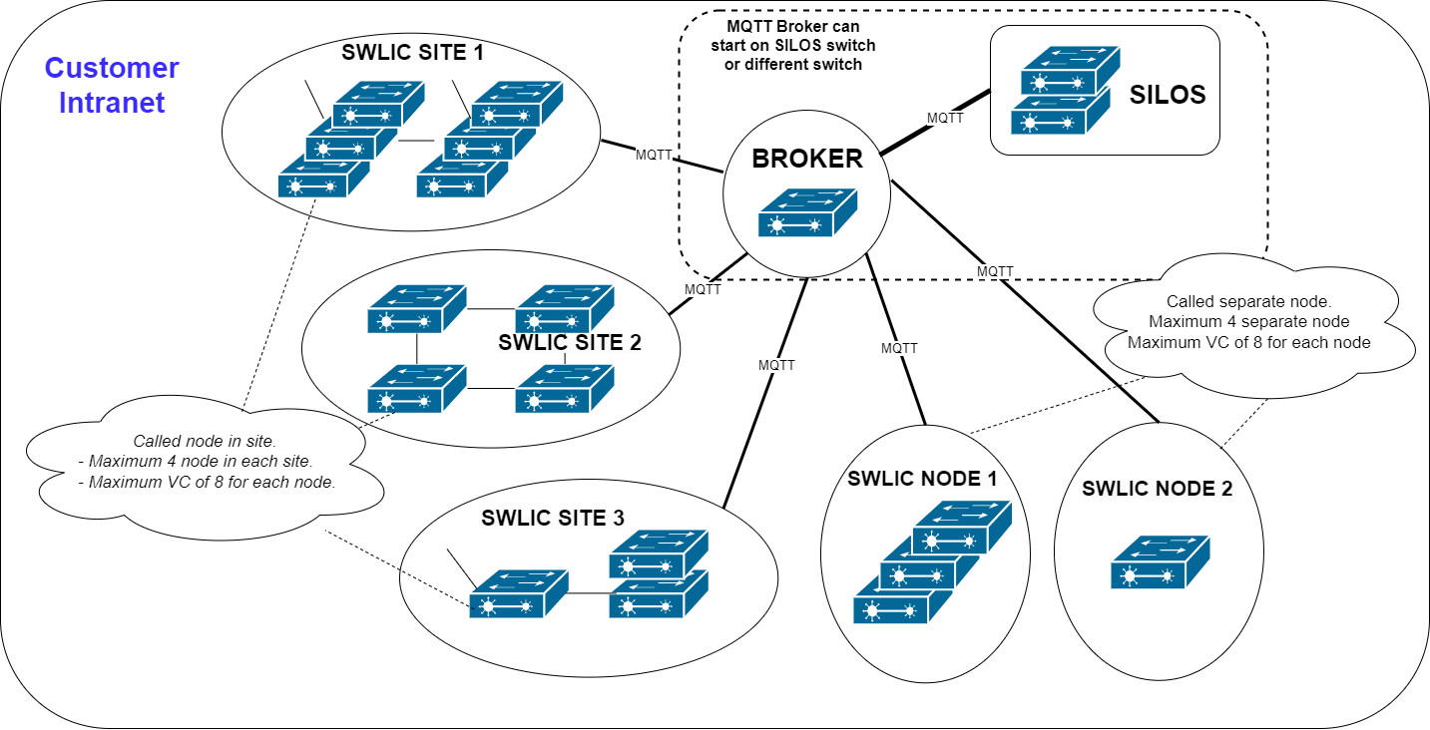

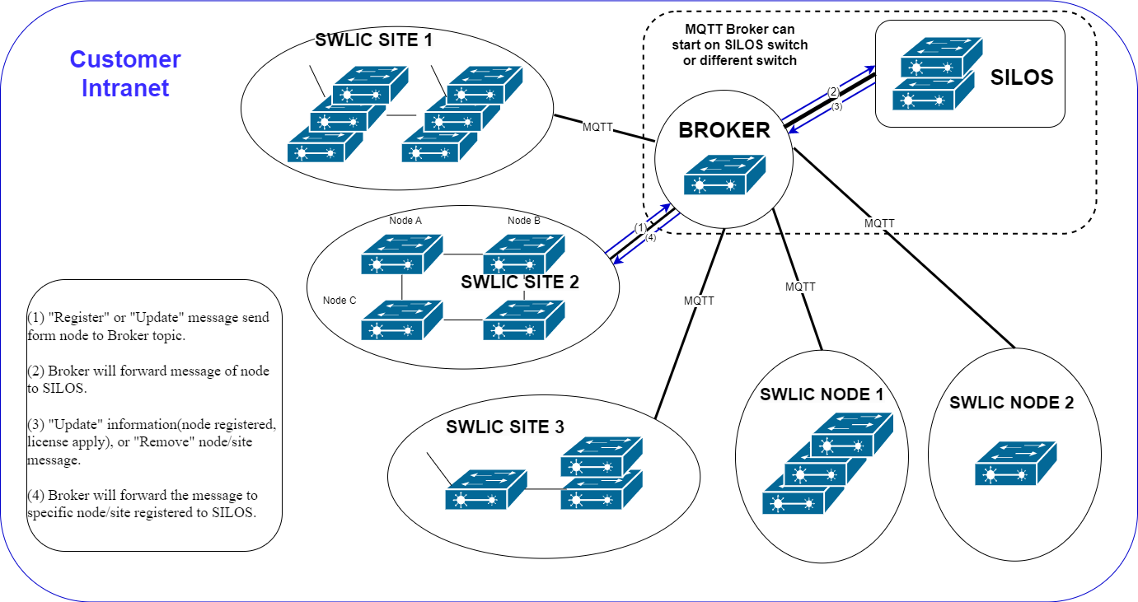

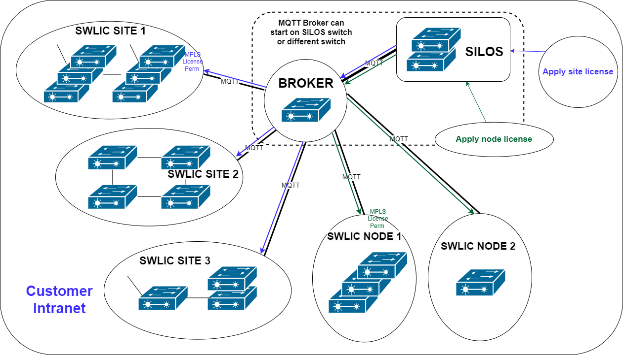

Site-Local Licensing Server (SILOS)
SILOS will be made available as an ALE Debian software package that can be installed on an ALE OmniSwitch using the AOS package manager mechanism.
SILOS software will be installed as an application in AOS environment running on an OmniSwitch network device.
In the initial release, only the manual mode of operation will be supported. Customers will download the site or node licenses generated on the ALE portal to the SILOS switch and install the licenses.
In a future release, when intelligent mode of operation is supported, the SILOS application will establish secure communication (using Secure MQTT) with the ALE portal. Any available licenses (purchased/subscribed by the customer) will be downloaded to local secure/encrypted storage and installed locally.

Switch-Local Client (SWLIC)
The Switch local Licensing client (SWLIC) application is bundled AOS image by default as well as delivered as (separate) installable (Debian) software package to support future solution upgrades, with minimal to zero changes to AOS software behavior or release management.
SWLIC should establish secure communication with the on-premises SILOS license server (using Secure MQTT transport protocol).

2.3 Platforms Supported
The feature shall be supported on the following products:
Hardware | MPLS Licensing Supported Starting Version
OS6860N
All models | 8.9.R03
Table 4: MPLS Site/Node based licensing supported platforms.

2.5 License Requirements
None.

2.6 Hardware Limitations
None.

2.7 Software Limitations
In License Server, the SILOS database contains the information of license keys, site/node connected etc. saved into a file “/flash/switch/sitemgr.db”. If this file has been deleted and the switch is rebooted immediately after that, all license information will be lost then user must re-install all Site or Node Licenses again.

2.8 Assumptions and Dependencies
To enable the Site/Node license in the License Server (SILOS), the customer must use the current ALE license portal to generate the license and install it manually using ALE License Server (SILOS) management configuration commands.
For License Client (SWLIC) to initiate a connection to the SILOS, there are some prerequisites that need to be met which are:
- MPLS package needs to be installed on the switch.
- Loopback0 interface needs to be configured before the MPLS interface is enabled.
- Server-Ip and Server-port need to be configured for SWLIC.
After user enables MPLS, MPLS will send an IPC message to License Client (SWLIC) and the License Client (SWLIC) will establish the connection to SILOS.

2.9 Resiliency Requirements
None.

3 FUNCTIONAL DESCRIPTIONS

3.1 Site License Basic Operation
The Site Licensing consists of 2 components: -
- The Site Local Licensing Server (SILOS) that runs on a switch or a VC, acts as a server issuing the Site or Node licenses to the Sites and Nodes.
- The Switch License Client (SWLIC) that runs on another switch or VC, acts as a client getting the Site or Node Licenses from the License Server (SILOS).
Note: The Site Local Licensing Server (SILOS) and Switch License Client (SWLIC) can run on two different switches or VC. Also, they both can run on the same switch or VC as well.

3.2 Site-Local Licensing Server (SILOS)
SILOS will be made available as an ALE Debian software package that can be installed on an ALE OmniSwitch using the AOS package manager mechanism.
SILOS software will be installed as an application in AOS environment running on an OmniSwitch network device on the customer On-Premises network.
In the 89R03 release, only the manual mode of operation will be supported. Customers will download the site/node licenses generated on the ALE portal to the SILOS switch and install the licenses.
SILOS will listen to any ALE switches on the customers’ intranet that request for license(s). If no customer-specific (site) licenses are available locally, a site/node license is instantiated with a 30-day demo/trial period validity. The demo license usage information is provided to the requesting switch for use. This server-defined demo period will either extend/override the switch’s default 15-day demo period to a maximum of 30 days.
SILOS will track switch usage of licenses. In manual mode of operation, switch license usage will be made available for local access (CLI/MIB/WebView).
SILOS should support intelligently assigning licenses to switches (VC’s) based on customer-configured Site Identifiers. A maximum of 4 switches (VC’s) configured with the same site identifiers should be assigned from the same Site license. Site identifiers are in the customers’ context and need not be exposed to the ALE portal for license generation.
SILOS should support intelligently assigning licenses to individual node’s (VC’s) based on node licenses installed. One node license is assigned to one switch (VC), Site identifiers are not required to be configured in case of node license.
License withdrawal on the SILOS switch should be supported by a manual command. Supplying the licensed switch’s Site identifier (Site-id), Node identifier (Switch SN) and Node IP address a command should be supported to withdraw the license from a previously licensed MPLS switch, by sending a License-Termination message and receiving an acknowledgement in return. SILOS application should track and save all such transactions locally, for auditing purposes.
Customers that intend to deploy MPLS functionality on AOS switches in their network using the Site-based licensing mechanism will have to install an instance of SILOS on one of the AOS switches in their network.
In the manual mode of operation (default mode in 89R03 release), customers will have to download the site/node license files generated on the ALE portal to this switch and install them.
Every instance of SILOS will run with a default site/node-based license that can support multiple MPLS sites (each site can have maximum of 4 nodes (single switch or VC)) or multiple nodes (single switch or VC) with a validity (demo) period of 30 calendar days. During this period, licenses purchased by the customer should be delivered to the switch hosting the SILOS application.
In manual mode of operation, customers should download the purchased licenses to the switch hosting the SILOS application and install them.
Site licenses downloaded from the ALE Business portal will be decoded by SILOS and saved on the local flash storage for secured retrieval. This mechanism will remain proprietary to ALE and not shared with the customer(s). Brute force deletion of such secured storage and rebooting the switch will result in loss of License Information in the SILOS, triggering the disabling of MPLS functionality on all network switches.
SILOS will allow SWLIC clients running on MPLS-enabled AOS switches to connect securely via MQTT. Switches provide information that will be tracked by SILOS locally for usage-based license grants and withdrawals.

3.3 Switch License Client (SWLIC)
The Switch local Licensing client (SWLIC) application is bundled AOS image by default as well as delivered as (separate) installable (Debian) software package to support future solution upgrades, with minimal to zero changes to AOS software behavior or release management.
When the MPLS feature is enabled on the switch for the first time, the MPLS module requests SWLIC to activate MPLS demo/trial period usage of 15 days. Prior to the expiry of this period, network reachability must be ensured to the on-premises SILOS license server. SWLIC client running on the switch will establish secure MQTT communication with the SILOS server within the customer network.
The following information of the MPLS-enabled switch must be provided by SWLIC:
- Configured Site-Identifier
- Switch (System) MAC Address (plus, List of System MAC addresses if VC)
- AOS Version
- AOS MPLS package version
If no connection is established with SILOS or the demo/trail period expires before the license can be obtained from SILOS, SWLIC should soft-disable the MPLS functionality (i.e., without changing MPLS-related configuration) on the switch. This involves imposing a hold-down by internally disabling functionality until the license is locally installed. Once the license is installed, the soft hold-down should be removed and MPLS functionality should be internally activated.
When a valid Site or Node license is obtained by SWLIC, an EEPROM bit should be set to indicate that MPLS is now licensed on this switch. Periodic heartbeat messages should be exchanged with the SILOS server to ensure reachability and to support mechanisms for license withdrawal.
License withdrawal on the SWLIC switch should be supported in two ways: (1) manually, by command on the SWLIC switch, and (2) triggered by receiving a License-Termination message from the SILOS server.
SWLIC will request to use the MPLS license from the SILOS server by providing the switch MAC address(es), including VC units if more than one, AOS software version, MPLS package version, etc. If no license was available, SILOS responds with License-Termination message and SWLIC will deactivate MPLS functionality on the switch (after the end of the demo period). SWLIC must make multiple attempts to request the license prior to the expiry of the demo period, to accommodate for dynamic changes to the site license usage by other switches. After the demo period expires, when MPLS functionality is disabled, SWLIC should continue to periodically request SILOS for a usage license. Such requests will trigger SILOS to either log/trap requests for new/additional MPLS licenses (in manual mode of operation).
Once a usage license is granted, SWLIC must save it on local secure storage and allow for MPLS functionality to continue/resume on the switch. An EEPROM bit must be programmed to indicate that MPLS is now licensed on the switch across system reboots.
If a new unit is attached to an existing VC, SWLIC must update the MAC address(es) information to the SILOS server. The same update must be done when a unit in a VC gets powered down.
SWLIC client must expose an API library that may be invoked my MPLS software components to check license status. This would be needed to dynamically adapt to changes in usage license status, without modifying MPLS configuration.
SWLIC must retain license grant/withdrawal state and related information across VC takeovers, in line with the rest of the AOS environment.

3.4 MPLS
After the MPLS package is installed in the switch and when the MPLS application is spawned on the switch it needs to establish an IPC connection to the Licensing Client (SWLIC).
When the user enables MPLS on the switch, it should send the IPC message include with package version to request license from License Client (SWLIC).
MPLS will be enabled only if it receives the license status is “permanent” or “demo” license not yet expired. And temporarily disable the feature if the license status is invalid(no-license) or “demo” license expired.

3.5 Functional Requirements
- For SILOS an ALE Debian Software Package needs to be introduced that can be installed on an ALE OmniSwitch using the AOS package manager mechanism.
- Need to have a provision for the customers to download the site/node licenses generated on the ALE portal to the SILOS switch and install the licenses.
- SILOS should run a default site/node based (demo) license that can support multiple MPLS sites (each site can have maximum of 4 nodes (single switch or VC)) or multiple nodes (single switch or VC) with a validity (demo) period of 30 calendar days.
- When no customer-specific (site) licenses are available locally, a site/node license is instantiated with a 30-day demo/trial period validity. SILOS needs to provide the demo license usage information to the requesting switch for use.
- The (SILOS) server-defined demo period will either extend/override the switch’s default 15-day demo period to a maximum of 30 days.
- SILOS should support assigning licenses to License Client switches (VC’s) based on customer-configured Site Identifiers. A maximum of 4 switches (VC’s) configured with the same site identifiers should be assigned from the same Site license.
- SILOS should support assigning licenses to individual node’s (VC’s) based on node licenses installed. One node license is assigned to one switch (VC), Site identifiers are not required to be configured in case of node license.
- SILOS should support License withdrawal by a manual command. Supplying the licensed switch’s Site identifier (Site-id), Node identifier (Switch SN) and Node IP address a command should be supported to withdraw the license from a previously licensed MPLS switch, by sending a License-Termination message and receiving an acknowledgement in return.
- SILOS should support customers downloading the purchased licenses to the switch hosting the SILOS application and install them. If no licenses are installed before the demo period expires, SILOS should trigger disabling of MPLS functionality on any network switches that may have requested the use of a license. This should be achieved by sending a License-Termination message to the SWLIC clients.
- Site licenses downloaded from the ALE Business portal should be able to be decoded by SILOS and saved on the local flash storage for secured retrieval.
- SILOS should allow SWLIC clients running on MPLS-enabled AOS switches to connect securely via MQTT.
- SILOS will check the connection between SWLIC through request/update message from SWLIC, if in a period (15 days) if no message is received, SILOS will conclude that SWLIC lost connection and deletes data of that node.
- The Switch local Licensing client (SWLIC) application shall be bundled in AOS image by default, also delivered as (separate) installable (Debian) software package to support future solution upgrades (as per need), with minimal to zero changes to AOS software behavior or release management.
- When MPLS feature is enabled on the switch for the first time, SWLIC shall activate MPLS demo/trial period usage of 15 days.
- When the MPLS feature is enabled on the switch for the first time, the MPLS module requests SWLIC to activate MPLS demo/trial period usage of 15 days.
- Prior to the expiry of the above demo/trials period, network reachability must be ensured to the on-premises SILOS license server so that SWLIC client running on the switch will establish secure MQTT communication with the SILOS server within the customer network.
- When MPLS feature is enabled and when SWLIC connects to SILOS, SWLIC should send the Configured Site-Identifier, Switch MAC address/addresses (if VC), AOS version, AOS MPLS package version etc.
- If no connection is established with SILOS or the demo/trail period expires before the license can be obtained from SILOS, SWLIC should soft-disable the MPLS functionality (i.e., without changing MPLS-related configuration) on the switch.
- Above involves imposing a hold-down by internally disabling functionality until the license is locally installed. Once the license is installed, the soft hold-down should be removed and MPLS functionality should be internally activated.
- When a valid Site or Node license is obtained by SWLIC, an EEPROM bit should be set to indicate that MPLS is now licensed on this switch. Periodic heartbeat messages should be exchanged with the SILOS server to ensure reachability and to support mechanisms for license withdrawal.
- SWLIC should support License Withdrawal in two ways 1) manually by CLI command on the SWLIC switch, and 2) triggered by receiving License-Termination message from the SILOS server.
- SWLIC should request the MPLS license from the SILOS server by providing the switch MAC address(es), including VC units if more than one, AOS software version, MPLS package version, etc.
- If no license was available, SILOS responds with License-Termination message and SWLIC should deactivate MPLS functionality on the switch (after the end of the demo period).
- SWLIC should make multiple attempts to request the license prior to the expiry of the demo period, to accommodate for dynamic changes to the site license usage by other switches.
- After the demo period expires, when MPLS functionality is disabled, SWLIC should continue to periodically request SILOS for a usage license. Such requests will trigger SILOS to either log/trap requests for new/additional MPLS licenses (in manual mode of operation).
- After SILOS granted the usage license, SWLIC should save it on local secure storage and allow for MPLS functionality to continue/resume on the switch. An EEPROM bit must be programmed to indicate that MPLS is now licensed on the switch across system reboots.
- When SWLIC has a permanent license, and if there is any request to remove the license, after removing the permanent license it will check if the previous demo period is still available. If it is available, it will switch back to the demo period.

3.5 Configuration Requirements
- A new CLI command should be introduced to configure broker for License Server (SILOS) with IP Address, port, VRF and admin state as inputs. In the first release (89R03) only default VRF is supported.
- A new CLI command should be introduced to install the site or node licenses (generated on the License Portal) on the License Server (SILOS) based on the license key stored in a file or a key string as inputs.
- A new CLI command should be introduced to remove the licenses installed on a site or node based on Site Id, Node Id, Node IP Address as inputs.
- A new CLI show command should be introduced to display the status of License Server (SILOS).
- A new CLI show command should be introduced to display the Site or Node licenses installed on the License Server (SILOS).
- A new CLI show command should be introduced to display the Sites or Nodes connected to the License Server (SILOS).
- A new CLI command should be introduced to configure the Switch License Client (SWLIC) to set the License Server IP Address and port that can establish a connection to the MQTT broker.
- A new CLI command should be introduced to remove the license installed on the Switch License Client (SWLIC).
- A new CLI show command should be introduced to display the configuration and status of the Switch License Client (SWLIC).

3.5.1 SNMP Configuration
- All new License Server (SILOS) and License Client (SWLIC) config should be supported from SNMP interface.

3.5.2 Web Configuration
- All new License Server (SILOS) and License Client (SWLIC) config should be supported from Webview interface.

3.5.3 SNMP Traps
- On the License Client (SWLIC), during the initial demo period (15 days) the SWLIC should monitor configuring the connection to License Server (SILOS) and if no License Server (SILOS) is configured or if the License Server (SILOS) is not reachable, an SNMP trap should be raised periodically (every 24 hours) to alert the customer to configure the License Server (SILOS) and ensure the connectivity as well.
- On the License Client (SWLIC), after connecting to License Server (SILOS), when the demo period is extended from 15 days to 30 days an SNMP trap should be raised.
- On the License Client (SWLIC), after connecting to License Server (SILOS), if there is no license available in the License Server (SILOS) after expiry of (30 day) demo period when the MPLS feature is disabled an SNMP trap should be raised.
- On the License Client (SWLIC), when the License Client receives the permanent Site or Node License from the License Server (SILOS) and after it is installed on the License Client (SWLIC) switches an SNMP trap should be raised.
- On the License Server (SILOS), when the SWLIC periodically request SILOS for a license and if no Site or Node license is available an SNMP trap should be raised periodically (every 24 hours) to alert the customer to install the license on the License Server (SILOS). The same trap shall be raised for requesting License before and after the expiry of 30-day demo period.
- On the License Server (SILOS), when the unit that maps to the Serial Number and MAC Address leaves VC permanently an SNMP trap should be raised with the reason for disable the license feature on the License Client (SWLIC).

3.6 Virtual Chassis Support
- The VC Master on the License Server (SILOS) should sync its local database to all Slave units, also when the database is updated. The database is updated for the cases below: -
- Change of information related to broker such as broker IP Address, broker port etc.
- New Site or Node registers to the License Server (SILOS), also when the Site or Node updates its information.
- New Site or Node license is installed on the License Server (SILOS)
- License Server (SILOS) removes the Site or Node from its License Management.
- On the License Server (SILOS), when a new Slave unit joins the VC, the VC Master should sync its local database to the new Slave unit that just joined the VC.
- On the License Server (SILOS), a Site or Node License should be allowed to be installed only if it meets the condition of MAC Address and Serial Number matches to any 1 unit either Master or Slave units.
- On the License Server (SILOS), if a unit leaves the VC an audit should be performed to check if the installed licenses are still valid. If the unit that maps to the Site or Node license installed leaves the VC permanently (more than 15 days), the VC Master should send a message to all nodes or sites using that license to disable the connection to the License Server (SILOS). The VC Master should temporarily block any new connection from a Site or Node until a valid license (generated based on any unit’s SN or MAC address) is installed on the License Server (SILOS).
- The VC Master on the License Client (SWLIC) should register and update with the information of all units in VC to the License Server (SILOS). The information includes Serial Number, MAC address, installed licenses, licensed feature state etc.
- The VC Master on the License Client (SWLIC) should be responsible for managing the demo licenses, if the demo license on the VC Master expires, demo license should be disabled on all VC units as well as the MPLS feature needs to be disabled on all VC units.
- When receiving the Permanent license from License Server (SILOS), the VC Master should inform all units to enable feature bit in EEPROM and sending IPC message MPLS CMM to enable the MPLS feature.
- When receiving "Delete" message from License Server (SILOS) due to license withdrawal, the VC Master should notify all VC units to remove feature bits in EEPROM and based on the status of demo license in VC Master switch back to Demo or No licensed state. Also send a message to MPLS CMM to disable the MPLS feature.
- On the License Client (SWLIC), when a new unit successfully joins the VC, the VC Master is responsible for updating the license information for the new units and updating the new unit information to the License Server (SILOS).
- On the License Client (SWLIC), when any unit leaves the VC, the VC Master should notify the License Server (SILOS) via an UPDATE message.
- When the connection between License Client (SWLIC) and License Server (SILOS) is lost, the VC Master shall start the timer for 15 days to try to establish a connection to License Server (SILOS). When this timer expires and if the connection is still not established the VC Master should soft disable all the features it manages. The VC Master should still try to establish the connection to the License Server (SILOS), if the connection is re-established the features should be re-enabled again.

3.6.1 Redundancy and VC-Takeover
- On the License Server (SILOS) when the VC-takeover happens the new VC Master should takeover the License Server (SILOS) functions based on the data synchronized (when it performed the Slave role). The License Clients (SWLIC) should be able to connect to the License Server (SILOS) on the new Master and there should not be any impact on the License Server (SILOS) functioning.
- On the License Server (SILOS), when the VC-takeover happens an audit should be performed to check if the installed licenses are still valid. If the unit that maps to the Site or Node license installed leaves the VC permanently (more than 15 days), the VC Master should send a message to all nodes or sites using that license to disable the connection to the License Server (SILOS). The VC Master should temporarily block any new connection from a Site or Node until a valid license (generated based on any unit’s SN or MAC address) is installed on the License Server (SILOS).
- On the License Client (SWLIC) when the VC-takeover happens the new VC Master should takeover the License Client (SWLIC) functions based on the data synchronized (when it performed the Slave role). The License Client (SWLIC) on the new Master should be able to connect to the License Server (SILOS) and there should not be any impact on the License Client (SWLIC) functioning.

3.6.2 VC-ISSU
Since the Site and Node based licensing is introduced in this (89R03) release there are no specific requirements for ISSU from previous release. How ever ISSU from this (89R03) release to any future release should be supported without any changes in both License Server (SILOS) and License Client (SWLIC).

3.7 Hardware Requirements
None.

3.8 Performance Requirements

3.8.1 Scalability
None.

3.8.2 Convergence Requirements
None.

3.9 Restriction Requirements
None.

3.10 Configuration Limits
None.

3.11 Security Concerns
None.

4 MANAGEMENT INTERFACE

4.1 Command Line Interface (CLI)

4.1.1 CLI Syntax Conventions
Convention | Description
< > | Brackets indicate that the information requested is required
{ } | Braces indicates that the user is required to choose from a set of options
| | A vertical bar separates a set of options
[ ] | Square brackets indicate that the information requested is optional
Table 7: CLI Syntax Conventions

4.1.2 Site License Command List
Site License Server commands | license server [vrf {default | <vrf_name>}] ip-address <ip-address> [listen-port <num>] [admin-state {enable | disable}]
 | license server apply {file file_name | key license_key}
 | license server remove {site site_id | node-ip node_ip | node-id node-id} [license mpls]
 | show license-server
 | show license-server info
 | show license-server usage
Switch Local Client command | license client { [site-id site_id] | [server-ip <ip-address> [server-port <num>]]}
 | license client remove license all | mpls
 | show license client info
Table 8: Site License Command List

4.1.3 Commands to configure Site License Server
4.1.3.1 Command to configure broker for Site License Server
license server [vrf {default | <vrf_name>}] ip-address <ip-address> [listen-port <num>] [admin-state {enable | disable}]
Input | Type | Range | Object | Description
default | string | 32 | alaSILOSBrokerConfigVrfName | The server IP address belongs to default VRF
<vrf_name> | string | 32 | alaSILOSBrokerConfigVrfName | The name of the VRF to which the server IP address belongs
<ip-address> | InetAddress |  | alaSILOSBrokerConfigIpAddress | IP address of MQTT broker
<num> | integer | 1024..65535 | alaSILOSBrokerConfigPort | Port number of MQTT broker
enable/disable | boolean |  | alaSILOSBrokerConfigAdminState | Status of MQTT broker
Description:
This command will enable or disable the connection of Site License Server to MQTT broker base on the ip-address and listen port.
Usage Guidelines:
- By default, the Site License Server is disabled on the switch. The default port number is 8883 and the host IP address is the IP address on localhost.
- Port configured should be greater than 1024.
- In the first phase only default VRF is supported.
Example:
-> license server ip-address 192.168.120.21 admin-state enable
-> license server ip-address 192.168.120.21 listen-port 27001 admin-state enable

4.1.3.2 Command to install Site/Node license on Site License Server
license server apply {file file_name | key license_key}
Input | Type | Range | Object | Description
<file_name> | string | 255 | alaSILOSLicensingConfigActionArg | The name of the license file containing the Site or Node license keys
<license_key> | string | 255 | alaSILOSLicensingConfigActionArg | The individual license key. The license key can contain special characters, the key must encase using single quote character (')
Description:
- This command is used to install site or node license on the Site License Server.
Usage Guidelines:
- By default, no Site or Node licenses are activated in Site License Server running on the switch.
- The user needs to generate the Site/Node licenses on the License Poral, copy the license file to the switch and install to the Site License Server running on the switch.
- The license server can install multiple licenses of the same type to increase the number of supported sites/nodes on the server.
Example:
-> license server apply file “/flash/license.txt”
-> license server apply key ‘pMJJ-i22p-Ps0y-%ROh-UCAx-54{T-}NE1-hJQK’

4.1.3.3 Command to remove license on the site/node from Site License Server
license server remove {site site_id | node-ip node_ip | node-id node-id} [license all | mpls | 50g]
Input | Type | Range | Object | Description
site_id | string | 255 | alaSILOSRemoveConfigTypeArg | Specific site-id that is connected to the Site License Server
node-ip | InetAddress |  | alaSILOSRemoveConfigTypeArgIpAddr | Specific IP address of the node in the site that is connected to the Site License Server
node-id | string | 255 | alaSILOSRemoveConfigTypeArg | Specific node-id that is connected to the Site License Server
all | mpls | 50g | integer |  | alaSILOSRemoveConfigFeature | Specific feature license that needs to be removed
Usage Guidelines:
- To get the specific site-id or node IP address, the command “show license-server usage” can be used. Also use the “show license-server usage” command to verify that node has been removed from Site License Server.
- Using “site site_id” will remove licenses from all nodes using the corresponding site id.
- Using “node-ip node_ip” will remove the license from the specified network node.
- Using “node-id node-id” will remove the license from the specified network node.
- If the command does not explicitly mention the license feature to be removed, all features will be removed according to site-id/node-id/node-ip.
- From 8.10.R02, introducing additional license feature EXP-50G on OS6870, this command also supports removing license feature 50G.
- 50G license supports each unit in the node, the "node-id" option can be considered "unit-id" in case of removing 50G license.
Description:
- This command will remove license on the specific site or node in the site that is connected to the Site License Server.
Example:
-> license server remove site test1
-> license server remove node-ip 192.168.120.51
-> license server remove node-id M1N2B3V4C5 license mpls
-> license server remove node-id M1N2B3V4C5 license 50G

4.1.3.4 Command to display the status of Site License Server
show license-server
Input | Type | Range | Object | Description
None
Description:
- This command is used to display the status of Site License Server running on the switch.
Example:
-> show license server
Package Version : 1.0,
Admin Status : Enable,
Server Ip Address : 10.120.0.120,
Server Port : 8884,
Connection Status : Connected,
Site connected : 4,
Node connected : 4

4.1.3.5 Command to display the licenses installed in the Site License Server
show license-server info
Input | Type | Range | Object | Description
None
Description:
- This command is be used to display the licenses installed in Site License Server.
Example:
-> show license server info
Type License Usage Install
Status Date
--------------+----------------+-------------+-----------------
MPLS-Site PERM 4 2023-04-20
MPLS-Node PERM 3 2023-04-19

4.1.3.6 Command to display the sites/nodes connected to Site License Server
show license-server usage
Input | Type | Range | Object | Description
None
Description:
- This command is used to display information related to sites/nodes connected to the Site License Server.
- The "Node-Id" field plays the role of "Unit-Id" in case the unit is using an "Individual" license.
Example:
->show license-server usage

Node-Id Site- System Ip- Feature Feature- License- Remain Connection
Id Name Address Id Version Status Days Status
-------------+----------------+------------ +----------------+------------+---------+-----------+-----------+-------------
V3981578 A1B2N3M4 OS6860N 10.120.0.120 MPLS-Site 1.0 PERM N/A Connected
V4961510 A1B2N3M4 OS6860N 10.120.0.121 MPLS-Site 1.0 PERM N/A Connected
V1385576 B1B2N3M4 OS6860N 10.120.0.122 MPLS-Site 1.0 PERM N/A Connected
V2385556 B1B2N3M4 OS6860N 10.120.0.123 MPLS-Site 1.0 PERM N/A Connected
A2456656 test OS6870 10.0.0.1 50G-Indv 1.0 PERM N/A Connected
BH33334 default OS6870 10.0.0.2 50G-Indv 1.0 PERM N/A Connected

4.1.4 Commands to configure Switch License Client
4.1.4.1 Command to configure Switch License Client and server connection.
license client { [site-id site_id] | [server-ip <ip-address> [server-port <num>]]}
Input | Type | Range | Object | Description
site_id | string | 16 | alaSWLICBrokerConfigSiteId | The text string to identify Site.
<ip-address> | InetAddress |  | alaSWLICBrokerConfigIpAddress | IP address of the Site License Server
<num> | integer | 1024..65535 | alaSWLICBrokerConfigPort | The port number of MQTT broker server
Description:
This command will set the site id for the Switch Licensing Client, set the server ip address and port that can establish a connection to the MQTT broker.
Usage Guidelines:
- By default, site-id will not be set on the switch, Site License Server IP address is “localhost”, and the port is 8883.
- If site-id is not set before establishing connection to SILOS, SWLIC will connect to SILOS as individual node.
- When changing the Site License Server IP address or port, the existing connection to the current MQTT broker server will be disconnected and the connection to the new address will be established.
Example:
-> license client site-id A1S2D3F4G5
-> license client site-id A1S2D3F4G5 server-ip 10.120.0.120 server-port 27000
-> license client server-ip 10.120.0.122

4.1.4.2 Command to remove feature license on Switch License Client
license client remove license all | mpls | 50g
Input | Type | Range | Object | Description
all | integer |  | alaSWLICLicenseRemoveFeature | This option will remove all feature licenses (received from the Site License Server) on the device
mpls | integer |  | alaSWLICLicenseRemoveFeature | This option will remove mpls feature license (received from the Site License Server) on the device
50g | integer |  | alaSWLICLicenseRemoveFeature | This option will remove 50G feature license (received from the Site License Server) on the device
Description:
This command is used to delete the feature license received from Site License Server.
From 8.10.R02, introducing additional license feature EXP-50G on OS6870, this command also supports removing license feature 50G.

Example:
->license client remove mpls
->license client remove all

4.1.4.3 Show Switch License Client information
show license-client info
Input | Type | Range | Object | Description
None
Description:
- This command is used to display the configuration and status of Switch License Client.
Example:

->show license-client info
Package Version : 1.0,
Site Id : A1S2D3F4G5,
Admin Status : Enable,
Server IpAddress : 10.120.0.120,
Server Port : 8884,
Connection Status : Connected,
Last message sent : 2024-04-19 20:24:20.506,
Last message received : 2024-04-19 20:24:21.606

4.2 SNMP Interface

4.2.1 Objects that contains the information of Site License Server(alaSILOS)
alaSILOS OBJECT-IDENTITY
STATUS current
DESCRIPTION
"Branch for SILOS MIB subsystem managed objects."
::= { alaIND1SiteLicenseServerMIBObjects 1 }

alaSILOSPackageVersion OBJECT-TYPE
SYNTAX SnmpAdminString (SIZE (1..32))
MAX-ACCESS read-only
STATUS current
DESCRIPTION "String displaying the SILOS debian package version."
::= { alaSILOS 1 }

alaSILOSAdminStatus OBJECT-TYPE
SYNTAX INTEGER {
enable (1),
disable (2)
}
MAX-ACCESS read-only
STATUS current
DESCRIPTION "The status indicates working process of SILOS."
DEFVAL { disable }
::= { alaSILOS 2 }

alaSILOSIpAddressType OBJECT-TYPE
SYNTAX InetAddressType
MAX-ACCESS read-only
STATUS current
DESCRIPTION "Integer displaying the configured address type for MQTT broker server host."
DEFVAL { ipv4 }
::= { alaSILOS 3 }

alaSILOSIpAddress OBJECT-TYPE
SYNTAX InetAddress
MAX-ACCESS read-only
STATUS current
DESCRIPTION "String displaying the configured address for MQTT broker server host."
::= { alaSILOS 4 }

alaSILOSPort OBJECT-TYPE
SYNTAX Integer32 ( 1024 .. 65535 )
MAX-ACCESS read-only
STATUS current
DESCRIPTION "Port number of the MQTT broker server host."
DEFVAL { 0 }
::= { alaSILOS 5 }

alaSILOSConnectionStatus OBJECT-TYPE
SYNTAX INTEGER {
connected (1),
disconnected (2)
}
MAX-ACCESS read-only
STATUS current
DESCRIPTION "The status indicates the connection between SILOS and MQTT broker."
DEFVAL { disconnected }
::= { alaSILOS 6 }

alaSILOSSiteConnected OBJECT-TYPE
SYNTAX Unsigned32
MAX-ACCESS read-only
STATUS current
DESCRIPTION "Number of sites connected to SILOS."
DEFVAL { 0 }
::= { alaSILOS 7 }

alaSILOSNodeConnected OBJECT-TYPE
SYNTAX Unsigned32
MAX-ACCESS read-only
STATUS current
DESCRIPTION "Number of separate nodes connected to SILOS."
DEFVAL { 0 }
::= { alaSILOS 8 }

4.2.2 Table that contains the license information installed on Site License Server (alaSILOSInfo)
alaSILOSInfo OBJECT-IDENTITY
STATUS current
DESCRIPTION
"Branch for SILOS MIB subsystem managed license objects."
::= { alaIND1SiteLicenseServerMIBObjects 2 }

alaSILOSInfoTable OBJECT-TYPE
SYNTAX SEQUENCE OF AlaSILOSInfoEntry
MAX-ACCESS not-accessible
STATUS current
DESCRIPTION "Table of SILOS license information."
::= { alaSILOSInfo 1 }

alaSILOSInfoEntry OBJECT-TYPE
SYNTAX AlaSILOSInfoEntry
MAX-ACCESS not-accessible
STATUS current
DESCRIPTION "Information of valid license information."
INDEX { alaSILOSInfoLicenseType }
::= { alaSILOSInfoTable 1 }

AlaSILOSInfoEntry ::=
SEQUENCE
{
alaSILOSInfoLicenseType INTEGER,
alaSILOSInfoLicenseStatus INTEGER,
alaSILOSInfoUsage Unsigned32,
alaSILOSInfoInstallDate DateAndTime
}

alaSILOSInfoLicenseType OBJECT-TYPE
SYNTAX INTEGER {
mpls-site (1),
mpls-node (2),
u50g-indv (3)
}
MAX-ACCESS accessible-for-notify
STATUS current
DESCRIPTION "License type information of the license installed on SILOS."
DEFVAL { mpls-site }
::= { alaSILOSInfoEntry 1 }

alaSILOSInfoLicenseStatus OBJECT-TYPE
SYNTAX INTEGER {
no-license (1),
demo (2),
permanent (3)
}
MAX-ACCESS read-only
STATUS current
DESCRIPTION "License status information of the license installed on SILOS."
DEFVAL { no-license }
::= { alaSILOSInfoEntry 2 }

alaSILOSInfoUsage OBJECT-TYPE
SYNTAX Unsigned32
MAX-ACCESS read-only
STATUS current
DESCRIPTION "The number of sites or nodes that the license supports."
DEFVAL { 0 }
::= { alaSILOSInfoEntry 3 }

alaSILOSInfoInstallDate OBJECT-TYPE
SYNTAX DateAndTime
MAX-ACCESS read-only
STATUS current
DESCRIPTION "Indicate license installation date."
::= { alaSILOSInfoEntry 4 }

4.2.3 Table that contains the license usage information on Site License Server (alaSILOSUsage)
Table alaSILOSUsage is no longer relevant in version 810R02, marked as deprecated, table alaSILOSUsageInfo will be used instead.
alaSILOSUsage OBJECT-IDENTITY
STATUS deprecated
DESCRIPTION
"Branch for SILOS MIB subsystem managed node objects."
::= { alaIND1SiteLicenseServerMIBObjects 3 }

alaSILOSUsageTable OBJECT-TYPE
SYNTAX SEQUENCE OF AlaSILOSUsageEntry
MAX-ACCESS not-accessible
STATUS deprecated
DESCRIPTION "Table of SILOS node connected information."
::= { alaSILOSUsage 1 }

alaSILOSUsageEntry OBJECT-TYPE
SYNTAX AlaSILOSUsageEntry
MAX-ACCESS not-accessible
STATUS deprecated
DESCRIPTION "Information of node connected to SILOS."
INDEX { alaSILOSUsageNodeId, alaSILOSUsageSiteId }
::= { alaSILOSUsageTable 1 }

AlaSILOSUsageEntry ::=
SEQUENCE
{
alaSILOSUsageNodeId OCTET STRING,
alaSILOSUsageSiteId SnmpAdminString,
alaSILOSUsageModelName SnmpAdminString,
alaSILOSUsageIpAddressType InetAddressType,
alaSILOSUsageIpAddress InetAddress,
alaSILOSUsageLicenseType INTEGER,
alaSILOSUsagePackageVersion SnmpAdminString,
alaSILOSUsageLicenseStatus INTEGER,
alaSILOSUsageRemainDays SnmpAdminString,
alaSILOSUsageConnectionStatus INTEGER
}

alaSILOSUsageNodeId OBJECT-TYPE
SYNTAX OCTET STRING (SIZE (1..25))
MAX-ACCESS not-accessible
STATUS deprecated
DESCRIPTION "String displaying the node identifier."
::= { alaSILOSUsageEntry 1 }

alaSILOSUsageSiteId OBJECT-TYPE
SYNTAX SnmpAdminString (SIZE (1..16))
MAX-ACCESS not-accessible
STATUS deprecated
DESCRIPTION "String displaying the site identifier."
::= { alaSILOSUsageEntry 2 }

alaSILOSUsageModelName OBJECT-TYPE
SYNTAX SnmpAdminString (SIZE (1..32))
MAX-ACCESS read-only
STATUS deprecated
DESCRIPTION "String displaying the model name of node connected."
::= { alaSILOSUsageEntry 3 }

alaSILOSUsageIpAddressType OBJECT-TYPE
SYNTAX InetAddressType
MAX-ACCESS read-only
STATUS deprecated
DESCRIPTION "Integer displaying the configured address type for the node connected."
DEFVAL { ipv4 }
::= { alaSILOSUsageEntry 4 }

alaSILOSUsageIpAddress OBJECT-TYPE
SYNTAX InetAddress
MAX-ACCESS read-only
STATUS deprecated
DESCRIPTION "String displaying the configured address for the node connected."
::= { alaSILOSUsageEntry 5 }

alaSILOSUsageLicenseType OBJECT-TYPE
SYNTAX INTEGER {
mpls-site (1),
mpls-node (2)
}
MAX-ACCESS read-only
STATUS deprecated
DESCRIPTION "License type information of the license installed on SWLIC."
DEFVAL { mpls-site }
::= { alaSILOSUsageEntry 6 }

alaSILOSUsagePackageVersion OBJECT-TYPE
SYNTAX SnmpAdminString (SIZE (1..32))
MAX-ACCESS read-only
STATUS deprecated
DESCRIPTION "String displaying the SWLIC debian package version of the node connected."
::= { alaSILOSUsageEntry 7 }

alaSILOSUsageLicenseStatus OBJECT-TYPE
SYNTAX INTEGER {
no-license (1),
demo (2),
permanent (3)
}
MAX-ACCESS read-only
STATUS deprecated
DESCRIPTION "License status information of the feature on node connected."
DEFVAL { no-license }
::= { alaSILOSUsageEntry 8 }

alaSILOSUsageRemainDays OBJECT-TYPE
SYNTAX SnmpAdminString (SIZE (0..31))
MAX-ACCESS read-only
STATUS deprecated
DESCRIPTION "String displaying the number of days the license is valid."
DEFVAL { "" }
::= { alaSILOSUsageEntry 9 }

alaSILOSUsageConnectionStatus OBJECT-TYPE
SYNTAX INTEGER {
connected (1),
disconnected (2)
}
MAX-ACCESS read-only
STATUS deprecated
DESCRIPTION "The status indicates the connection between SWLIC and SILOS."
DEFVAL { disconnected }
::= { alaSILOSUsageEntry 10 }

alaSILOSUsageInfo OBJECT-IDENTITY
STATUS current
DESCRIPTION
"Branch for SILOS MIB subsystem managed node objects."
::= { alaIND1SiteLicenseServerMIBObjects 7 }

alaSILOSUsageInfoTable OBJECT-TYPE
SYNTAX SEQUENCE OF AlaSILOSUsageInfoEntry
MAX-ACCESS not-accessible
STATUS current
DESCRIPTION "Table of SILOS node connected information."
::= { alaSILOSUsageInfo 1 }

alaSILOSUsageInfoEntry OBJECT-TYPE
SYNTAX AlaSILOSUsageInfoEntry
MAX-ACCESS not-accessible
STATUS current
DESCRIPTION "Information of node connected to SILOS."
INDEX { alaSILOSUsageInfoSiteId, alaSILOSUsageInfoNodeId, alaSILOSUsageInfoUnitId, alaSILOSUsageInfoLicenseType}
::= { alaSILOSUsageInfoTable 1 }

AlaSILOSUsageInfoEntry ::=
SEQUENCE
{
alaSILOSUsageInfoSiteId SnmpAdminString,
alaSILOSUsageInfoNodeId OCTET STRING,
alaSILOSUsageInfoUnitId OCTET STRING,
alaSILOSUsageInfoModelName SnmpAdminString,
alaSILOSUsageInfoIpAddressType InetAddressType,
alaSILOSUsageInfoIpAddress InetAddress,
alaSILOSUsageInfoLicenseType INTEGER,
alaSILOSUsageInfoPackageVersion SnmpAdminString,
alaSILOSUsageInfoLicenseStatus INTEGER,
alaSILOSUsageInfoRemainDays SnmpAdminString,
alaSILOSUsageInfoConnectionStatus INTEGER
}

alaSILOSUsageInfoSiteId OBJECT-TYPE
SYNTAX SnmpAdminString (SIZE (1..16))
MAX-ACCESS not-accessible
STATUS current
DESCRIPTION "String displaying the site identifier."
::= { alaSILOSUsageInfoEntry 1 }

alaSILOSUsageInfoNodeId OBJECT-TYPE
SYNTAX OCTET STRING (SIZE (1..25))
MAX-ACCESS not-accessible
STATUS current
DESCRIPTION "String displaying the node identifier."
::= { alaSILOSUsageInfoEntry 2 }

alaSILOSUsageInfoUnitId OBJECT-TYPE
SYNTAX OCTET STRING (SIZE (1..25))
MAX-ACCESS not-accessible
STATUS current
DESCRIPTION "String displaying the unit identifier."
::= { alaSILOSUsageInfoEntry 3 }

alaSILOSUsageInfoModelName OBJECT-TYPE
SYNTAX SnmpAdminString (SIZE (1..32))
MAX-ACCESS read-only
STATUS current
DESCRIPTION "String displaying the model name of node connected."
::= { alaSILOSUsageInfoEntry 4 }

alaSILOSUsageInfoIpAddressType OBJECT-TYPE
SYNTAX InetAddressType
MAX-ACCESS read-only
STATUS current
DESCRIPTION "Integer displaying the configured address type for the node connected."
DEFVAL { ipv4 }
::= { alaSILOSUsageInfoEntry 5 }

alaSILOSUsageInfoIpAddress OBJECT-TYPE
SYNTAX InetAddress
MAX-ACCESS read-only
STATUS current
DESCRIPTION "String displaying the configured address for the node connected."
::= { alaSILOSUsageInfoEntry 6 }

alaSILOSUsageInfoLicenseType OBJECT-TYPE
SYNTAX INTEGER {
mplsSite (1),
mplsNode (2),
u50gIndv (3)
}
MAX-ACCESS not-accessible
STATUS current
DESCRIPTION "License type information of the license installed on SWLIC."
DEFVAL { mplsSite }
::= { alaSILOSUsageInfoEntry 7 }

alaSILOSUsageInfoPackageVersion OBJECT-TYPE
SYNTAX SnmpAdminString (SIZE (1..32))
MAX-ACCESS read-only
STATUS current
DESCRIPTION "String displaying the SWLIC debian package version of the node connected."
::= { alaSILOSUsageInfoEntry 8 }

alaSILOSUsageInfoLicenseStatus OBJECT-TYPE
SYNTAX INTEGER {
noLicense (1),
demo (2),
permanent (3)
}
MAX-ACCESS read-only
STATUS current
DESCRIPTION "License status information of the feature on node connected."
DEFVAL { noLicense }
::= { alaSILOSUsageInfoEntry 9 }

alaSILOSUsageInfoRemainDays OBJECT-TYPE
SYNTAX SnmpAdminString (SIZE (0..31))
MAX-ACCESS read-only
STATUS current
DESCRIPTION "String displaying the number of days the license is valid."
DEFVAL { "" }
::= { alaSILOSUsageInfoEntry 10 }

alaSILOSUsageInfoConnectionStatus OBJECT-TYPE
SYNTAX INTEGER {
connected (1),
disconnected (2)
}
MAX-ACCESS read-only
STATUS current
DESCRIPTION "The status indicates the connection between SWLIC and SILOS."
DEFVAL { disconnected }
::= { alaSILOSUsageInfoEntry 11 }

4.2.4 Objects that contain the configurations of Site License Server (alaSILOSBrokerConfig)
alaSILOSBrokerConfig OBJECT-IDENTITY
STATUS current
DESCRIPTION
"Branch for SILOS MIB subsystem managed broker configuration objects."
::= { alaIND1SiteLicenseServerMIBObjects 4 }

alaSILOSBrokerConfigVrfName OBJECT-TYPE
SYNTAX OCTET STRING(SIZE (0..32))
MAX-ACCESS read-write
STATUS current
DESCRIPTION
"The name of the VRF."
DEFVAL { "default" }
::= { alaSILOSBrokerConfig 1 }

alaSILOSBrokerConfigIpAddressType OBJECT-TYPE
SYNTAX InetAddressType
MAX-ACCESS read-write
STATUS current
DESCRIPTION "Integer that configures the address type for MQTT broker server host."
DEFVAL { ipv4 }
::= { alaSILOSBrokerConfig 2 }

alaSILOSBrokerConfigIpAddress OBJECT-TYPE
SYNTAX InetAddress
MAX-ACCESS read-write
STATUS current
DESCRIPTION "String that configures the address for MQTT broker server host."
::= { alaSILOSBrokerConfig 3 }

alaSILOSBrokerConfigPort OBJECT-TYPE
SYNTAX Integer32 ( 0 .. 65535 )
MAX-ACCESS read-write
STATUS current
DESCRIPTION "Port number of the MQTT broker server host."
DEFVAL { 0 }
::= { alaSILOSBrokerConfig 4 }

alaSILOSBrokerConfigAdminState OBJECT-TYPE
SYNTAX INTEGER {
enable (1),
disable (2)
}
MAX-ACCESS read-write
STATUS current
DESCRIPTION "Used to configure broker state on SILOS.."
DEFVAL { disable }
::= { alaSILOSBrokerConfig 5 }

4.2.5 Objects that contain the remove configurations on Site License Server (alaSILOSRemoveConfig)
alaSILOSRemoveConfig OBJECT-IDENTITY
STATUS current
DESCRIPTION
"Branch for SILOS MIB subsystem managed remove configuration objects."
::= { alaIND1SiteLicenseServerMIBObjects 6 }

alaSILOSRemoveConfigType OBJECT-TYPE
SYNTAX INTEGER {
default (0),
site (1),
nodeId (2),
nodeIp (3)
}
MAX-ACCESS read-write
STATUS current
DESCRIPTION "Object to define the action to remove site/node connected to SILOS."
::= { alaSILOSRemoveConfig 1}

alaSILOSRemoveConfigTypeArg OBJECT-TYPE
SYNTAX SnmpAdminString (SIZE (0..255))
MAX-ACCESS read-write
STATUS current
DESCRIPTION "Argument of the site local remove site/node action."
::= { alaSILOSRemoveConfig 2}

alaSILOSRemoveConfigTypeArgIpAddrType OBJECT-TYPE
SYNTAX InetAddressType
MAX-ACCESS read-write
STATUS current
DESCRIPTION "Integer that configures the address type for the node to be deleted."
DEFVAL { ipv4 }
::= { alaSILOSRemoveConfig 3 }

alaSILOSRemoveConfigTypeArgIpAddr OBJECT-TYPE
SYNTAX InetAddress
MAX-ACCESS read-write
STATUS current
DESCRIPTION "String that configures the address for the node to be deleted."
::= { alaSILOSRemoveConfig 4}

alaSILOSRemoveConfigFeature OBJECT-TYPE
SYNTAX INTEGER {
all (1),
mpls (2),
f50g (3)
}
MAX-ACCESS read-write
STATUS current
DESCRIPTION "Feature id to delete on site/node."
::= { alaSILOSRemoveConfig 5}

4.2.6 Objects that contain the apply license configurations on Site License Server (alaSILOSLicensingConfig)
alaSILOSLicensingConfig OBJECT-IDENTITY
STATUS current
DESCRIPTION
"Branch for SILOS MIB subsystem managed licensing configuration objects."
::= { alaIND1SiteLicenseServerMIBObjects 5 }

alaSILOSLicensingConfigAction OBJECT-TYPE
SYNTAX INTEGER {
default (0),
applyFile (1),
applyKey (2)
}
MAX-ACCESS read-write
STATUS current
DESCRIPTION "Object to define the action related to site local software licensing."
::= { alaSILOSLicensingConfig 1}

alaSILOSLicensingConfigActionArg OBJECT-TYPE
SYNTAX SnmpAdminString (SIZE (1..256))
MAX-ACCESS read-write
STATUS current
DESCRIPTION "Argument of the site local software licensing action."
::= { alaSILOSLicensingConfig 2}

4.2.7 Objects that contain the information of Switch License Client (alaSWLICInfo)
alaSWLICInfo OBJECT-IDENTITY
STATUS current
DESCRIPTION
"Branch for SWLIC MIB subsystem managed information objects."
::= { alaIND1SiteLicenseClientMIBObjects 1 }

alaSWLICInfoPackageVersion OBJECT-TYPE
SYNTAX SnmpAdminString (SIZE (1..32))
MAX-ACCESS read-only
STATUS current
DESCRIPTION "String displaying the SWLIC debian package version."
::= { alaSWLICInfo 1 }

alaSWLICInfoSiteId OBJECT-TYPE
SYNTAX SnmpAdminString (SIZE (1..16))
MAX-ACCESS read-only
STATUS current
DESCRIPTION "String displaying the SWLIC site identifier."
::= { alaSWLICInfo 2 }

alaSWLICInfoAdminStatus OBJECT-TYPE
SYNTAX INTEGER {
enable (1),
disable (0)
}
MAX-ACCESS read-only
STATUS current
DESCRIPTION "The status indicates working process of SWLIC."
DEFVAL { disable }
::= { alaSWLICInfo 3 }

alaSWLICInfoIpAddressType OBJECT-TYPE
SYNTAX InetAddressType
MAX-ACCESS read-only
STATUS current
DESCRIPTION "Integer displaying the configured address type for MQTT broker server host."
DEFVAL { ipv4 }
::= { alaSWLICInfo 4 }

alaSWLICInfoIpAddress OBJECT-TYPE
SYNTAX InetAddress
MAX-ACCESS read-only
STATUS current
DESCRIPTION "String displaying the configured address for MQTT broker server host."
::= { alaSWLICInfo 5 }

alaSWLICInfoPort OBJECT-TYPE
SYNTAX Integer32 ( 1024 .. 65535 )
MAX-ACCESS read-only
STATUS current
DESCRIPTION "Port number of the MQTT broker server host."
DEFVAL { 0 }
::= { alaSWLICInfo 6 }

alaSWLICInfoConnectionStatus OBJECT-TYPE
SYNTAX INTEGER {
connected (1),
disconnected (2)
}
MAX-ACCESS read-only
STATUS current
DESCRIPTION "The status indicates the connection between SWLIC and MQTT broker."
DEFVAL { disconnected }
::= { alaSWLICInfo 7 }

alaSWLICInfoLastMsgSend OBJECT-TYPE
SYNTAX DateAndTime
MAX-ACCESS read-only
STATUS current
DESCRIPTION "String displaying the time when SWLIC sent the last message to the Broker."
::= { alaSWLICInfo 8 }

alaSWLICInfoLastMsgReceive OBJECT-TYPE
SYNTAX DateAndTime
MAX-ACCESS read-only
STATUS current
DESCRIPTION "String displaying the time when SWLIC received the last message from the Broker."
::= { alaSWLICInfo 9 }

4.2.8 Objects that contain the configuration of Switch License Client (alaSWLICBrokerConfig)
alaSWLICBrokerConfig OBJECT-IDENTITY
STATUS current
DESCRIPTION
"Branch for SWLIC MIB subsystem managed broker configuration objects."
::= { alaIND1SiteLicenseClientMIBObjects 2 }

alaSWLICBrokerConfigSiteId OBJECT-TYPE
SYNTAX SnmpAdminString (SIZE (1..16))
MAX-ACCESS read-write
STATUS current
DESCRIPTION "The SWLIC site identifier."
DEFVAL { "default" }
::= { alaSWLICBrokerConfig 1 }

alaSWLICBrokerConfigIpAddressType OBJECT-TYPE
SYNTAX InetAddressType
MAX-ACCESS read-write
STATUS current
DESCRIPTION "Integer that configures the address type for the MQTT broker server host."
DEFVAL { ipv4 }
::= { alaSWLICBrokerConfig 2 }

alaSWLICBrokerConfigIpAddress OBJECT-TYPE
SYNTAX InetAddress
MAX-ACCESS read-write
STATUS current
DESCRIPTION "String that configures the address for the MQTT broker server host."
::= { alaSWLICBrokerConfig 3 }

alaSWLICBrokerConfigPort OBJECT-TYPE
SYNTAX Integer32 ( 0 .. 65535 )
MAX-ACCESS read-write
STATUS current
DESCRIPTION "Port number of the MQTT broker server host."
DEFVAL { 0 }
::= { alaSWLICBrokerConfig 4 }

4.2.9 Objects that contain the license remove configurations on Switch License Client (alaSWLICLicenseRemove)

alaSWLICLicenseRemove OBJECT-IDENTITY
STATUS current
DESCRIPTION
"Branch for SWLIC MIB subsystem managed remove license objects."
::= { alaIND1SiteLicenseClientMIBObjects 3 }

alaSWLICLicenseRemoveFeature OBJECT-TYPE
SYNTAX INTEGER {
all (1),
mpls (2),
f50g (3)
}
MAX-ACCESS read-only
STATUS current
DESCRIPTION "The license feature id need remove."
DEFVAL { all }
::= { alaSWLICLicenseRemove 1 }

4.2.10 Objects that contain the Site License Server notification
alaSiteLicenseSerialId OBJECT-TYPE
SYNTAX OCTET STRING (SIZE(1..25))
MAX-ACCESS accessible-for-notify
STATUS current
DESCRIPTION "String displaying the serial number for which this license is valid."
::= { alaSiteLicenseServerNotificationObjects 1 }

4.2.11 Site License Server trap notification

alaSILOSNoLicenseInstalledAlert NOTIFICATION-TYPE
OBJECTS
{
alaSiteLicenseSerialId,
alaSILOSInfoLicenseType,
alaSILOSInfoLicenseStatus
}
STATUS current
DESCRIPTION
"If no Site or Node license is available, this trap is raised periodically (every 24 hours) to alert the customer to install the license on the License Server. The same trap is raised while requesting License before and after the expiry of 30-day demo period."
::= { alaSiteLicenseServerMibNotifications 1 }

alaSILOSLicenseUnitLeaveAlert NOTIFICATION-TYPE
OBJECTS
{
alaSiteLicenseSerialId,
alaSILOSInfoLicenseType,
alaSILOSInfoLicenseStatus
}
STATUS current
DESCRIPTION
"This trap is raised when the unit that maps to the Serial Number and MAC Address leaves VC permanently, with the reason for disable the license feature on the License Client"
::= { alaSiteLicenseServerMibNotifications 2 }

4.2.12 Objects that contain the Site License Client notification
alaSWLICSerialId OBJECT-TYPE
SYNTAX OCTET STRING (SIZE(1..25))
MAX-ACCESS accessible-for-notify
STATUS current
DESCRIPTION "String displaying the serial number for which this license is valid."
::= { alaSiteLicenseClientNotificationObjects 1 }

alaSWLICDemoPeriodTime OBJECT-TYPE
SYNTAX Unsigned32 (0..64)
MAX-ACCESS read-write
STATUS current
DESCRIPTION "The number displaying demo period days"
::= { alaSiteLicenseClientNotificationObjects 2 }

alaSWLICLicenseFeature OBJECT-TYPE
SYNTAX INTEGER {
mpls (1),
f50g (2)
}
MAX-ACCESS read-write
STATUS current
DESCRIPTION "The license feature id."
::= { alaSiteLicenseClientNotificationObjects 3 }

4.2.13 Site License Client trap notification
alaSWLICNoConnectivityAlert NOTIFICATION-TYPE
OBJECTS
{
alaSWLICSerialId,
alaSWLICInfoSiteId,
alaSWLICInfoConnectionStatus
}
STATUS current
DESCRIPTION
"If no License Server is configured or if the License Server is not reachable, this trap is raised periodically (every 24 hours) to alert the customer to configure the License Server (SILOS) and ensure the connectivity as well."
::= { alaSiteLicenseClientMibNotifications 1 }

alaSWLICExtendDemoLicenseAlert NOTIFICATION-TYPE
OBJECTS
{
alaSWLICSerialId,
alaSWLICInfoSiteId,
alaSWLICDemoPeriodTime,
alaSWLICLicenseFeature
}
STATUS current
DESCRIPTION
"This trap is raised when the demo period is extended from 15 days to 30 days (after connecting to the License Server)."
::= { alaSiteLicenseClientMibNotifications 2 }

alaSWLICDemoLicenseExpiredAlert NOTIFICATION-TYPE
OBJECTS
{
alaSWLICSerialId,
alaSWLICInfoSiteId,
alaSWLICLicenseFeature
}
STATUS current
DESCRIPTION
"This trap is raised when there is no license available in the License Server (SILOS) after expiry of (30 day) demo period and the MPLS feature is disabled."
::= { alaSiteLicenseClientMibNotifications 3 }

alaSWLICPermanentLicenseInstalledAlert NOTIFICATION-TYPE
OBJECTS
{
alaSWLICSerialId,
alaSWLICInfoSiteId,
alaSWLICLicenseFeature
}
STATUS current
DESCRIPTION
"This trap is raised when the Site License Client receives the permanent Site or Node License from the License Server."
::= { alaSiteLicenseClientMibNotifications 4 }

4.3 Web Interface
The webpage support all Command Line Interface (CLI) below.
- license server [vrf {default | <vrf_name>}] ip-address <ip-address> [listen-port <num>] [admin-state {enable | disable}]
- license server apply {file file_name | key license_key}
- license server remove {site site_id | node-ip node_ip | node-id node-id} [license mpls]
- show license-server
- show license-server info
- show license-server usage
- license client { [site-id site_id] | [server-ip <ip-address> [server-port <num>]]}
- license client remove license all | mpls
- show license-client info
4.3.1 Web Interface Entry Page
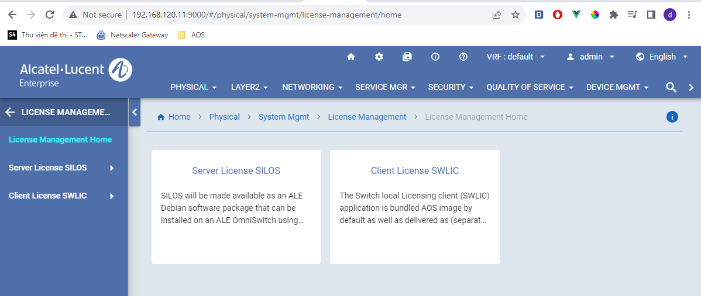

4.3.2 Configure broker for Site License Server Page
CLI: license server [vrf {default | <vrf_name>}] ip-address <ip-address> [listen-port <num>] [admin-state {enable | disable}]
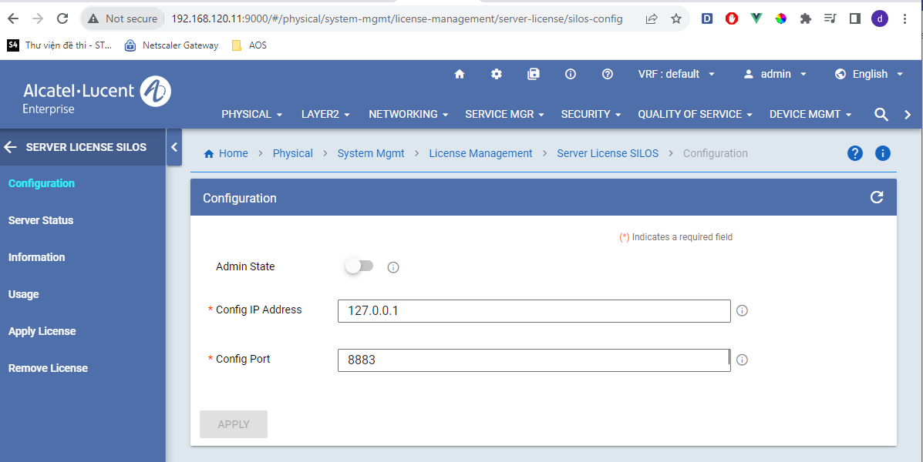

4.3.3 Install Site/Node license on Site License Server Page

CLI: license server apply {file file_name | key license_key}
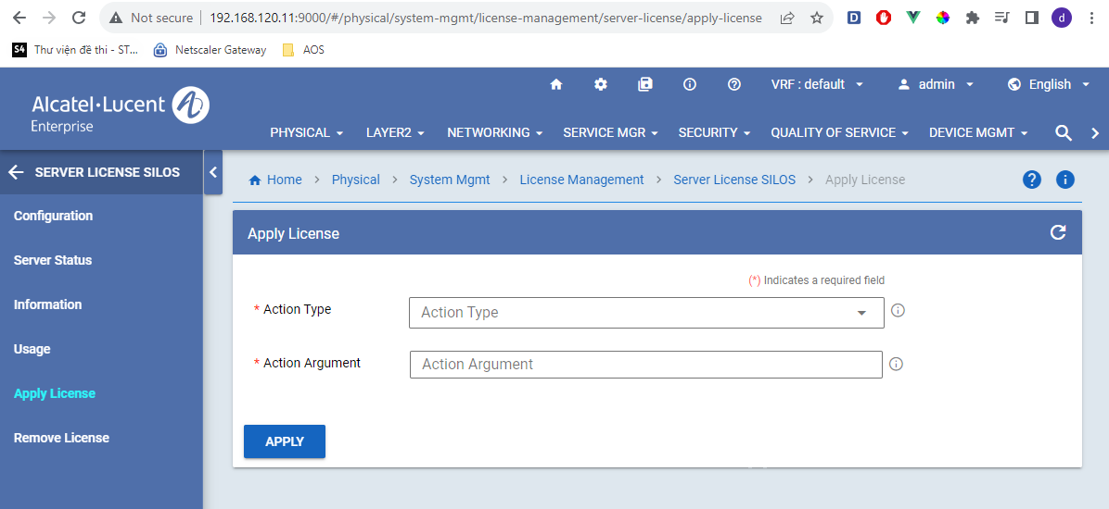

4.3.4 Remove license on the site/node from Site License Server Page

CLI: license server remove {site site_id | node-ip node_ip | node-id node-id} [license mpls]
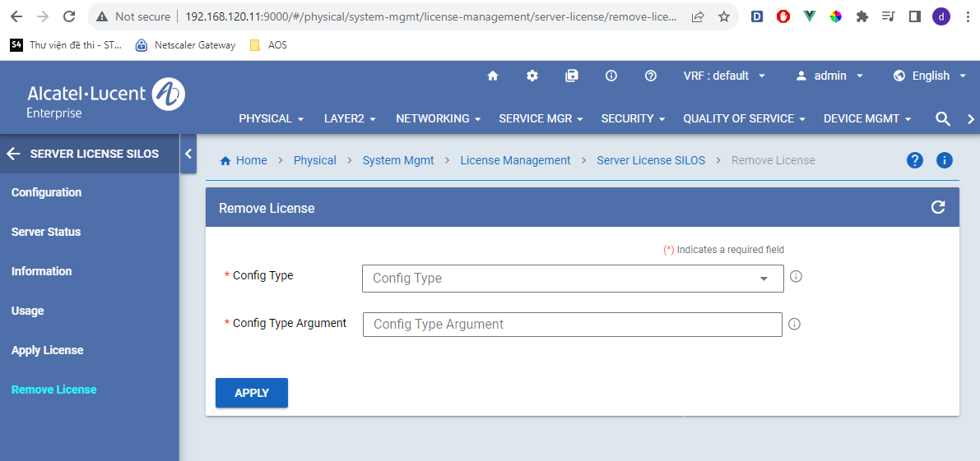

4.3.5 Command to display the status of Site License Server Page

CLI: show license-server
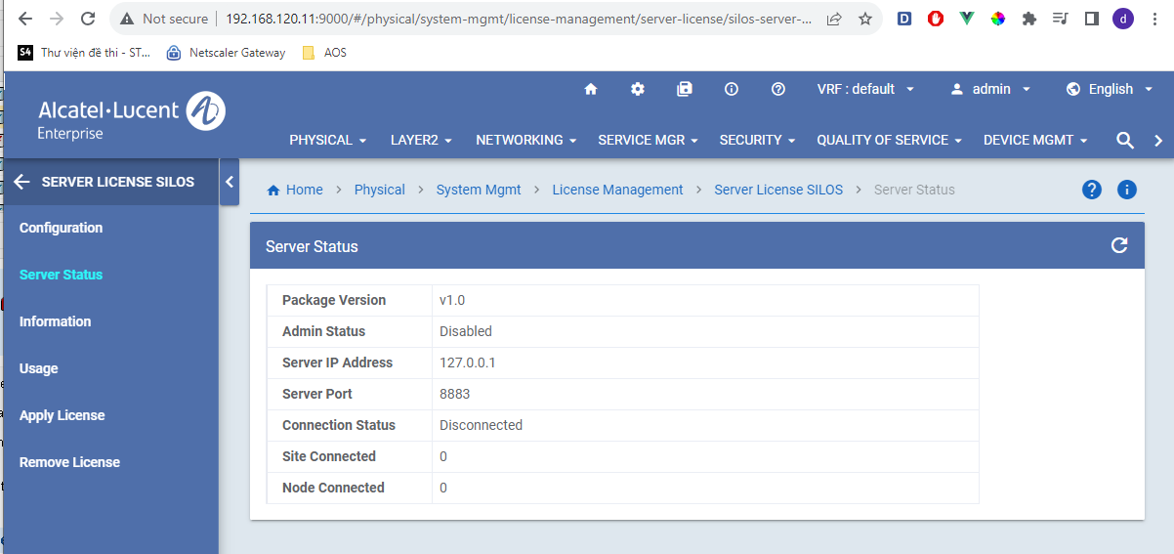

4.3.6 Display the licenses installed in the Site License Server Page

CLI: show license-server info
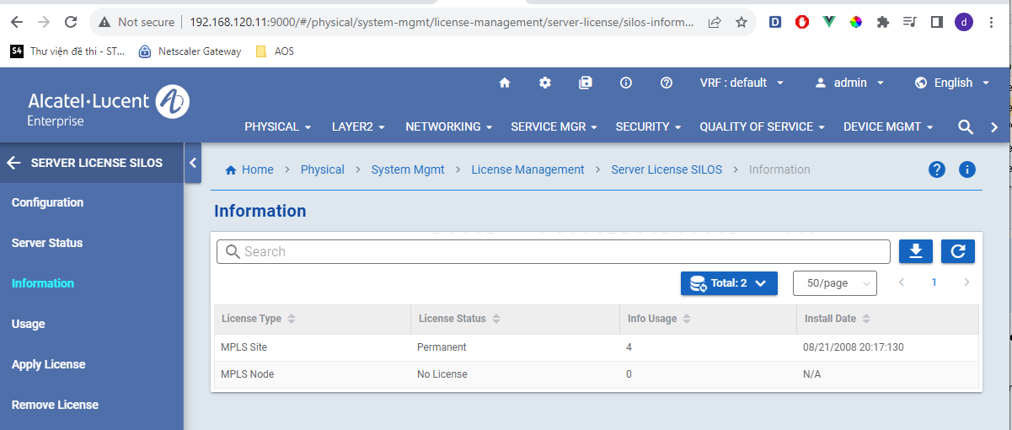

4.3.7 Display the sites/nodes connected to Site License Server Page

CLI: show license-server usage
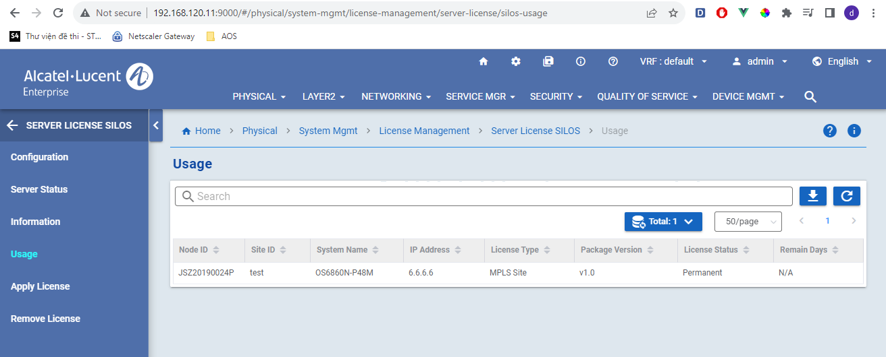

4.3.8 Configure Switch License Client Page
CLI: license client { [site-id site_id] | [server-ip <ip-address> [server-port <num>]]}

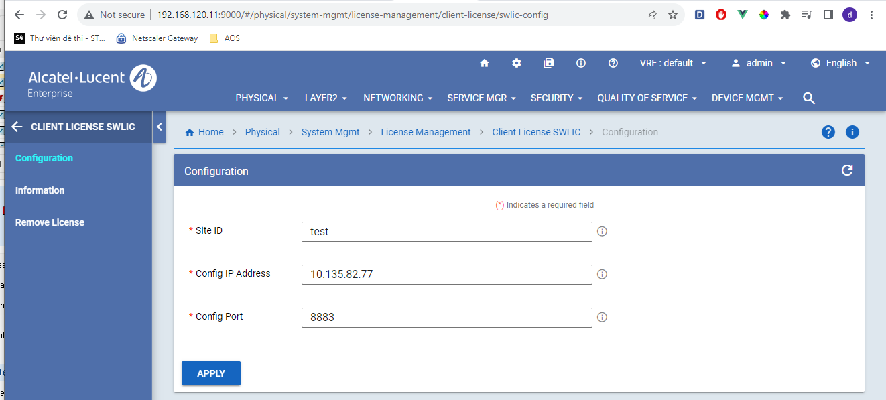
4.3.9 Remove feature license on Switch License Client Page

CLI: license client remove license all | mpls
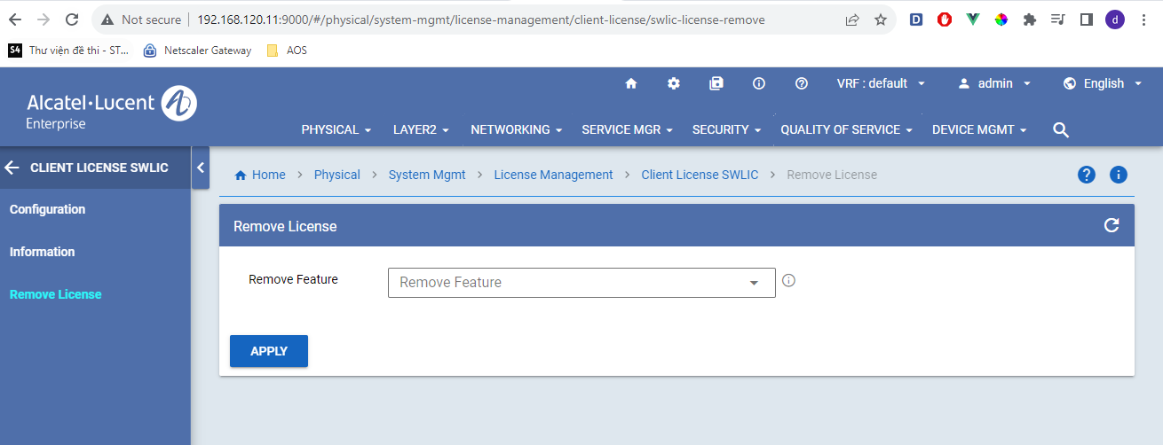
4.3.11 Show Switch License Client information
CLI: show license-client info
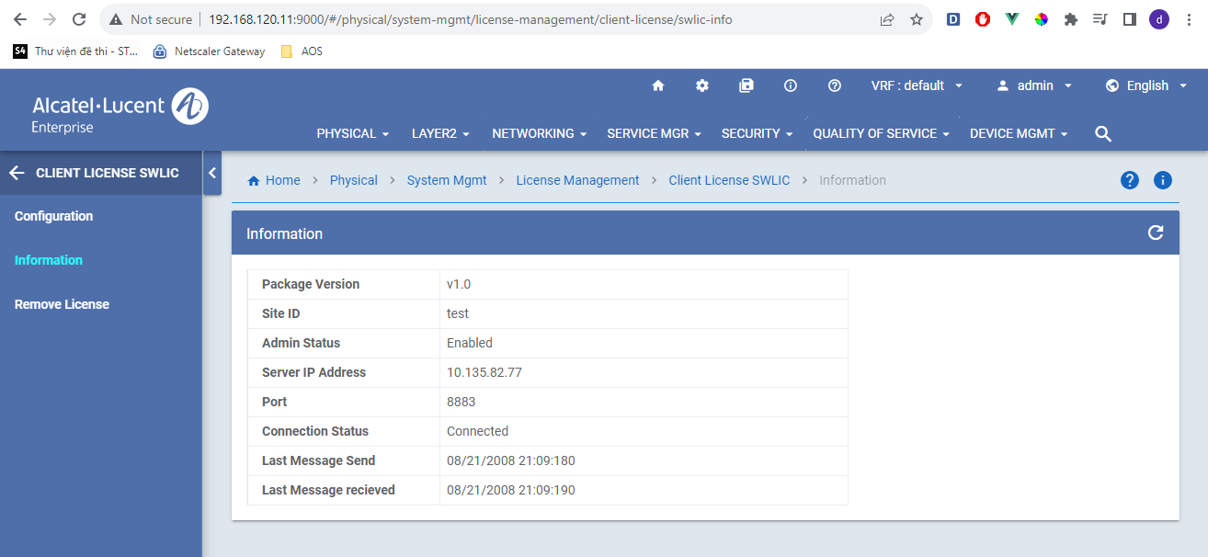

5 SAMPLE CONFIGURATION / USE CASE

5.1 Configuration Example
Here are some basic steps to configure site-base license on switch
+ Install a site management application on a switch that is intended to be a license server
-> pkgmgr install uosn-sitemgr-v1.deb
Verifying MD5 checksum.. OK
System Memory check.. PASS
Extracting control files for package uosn-sitemgr-v1.deb .. OK
TARGET_AOS_PLATFORMS OS6860N
Package target platforms check.. PASS
Package Dependency check.. PASS
Unpacking sitemgr (from /flash/working/pkg/uosn-sitemgr-v1.deb)...
Setting up sitemgr (1)...
Installing package uosn-sitemgr-v1.deb .. OK
Execute the command 'write memory' for the sitemgr package to remain installed after a system reboot.
+ Configure the license server with the available ip interface on the switch or create a new one:
-> license server ip-address 10.135.81.35 admin-state enable
+ MQTT server will be started and site-manager will connect to it, we can monitor the status with the following command:
-> show license-server
Package Version : v1.0,
Admin Status : Enable,
Server IpAddress : 10.135.81.35,
Server Port : 8883,
Connection Status : Connected,
Site Connected : 0,
Node Connected : 0
To check broker’s configuration, we can view the content of /flash/<running>/pkg/sitemgr/sitemgr.cfg” file.
SHASTA_N #-> cat /flash/working/pkg/sitemgr/sitemgr.cfg
-h 10.135.81.35
-p 8883
-u omniswitch
-P 43999035FF06DE228172EE59538F8AC0
-q 2
--psk abcdefabcdef
--psk-identity alcatel
--disable-clean-session
--encrypted-password
SHASTA_N #-> ps -ef | grep mos
5773 admin 0:01 /bin/mosquitto -c /etc/sitemgr.cfg
8440 root 0:00 grep mos
SHASTA_N #->
SHASTA_N #-> lsof -i:8883
COMMAND PID USER FD TYPE DEVICE SIZE NODE NAME
mosquitto 5773 admin 4u IPv4 14980 TCP *:8883 (LISTEN)
mosquitto 5773 admin 5u IPv6 14981 TCP *:8883 (LISTEN)
SHASTA_N #->

+ Continue to need to configure license server information on the license client switch
-> license client site-id test server-ip 10.135.81.35

To check server’s configuration, we can view the content of /flash/<running>/pkg/siteend/siteend.cfg” file.
SHASTA_N #-> cat /flash/working/pkg/siteend/siteend.cfg
-h 10.135.81.35
-p 8883
-u omniswitch
-P 43999035FF06DE228172EE59538F8AC0
-q 2
--psk abcdefabcdef
--psk-identity alcatel
--disable-clean-session
--encrypted-password

+ Install MPLS application
-> pkgmgr install uosn-mpls-v1.deb
Verifying MD5 checksum.. OK
System Memory check.. PASS
Extracting control files for package uosn-mpls-v1.deb .. OK
TARGET_AOS_PLATFORMS OS6860N
Package target platforms check.. PASS
Package Dependency check.. PASS
Unpacking mpls (from /flash/working/pkg/uosn-mpls-v1.deb)...
Please wait...
Setting up mpls (1)...
entering postinst
sh: update-alternatives: not found
sh: update-alternatives: not found
Installing package uosn-mpls-v1.deb .. OK
Execute the command 'write memory' in order for the mpls package to remain installed after a system reboot.
+ A prerequisite for the license client to provide license information to MPLS is to configure the Loopback0 interface.
-> ip interface Loopback0 address 50.0.0.1

+ Enable MPLS configuration so that it automatically requests licenses from the license client.
-> mpls interface "intf1" admin-state enable
WARNING: Please wait while the MPLS Licence Status is being fetched

Note: If mpls interface is configured, but no Loopback0 interface is configured, the connection from SWLIC to SILOS will not be established. The user needs to configure the Loopback0 interface and execute the license client configuration command again to trigger the connection.

+ The license client after receiving a license request from MPLS will turn on the license demo period and establish a connection to the license server to request license information. We can monitor the status with the following command:
-> show license-client info
Package Version : v1.0,
Site Id : test,
Admin Status : Enable,
Server IpAddress : 10.135.81.35,
Server Port : 8883,
Connection Status : Connected,
Last message sent : 2008-01-18 08:13:23,
Last message received : 2008-01-18 08:13:25
-> show license-info
Time (Days) Upgrade Expiration
VC device License Type Remaining Status Date
----+------+---------------+---------------+---------------+--------------+----------------
1 0 Advanced PERM NA NA NA
1 0 MPLS DEMO 30 NA NA
+ From the license server switch, we can monitor the information of the incoming connect node with the command:
-> show license-server usage
Node-Id Site-Id System Ip Feature Feature License Remain
Name Address Id Version Status Days
--------------+-----------+------------+---------------+----------+--------+------------+-------+
JSZ20440057P test OS6860N-P24M 50.0.0.1 MPLS_Site v1.0 DEMO 30
-> show license-server
Package Version : v1.0,
Admin Status : Enable,
Server IpAddress : 10.135.81.35,
Server Port : 8883,
Connection Status : Connected,
Site Connected : 1,
Node Connected : 0

+ Install site license on license server.
-> license server apply file /flash/lic.4.site.txt
-> show license-server info
Type License Status Usage Install Date
-----------+----------------+-------------+--------------------+
MPLS_Site PERM 4 2008-01-18 08:20:34
MPLS_Node NO LICENSE 0 N/A

-> show license-server usage
Node-Id Site-Id System Ip Feature Feature License Remain
Name Address Id Version Status Days
--------------+-----------+------------+---------------+----------+--------+------------+-------+
JSZ20440057P test OS6860N-P24M 50.0.0.1 MPLS_Site v1.0 PERM N/A

+ After installing the license on the server, check the license status of the MPLS feature in the license client.
-> show license-info
Time (Days) Upgrade Expiration
VC device License Type Remaining Status Date
----+------+---------------+---------------+---------------+--------------+----------------
1 0 Advanced PERM NA NA NA
1 0 MPLS PERM NA NA NA

6 SOFTWARE SUBSYSTEM DESIGN

6.1 Software Subsystem Design Overview

6.1.1 Task Model
A new task siteMgrCmm shall be spawned to support the site license server feature.
A new task swlicCmm shall be spawned to support the switch license client feature.

6.1.2 Module Placement

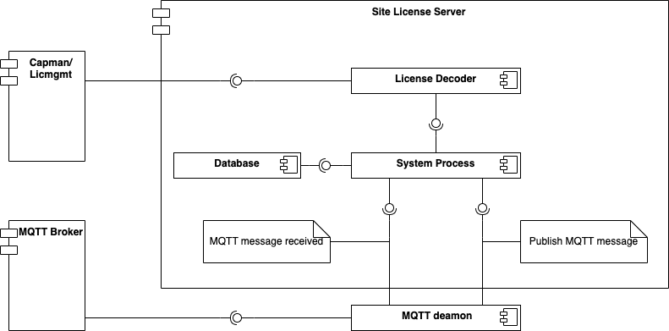
Figure 5: Site License Server in AOS
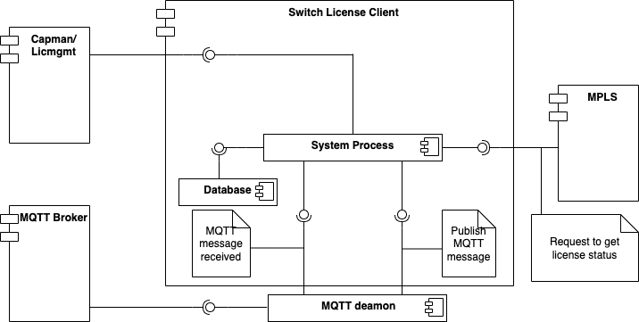

Figure 6: Switch License Client in AOS

6.2 Site License Software Support

6.2.1 Capability Manager API
The subsystem needs to use the following Capability Manager macros to query/lookup the MPLS licensing information:
CMLCHK_STATUS_MPLS_LEGACY()

6.2.2 Capability Manager and Site-base License Lookup Service
Capability/Site-base license reads in the licensed features from the backplane EEPROM, store in its shared memory and make this information available to applications immediately. Applications can inquire about each licensed features through capability manager API calls.

6.2.3 Chassis Supervision Dependencies
Capability Manager/License Manager relies on CS’s I2CMgr API to read/write the licensing information from/to the EEPROM memory.
I2CMgr’s EEPROM APIs are used under the following cases:
- During unit boot-up (Read API).
- When installing a license (Read and Write APIs).

6.3 Software Subsystem Interfaces

6.3.1 System Interfaces

6.4 Software System Flows

6.4.1 Summary of Flows

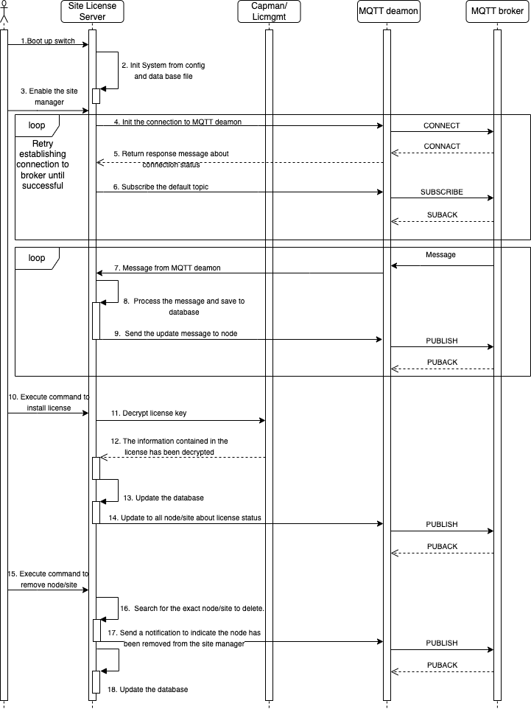
Figure 7: Site License Server flows in AOS
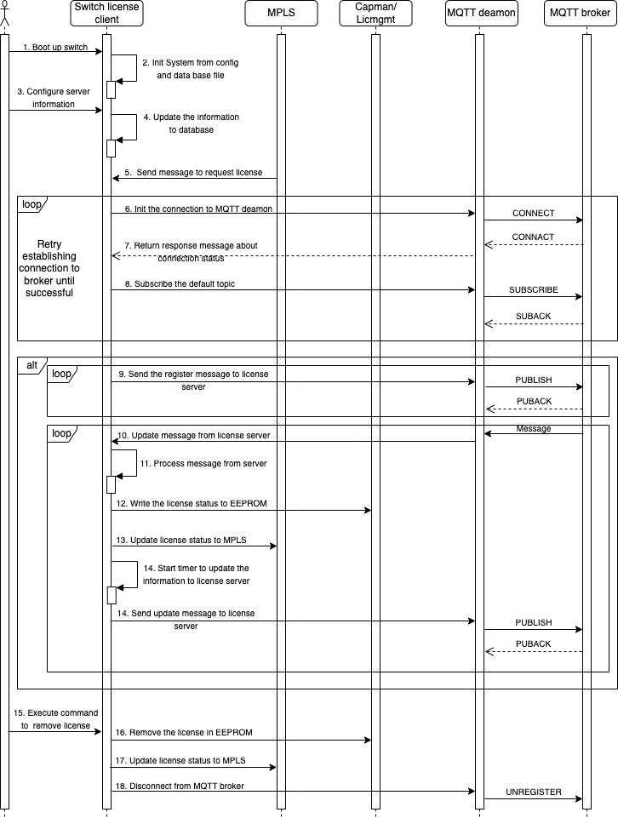
Figure 8: Switch License Client flows in AOS

7 DEBUG AND TRACING MECHANISM
The software tech-support should be enhanced to capture the debug information and show commands related to License Server (SILOS) and License Client (SWLIC) modules.

8 TEST AND VERIFICATION

8.1 Test Methodology
Both License Server (SILOS) and License Client (SWLIC) functions should be covered in UT, PT and ST validation.

8.1.1 Test Components
The below are the test components to be validated: -
- License Server (SILOS)
- License Client (SWLIC)
- MPLS CMM

8.1.2 Test cases

8.1.2.1 Standalone/VC1 Setup
Capman UT:
- Building and loading to switch the image for verifying that the switch boots up property without crashes when the image is loaded.
- Verifying that there are no undefined symbols during boot-up in Primary/Secondary.
- Verifying that there should not be any error or warning message printed out during boot-up.
- Verifying that the switch CPU on all devices return to normal once the boot-up is completed.
- Verifying that the system doesn't overrun boundaries of a memory allocation, touch a memory allocation that has been released and cause any memory leak.
- After the system has reached L8, the MPLS feature license is reading from eeprom normally.
- Verifying that The Get API of MPLS license (EEPROM) works normally.
- Verifying that The Set API of MPLS license (EEPROM) works normally.
- Verifying that when setting the eeprom, MPLS Licenses is not conflicted with License Management.
- Verify new binary to generate license does not conflict with legacy license.
- Verify demo license is setting correctly with demo bit and demo time.
- Verify License manager stores the SILOS demo day correctly even the switch reload.
- Verify License manager stores the SWLIC timer correctly even if the switch reload.
- Verify License manager cannot apply the MPLS license key via command "license apply file 'key'".
SILOS UT:
- Check whether there is no undefined symbol during boot-up.
- Check whether there is no error message or warning message printed during boot-up.
- Check application can install by package manager without any issue (swlog, undefined symbol).
- Check if debug logs could be seen for sitemgr when swlog is enabled.
- Verify the default server configuration shown when executing "show license-server".
- Verify the default license info configuration is shown when executing "show license-server info".
- Check if 'sitemgr.cfg' is created in /flash/<working>/pkg/sitemgr with the default contents when sitemgr package installed.
- Delete content of/Remove 'sitemgr.cfg' file and check whether switch is stable.
- Verify the MQTT broker ip and port by 'show license-server' after configuring by "license server ip-address listen-port".
- Verify the MQTT server start with ip-address and port after configuring by "license server ip-address listen-port".
- Verify the connection between license server to MQTT broker establish after configuring by "license server ip-address listen-port".
- Verify the license server can receive and parse the message from MQTT broker normally.
- Verify the license server receive "registration" message from node and add to managed list.
- Verify license server reject new registration message from node in new site if the maximal site that license server managed reach.
- Verify license server reject new registration message from node in default site if the maximal node that license server managed reach.
- Verify license server reply to the node "registration"/"update" message with server license information.
- Verify license server reply message with enough information.
- Verify all managed nodes display correct information with show command.
- Verify license server reply message has information to extend the demo period of node client.
- Verify the valid license key can install by site license server and the message to update new license state will send to all managed nodes.
- Verify the license key for node can be installed by license server and send the update message to all managed separate nodes.
- Verify the license key for node not able to install if the max support node in the license smaller than the separate node managed number.
- Verify the license key for site can be installed by license server and send the update message to all managed node in sites.
- Verify the license key for site not able to install if the max support site in the license smaller than the managed sites number.
- Verify the license status is shown correct after installing the license by show command.
- Verify all the nodes in site can be removed by "license server remove siteid" command and database is updated.
- Verify the license server usage after removing all nodes in site by show command.
- Verify specific node can be removed by "license server remove nodeid" command and database is updated.
- Verify the license server usage after removing specific node use nodeid by show command.
- Verify specific node can be remove by "license server remove ipaddress" command and database is update.
- Verify the license server usage after removing specific node use ipaddress by show command.
- Verify the counter for node/site connected to sitemgr after removing.
- Verify if the license for the site/node has been successfully installed in sitemgr, the license key will save to database.
- Verify if the license for the site/node has been successfully installed in sitemgr, it will retrive after restarting the switch.
- Verify if changing the broker host or port by cli in sitemgr, the MQTT broker will restart with new configuration and site manager will restart connection to MQTT broker.
- Verify the site manager's configuration display in configuration snapshot.
- Verify the configuration of the MQTT broker and site manager after executing write-memory and rebooting switch.
- Verify the operation of the MQTT broker and site manager after executing write-memory and rebooting switch.
- Validate the persistence of the configuration after multiple system reload.
- Verify the correctness of alaSILOS MIB object using SNMP (Get).
- Verify the correctness of alaSILOSInfo MIB object using SNMP (Get/GetNext).
- Verify the correctness of alaSILOSUsage MIB object using SNMP (Get/GetNext).
- Verify the correctness of alaSILOSBrokerConfig MIB object using SNMP (Get/Test/Set).
- Verify the correctness of alaSILOSRemoveConfig MIB object using SNMP (Get/Test/Set).
- Verify the correctness of alaSILOSLicensingConfig MIB object using SNMP (Get/Test/Set).
SWLIC UT:
- Check whether there is no undefined symbol during boot-up.
- Check whether there is no error message or warning message printed during boot-up.
- Check application can install by package manager without any issue(swlog, undefined symbol).
- check the SWLIC is running by default as part of base AOS image.
- Check if debug logs could be seen for swlic when swlog is enabled.
- Verify the default server configuration shown when executing "show license-client info".
- Verify the default license info configuration is shown when executing "show license-server info"
- Check if 'siteend.cfg' is created in /flash/<working>/pkg/siteend with the default contents.
- Delete content of/Remove 'swlic.cfg' file and check whether switch is stable.
- Verify the server MQTT broker ip and port by 'show license-client info' after configuring by "license client server-ip server-port".
- Verify swlic does not automatically enable the demo period or start the connection to the server if the switch has never enabled the demo period after configuring server-ip or server-port.
- Verify swlic automatically creates a connection to the server via configuration if the demo period has been enabled on the unit after configuring server-ip or server-port.
- Verify that the connection from swlic to server will establish if receiving message request license from MPLS.
- Verify that the swlic to server connection will be established after configuring server-ip and server-port in case the test phase was previously enabled.
- Verify the license client can receive and parse the message from MQTT broker normally.
- Verify the license client sends the "registration" message to server after the connection between swlic and server established.
- Verify the registration message has enough information.
- Verify the registration message will be sent periodically if an update message from the server is not received to indicate successful node registration.
- Verify update notification will be sent periodically after receiving update notification from registered node confirmation server.
- Verify that swlic can parse all the information in update message from server.
- Verify the demo period day of swlic will update follow information in update message.
- Verify the permanent license installed in swlic unit after parsing and processing the update message from server with permanent license information in this message.
- Verify eeprom bit in swlic for the feature has permanent license in update message from server.
- Verify the demo/permanent license will be removed if received delete message from server.
- Verify eeprom bit will be clean if received delete message from server.
- Verify the connection between swlic to server (MQTT broker) will be closed if received delete message from server.
- Verify in the case permanent license enable for the feature on swlic, if the connection from swlic to server lost, swlic will start the timer for 15 days. If this timer expired and the connection is still lost, permanent license will be removed.
- Verify MPLS application will receive the delete msg from SWLIC after the connection between SWLIC and server is disconnected by 15 days.
- Verify in the first time boot up, the MPLS application sends a require msg, SWLIC needs to enable demo period also start connection to the server base on the configuration.
- Verify in the first time boot up,If there is no require msg from the MPLS application it means the license is in default type, SWLIC will not start connection to the server even User tries to configure via CLI's SWLIC
- Verify if SWLIC is not able to find the Loopback0 interfaces, the connection of SWLIC to server cannot start.
- Verify when the app MPLS requires a license status, SWLIC needs to response correctly license status to the app MPLS.
- Verify when the license status changes for the MPLS feature, swlic will send the update message to MPLS application.
- Verify if the demo license expired in swlic, swlic continue send periodically update message to server to request license.
- Verify if changing the server host or port by cli in swlic, swlic will restart connection to MQTT broker with new configuration.
- Verify the swlic's configuration display in configuration snapshot.
- Verify the configuration of the swlic after executing write-memory and rebooting switch.
- Verify the operation of the swlic after executing write-memory and rebooting switch.
- Validate the persistence of the configuration after multiple system reload.
- Verify the correctness of alaSwlicInfo MIB object using SNMP (Get).
- Verify the correctness of alaSwlicBrokerConfig MIB object using SNMP (Get/Test/Set).

8.1.2.2 VC Setup
SILOS UT:
- Verify no error messages appear at system startup.
- After booting up, and installing the sitemgr package, sitemgr application will run on all units. Also verify after write-memory and reboot.
- Verify the license server connects to the MQTT broker and receive messages from the switch client normally after configuring the server information.
- Verify the license server connects to the MQTT broker and receive messages from the switch client normally after write-memory and reboot switch.
- VC-takeover (multiple times) and verify the license server connect to MQTT broker and receive messages from the switch client normally.
- Install the license for the site and node using master/slave information and check if it works fine.
- Verify the license still exists after rebooting switch.
- Verify the license still exists after vc-takeover multiple times.
- Verify the license-state on switch client after installing license and reboot.
- Verify the license-state on switch client after installing license and vc-takeover multiple times.
- Verify database between master and slave sync in everytime new license install, switch license client changes the information, new node connects to sitemgr...
- Remove the unit that has an installed license using its information from setup and check the timer for license verification start.
- Remove the unit that has an installed license using its information from setup and check that the permanent license is still available for 15 days.
- Remove the unit that has an installed license using its information from setup and check after 15 days, that unit does not join to vc, vc will remove permanent license and inform to all node connected.
- Remove the unit that has an installed license using its information from setup and check after this unit rejoins to vc 15 days ahead of time, the timer for license verification stops and permanent license still exists.
- Check License Withdrawal on SILOS using Site Id, Node Id and IP Address, the licenses need to be disabled on all VC units on the nodes.
- After a unit leaves the VC permanently and if the Site/Node license is not generated based on its SN/MAC address check if the licenses are disabled automatically and they should not work as another SILOS
- After the unit (based on which Site/Node license is generated) leaves permanently check if the licenses are disabled automatically. Also check if the licenses are disabled at the SWLIC as well.
- After a new unit joins and if any site/node license generated based on the new units SN/MAC address is installed, check if the SILOS can extend the Site/Node licenses and assign licenses for the new requests coming from SWLIC.
- If there is a momentary VC split/join (i.e VC units leave and join in a short span of time) check if there is no impact on the license information shared between Master/Slave.
- The SILOS test double vc-takeover and check if the license information is intact on the new Master as well as on the Slave units.
SWLIC UT:
- Verify after the connection between master and slave is established, the master needs to send its information to the slave.
- Verify if Master receiving the new license state, Master will install license and send its information to slave.
- Verify that after receiving the msg from Master, the slave needs update Master's information to its database, all slave will have the same information with Master
- Verify the slave is applied the license correctly and there is no conficted with other licenses.
- If in demo period, just only Master starts the demo timer and It has to send demo timer to the slave then slave update this to its database
- Verify just only Master works with mplsCmm
- Verify just only master works with SILOS.
- Verify if another slave joins to the VC, It needs to request Master sends its information to update its database
- Verify license is existed if rebooting or vc-takeover.
- Verify if vc-takeover, the new master will send msg to mplsCmm if mplsCmm request license state.
- Verify after vc-takeover,the new master needs to work with SILOS normally
- If remove the unit has installed the license, the splited chassis will work as the VC1.
- During the initial 15-day demo period without connecting to the SILOS check if the demo period is active after reload.
- During the initial 15-day demo period without connecting to the SILOS check if the demo period is active on the new Master after vc-takeover. The demo period on the new Master needs to count starting from where it left before vc-takeover.
- If the initial 15-day demo period expires check if the demo license is terminated on all VC units and MPLS CMM on the Master is informed.
- During the extended 30-day demo period with connecting to SILOS check if the demo period is active after reload.
- During the extended 30-day demo period with connecting to SILOS check if the demo period is active on the new Master after vc-takeover. The demo period on the new Master needs to count starting from where it left before vc-takeover.
- If the extended 30-day demo period expires check if the demo license is terminated on all VC units and MPLS CMM on the Master is informed.
- Check License Withdrawal on SWLIC, the licenses need to be disabled on all VC units on the nodes.
- If a unit leaves permanently and doesnt have any connection to the SILOS check if the MPLS licenses are disabled after the timeout.
- If there is a momentary VC split/join (i.e VC units leave and join in a short span of time) check if there is no impact on the MPLS licenses installed on the nodes.
- Test double vc-takeover and check if the license information is intact on the new Master as well as on the Slave units.

9 FUTURE ENHANCEMENTS
Below are the possible future enhancements discussed, they could be taken up in a future release.
- The license server application should work in conjunction with the ALE Customer/Business (License Generation) portal. Secure communication must be established with the ALE portal across the Internet. Licenses generated on the portal must be securely downloaded and installed onto the AOS switch.
- The Site/Node based licensing can potentially be extended to support other types of CAPEX Licenses (10G, METRO etc.) in future.

10 APPENDIX A: AOSDEV-2233 6 x 50G speed support through license

10.1 Introduction
The OS6870-LNI-U6 module, an expansion board of the Alcatel Lucent 6870 network switching platform, supports maximum speeds of up to 6 x 50G, but requires a mechanism for speed upgrades. This upgrade is supported through a licensing mechanism, preferably allowing 50G speed changes without system or module reset. The document will provide a detailed overview of the requirements and functional descriptions for this upgrade.
10.2 Overview
The site base license is a robust and secure licensing mechanism, suitable for speed upgrades of the OS6870 module.
From 8.10.R02, the site-base license will be supported with the "EXP-50G" license with the function of upgrading the port speed for the OS6870 expansion board to 50G.
And the site-base license will have some design adaptations.
10.3 Functional descriptions
The "EXP-50G" license licensing mechanism also complies with the basic requirements of the site base license, and with "EXP-50G" only "individual licenses" are supported.
General design to adapt when managing multiple licenses
Introducing a new license called "Individual", this license can be combined with the setup(VCs) using the site/node license. It is responsible for requesting feature licenses for each unit in the VC setup.
The server will receive the client's license request for specific features through the license flag in the client's request license message.
The server must check whether the client is eligible to be registered at the server or not by checking the number of sites/nodes supported by the license server corresponding to the feature at the license server and the number of features requiring a license at the client reaches the limit or not.
Clarifying this condition:
- A client can request licenses for many different features, depending on user needs or platform limitations.
- When a client requests a license for a feature that does not have a license installed on the license server, the license server accepts the client's registration and only checks the support limit for "node in site" (maximum support of 4 configured nodes for 1 site).
- When a new client registers to the server and requests a license for different features, we need to determine which of these features has exceeded the limit that the license server can support, if so, does not allow registration and sending notification messages.
Example: Let's assume the settings below register to the license server in order.

Setup | VCs of | Configure As | SiteId | Feature MPLS  (Site/Node) | Feature EXP-50G  (Indv) | Feature Adv-Routing  (Site/Node)
1 | 4 | Site | test1 | x | 2
2 | 4 | Site | test1 | x | 1
3 | 4 | Site | test2 |  | 0
4 | 4 | Site | test3 | x | 1
5 | 4 | Site | test4 |  | 0 | x
6 | 4 | Site | test5 | x | 0 | x
7 | 4 | Node | default | x | 2
8 | 4 | Node | default | x | 2 | x
9 | 4 | Node | default |  | 0 | x
10 | 4 | Node | default |  | 0
11 | 4 | Node | default |  | 2
12 | 4 | Node | default | x | 1 | 0
Total site license |  |  |  | 3 | 0 | 2
Total node license |  |  |  | 3 | 0 | 2
Total individual license |  |  |  | 0 | 11 | 0

When the setup 4 send the message to register to license server: -
If all licenses are not installed on the server, the setup 4 will register successful.
If all features have licenses installed on the server, then all of the following conditions must be met for setup 4 to be registered:
    - The number of sites the license supports for feature MPLS must be at least 2.
( 1 x site_id “test1” + 1 x site_id “test3” = site license support for 2 sites)
    - The number of licensed individuals that support feature 50G must be at least 4 .
( 2 units in setup “1” + 1 unit in setup “2” + 1 unit in setup “4” = indv license support for 4 units)
When the setup 12 send the message to register to license server: -
If all licenses are not installed on the server, the setup 12 will register successful.
If all features have licenses installed on the server, then all of the following conditions must be met for setup 12 to be registered:
    - The number of nodes the license supports for feature MPLS must be at least 3.
( 1 node in setup 7 + 1 node in setup 8 + 1 node in setup 12 = node license support for 3 nodes)
    - The number of licensed individuals that support feature 50G must be at least 11.

Updated communication between license server and license client
Json message type | New Json message | Note
Client Register/Update | {  "msgId": 14024706,  "siteId": "default",  "aosVersion": "7.X.X.8683.R01 ",  "endsiteVersion": "v1.0",  "loopback0": 167772162,  "unitData": [  {  "chassisId": 1,  "serialNumber": "T1234567889B",  "macAddress": "00:D0:95:01:88:9B",  "role": 0,  "modelName": "OS687024-SIM",  "licenseInfo": [  {  "featureId": 10,  "version": "version-mpls",  "featureStatus": 1,  "licenseStatus": 1,  "demoLicense": {  "time": 30,  "running": 0  },  "requireLicense":1  },  {  "featureId": 13,  "version": "version-exp-50G",  "featureStatus": 1,  "licenseStatus": 1,  "demoLicense": {  "time": 30,  "running": 0  },  "requireLicense":1  }  ]  },  {  "chassisId": 2,  "serialNumber": "T1234567889K",  "macAddress": "00:D0:95:01:88:9C",  "role": 1,  "modelName": "OS687024-SIM",  "licenseInfo": [  {  "featureId": 13,  "version": "version-exp-50G",  "featureStatus": 1,  "licenseStatus": 1,  "demoLicense": {  "time": 30,  "running": 0  },  "requireLicense":1  ]  },  ]  }
Server Response Update | {  "msgId": 14024707,  "siteId": "default",  "nodeId": "01234567-E5DB",  "license": [  {  "featureId": 10,  "licenseStatus": 0,  "licenseType": 1,  "licenseDemoDay": 30,  "licenseTimer": 0  },  {  "featureId": 13,  "licenseStatus": 0,  "licenseType": 1,  "licenseDemoDay": 30,  "licenseTimer": 0,  "numberOfUnits": 2,  "units": ["T1234567889B", "T1234567889K"]  }  ]  }

10.3.1 Site-Local Licensing Server
AOS_SILOS_FUNC_01: Support install “EXP-50G-Indv” license and display the license information when executing “show license-server info”.
AOS_SILOS_FUNC_02: Provide the license status of the feature to the license client upon request message. Information about the features that need a license from the license client must be present in the license request message.
AOS_SILOS_FUNC_03: Manage the number of sites/nodes/individuals supported in the license based on the number of client using the license, not the total number of sites/nodes connecting to the license server.
AOS_SILOS_FUNC_04: Individual licenses can be used for units within a node or site. Aggregate all the number of units in use to compare to the actual number of units that individual licenses support for this feature.
AOS_SILOS_FUNC_05: The server will provide individual license information of the feature to the node requesting the license, in the response message there will be the number of units allocated to the feature's individual license and the status of the license.
AOS_SILOS_FUNC_06: When a node updates license requests for new units joining VC, if the number of licenses at the server is not enough, the server needs to have a swlog message to notify, and not continue to update license information for that node. This unit will be marked as not updating information and the connection timer will be turned on to check for 15 days.
10.3.2 Switch License Client and License Manager
AOS_SWLIC_FUNC_01: License Client needs to create an IPC connection to esmCmm during startup.
AOS_SWLIC_FUNC_02: License Client only requests the license status for features that have received its license request.
AOS_SWLIC_FUNC_03: Automatically installing a demo license for the first time esmCmm requires an “EXP-50G” license and the demo license is valid for 15 days. And establish a connection to the license server. If receiving an extended trial period from the server, the trial period will be changed to 30 days (default- parameters in the server's response message).
AOS_SWLIC_FUNC_04: Loopback0 interface configuration is required when the feature requires an “EXP-50G” license.
AOS_SWLIC_FUNC_05: For features that require individual licenses, when receiving license information from the server, need to check that the number of units that the license server has allocated matches the number of units requiring the license.
AOS_SWLIC_FUNC_06: All changes will need to not affect MPLS feature licensing.
AOS_SWLIC_FUNC_07: Only install the license/enable EEPROM bit for the license that requires the unit, not the entire VC.
AOS_SWLIC_FUNC_08: The IPC message will be send to esmCmm to notify the license status (DEMO/DEMO-EXPIRED/PERMANENT/REVOKED) via messageID SWLIC_RESPONSE_LIC_STATUS_TO_ESM.
AOS_SWLIC_FUNC_09: License Manager only displays EXP-50G license status for license activated units.
AOS_SWLIC_FUNC_10: Allow “EXP-50G” license mismatch in VC (similar to 10G license).
AOS_SWLIC_FUNC_11: The demo timer for 50G license will run for each unit using license.
AOS_SWLIC_FUNC_12: When a licensed unit leaves the VC setup, the license client needs to immediately notify the license server for adjustment.
AOS_SWLIC_FUNC_13: When a new unit joins the VC setup and requests a license, the license client must immediately notify the license server. In case the license server is not capable of providing permanent licenses to the new unit, and the license client does not receive update notifications from the server, the disconnect timer is enabled.

10.3.3 esmCmm
Need to open the connection point so that the licensed client can connect during startup.
Sending a license request when an expansion slot is installed in the switch and also when a 50G SFP is inserted, esmCmm needs to send an IPC message to the licensing client to request a demo license. In the license request message, esmCmm needs to specify the unit requesting the license.
Change the port speed to 50G if receiving the license status is DEMO/PERMANENT, and put the port speed back to default if receiving the license status is DEMO-EXPIRED/REMOVE.
By using the API: esmCmmSendRequestToSwlicCmm()
EsmCmm will send the messageId(ESM_REQUEST_LICENSE_INFO) to swlicCmm to get license status.
To get the license status of the 50G license, ESM can use capman api CMLCHK_IS_50G_LICENSED().
10.3.4 Summary of Flows
