差异
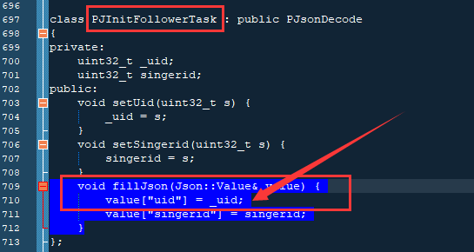
PJInitFollowerTask
uint32_t | _uid | setUid(uint32_t s)
uint32_t | singerid | setSingerid(uint32_t s)
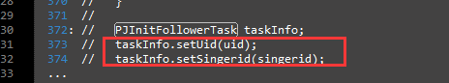
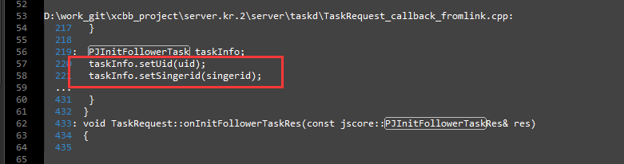

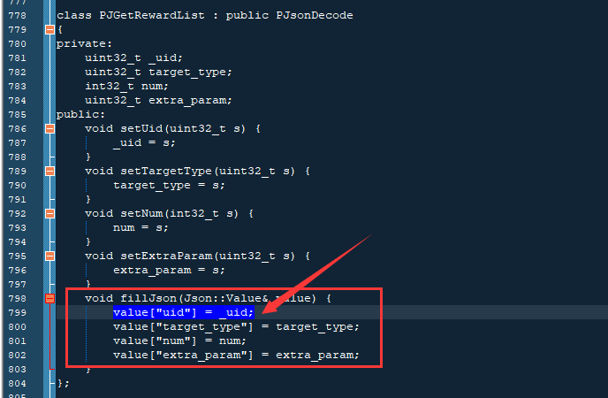
PJGetRewardList
uint32_t | _uid |  | setUid(uint32_t s)
uint32_t | target_type |  | setTargetType(uint32_t s)
uint32_t | num |  | setNum(int32_t s)
uint32_t | extra_param |  | setExtraParam(uint32_t s)

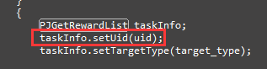
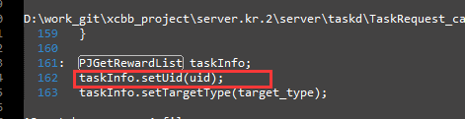

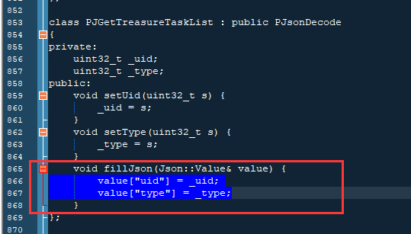
PJGetTreasureTaskList
uint32_t | _uid | setUid(uint32_t s)
uint32_t | _type | setType(uint32_t s)

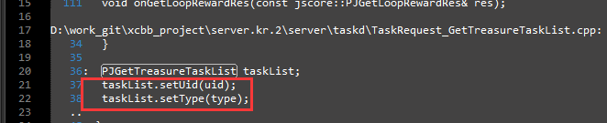

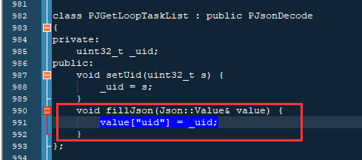
PJGetLoopTaskList
uint32_t | _uid |  | setUid(uint32_t s)

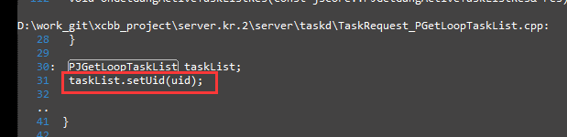

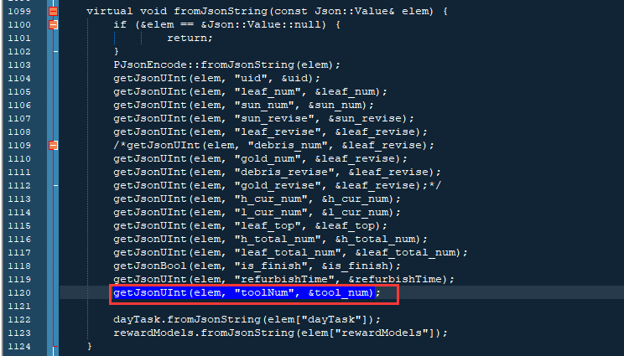
PJGetLoopTaskListRes
用户 uint32_t | uid | getUid()
本次任务奖励的叶子数 uint32_t | leaf_num | getLeafNum()
本次任务奖励的阳光数 uint32_t | sun_num | getSunNum()
本次任务奖励的叶子系数 uint32_t | leaf_revise | getLeafRevise()
本次任务奖励的阳光系数 uint32_t | sun_revise | getSunRevise() con
当前环数 uint32_t | h_cur_num | getCurHNum()
当前轮数 uint32_t | l_cur_num | getCurLNum()
换宝箱需要的叶子数 uint32_t | leaf_top | getLeafTop()
每轮环数 uint32_t | h_total_num | getHtotalNum()
用户拥有的叶子数 uint32_t | leaf_total_num | getLeafTotalNum()
是否完成 bool | is_finish | isFinish()
点击刷新按钮的时间，如未点击  值为0 uint32_t | refurbishTime | getRefurbishTime()
道具数量 uint32_t | tool_num | getToolNum()
PJVectors<PJTaskInfo> | dayTask | getDayTaskInfos()
PJVectors<PJRewardModel> | rewardModels | getRewardModels()

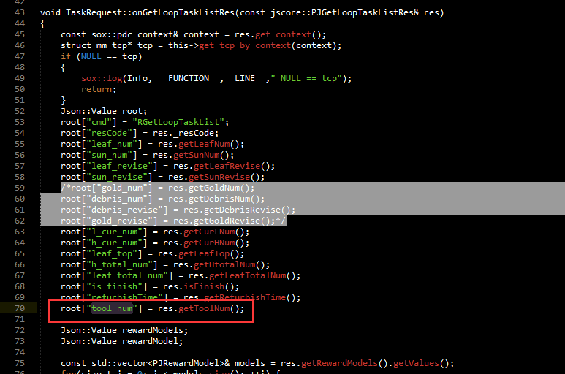
找不到PJGetLoopTaskListRes是在哪里对tool_num赋值的

但是按照取地址符合来看应该是同一个字段
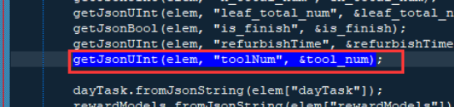

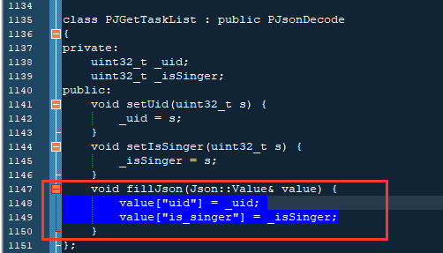
PJGetTaskList
uint32_t | _ui |  | setUid(uint32_t s)
uint32_t | _isSingerd |  | setIsSinger(uint32_t s)

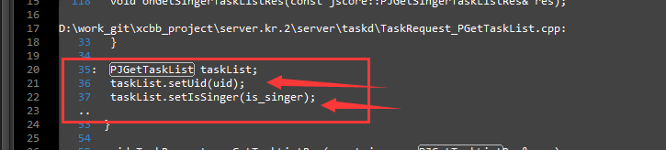

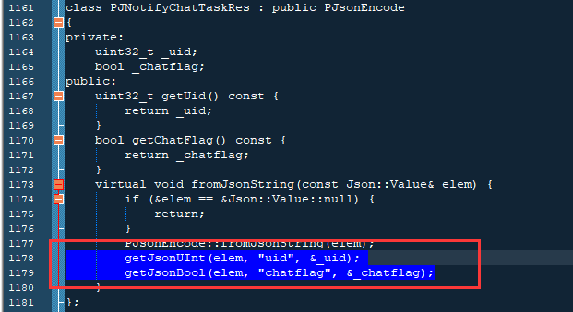
PJNotifyChatTaskRes
uint32_t | _uid | getUid()
bool | _chatflag | getChatFlag()
不知道_chatflag是个什么，也不知道在哪赋值
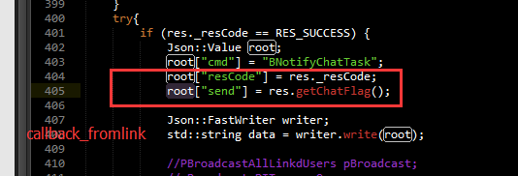
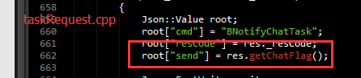

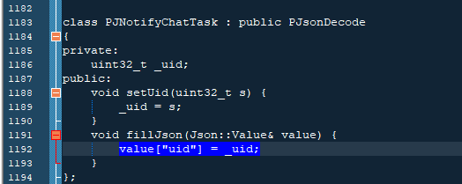
PJNotifyChatTask
uint32_t | _uid |  | setUid(uint32_t s)
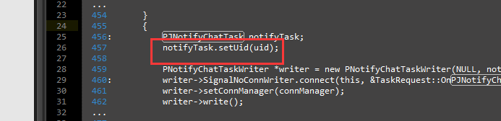
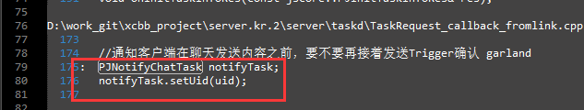

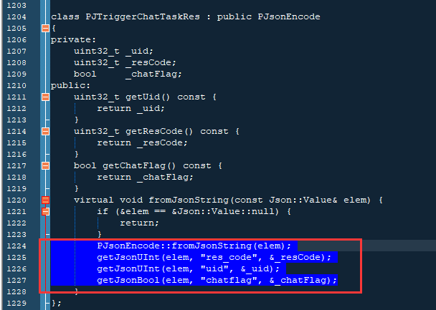
PJTriggerChatTaskRes
uint32_t | _uid | getUid()
uint32_t | _resCode | getResCode()
bool | _chatFlag | getChatFlag()
不知道这些是哪里进行设置的
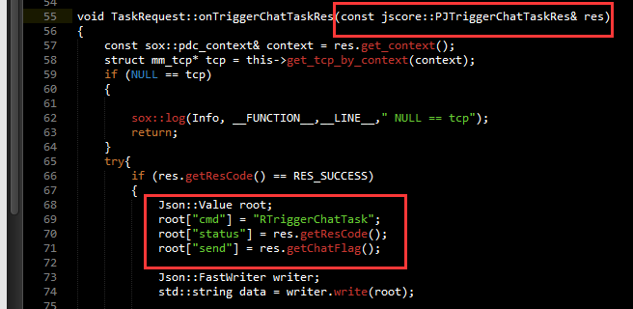

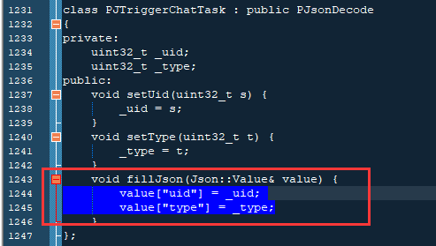
PJTriggerChatTask
uint32_t | _uid |  | setUid(uint32_t s)
uint32_t | _type |  | setType(uint32_t t)

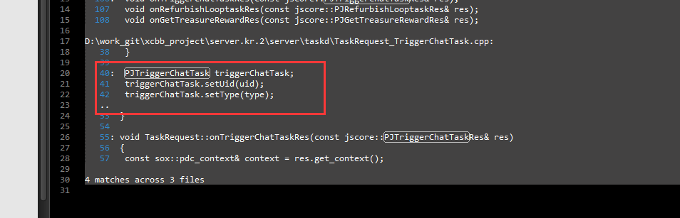

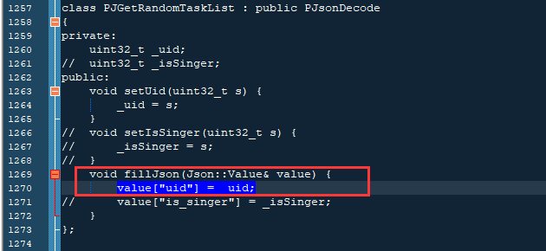
PJGetRandomTaskList
uint32_t | _uid |  | setUid(uint32_t s)
uint32_t | _isSingerd |  | setIsSinger(uint32_t s)

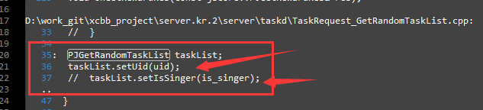

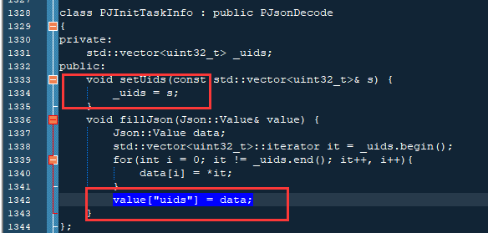
PJInitTaskInfo
std::vector<uint32_t> | _uids |  | setUids(const std::vector<uint32_t>& s)
输入的是uid
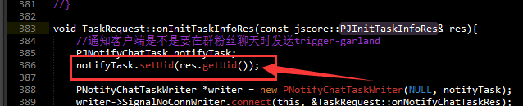

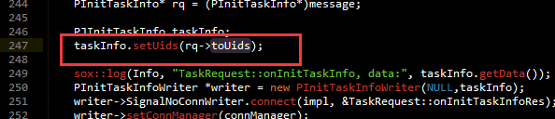

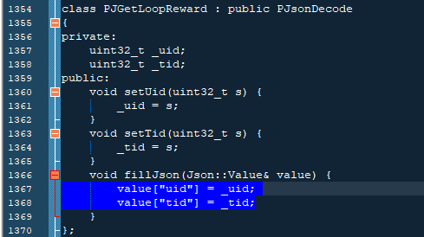
PJGetLoopReward
uint32_t | _uid |  | setUid(uint32_t s)
uint32_t | _tid |  | setTid(uint32_t s)

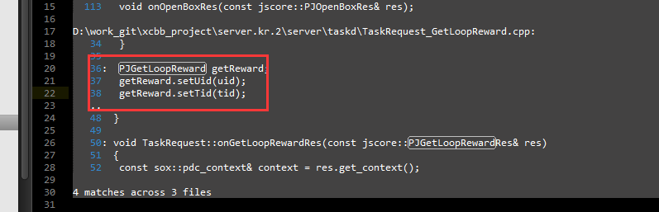

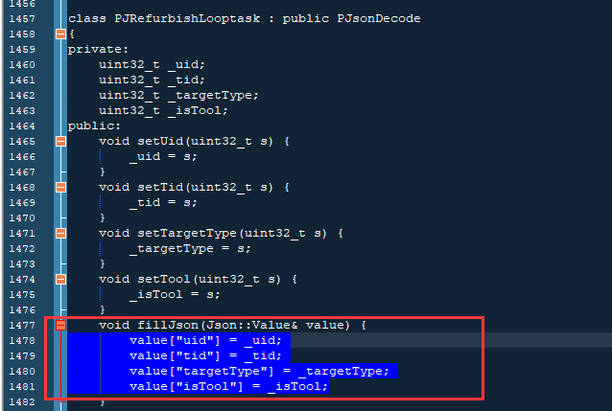
PJRefurbishLooptask
uint32_t | _uid |  | setUid(uint32_t s)
uint32_t | _tid |  | setTid(uint32_t s)
uint32_t | _targetType |  | setTargetType(uint32_t s)
uint32_t | _isTool |  | setTool(uint32_t s)

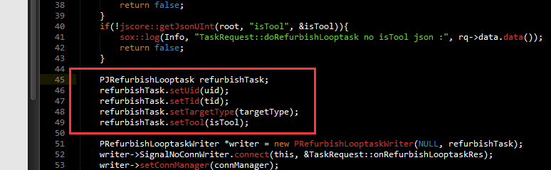

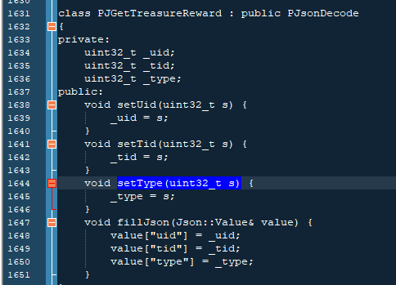
PJGetTreasureReward
uint32_t | _uid |  | setUid(uint32_t s)
uint32_t | _tid |  | setTid(uint32_t s)
uint32_t | _type |  | setType(uint32_t s)

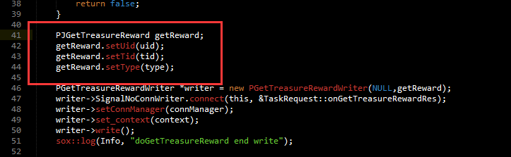

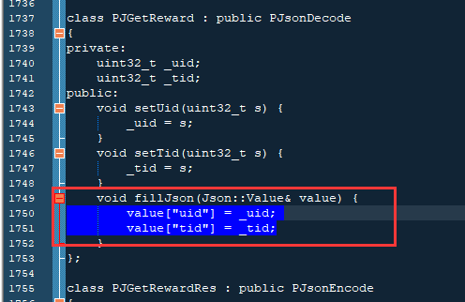
PJGetReward
uint32_t | _uid | setUid(uint32_t s)
uint32_t | _tid | setTid(uint32_t s)

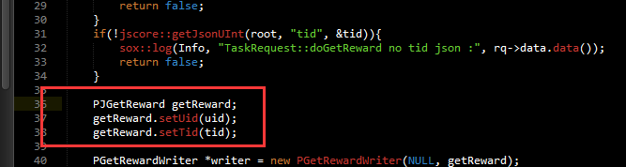

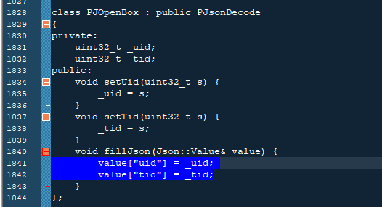
PJOpenBox
uint32_t | _uid |  | setUid(uint32_t s)
uint32_t | _tid |  | setTid(uint32_t s)

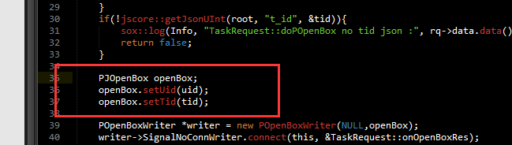

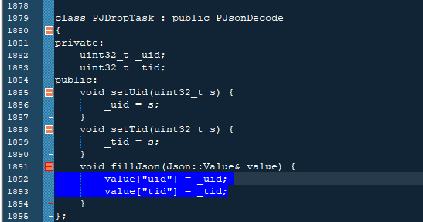
PJDropTask
uint32_t | _uid |  | setUid(uint32_t s)
uint32_t | _tid |  | setTid(uint32_t s)

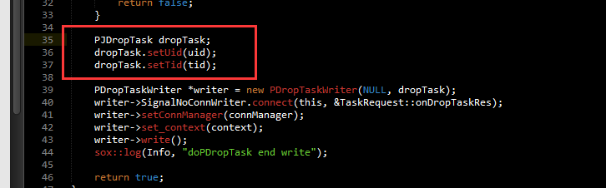

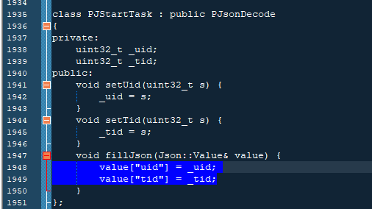

PJStartTask
uint32_t | _uid |  | setUid(uint32_t s)
uint32_t | _tid |  | setTid(uint32_t s)

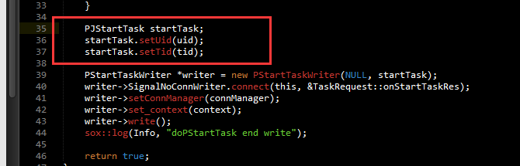

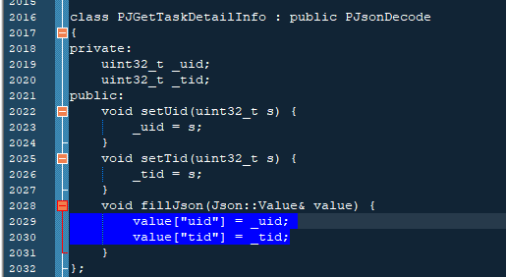
PJGetTaskDetailInfo
uint32_t | _uid |  | setUid(uint32_t s)
uint32_t | _tid |  | setTid(uint32_t s)

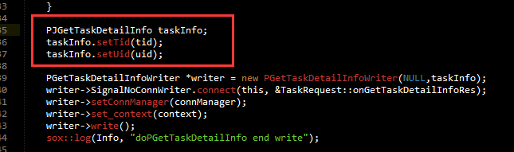

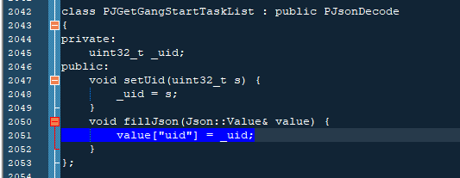
PJGetGangStartTaskList
uint32_t | _uid |  | setUid(uint32_t s)

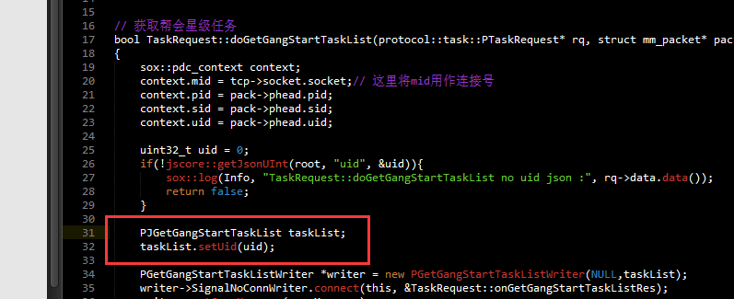

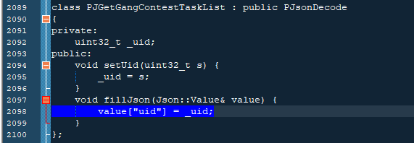
PJGetGangContestTaskList
uint32_t | _uid |  | setUid(uint32_t s)

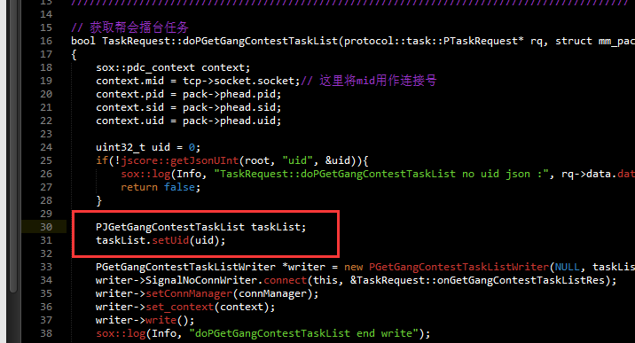

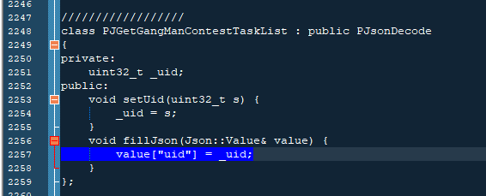
PJGetGangManContestTaskList
uint32_t | _uid |  | setUid(uint32_t s)

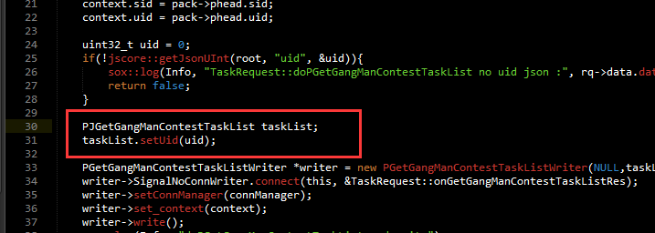

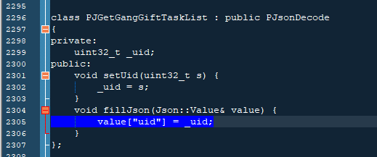
PJGetGangGiftTaskList
uint32_t | _uid |  | setUid(uint32_t s)

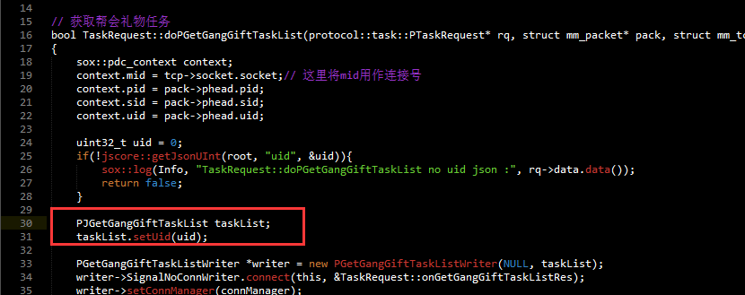

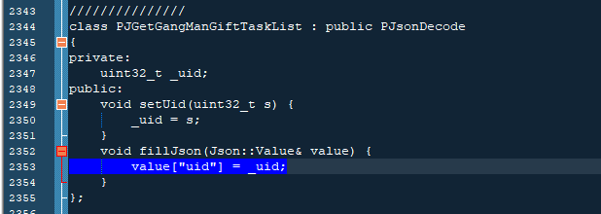
PJGetGangManGiftTaskList
uint32_t | _uid |  | setUid(uint32_t s)

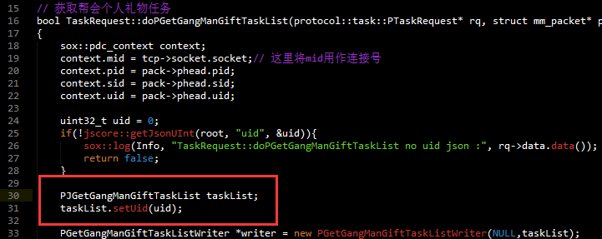

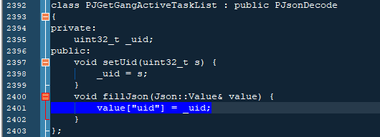
PJGetGangActiveTaskList
uint32_t | _uid |  | setUid(uint32_t s)

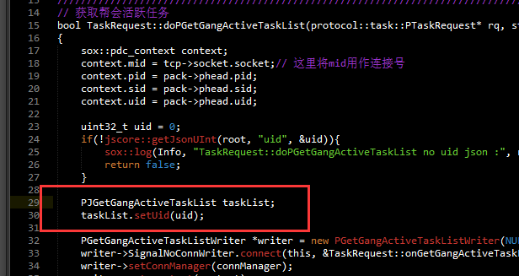

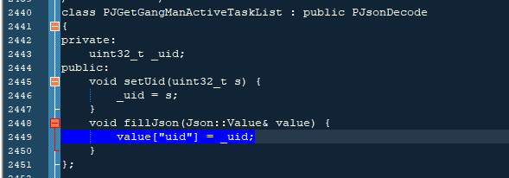
PJGetGangManActiveTaskList
uint32_t | _uid |  | setUid(uint32_t s)

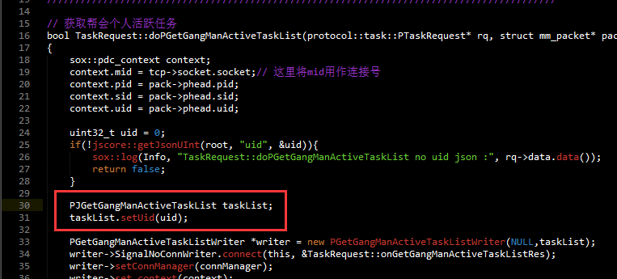

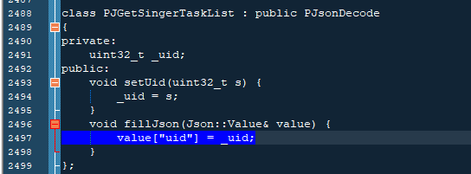
PJGetSingerTaskList
uint32_t | _uid |  | setUid(uint32_t s)

