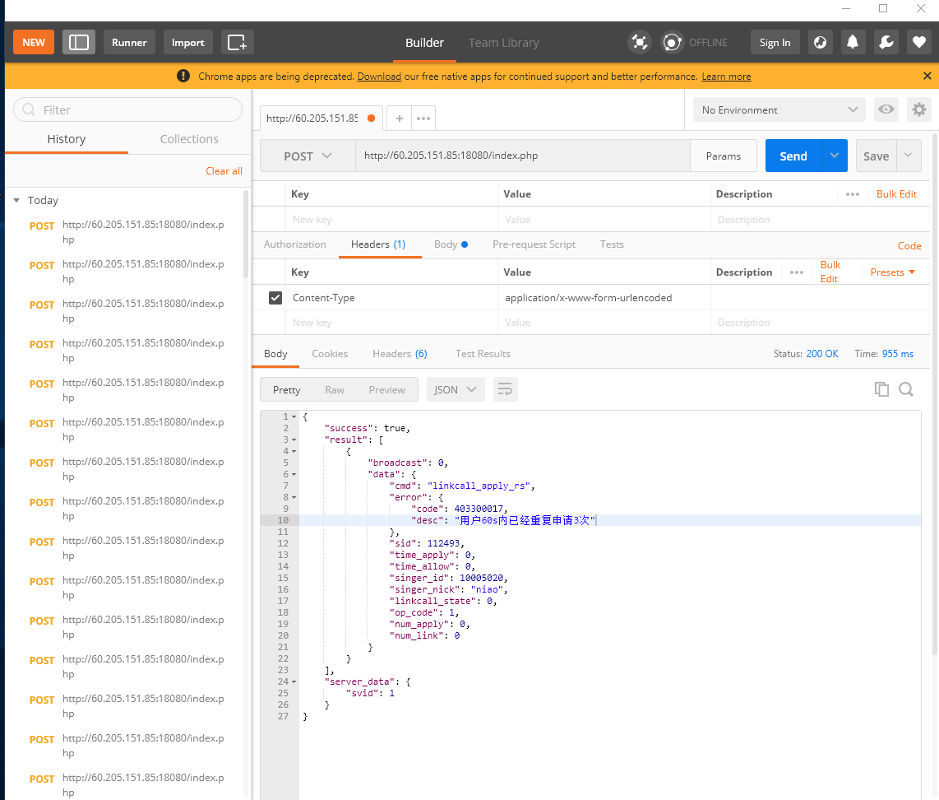

Post http://60.205.151.85:18080/index.php

Content-Type

application/x-www-form-urlencoded

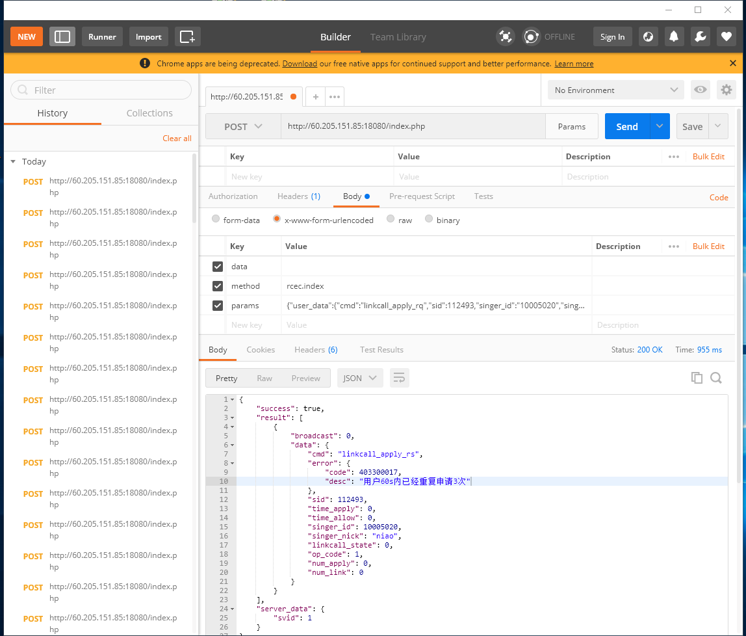

data

Method rcec.index

Params {"user_data":{"cmd":"linkcall_apply_rq","sid":112493,"singer_id":"10005020","singer_nick":"niao","data":{"user_id": 10005114,"user_nick": "","user_icon": "",

"linkcall_apply": 0,"user_wealth": 0 ,"user_level": 0 ,"is_singer": 0,"time_apply": 0,"time_allow": 0},"op_code":1},"server_data":{"svid":1}}