Thomas von Davier

PUI

26/2/18

Dr. Hong

Assignment 4

**Heuristic Evaluation**

1. Felix Liu’s Bun Bun Bakeshop

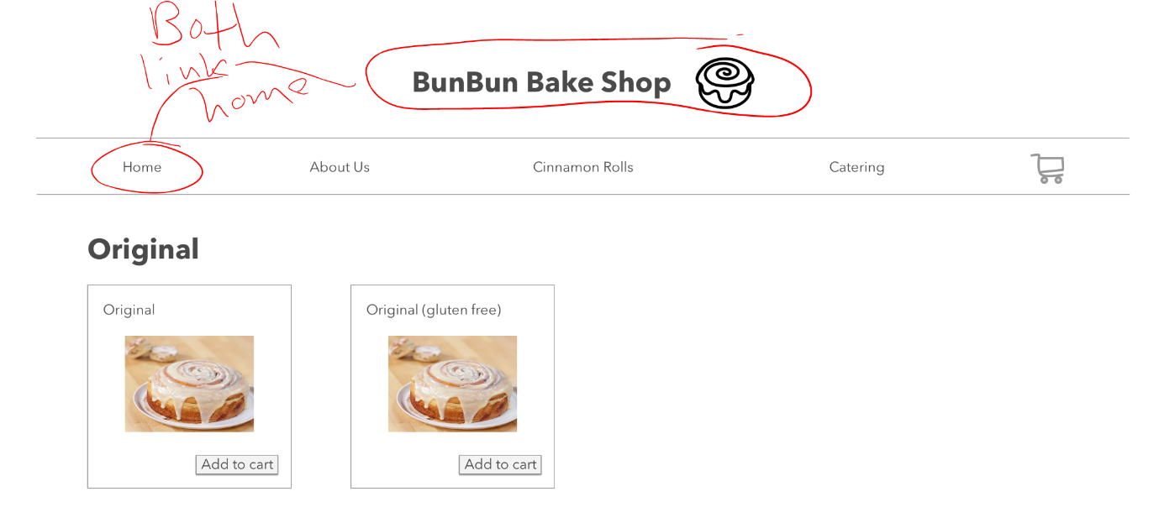This hi-fi prototype does a great job of achieving heuristic **H2-3: User Control and Freedom**. The heuristic is especially well exhibited on the *menu* and *detail page*. Both pages gave the user the ability to exit and return to the homepage if they wish to exit the current state of the system. On the two pages a user can click either the clearly marked title and logo of the page, or the labelled home button in the navbar. Either way the user clicks will lead to a successful exit from whatever page they were currently involved in. Below are screenshots of both pages that indicate the home links in red.

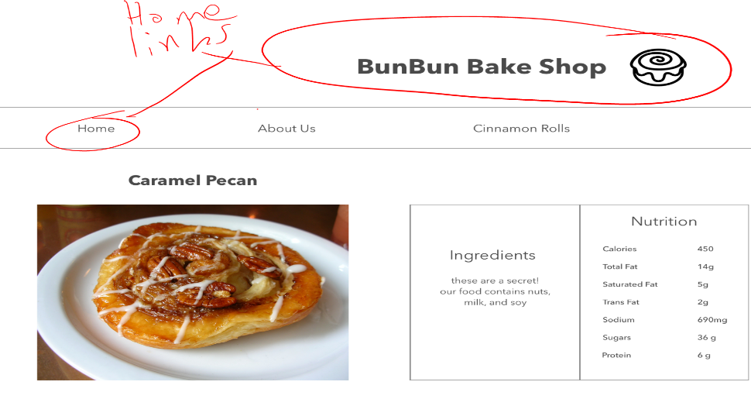

Another heuristic the prototype complies with is **H2-6: Recognition over Recall**. On the checkout pages and other pages of the site, the heuristic can be seen in two different ways. First, in the checkout page it allows the user to skip the steps of having to recall addresses by allowing them to click a button to repeat the billing address. This means they do not need to recall that information. On the other pages there is a tiny shopping cart in the navbar that will have a small number icon pop up if the user clicks “add to cart”. The user does not need to recall how many items they have added to the cart, instead they can look at the symbol and recognize how much is currently in their cart. Images below highlight these two icons in blue.

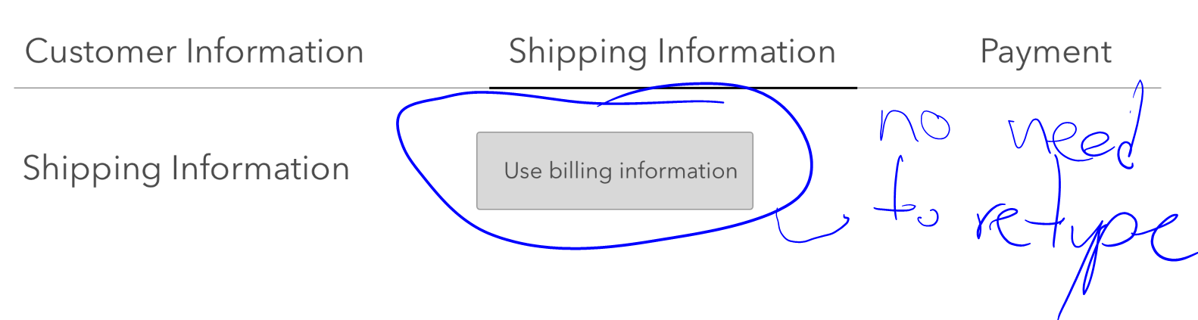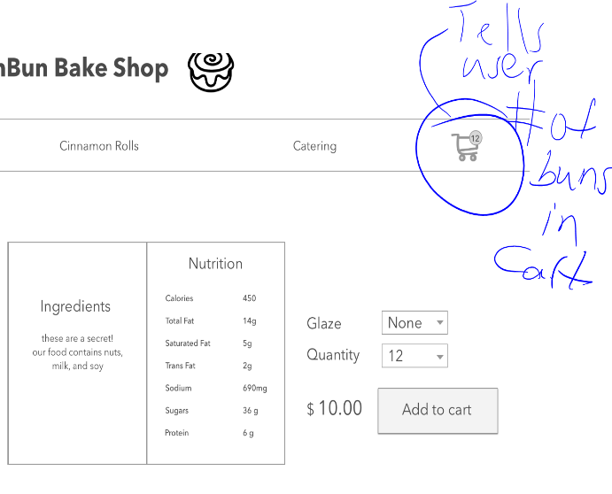

The prototype also complies with the heuristic **H2-8: Aesthetic and Minimalistic Design**. This especially applies to the checkout process. After the user selects checkout the entire site changes its visuals. It removes all the information and links that are not necessary to completing the sale. Now there are no links to other pages that will either delay or stop the checkout process (Home, Menu, About Us, etc.). All that is available to the user is the immediate process of the purchase, and their current step in it. Shown below in a marked screen grab.

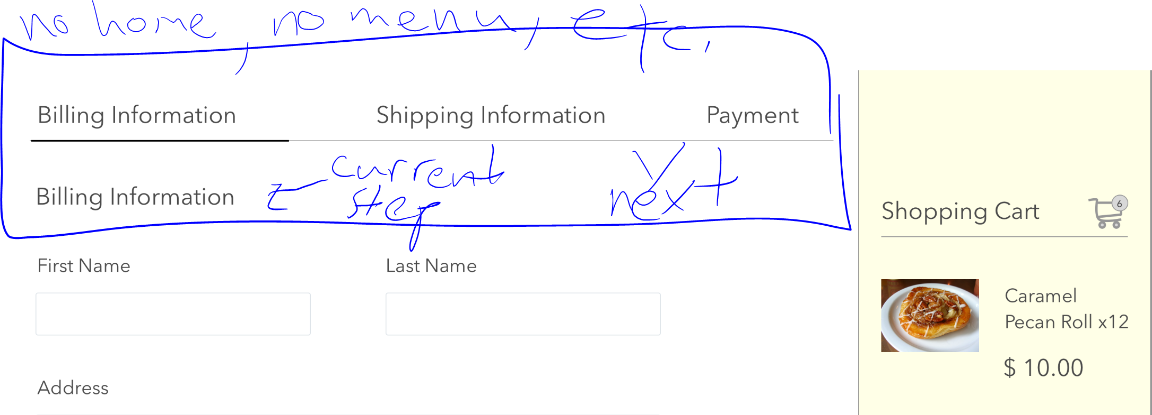

The is a heuristic that the prototype struggles with a little bit, and that is heuristic **H2-1: Visibility of System Status**. For the majority of the without clicking, it is difficult to tell when the user is on the menu, home, or detail page if they are isolated pages. However, the site does do well with response time. Therefore, if something is clicked on the desired page will load quickly and the site is easy to navigate. The clearest difference between the pages is when the user goes to checkout from the site.

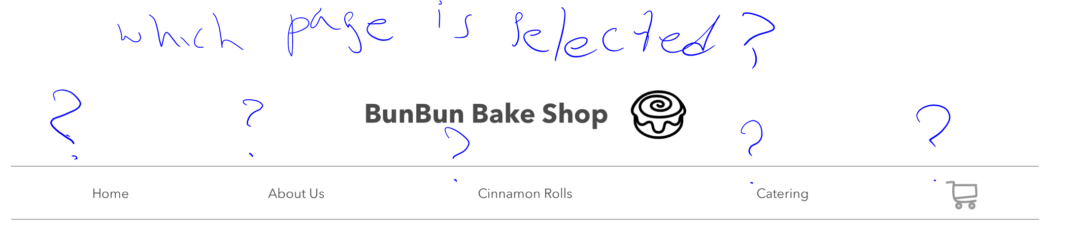

The final heuristic to discuss with the prototype is heuristic **H2-2: Match Between System and Real World**. The site is clear with the information it provides to its users. All the language is simple and directed to anyone looking for more information about a cinnamon bun and a bakery that bakes cinnamon buns. All the labels are clear and concise. See below.

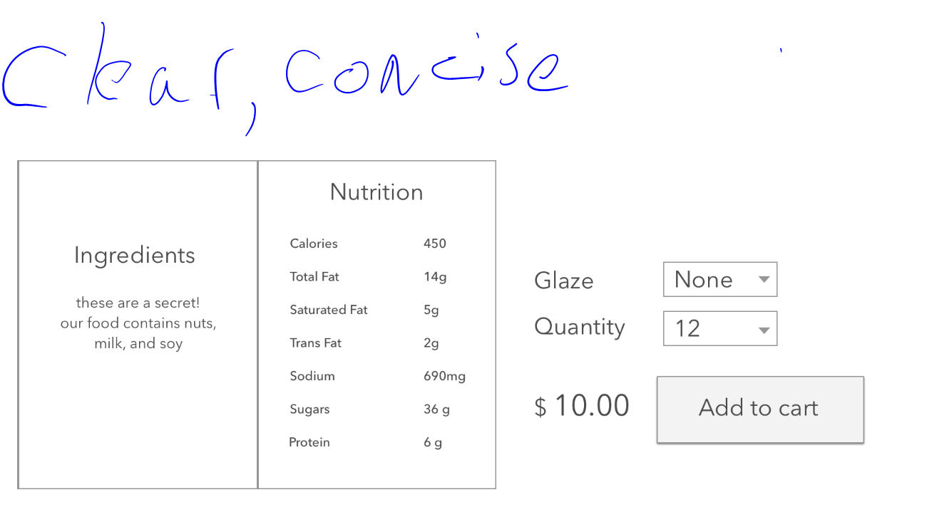

1. Zoe Feng’s Flip Stitch Pillow

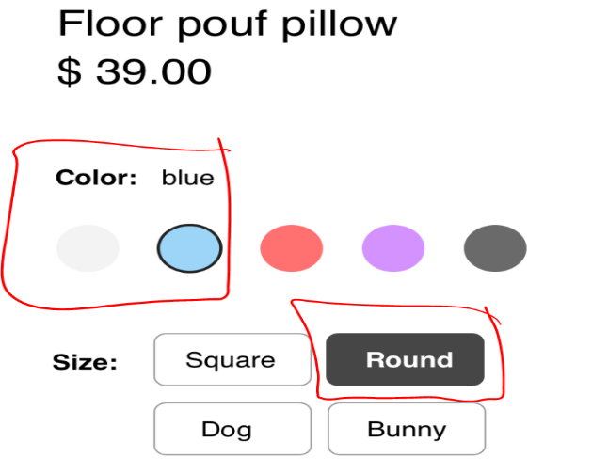This prototype complies with heuristic **H2-1: Visibility of System Status**. As the user moves the site, the current selections and preferences are highlighted as active. This makes it clear to the user which stage in the process of exploring the site they are currently on. One example is that the current pillow type option is highlighted when the user selects it. This is also done on the following steps as the user customizes the pillow. Check it out below.

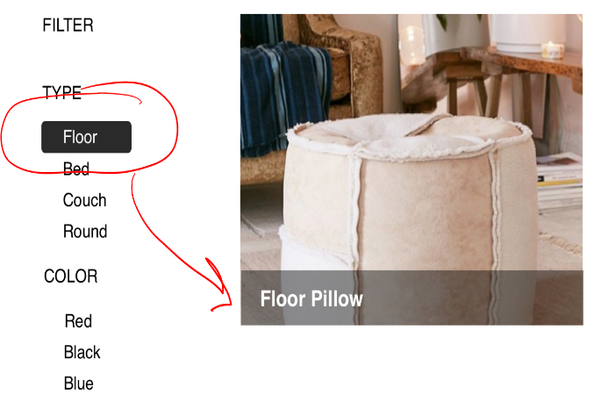

Another heuristic that applies to the prototype is heuristic **H2-4 Consistency and Standards**. The site prototype follows the general pattern of having a navbar at the top of the screen and miscellaneous information at the bottom of the page. Exactly as most users have come to expect of websites these days. All the labels are clear and have redundancies below the scroll in case the user goes too far in their scrolling. Examples are below.

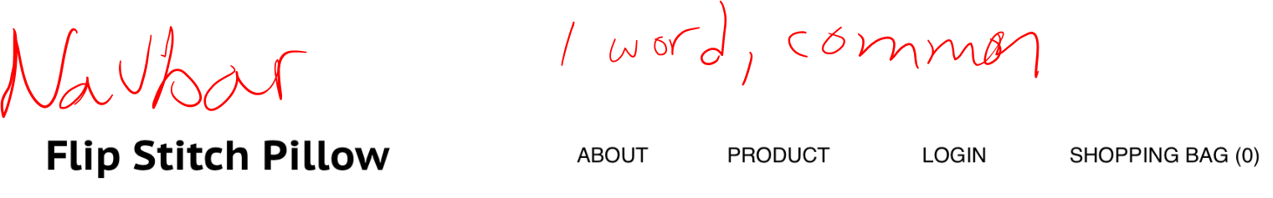

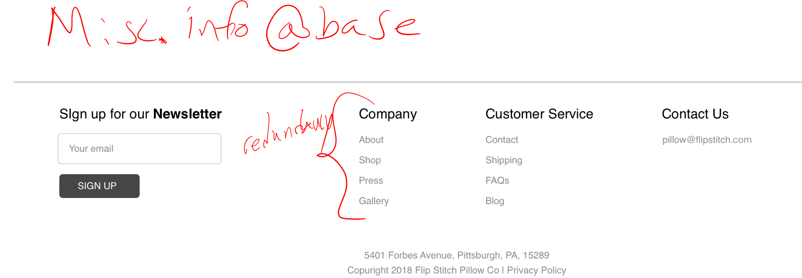

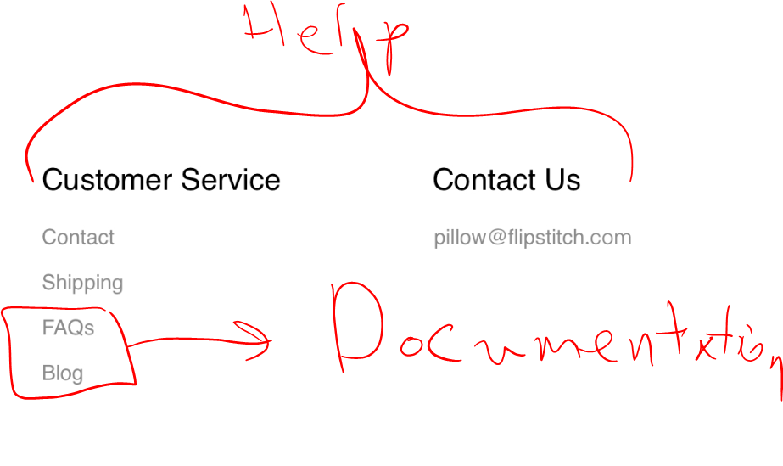 The prototype appears to include aspects of heuristic **H2-10: Help and Documentation**. At the bottom of every page is the miscellaneous information section discussed above. Within this section exists both a customer service subsection and a contact subsection. Both of which imply an ability to assist users in the case that things go wrong with the site. They are highlighted below.

The designed prototype struggles with two heuristics. The first heuristic it struggles with is heuristic **H2-3: User Control and Freedom**. The prototype is currently set up to be very linear, and there are not enough ways for the user to explore the site. The title of the site does not function as a home button, and every part of the prototype only offers one link that currently allows the user to continue. This limits their current experience with the site, and so the user is very stuck in place following a wizard like system. Below are the links that currently do not allow for user exploration.

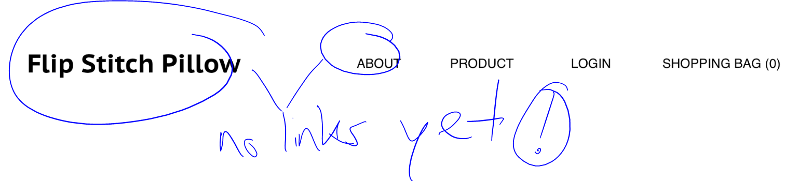

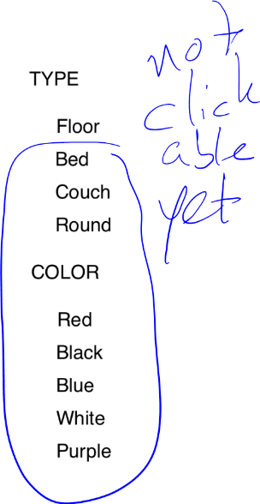 The final heuristic and the other heuristic that the prototype struggles with is heuristic **H2-Aesthetic and Minimalist Design**. There are many unnecessary pieces of information and processes that the user needs to go through to complete a purchase and use the site. For example, many of the final steps of the item selection and customization rest below the scroll. Another inconvenient/unnecessary process is the need to login before completing a purchase. This does not welcome one time customers have an expediated purchase path.

