**Low Fidelity Sketch with Balsamiq**

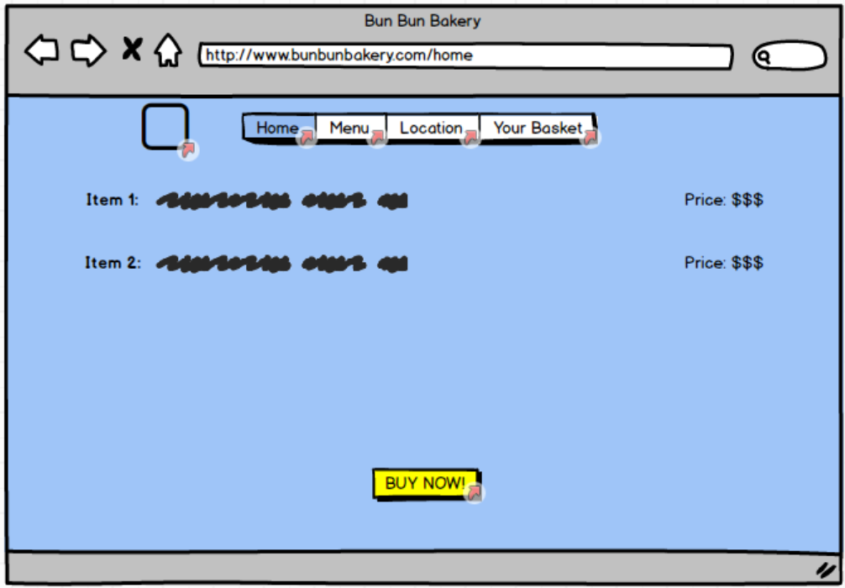

I created this low fidelity sketch for the previous assignment earlier this semester. I had a simple list of items with their price listed next to them. Now with HTML, CSS, and JavaScript I have included images, item descriptions and reactive pricing that changes depending on how many of a certain item a user wants. The checkout button has moved and changed color, and there are now buttons that allow users to remove the items they no longer want from the cart.

**High Fidelity Prototype with InVision**

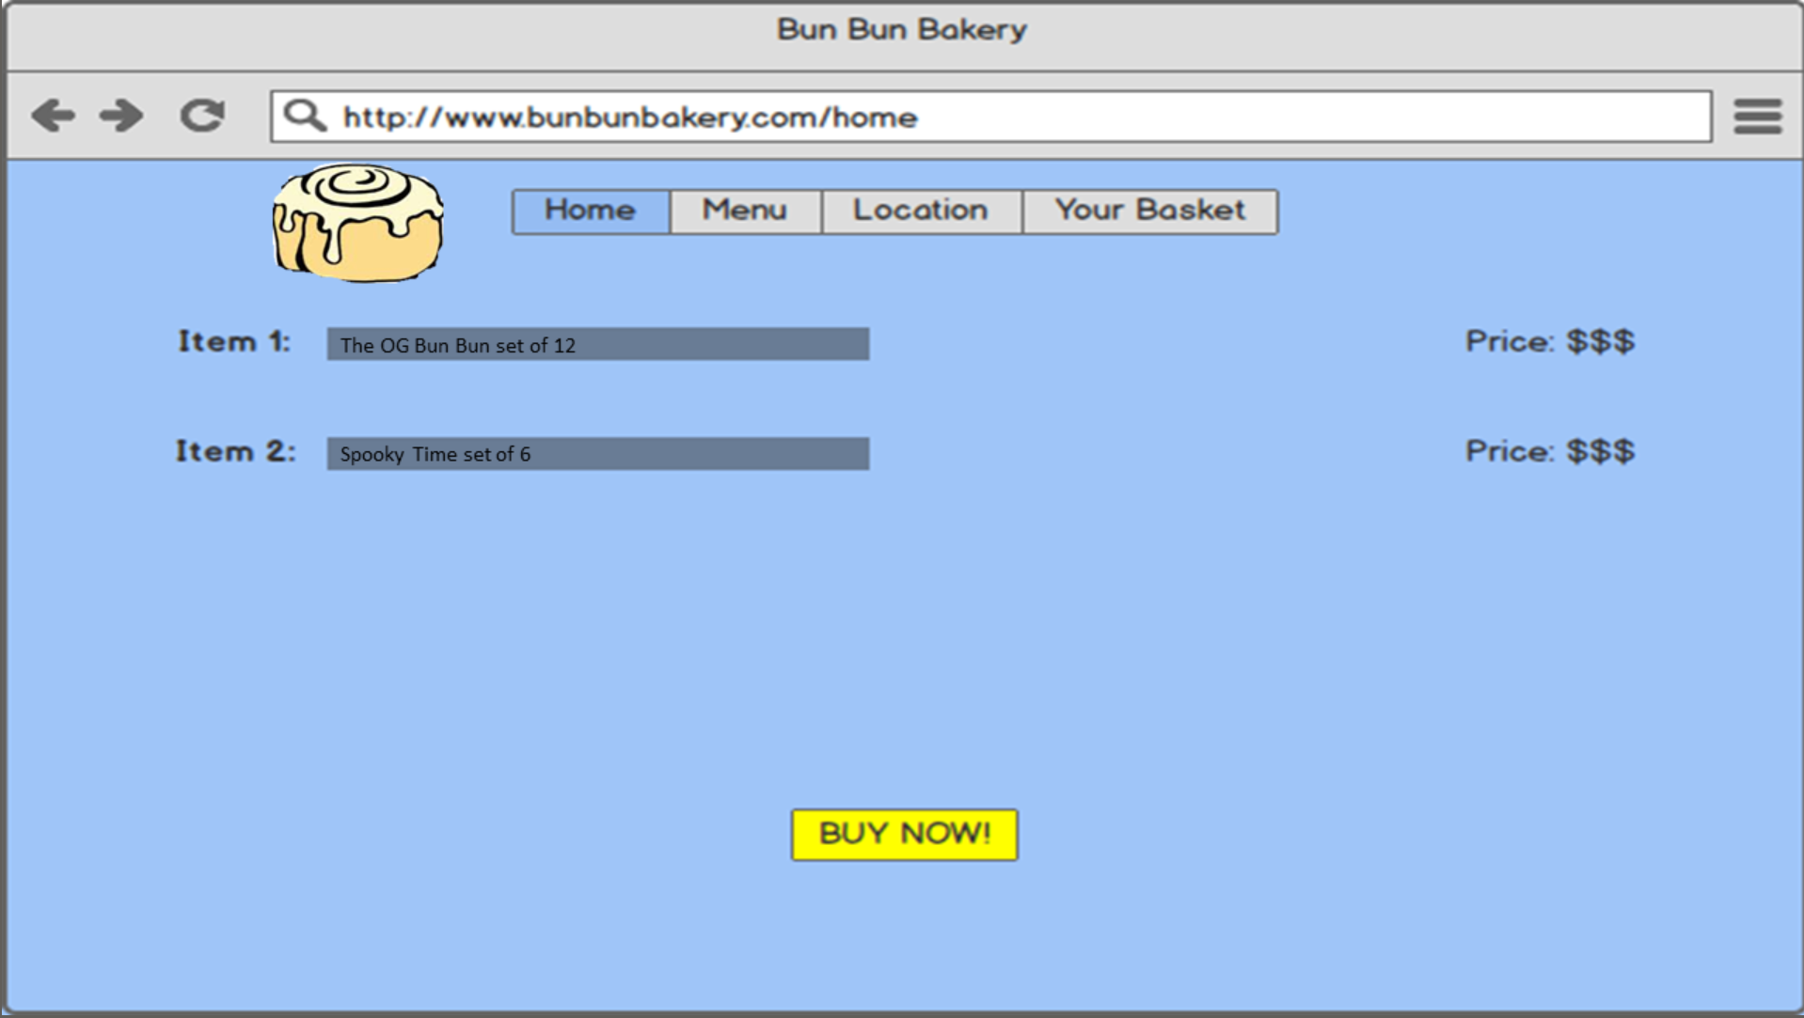

This was also created for a previous assignment this semester. There are far more similarities between this sketch and the low fidelity sketch on the previous page than there are between this prototype and the current version that is implemented with HTML, CSS, and JavaScript. The only major difference between the high and low fidelity prototypes is the quality of the display and the inclusion of a logo and some more descriptive words. Again, the button shifted for the final version and buttons were included for the removal of unwanted items. However, there is one striking similarity between this high-fidelity prototype from 4 weeks ago and my current version. Both versions indicated the number of each item within the description of what the user put in their cart. This was not previously seen in the low fidelity prototype and did persist in the ultimate version.

**Reflections**

I encountered many challenges with JavaScript. It is incredibly annoying but fulfilling to overcome the challenges. The first challenge was storing multiple pieces of information into localStorage. This took me a long time to figure out, and I spent many hours in the very start of my project looking up all sorts of clever ways to store multiple objects in various places with JavaScript. Eventually, I settled upon creating multiple arrays that I could manipulate and change, and then later store in localStorage.

The next major challenge I encountered was moving all the changes and information I had implemented on the details page over to the basket (cart) page. I realized quickly that anytime I would click from one page to the next the changes I have just made with JavaScript would be refreshed. I learned that the document.ready(function()) was going to give me a lot of problems. As I was sharing my frustrations with a friend, he casually mentioned that customary practice is to have only one JavaScript file per HTML page. This simple pro-tip about the best widespread practice allowed me to then reframe the problem and I was able to quickly write the next pieces of code for the project.

This is where I encountered the third major issue with my coding and thought process. I had multiple items that were stored in localStorage, but no way to display them in the one div I had currently written in my HTML. I needed a way to be able to display up to four distinct types of cinnamon bun glazes but to do that I needed more divs. This problem was solved by simply sitting down and typing out an impressive chunk of code. In the end I was now able to display all the possible types of items.

After all these edits and changes I quickly realized everything looked rather shoddy, and I quickly worked to update my CSS to reformat all the changes I had made into the style that can be seen across the website. This wasn’t a problem just the finishing touches that took me quite a while.