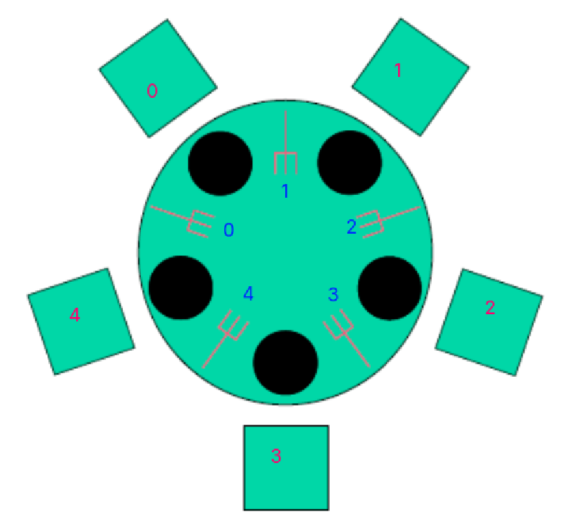
Phy-i

init(Fork_i,1)

For Phylosopher 0-3 (takes the right fork first)
loop
wait(Fork_i)
wait( Fork_( (i+1) % 5 ) )
eat()
signal(Fork_i)
signal( Fork_( (i+1) % 5 ) )
endloop

For Phylosopher 4 (take the left fork first to avoid the deadloop thats everyone has picked up the left fork and now wait forever)
loop
wait(Fork_0)
wait(Fork_4)
eat()
signal(Fork_0)
signal(Fork_4)
endloop

