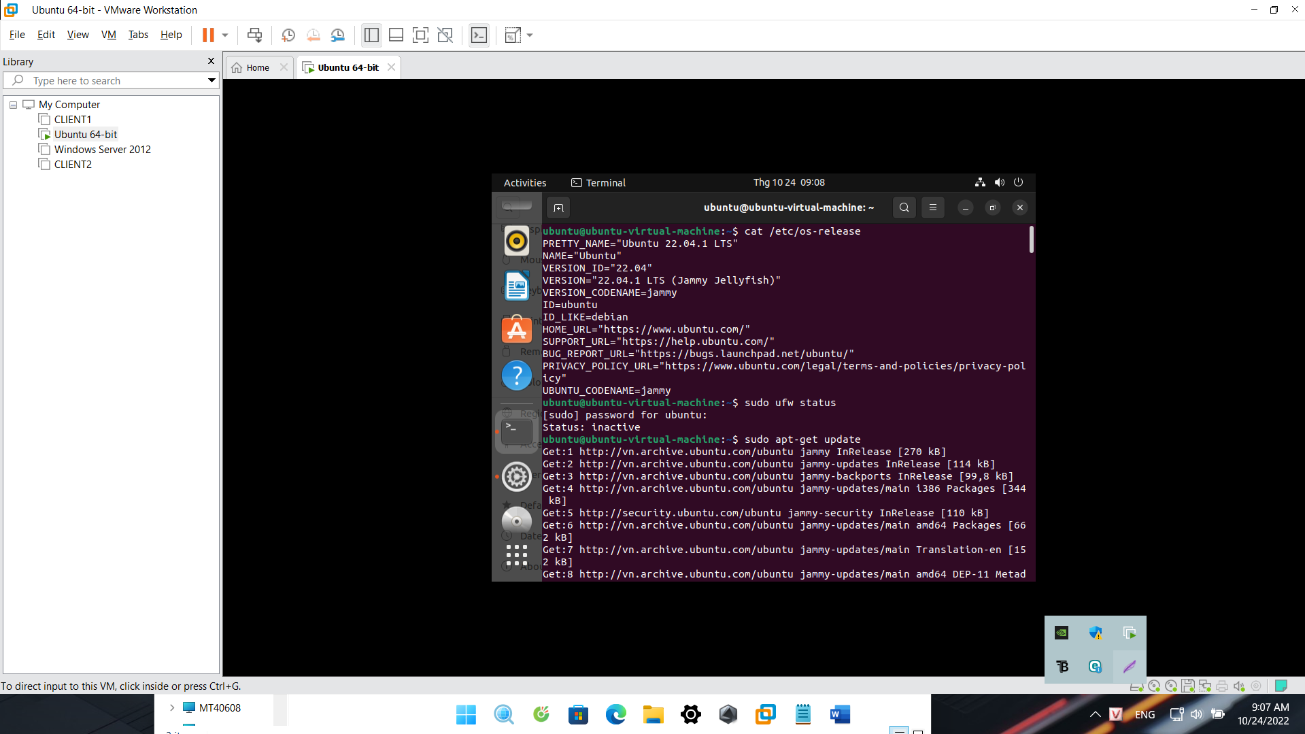

**Kết nối database với Dbeaver**



