Astrology app
App name: tpehaf%u;j;jp VEDIC ASTROLOGY SOFTWARE
Features:
- One device-one account with one person’s personal date of birth, place, time, name, mobile, email, palm photo use for sign in.
- We need to create a traditional old style theme login page.
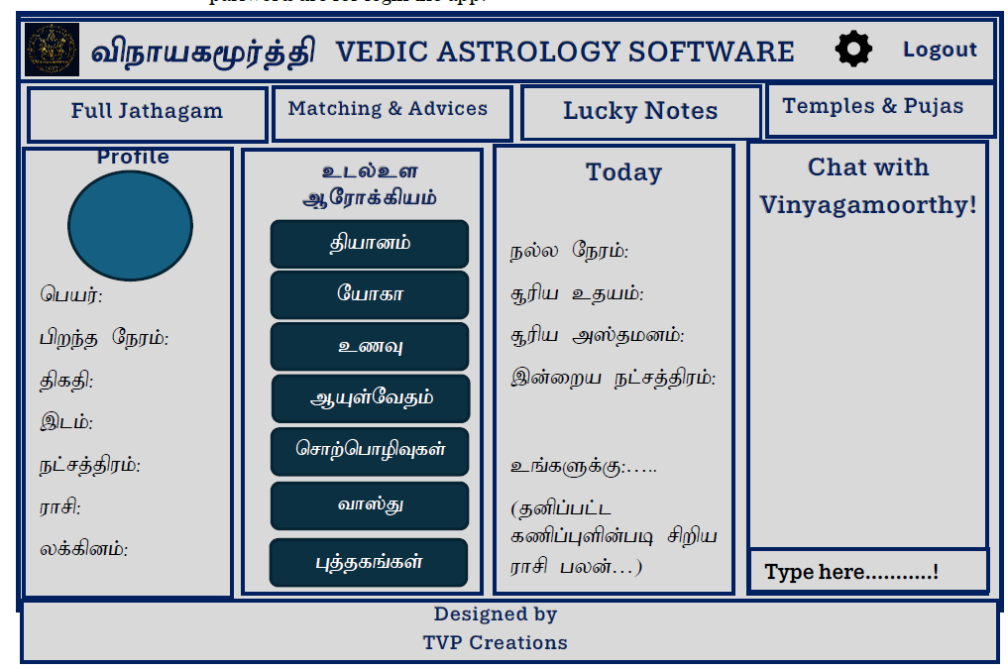
- Email/mobile number verification for forget password however user name and password use for login the app.

clNd Muk;gpf;fTk;

Manual Template Edit
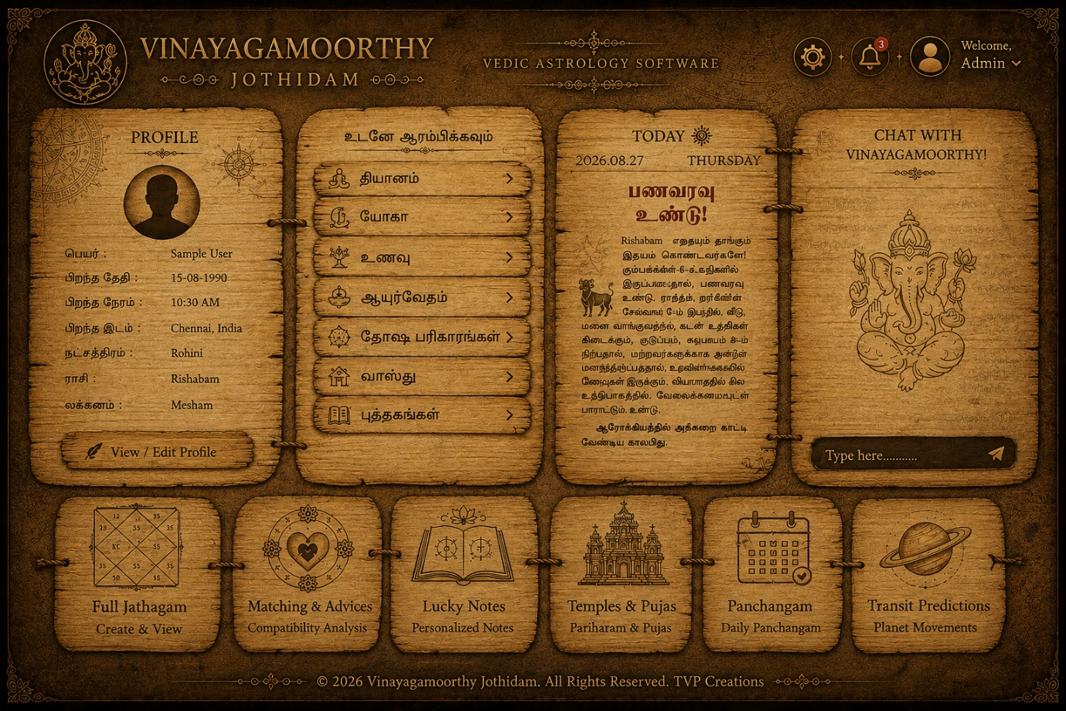

Professional Ai Edit Template

1.Jathagam.
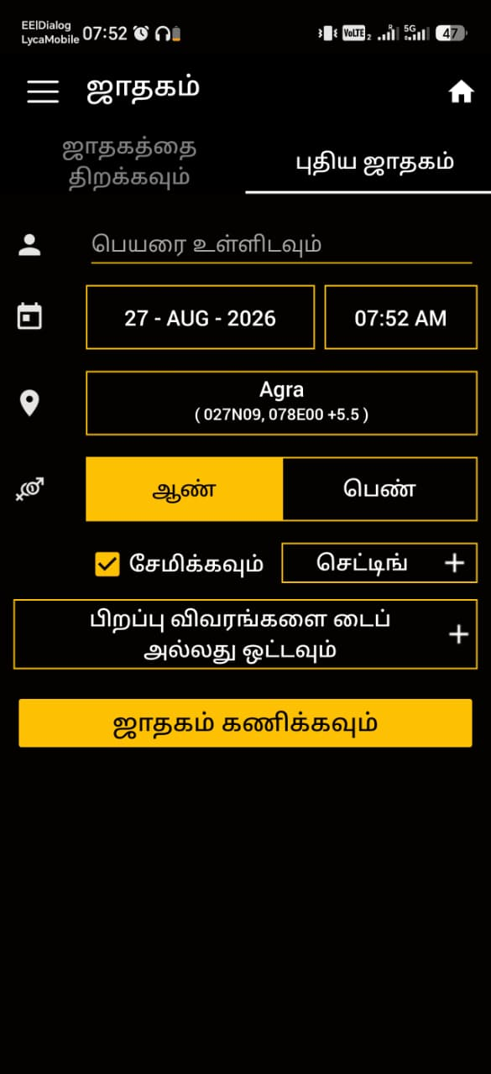
If we look at the jathagam category, any one click the jathagam button, then they can see their full horoscope in heir favourite language. Because we already provide a options in their app setting. No need to type anything again when they click jathagam button because this app automatically findout and calculate their horoscope according to saved data which is in the software.

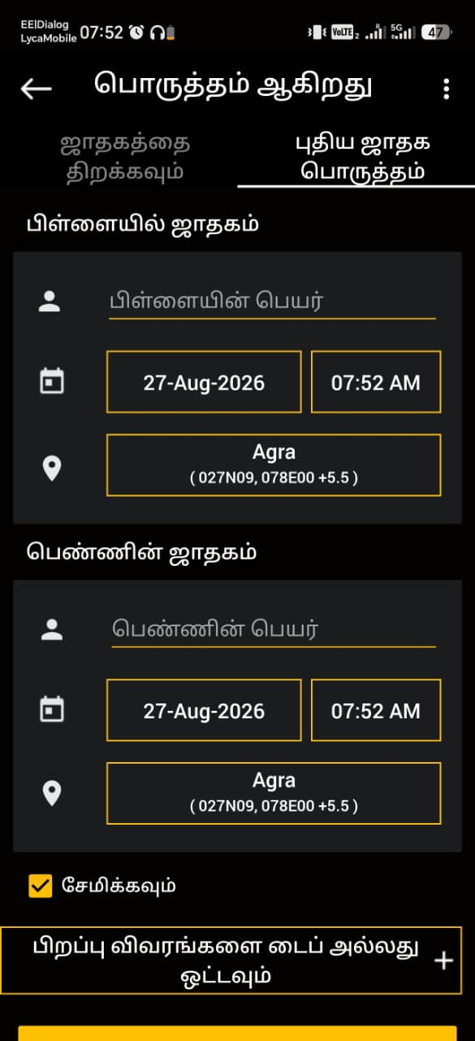
2.Matching & advices: if anyone click this button immediately small dialog box will open, and matching person’s date of birth and time, place, name will ask, if fillup then they can see their matching report perfectly. Sample matching report also attached below.

3.lucky notes: if click this button, gems, colours, wearings lucky details are showing according their jathagam.Sample image below.
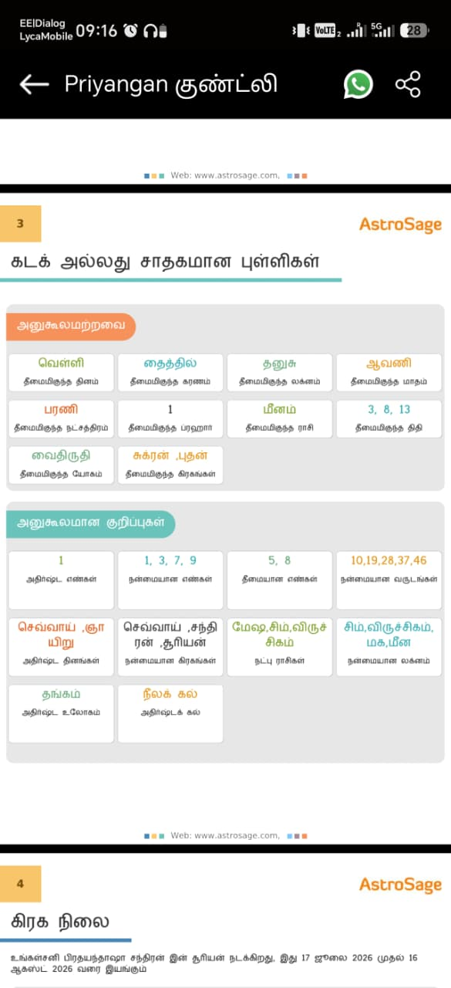

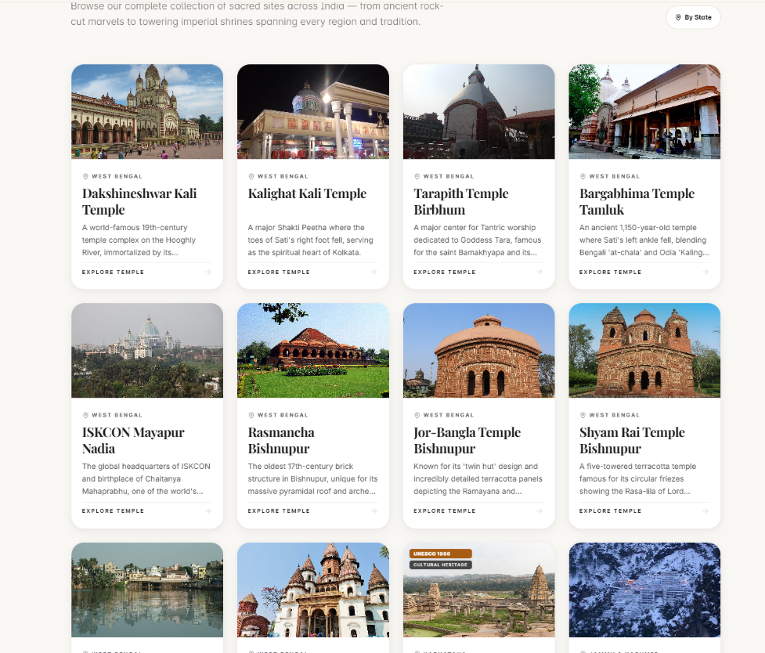
4.temle and pujas. This button shows top 50 famous and important temple details and the parigaram and special pujas details or this user, s they can make a plan to go to that temple ttheir free time. This temple and other details can take from Wikipedia.

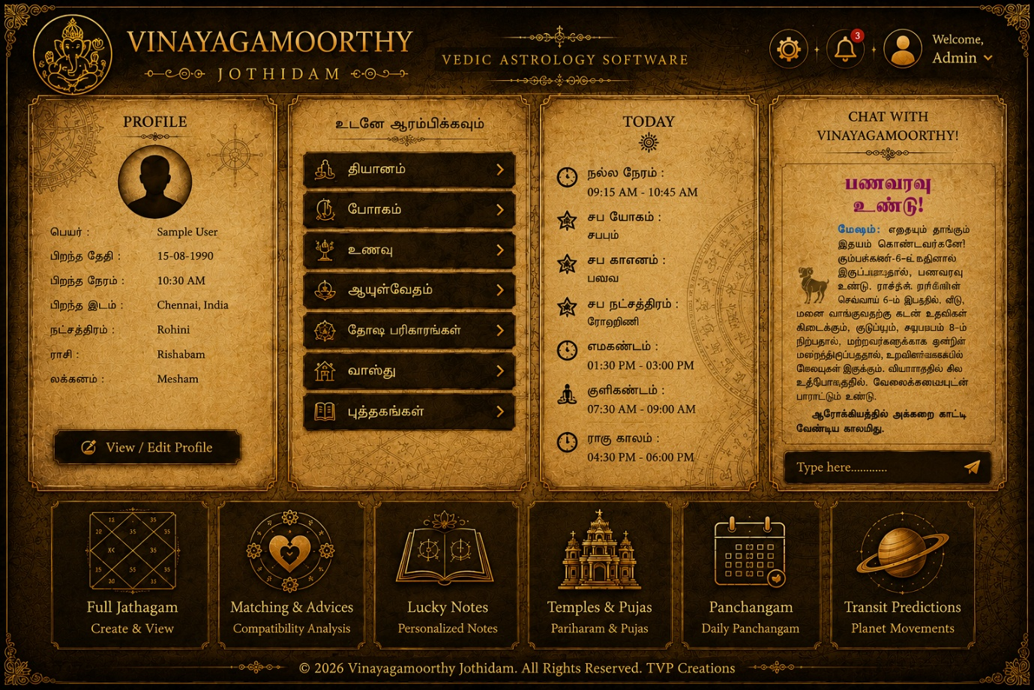
5.panchangam: This part shows the accurate prediction of below details according the planet movements .

1.profile; profile has user photo(optional), and other signup important personal etails. These details are the core iformations of the softwRE full calculations.okalways showing this details in left side according the sample design.

2.today: this button shows the important and rasi palan details of that user according the sample image and famous sample images attached below here.

3.clNd Muk;gpf;fTk;: this part show some buttons according the template. Each headings contain more relevant datas. Sources are youtube, Wikipedia, google, and other websites.

4.chat with vinayagamorthy: if amy one want to ask any astrology question abut them, definitely they can ask here, this Ai can findout any details about them from the jathagam and other calculations or websites. In future, I will update this Ai to send some notifications to user’s mobile task bar, special note about them to attract them to see the app.
5. footer part always shows the owner details.

