Analysis of Graphs

1.Loop time averaged over all reruns for various iteration values

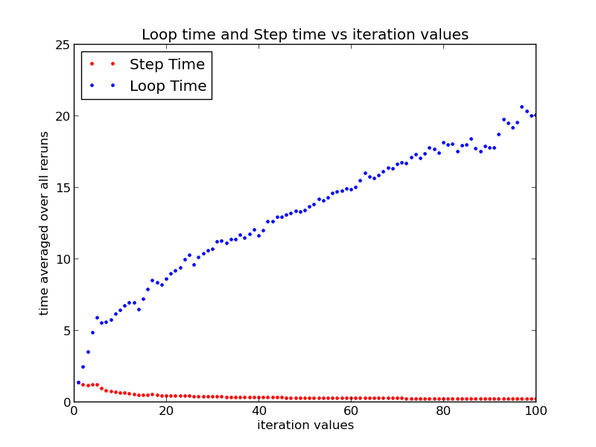
Observation: Loop time averaged over all reruns (the points with the blue dots) increases linearly .

Explanation: The step() function of Box2D world detects that if an event is occurred or not, if yes, then corresponding callback is given. An increase in the iteration value means addition of time taken for an extra step function with a callback causing a significant increase in the loop time. Hence, we can see the significant increasing trend of loop times.

2.Values of times before and after adding load

Observation : Values of loop time for all iteration values and rerun values increase significantly when system is heavily loaded.

Explanation : If the system is heavily loaded, the function gets less share of CPU resources thus increasing the time of processing.

When system is without load slope of graph is approximately 0.21 ms/iteration, which means each iteration takes approximately approximately .21 ms. But in case of heavily load it is 0.30 ms which meas each extra iteration takes approximately 0.30 ms.

before load plot01bf

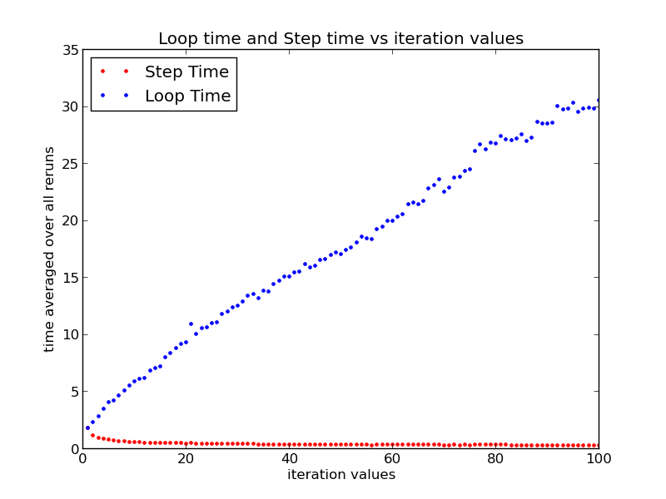
after load plot1

Those two graphs

When system is less loaded, loop time averaged over all reruns is around 13ms and it is around 15 ms in case of heavy load with some variation.

Observation : The length of y-error bars for lower iteration values is more as compared to the length of y-error bars for higher iteration values.

Explanation : When iteration value is lower, the average step time is calculated for less number of steps which is then averaged over all reruns(100 reruns). Thus, less amount of data is available for averaging the values when iteration value is lower. Due to less data, the averages for lower iteration values are less accurate giving larger errors. Hence, the larger y-error bars for low iteration values.

