Deletion Sequence: 5,12,9

Original tree: 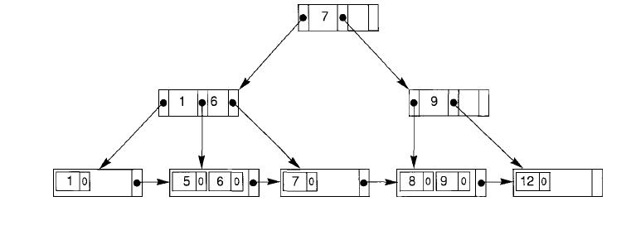a) Deleting: 5 (No underflow)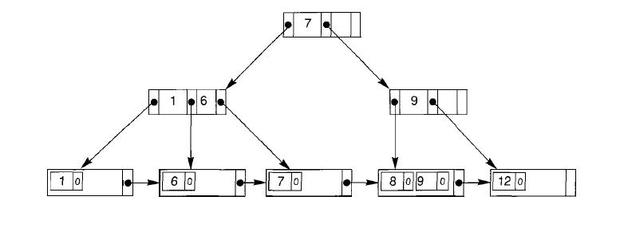b) Deleting: 12 (Underflow, thus redistribute)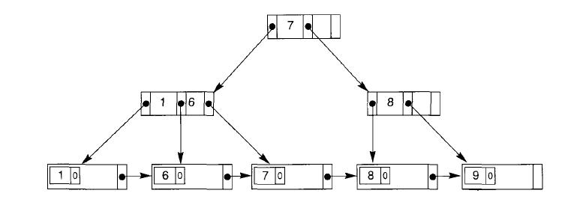 c) Deleting: 9 (Underflow, thus merge with left. Still underflow, thus reduce level)

