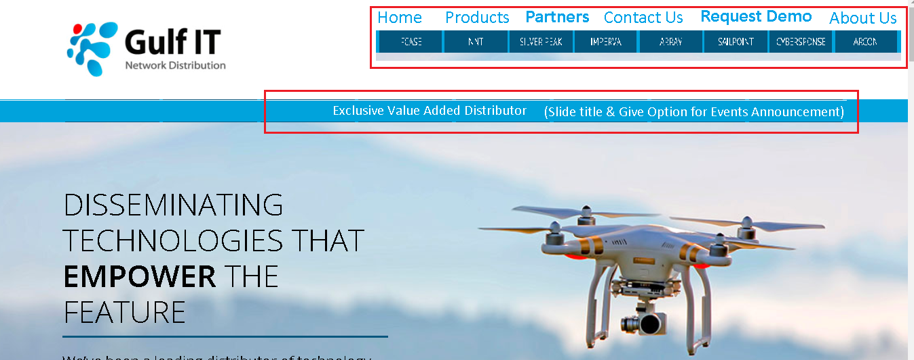

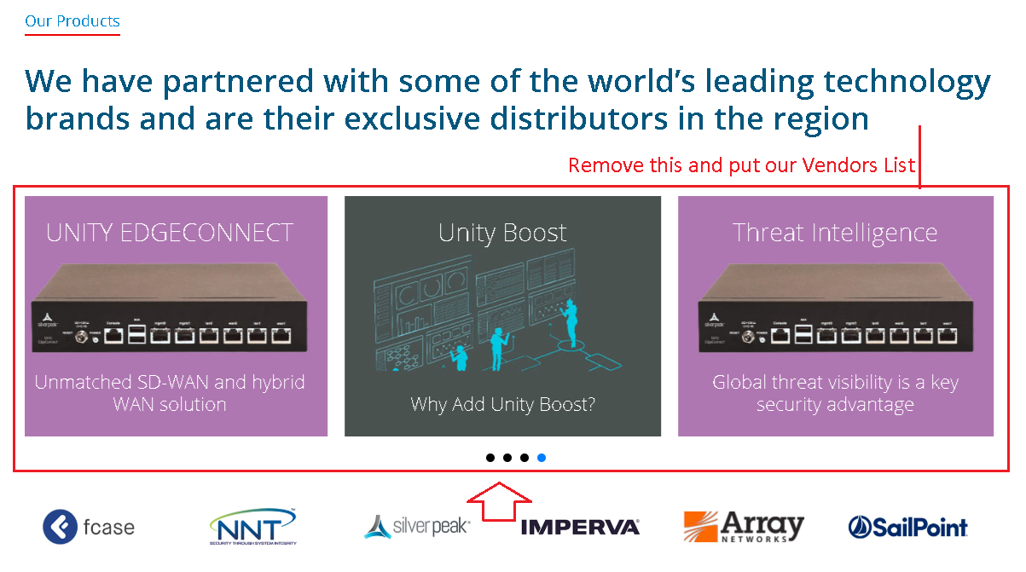

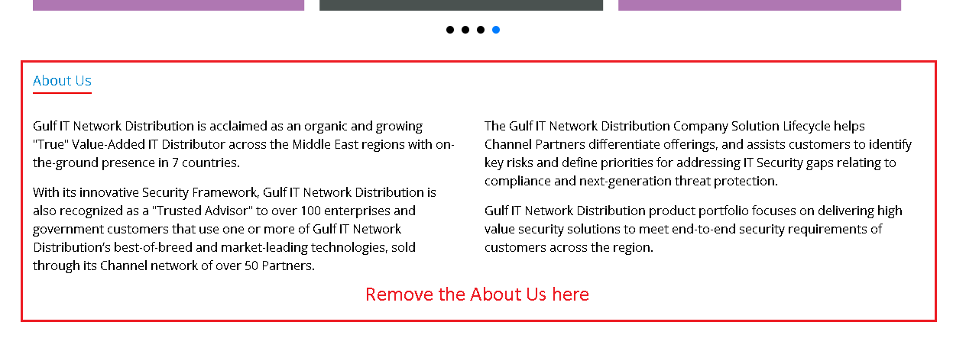





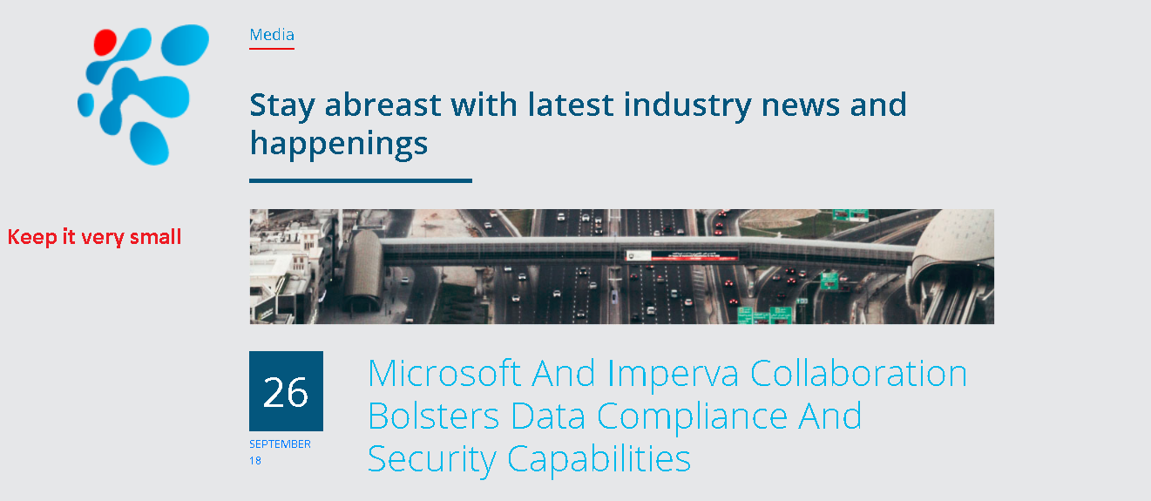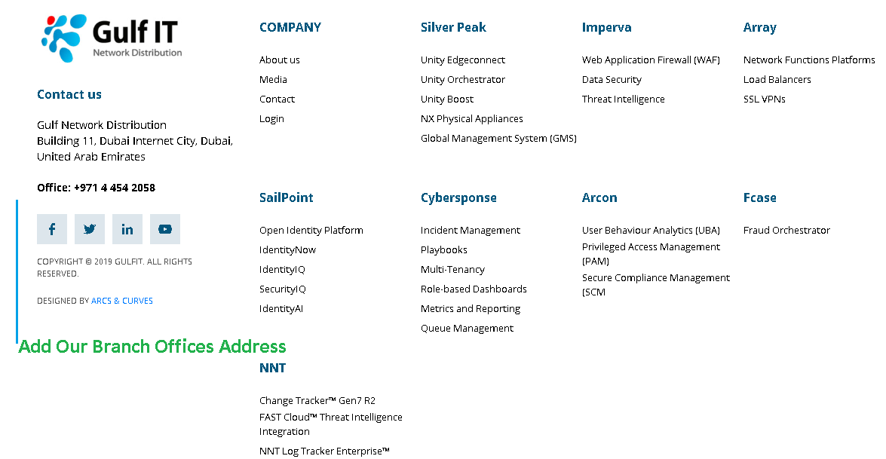

**Our Brach Offices Address:**

* **Saudi Arabia**

**Gulf IT Network Distribution**

**Address: Office 602, Sercon Tower 15, Olaya Street, Riyadh, Saudi Arabia**

* **Qatar**

**Gulf IT Network Distribution**

**Address: 1H Unit H13, Century 21 Commercial Offices, Mirqab Mall, Al Nasser St. Doha-Qatar**

**In the Page Become Partner**

Please provide the option to fill the information.

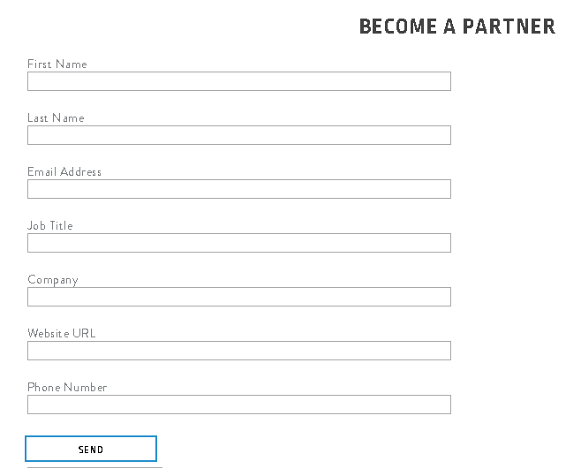

Request Demo

