Project Title: Personal Profile Showcase

Objective: Create a dynamic, interactive personal profile page that uses HTML5 features (audio, video, and image), servlets, cookies, sessions, and JavaScript to make it more personalized and engaging.

**Instructions**

1. Load an HTML5 page where users can add their name, their email and upload their favorite song audio,video and image .

For the **email** use type=”email” and make the field required

For the **name** – should be required ,add placeholder “Enter name”and with minimum length 2

Uploaded picture to accept only image/*

Uploaded video – video/* files and audio only audio/* files

1. Use section,header and footer to structure page
2. Files to be saved on server in server directory for example /uploads
3. Set and retrieve a cookie to remember the user's theme preference (dark or light mode).
4. Use sessions to store the user's name and audio path,video for the current session.

This project will include:

* **Servlet**: To handle the session and cookie management and render the HTML5 page.
* **HTML5 page**: With inputs for uploading audio, setting a theme, and displaying a personalized message.
* **When a user visits /profile**:
  + They see a form to enter their name, upload their favorite song, and toggle the theme.
  + Upon submission, the servlet saves the data in a session.
  + On reload, it displays a personalized greeting, audio player, and their chosen theme.

**User Inputs:**

* Name and email (required fields).
* Favourite image
* Favorite audio file (MP3, WAV, etc.).
* Favorite video file (MP4, WebM, etc.).
* Theme preference (light or dark).

**After Upload:**

* The user is greeted by name.
* The uploaded song is playable through the audio player.
* The uploaded video is playable through the video player.
* The chosen theme is applied and stored in a cookie.
* For the **picture** if the screen width is **460 pixels or less**, the browser will use this smaller image

Welcome Test_Name

* + **You favorurite singer picture is:**
  + A tree stump with moss

    Description automatically generatedA screenshot of a video player

    Description automatically generated

Example of dark theme:

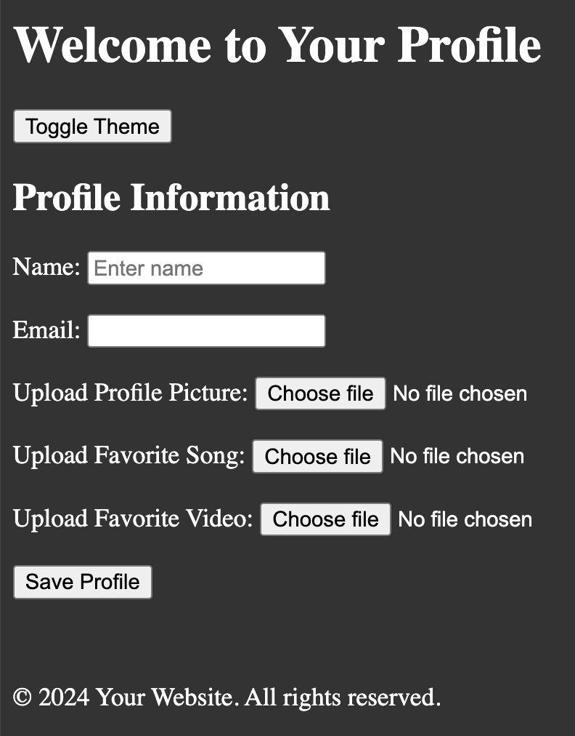

**Usefull links:**

<https://www.moreofless.co.uk/unable-process-parts-no-multi-part-configuration-provided>

<https://www.codejava.net/java-ee/servlet/multipartconfig-annotation-examples>