**Proposal Form**

|  |  |
| --- | --- |
| Student name: NGUYEN PHAM THANH DAT | Student number: GCS18525 |
| Centre name: University of Greenwich (Vietnam) - Ho Chi Minh | Date:20/02/2021 |
| Tutor: LE MINH NHUT TRIEU |  |
| Unit: Project |  |

**Proposed title**: This website sells books, we have all kinds of books you need to buy, just order online and you will receive them at home.

**Abstract**

In this life, there are many stores that do business with different marketing trends, so to be competitive we need to keep up with the trend, since online shopping, in general, is growing so fast, the next statistic shouldn’t come as a surprise to you. In 2023, ecommerce retail purchases are [expected to rise](https://www.statista.com/statistics/534123/e-commerce-share-of-retail-sales-worldwide/) from 14.1% to 22% (Coral Ouellette). So I want to create a sales website to serve the sale more effectively. Specifically, I want to create a website that sells different kinds of books. To be able to compete creating a sales website is essential, customers can consult books through the website without going to the store. In addition, they can preview the store's services to be able to make a decision. Attracting customers to the website you create must be professional in both appearance and content so that the store's reputable customers if you just make the website sloppy and amateurs, can be viewed as fake stores by customer’s virtual website, which can affect the store's business.

1. **Introduction**

The number of internet users in the world is growing on a large scale, as of January 2021, there were 4.66 billion active internet users worldwide - 59.5 percent of the global population. Of this total, 92.6 percent (4.32 billion) accessed the internet via mobile devices (Joseph Johnson, Mar 5, 2021), the number of people shopping through the website is increasing steadily. So for a store to develop a website is very necessary, nowadays people's shopping needs are increasing, but not everyone has a lot of free time to go shopping. Most of them choose to shop online to save time and there are many attractive incentives.

The User Types of the site are:

* Guest
* Customers (Registered Members)
* Administrators
  1. **Aim**

The purpose of this website is to cater to those who want to shop online specifically to buy books but don't have time to go to the store or they are too far away from the store. The website will make it easier for them to shop online through several basic features such as:

* View home page and manipulation: When visiting the website, users will see the first homepage, they can interact with the website and do what they want, such as choosing the right products that they want to buy.
* Login: Login function for the system to recognize users. If you want to buy a product, you must have an account to order. If you are an administrator, log in to the system to manage the website.
* Add cart; If customers want to select multiple products at the same time to purchase, they can add products to the cart so they can continue to choose more products.
* Payment: The user will proceed to pay directly on the website to buy the product
* Security: Security is one of the most important features for customers to trust the store, so revealing customer information will be very worrying.
* Delivery: Customers can see whether their order has been shipped or not

**1.2. The function of the site:**

**1.2.1. Guest account**

* Register for an account of the system
* View product information in the store
* View detailed information for each product
* Basic search

**1.2.2. Customers have registered for an account**

* Sign in
* Add goods to cart
* Order and payment
* Edit delivery information
* Cancel order

**1.2.3. Admin**

* Manage user accounts
* product advertising
* Order management

1. **Key phrases**

Shopping, online system, eshop, shopping sites, online sale, cheap online shopping, online shopping

1. **Objectives**

**3.1. Interacting with customers**

In business, interaction with customers is one of the essential needs to help the store grow more and more. When a store does not have a website, it is very limited, customers will not be able to refer to the products and buy directly through the website while the demand for online shopping is very popular.

Having a website to sell online also helps increase the number of customers significantly, not only have customers come directly to the store to buy products, but they can also shop online through the website, even the store there are more customers from faraway places through online shopping that cannot reach the store.

Customers can also view detailed information of products and promotions that will be updated quickly.

**3.2. Create reputation for the store**

As mentioned in the introduction, building a website helps to build a store's reputation. A professional website with many reviews will create a store's reputation and help customers reach the store faster through a user-friendly and easy-to-use interface.

**3.3. Receive feedback from customers**

Whether a business store develops or not depends on the prestige of the store and customer satisfaction so building a website to help receive feedback from customers more conveniently, helps the store to meet the needs customer demand is easily through positive or negative feedback, so that more effective adjustment can be taken to match the needs of customers.

Website will help the store get a lot of feedback from customers, which is what stores are essential to help them grow. Having this feedback, the store will have solutions to make customers feel satisfied and ready to support the store in the long run.

**3.4. Platform for product sales**

The foundation for selling products is the essential element for you to decide on designing a website for online sales. Nowadays, most people are busy with work, so they rarely go to stores to shop, in addition, customers from far away can consult products and buy products so building a website is a very important necessary need.

**3.5. Provide useful information to customers**

Having a website will help the store not spend too much money on advertising or distributing flyers, etc. Instead, we just need to put promotional notices on the website, the information will be provided to customers quickly. fast.

**3.6. Increase competitiveness**

As everyone knows nowadays, most of the stores own a website to easily reach their customers. So in order not to fall behind the competition and increase the competitiveness of the store having a website is indispensable.

**3.7. Cost savings**

Having a professional website will save you a lot of money. We don't have to spend huge sums of money hiring a team of sales, marketing, and so on. Just describe the product specifications on each product and customers will automatically refer.

1. **Project plan**

When it comes to designing and developing a new website, the two most common questions we hear revolve around price and timeline. How much does it cost for a website project? How long does it take to launch a new website? (UPANUP, October 20, 2018)

**4.1. Discovery and planning (2 to 10 weeks)**

This is the phase when my project will be successful or not. If I do it well, my chances of success will increase. During this phase, we will perform some work such as research, discovery sessions, write creative summaries, technical summary text.

**4.2. Design (4 to 12 weeks)**

After obtaining data from research in the next stage, we will base on what has been researched to conduct website design. After the preliminary design will consider and design the home page, designing many internal pages of the web. If we have a good design, the programming development will become easier and more favourable.

**4.3. Content writing and assembly (5 to 15 weeks)**

Content writing and assembly involves establishing key messages and calls-to-action, porting over content from existing sites, writing new text, editing text, creating headlines, page titles, captions and text for SEO purposes, headlines, descriptions and tags. (UPANUP, October 20, 2018)

**4.4. Development and programming (6 to 15 weeks)**

After having all the necessary information, we will proceed to the programming phase to create a web page that meets all of the given requirements. However, at this stage, the website only meets 80% of the requirements, not a 100% complete website.

**4.5. Beta testing and review (2 to 6 weeks)**

After you have programmed the website, we will proceed to an important stage that is to test and evaluate the website that has just finished coding, carefully check each function of the website to ensure the process of running smoothly.

**4.6. Site launch (1 day to 2 weeks)**

After the test is completed the next step is the website test run

**4.7. Maintenance and Enhancements (ongoing)**

Once a website is officially operational maintenance and improvements will have to be done regularly to ensure it will function properly and be secure.

**4.8 Gantt chart**

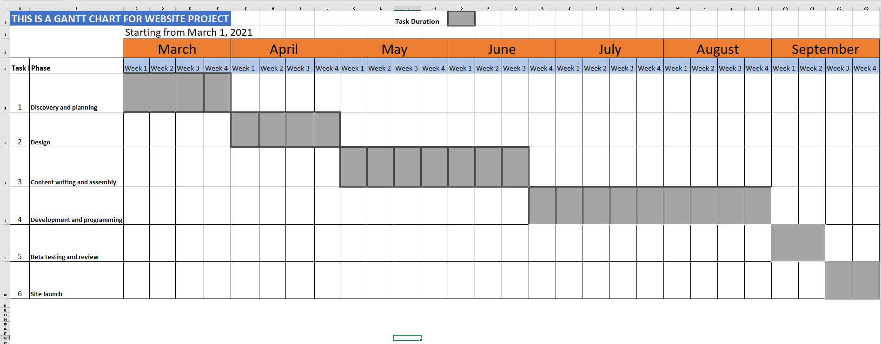

1. **Required resources**

**5. 1 Technology:**

* HTML/ HTML 5
* CSS/CSS 3
* JAVA SCRIPT
* Node Js

**5. 2 Tools:**

* Notepad ++
* Githup
* Express.js
* DREAM WEAVER
* PHOTOSHOP
* MongoDb

1. **Initial references**

*Internet users in the world 2021 | Statista* (2021). Available at: https://www.statista.com/statistics/617136/digital-population-worldwide/ (Accessed: 10 March 2021).

*Online Shopping Statistics You Need to Know in 2021* (2019). Available at: https://optinmonster.com/online-shopping-statistics/#:~:text=In%202019%2C%20it's%20estimated%20there,from%2014.1%25%20to%2022%25. (Accessed: 11 March 2021).

Website Timeline in 2021 |Upanup (2018). Available at: https://www.upanup.com/news/website-timeline-plan-success

**Comments and agreement from tutor**

Comments (optional):

I confirm that the project is not work which has been or will be submitted for another qualification and is appropriate.

Agreed: .................................................................................................................... (Name)...................................................................................(Date) ......................................................

**Comments and agreement from project proposal checker (if applicable)**

Comments (optional):

I confirm that the project is appropriate.

Agreed: .................................................................................... (Name) .................................................................................... (Date) ......................................................

